**Introduction to Data StructuresWhat is Data Structure?**

Whenever we want to work with large amount of data, then organizing that data is very important. If that data is not organized effectively, it is very difficult to perform any task on that data. If it is organized effectively then any operation can be performed easily on that data.  
  
A data structure can be defined as follows...

**Data structure is a method of organizing large amount of data more efficiently so that eany operation on that data becomes easy**

**NOTE**

☀ Every data structure is used to organize the large amount of data  
☀ Every data structure follows a particular principle  
☀ The operations in a data structure should not violate the basic principle of that data structure.

Based on the organizing method of a data structure, data structures are divided into two types.

1. Linear Data Structures
2. Non - Linear Data Structures

**Linear Data Structures**

**If a data structure is organizing the data in *sequential order*, then that data structure is called as Linear Data Structure.**

**Example**

1. Arrays
2. List (Linked List)
3. Stack
4. Queue

**Non - Linear Data Structures**

**If a data structure is organizing the data in *random order*, then that data structure is called as Non-Linear Data Structure.**

**Example**

1. Tree
2. Graph
3. Dictionaries
4. Heaps

# Stacks (LIFO-Last In First Out)

**Stack ADT**

**What is a Stack?**

Stack is a linear data structure in which the insertion and deletion operations are performed at only one end. In a stack, adding and removing of elements are performed at single position which is known as "**top**". That means, new element is added at top of the stack and an element is removed from the top of the stack. In stack, the insertion and deletion operations are performed based on **LIFO** (Last In First Out) principle.

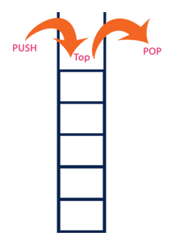

In a stack, the insertion operation is performed using a function called **"push"** and deletion operation is performed using a function called **"pop"**.  
  
In the figure, PUSH and POP operations are performed at top position in the stack. That means, both the insertion and deletion operations are performed at one end (i.e., at Top)  
  
A stack data structure can be defined as follows...

**Stack is a linear data structure in which the operations are performed based on LIFO principle.**

Stack can also be defined as

**"A Collection of similar data items in which both insertion and deletion operations are performed based on LIFO principle".**

**Example**

If we want to create a stack by inserting 10,45,12,16,35 and 50. Then 10 becomes the bottom most element and 50 is the top most element. Top is at 50 as shown in the image below...

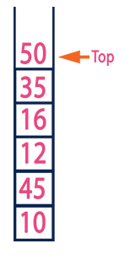

**Operations on a Stack**

The following operations are performed on the stack...

1. **Push (To insert an element on to the stack)**
2. **Pop (To delete an element from the stack)**
3. **Display (To display elements of the stack)**

Stack data structure can be implement in two ways. They are as follows...

1. **Using Array**
2. **Using Linked List**

When stack is implemented using array, that stack can organize only limited number of elements. When stack is implemented using linked list, that stack can organize unlimited number of elements.

**Stack Using Array**

A stack data structure can be implemented using one dimensional array. But stack implemented using array, can store only fixed number of data values. This implementation is very simple, just define a one dimensional array of specific size and insert or delete the values into that array by using **LIFO principle** with the help of a variable **'top'**. Initially top is set to -1. Whenever we want to insert a value into the stack, increment the top value by one and then insert. Whenever we want to delete a value from the stack, then delete the top value and decrement the top value by one.

**Stack Operations using Array**

A stack can be implemented using array as follows...  
  
Before implementing actual operations, first follow the below steps to create an empty stack.

* **Step 1:** Include all the **header files** which are used in the program and define a constant **'SIZE'** with specific value.
* **Step 2:** Declare all the **functions** used in stack implementation.
* **Step 3:** Create a one dimensional array with fixed size (**int stack[SIZE]**)
* **Step 4:** Define a integer variable **'top'** and initialize with **'-1'**. (**int top = -1**)
* **Step 5:** In main method display menu with list of operations and make suitable function calls to perform operation selected by the user on the stack.

**push(value) - Inserting value into the stack**

In a stack, push() is a function used to insert an element into the stack. In a stack, the new element is always inserted at **top** position. Push function takes one integer value as parameter and inserts that value into the stack. We can use the following steps to push an element on to the stack...

* **Step 1:** Check whether **stack** is **FULL**. (**top == SIZE-1**)
* **Step 2:** If it is **FULL**, then display **"Stack is FULL!!! Insertion is not possible!!!"** and terminate the function.
* **Step 3:** If it is **NOT FULL**, then increment **top** value by one (**top++**) and set stack[top] to value (**stack[top] = value**).

**pop() - Delete a value from the Stack**

In a stack, pop() is a function used to delete an element from the stack. In a stack, the element is always deleted from **top** position. Pop function does not take any value as parameter. We can use the following steps to pop an element from the stack...

* **Step 1:** Check whether **stack** is **EMPTY**. (**top == -1**)
* **Step 2:** If it is **EMPTY**, then display **"Stack is EMPTY!!! Deletion is not possible!!!"** and terminate the function.
* **Step 3:** If it is **NOT EMPTY**, then delete **stack[top]** and decrement **top** value by one (**top--**).

**display() - Displays the elements of a Stack**

We can use the following steps to display the elements of a stack...

* **Step 1:** Check whether **stack** is **EMPTY**. (**top == -1**)
* **Step 2:** If it is **EMPTY**, then display **"Stack is EMPTY!!!"** and terminate the function.
* **Step 3:** If it is **NOT EMPTY**, then define a variable '**i**' and initialize with top. Display **stack[i]** value and decrement **i** value by one (**i--**).
* **Step 3:** Repeat above step until **i** value becomes '0'.

## The Basics

A stack is a LIFO sequence. Addition and removal takes place **only** at one end, called the top.

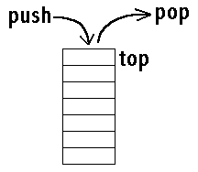

Operations

* push(x): add an item on the top
* pop: remove the item at the top
* peek: return the item at the top (without removing it)
* size: return the number of items in the stack
* isEmpty: return whether the stack has no items

## Method Index

*  [**empty**](https://www.cis.upenn.edu/~bcpierce/courses/629/jdkdocs/api/java.util.Stack.html#empty())()
* Tests if this stack is empty.
*  [**peek**](https://www.cis.upenn.edu/~bcpierce/courses/629/jdkdocs/api/java.util.Stack.html#peek())()
* Looks at the object at the top of this stack without removing it from the stack.
*  [**pop**](https://www.cis.upenn.edu/~bcpierce/courses/629/jdkdocs/api/java.util.Stack.html#pop())()
* Removes the object at the top of this stack and returns that object as the value of this function.
*  [**push**](https://www.cis.upenn.edu/~bcpierce/courses/629/jdkdocs/api/java.util.Stack.html#push(java.lang.Object))(Object)
* Pushes an item onto the top of this stack.
*  [**search**](https://www.cis.upenn.edu/~bcpierce/courses/629/jdkdocs/api/java.util.Stack.html#search(java.lang.Object))(Object)
* Returns where an object is on this stack.

## Examples

* Stacks of plates
* Trains
* Vending Machines
* Expression Evaluation
* Matching delimiters
* Navigating a maze
* Map coloring
* Many more examples

## Representations

* Wrapper around a built-in list object
* Array-based, bounded or expandable (All operations in Θ(1))

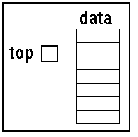

// Stack Program***************************************

#include<stdio.h>

#include<process.h>

#define MAXSIZE 10

void push();

void pop();

void traverse();

int stack[MAXSIZE];

int Top=-1;

int main()

{

int choice;

char ch;

do

{

printf("n1. PUSH ");

printf("n2. POP ");

printf("n3. TRAVERSE ");

printf("nEnter your choice ");

scanf("%d",&choice);

switch(choice)

{

  case 1: push();

  break;

  case 2: printf("nThe deleted element is %d ",pop());

  break;

  case 3: traverse();

  break;

  default: printf("nYou Entered Wrong Choice");

}

printf("nDo You Wish To Continue (Y/N)");

fflush(stdin);

scanf("%c",&ch);

}

while(ch=='Y' || ch=='y');

return 0;

}

void push()

{

int item;

if(Top>= MAXSIZE )

{

  printf("nThe Stack Is Full");

  exit(0);

}

else

{

  printf("Enter the element to be inserted ");

  scanf("%d",&item);

top++;

  stack[Top] = item;

}

}

void pop()

{

int item;

if(Top == -1)

{

  printf("The stack is Empty");

  exit(0);

}

else

{

  item = stack[Top];

  Top = Top-1;

}

Printf(”\n Element deleted is %d“,item);

}

void traverse()

{

int i;

if(Top == -1)

{

  printf("The Stack is Empty");

  exit(0);

}

else

{

  for(i=Top;i>=0;i--)

  {

   printf("%dn",stack[i]);

  }

}

}

**Queue ADT**

**What is a Queue?**

Queue is a linear data structure in which the insertion and deletion operations are performed at two different ends. In a queue data structure, adding and removing of elements are performed at two different positions. The insertion is performed at one end and deletion is performed at other end. In a queue data structure, the insertion operation is performed at a position which is known as '**rear**' and the deletion operation is performed at a position which is known as '**front**'. In data structure, the insertion and deletion operations are performed based on **FIFO (First In First Out)** principle.



In a queue data structure, the insertion operation is performed using a function called "**enQueue()**" and deletion operation is performed using a function called "**deQueue()**".  
  
Queue data structure can be defined as follows...

**Queue data structure is a linear data structure in which the operations are performed based on FIFO principle.**

A queue can also be defined as

**"Queue data structure is a collection of similar data items in which insertion and deletion operations are performed based on FIFO principle".**

**Example**

Queue after inserting 25, 30, 51, 60 and 85.

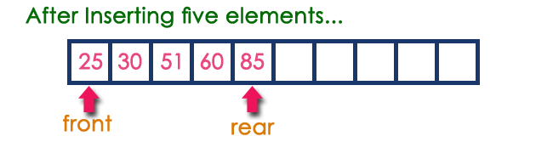

**Operations on a Queue**

The following operations are performed on a queue data structure...

1. **enQueue(value) - (To insert an element into the queue)**
2. **deQueue() - (To delete an element from the queue)**
3. **display() - (To display the elements of the queue)**

Queue data structure can be implemented in two ways. They are as follows...

1. **Using Array**
2. **Using Linked List**

When a queue is implemented using array, that queue can organize only limited number of elements. When a queue is implemented using linked list, that queue can organize unlimited number of elements.

**Queue Using Array**

A queue data structure can be implemented using one dimensional array. But, queue implemented using array can store only fixed number of data values. The implementation of queue data structure using array is very simple, just define a one dimensional array of specific size and insert or delete the values into that array by using **FIFO (First In First Out) principle** with the help of variables **'front'** and '**rear**'. Initially both '**front**' and '**rear**' are set to -1. Whenever, we want to insert a new value into the queue, increment '**rear**' value by one and then insert at that position. Whenever we want to delete a value from the queue, then increment 'front' value by one and then display the value at '**front**' position as deleted element.

**Queue Operations using Array**

Queue data structure using array can be implemented as follows...  
  
Before we implement actual operations, first follow the below steps to create an empty queue.

* **Step 1:** Include all the **header files** which are used in the program and define a constant **'SIZE'** with specific value.
* **Step 2:** Declare all the **user defined functions** which are used in queue implementation.
* **Step 3:** Create a one dimensional array with above defined SIZE (**int queue[SIZE]**)
* **Step 4:** Define two integer variables **'front'** and '**rear**' and initialize both with **'-1'**. (**int front = -1, rear = -1**)
* **Step 5:** Then implement main method by displaying menu of operations list and make suitable function calls to perform operation selected by the user on queue.

**enQueue(value) - Inserting value into the queue**

In a queue data structure, enQueue() is a function used to insert a new element into the queue. In a queue, the new element is always inserted at **rear** position. The enQueue() function takes one integer value as parameter and inserts that value into the queue. We can use the following steps to insert an element into the queue...

* **Step 1:** Check whether **queue** is **FULL**. (**rear == SIZE-1**)
* **Step 2:** If it is **FULL**, then display **"Queue is FULL!!! Insertion is not possible!!!"** and terminate the function.
* **Step 3:** If it is **NOT FULL**, then increment **rear** value by one (**rear++**) and set **queue[rear]** = **value**.

**deQueue() - Deleting a value from the Queue**

In a queue data structure, deQueue() is a function used to delete an element from the queue. In a queue, the element is always deleted from **front** position. The deQueue() function does not take any value as parameter. We can use the following steps to delete an element from the queue...

* **Step 1:** Check whether **queue** is **EMPTY**. (**front == rear**)
* **Step 2:** If it is **EMPTY**, then display **"Queue is EMPTY!!! Deletion is not possible!!!"** and terminate the function.
* **Step 3:** If it is **NOT EMPTY**, then increment the **front** value by one (**front ++**). Then display **queue[front]** as deleted element. Then check whether both **front** and **rear** are equal (**front** == **rear**), if it **TRUE**, then set both **front** and **rear** to '**-1**' (**front** = **rear** = **-1**).

**display() - Displays the elements of a Queue**

We can use the following steps to display the elements of a queue...

* **Step 1:** Check whether **queue** is **EMPTY**. (**front == rear**)
* **Step 2:** If it is **EMPTY**, then display **"Queue is EMPTY!!!"** and terminate the function.
* **Step 3:** If it is **NOT EMPTY**, then define an integer variable '**i**' and set '**i** = **front+1**'.
* **Step 3:** Display '**queue[i]**' value and increment '**i**' value by one (**i++**). Repeat the same until '**i**' value is equal to **rear** (**i** <= **rear**)

1. */\**
2. *\* C Program to Implement a Queue using an Array*
3. *\*/*
4. #include <stdio.h>
6. #define MAX 50
7. int queue_array[MAX];
8. int rear = - 1;
9. int front = - 1;
10. main()
11. {
12. int choice;
13. while (1)
14. {
15. printf("1.Insert element to queue **\n**");
16. printf("2.Delete element from queue **\n**");
17. printf("3.Display all elements of queue **\n**");
18. printf("4.Quit **\n**");
19. printf("Enter your choice : ");
20. scanf("%d", &choice);
21. switch (choice)
22. {
23. case 1:
24. insert();
25. **break**;
26. case 2:
27. delet();
28. **break**;
29. case 3:
30. display();
31. **break**;
32. case 4:
33. exit(1);
34. default:
35. printf("Wrong choice **\n**");
36. } */*End of switch*/*
37. } */*End of while*/*
38. } */*End of main()*/*
39. insert()
40. {
41. int add_item;
42. if (rear == MAX)
43. printf("Queue Overflow **\n**");
44. else
45. {
46. if (front == - 1)
47. */*If queue is initially empty */*
48. front = 0;
49. printf("Inset the element in queue : ");
50. scanf("%d", &add_item);
51. rear = rear + 1;
52. queue_array[rear] = add_item;
53. }
54. } */*End of insert()*/*

1. delet()
2. {
3. if(front==-1)
4. printf("\nQueue is empty");
5. else
6. {
7. printf("\n Element deleted is %d",queue[front]);
8. front++;
9. }
10. if(front>rear)
11. front=rear=-1; }
12. } */*End of delete() */*
13. display()
14. {
15. int i;
16. if (front == - 1)
17. printf("Queue is empty **\n**");
18. else
19. {
20. printf("Queue is : **\n**");
21. for (i = front; i <= rear; i++)
22. printf("%d ", queue_array[i]);
23. printf("**\n**");
24. }
25. } */*End of display() */*

**Single Linked List**

**What is Linked List?**

When we want to work with unknown number of data values, we use a linked list data structure to organize that data. Linked list is a linear data structure that contains sequence of elements such that each element links to its next element in the sequence. Each element in a linked list is called as **"Node"**.

**What is Single Linked List?**

Simply a list is a sequence of data, and linked list is a sequence of data linked with each other.   
  
The formal definition of a single linked list is as follows...

**Single linked list is a sequence of elements in which every element has link to its next element in the sequence.**

In any single linked list, the individual element is called as **"Node"**. Every **"Node"** contains two fields, **data** and **next**. The **data** field is used to store actual value of that node and next field is used to store the address of the next node in the sequence.  
  
The graphical representation of a node in a single linked list is as follows...



**NOTE**

☀ In a single linked list, the address of the first node is always stored in a reference node known as "front" (Some times it is also known as "head").  
☀ Always next part (reference part) of the last node must be NULL.

**Example**

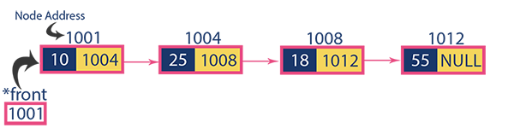

**Operations**

In a single linked list we perform the following operations...

1. Insertion
2. Deletion
3. Display

Before we implement actual operations, first we need to setup empty list. First perform the following steps before implementing actual operations.

* **Step 1:** Include all the **header files** which are used in the program.
* **Step 2:** Declare all the **user defined** functions.
* **Step 3:** Define a **Node** structure with two members **data** and **next**
* **Step 4:** Define a Node pointer '**head**' and set it to **NULL**.
* **Step 4:** Implement the **main** method by displaying operations menu and make suitable function calls in the main method to perform user selected operation.

**Insertion**

In a single linked list, the insertion operation can be performed in three ways. They are as follows...

1. Inserting At Beginning of the list
2. Inserting At End of the list
3. Inserting At Specific location in the list

**Inserting At Beginning of the list**

We can use the following steps to insert a new node at beginning of the single linked list...

* **Step 1:** Create a **newNode** with given value.
* **Step 2:** Check whether list is **Empty** (**head** == **NULL**)
* **Step 3:** If it is **Empty** then, set **newNode→next** = **NULL** and **head** = **newNode**.
* **Step 4:** If it is **Not Empty** then, set **newNode→next** = **head** and **head** = **newNode**.

**Inserting At End of the list**

We can use the following steps to insert a new node at end of the single linked list...

* **Step 1:** Create a **newNode** with given value and **newNode → next** as **NULL**.
* **Step 2:** Check whether list is **Empty** (**head** == **NULL**).
* **Step 3:** If it is **Empty** then, set **head** = **newNode**.
* **Step 4:** If it is **Not Empty** then, define a node pointer **temp** and initialize with **head**.
* **Step 5:** Keep moving the **temp** to its next node until it reaches to the last node in the list (until **temp → next** is equal to **NULL**).
* **Step 6:** Set **temp → next** = **newNode**.

**Inserting At Specific location in the list (After a Node)**

We can use the following steps to insert a new node after a node in the single linked list...

* **Step 1:** Create a **newNode** with given value.
* **Step 2:** Check whether list is **Empty** (**head** == **NULL**)
* **Step 3:** If it is **Empty** then, set **newNode → next** = **NULL** and **head** = **newNode**.
* **Step 4:** If it is **Not Empty** then, define a node pointer **temp** and initialize with **head**.
* **Step 5:** Keep moving the **temp** to its next node until it reaches to the node after which we want to insert the newNode (until **temp1 → data** is equal to **location**, here location is the node value after which we want to insert the newNode).
* **Step 6:** Every time check whether **temp** is reached to last node or not. If it is reached to last node then display **'Given node is not found in the list!!! Insertion not possible!!!'** and terminate the function. Otherwise move the **temp** to next node.
* **Step 7:** Finally, Set '**newNode → next** = **temp → next**' and '**temp → next** = **newNode**'

**Deletion**

In a single linked list, the deletion operation can be performed in three ways. They are as follows...

1. Deleting from Beginning of the list
2. Deleting from End of the list
3. Deleting a Specific Node

**Deleting from Beginning of the list**

We can use the following steps to delete a node from beginning of the single linked list...

* **Step 1:** Check whether list is **Empty** (**head** == **NULL**)
* **Step 2:** If it is **Empty** then, display **'List is Empty!!! Deletion is not possible'** and terminate the function.
* **Step 3:** If it is **Not Empty** then, define a Node pointer **'temp'** and initialize with **head**.
* **Step 4:** Check whether list is having only one node (**temp → next** == **NULL**)
* **Step 5:** If it is **TRUE** then set **head** = **NULL** and delete **temp** (Setting **Empty** list conditions)
* **Step 6:** If it is **FALSE** then set **head** = **temp → next**, and delete **temp**.

**Deleting from End of the list**

We can use the following steps to delete a node from end of the single linked list...

* **Step 1:** Check whether list is **Empty** (**head** == **NULL**)
* **Step 2:** If it is **Empty** then, display **'List is Empty!!! Deletion is not possible'** and terminate the function.
* **Step 3:** If it is **Not Empty** then, define two Node pointers **'temp1'** and '**temp2'** and initialize '**temp1**' with **head**.
* **Step 4:** Check whether list has only one Node (**temp1 → next** == **NULL**)
* **Step 5:** If it is **TRUE**. Then, set **head** = **NULL** and delete **temp1**. And terminate the function. (Setting **Empty** list condition)
* **Step 6:** If it is **FALSE**. Then, set '**temp2 = temp1**' and move **temp1** to its next node. Repeat the same until it reaches to the last node in the list. (until **temp1 → next** == **NULL**)
* **Step 7:** Finally, Set **temp2 → next**= **NULL** and delete **temp1**.

**Deleting a Specific Node from the list**

We can use the following steps to delete a specific node from the single linked list...

* **Step 1:** Check whether list is **Empty** (**head** == **NULL**)
* **Step 2:** If it is **Empty** then, display **'List is Empty!!! Deletion is not possible'** and terminate the function.
* **Step 3:** If it is **Not Empty** then, define two Node pointers **'temp1'** and '**temp2**' and initialize '**temp1**' with **head**.
* **Step 4:** Keep moving the **temp1** until it reaches to the exact node to be deleted or to the last node. And every time set '**temp2 = temp1**' before moving the '**temp1**' to its next node.
* **Step 5:** If it is reached to the last node then display **'Given node not found in the list! Deletion not possible!!!'**. And terminate the function.
* **Step 6:** If it is reached to the exact node which we want to delete, then check whether list is having only one node or not
* **Step 7:** If list has only one node and that is the node to be deleted, then set **head** = **NULL** and delete **temp1** (**free(temp1)**).
* **Step 8:** If list contains multiple nodes, then check whether **temp1** is the first node in the list (**temp1 == head**).
* **Step 9:** If **temp1** is the first node then move the **head** to the next node (**head = head → next**) and delete **temp1**.
* **Step 10:** If **temp1** is not first node then check whether it is last node in the list (**temp1 → next == NULL**).
* **Step 11:** If **temp1** is last node then set **temp2 → next** = **NULL** and delete **temp1** (**free(temp1)**).
* **Step 12:** If **temp1** is not first node and not last node then set **temp2 → next** = **temp1 → next** and delete **temp1** (**free(temp1)**).

**Displaying a Single Linked List**

We can use the following steps to display the elements of a single linked list...

* **Step 1:** Check whether list is **Empty** (**head** == **NULL**)
* **Step 2:** If it is **Empty** then, display **'List is Empty!!!'** and terminate the function.
* **Step 3:** If it is **Not Empty** then, define a Node pointer **'temp'** and initialize with **head**.
* **Step 4:** Keep displaying **temp → data** with an arrow (**--->**) until **temp** reaches to the last node
* **Step 5:** Finally display **temp → data** with arrow pointing to **NULL** (**temp → data ---> NULL**).

// Final Linked List Program

**#include<stdio.h>**

**#include<conio.h>**

**#include<stdlib.h>**

**struct** node

{

**int** data;

**struct** node *next;

}*head,*var,*trav;

**void** insert_at_begning(**int** value)

{

var=(**struct** node*)malloc(**sizeof** (**struct** node));

var->data=value;

**if**(head==NULL)

{

head=var;

head->next=NULL;

}

**else**

{

var->next=head;

head=var;

}}

**void** insert_at_end(**int** value)

{

**struct** node *temp;

temp=head;

var=(**struct** node *)malloc(**sizeof** (**struct** node));

*var->data=value;*

***if****(head==NULL)*

*{*

*head=var;*

head->next=NULL;

}

**else**

{

**while**(temp->next!=NULL)

{

temp=temp->next;

}

var->next=NULL;

temp->next=var;

}

}

**void** insert_at_middle(**int** value, **int** loc)

{ **struct** node *temp;

var=(**struct** node *)malloc(**sizeof** (**struct** node));

var->data=value;

temp=head;

**if**(head==NULL)

{ head=var;

head->next=NULL;

}

**else**

{

**while**(temp->data!=loc)

{

temp=temp->next;

}

var->next =temp->next;

temp->next=var;

}

}

**int** delete_from_middle(**int** value)

{

**struct** node *temp,*var;

temp=head;

**while**(temp!=NULL)

{

**if**(temp->data == value)

{

**if**(temp==head)

{

head=temp->next;

free(temp);

**return** 0;

}

**else**

{

var->next=temp->next;

free(temp);

**return** 0;

}

}

**else**

{

var=temp;

temp=temp->next;

}

Cout<<**"data deleted from list is”<<**value;

}}

**int** delete_from_end()

{

**struct** node *temp;

temp=head;

**while**(temp->next != NULL)

{

var=temp;

temp=temp->next;

}

**if**(temp ==head)

{

head=temp->next;

free(temp);

**return** 0;

}

Cout<<**"data deleted from list is”<<**temp->data;

var->next=NULL;

free(temp);

}

**void** display()

{

trav=head;

**if**(trav==NULL)

{

Cout<<**"\nList is Empty"**;

}

**else**

{

Cout<<**"\nElements in the List: "**;

**while**(trav!=NULL)

{

Cout<<trav->data;

trav=trav->next;

}

Cout<<**"\n"**;

}

}

**void** main()

{

*head=NULL;*

insert_beggining();

insert_end();

insert_middle();

delete();

getch();

}

## Algorithm

1. Getnode()//creates  node
2. 1.  [allocate memory **for** node] Set temp:=(node *)malloc(**sizeof**(node));
3. 2.  If (temp==NULL) then:  **return** â€œerrorâ€ and exit
4. 3.  Else **return** temp;
5. 4.  Exit
6. Insert_beg(x)//inserts element  x at beginning of list
7. 1.  Call getnode();
8. 2.  [store value in newly created node] Set temp->data := x and temp->next := NULL;
9. 3.  If start==NULL then: Set start := temp;
10. 4.  Else
11. a.  Set  temp->next := start;
12. b.  Set start  := temp;
13. 5.  Exit
14. Insert_end(x)//inserts x at the end of the list
15. 1.  Call getnode();
16. 2.  [store value in newly created node] Set temp->data := x and temp->next := NULL;
17. 3.  If start==NULL then: Set start := temp;
18. 4.  Else
19. a.  Set  ptr:=start;
20. b.  Repeat  step c and d **while** ptr!=NULL
21. c.  Set save := ptr;
22. d.  Set  ptr:= ptr->next;
23. e.  Set save->next:= temp;
24. 5.  Exit
25. Insert_mid(index,x)//Inserts  node with value x after  index no. of  nodes
26. 1.  [initialize ct] ct := 0;
27. 2.  Call getnode();
28. 3.  [store value in newly created node] Set temp->data := x and temp->next := NULL;
29. 4.   Set ptr:= start;
30. 5.  Repeat **while**(ct<index)
31. a.  Set save := ptr;
32. b.  Set ptr := ptr -> next;
33. c.  [increment ct] ct++;
34. 6.  If start==NULL then: set start :=temp;
35. 7.  Else **if** (ptr==start)
36. a.  Set temp->next := ptr;
37. b.  Set start  :=  temp;
38. 8.  Else
39. a.  Set temp->next := save->next;
40. b.  Save->next := temp;
41. 9.  exit
42. reverse()//reverses the given linked list
43. 1.  Set  ptr := save := start;
44. 2.  If  (start==NULL) then print â€œlist is emptyâ€;
45. 3.  Else
46. a.  Set save := NULL
47. b.  Repeat steps c,d and e **while** (ptr!=NULL)
48. c.  Set  temp := save;
49. d.  Set save := ptr and save->next:= temp;
50. e.  Set ptr := ptr->next;
51. f.  Set start := save;
52. 4.  Exit
53. Delete_node(v)//deletes node with value v from list
54. 1.  Set ptr := start;
55. 2.  If start := NULL then print â€œlist is emptyâ€;
56. 3.  Else
57. a.  Repeat **while** ((ptr != NULL ) && (ptr->data != v))
58. b.  Set save := ptr;
59. c.  Set ptr := ptr -> next;
60. d.  [end of **while**]
61. e.  Repeat steps  f,g,and h **if**(ptr->data == v) then:
62. f.  If ptr==start  then:
63. i.  Set del := ptr->data and ptr := ptr->next;
64. ii. Free(start);
65. iii.    Set start := ptr;
66. g.  Else
67. i.  Set del:=ptr->data and save->next := ptr->next;
68. ii. Free ptr;
69. h.  Return del;
70. 4.  Else print â€œElement to be deleted not foundâ€ and exit;
71. 5.  [End]
72. Search(v)//searches element v in list
73. 1.  Initialize ptr := start;
74. 2.  If start == NULL  then : print â€œlist is emptyâ€;
75. 3.  Else
76. a.  Do ptr := ptr->next,  **while** (ptr !=NULL  && ptr->data !=v)
77. b.  If ptr->data == v then **return** ptr;
78. c.  Else print â€œElement not foundâ€;
79. 4.  [End]
80. Count()//counts number of nodes in the list
81. 1.  Initialize ct := 0 and ptr := start;
82. 2.  Repeat  step 3 **while** (ptr!=NULL)
83. 3.  [increase ct] ct++ and set ptr := ptr->next;
84. 4.  Return ct and exit;

**Stack using Linked List**

The major problem with the stack implemented using array is, it works only for fixed number of data values. That means the amount of data must be specified at the beginning of the implementation itself. Stack implemented using array is not suitable, when we don't know the size of data which we are going to use. A stack data structure can be implemented by using linked list data structure. The stack implemented using linked list can work for unlimited number of values. That means, stack implemented using linked list works for variable size of data. So, there is no need to fix the size at the beginning of the implementation. The Stack implemented using linked list can organize as many data values as we want.   
  
In linked list implementation of a stack, every new element is inserted as '**top**' element. That means every newly inserted element is pointed by '**top**'. Whenever we want to remove an element from the stack, simply remove the node which is pointed by '**top**' by moving '**top**' to its next node in the list. The **next** field of the first element must be always **NULL**.

**Example**

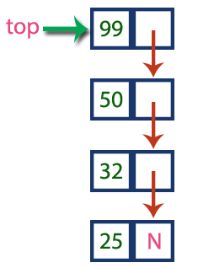

In above example, the last inserted node is 99 and the first inserted node is 25. The order of elements inserted is 25, 32,50 and 99.

**Operations**

To implement stack using linked list, we need to set the following things before implementing actual operations.

* **Step 1:** Include all the **header files** which are used in the program. And declare all the **user defined functions**.
* **Step 2:** Define a '**Node**' structure with two members **data** and **next**.
* **Step 3:** Define a **Node** pointer '**top**' and set it to **NULL**.
* **Step 4:** Implement the **main** method by displaying Menu with list of operations and make suitable function calls in the **main** method.

**push(value) - Inserting an element into the Stack**

We can use the following steps to insert a new node into the stack...

* **Step 1:** Create a **newNode** with given value.
* **Step 2:** Check whether stack is **Empty** (**top** == **NULL**)
* **Step 3:** If it is **Empty**, then set **newNode → next** = **NULL**.
* **Step 4:** If it is **Not Empty**, then set **newNode → next** = **top**.
* **Step 5:** Finally, set **top** = **newNode**.

**pop() - Deleting an Element from a Stack**

We can use the following steps to delete a node from the stack...

* **Step 1:** Check whether **stack** is **Empty** (**top == NULL**).
* **Step 2:** If it is **Empty**, then display **"Stack is Empty!!! Deletion is not possible!!!"** and terminate the function
* **Step 3:** If it is **Not Empty**, then define a **Node** pointer '**temp**' and set it to '**top**'.
* **Step 4:** Then set '**top** = **top → next**'.
* **Step 7:** Finally, delete '**temp**' (**free(temp)**).

**display() - Displaying stack of elements**

We can use the following steps to display the elements (nodes) of a stack...

* **Step 1:** Check whether stack is **Empty** (**top** == **NULL**).
* **Step 2:** If it is **Empty**, then display **'Stack is Empty!!!'** and terminate the function.
* **Step 3:** If it is **Not Empty**, then define a Node pointer **'temp'** and initialize with **top**.
* **Step 4:** Display '**temp → data** --->' and move it to the next node. Repeat the same until **temp** reaches to the first node in the stack (**temp → next** != **NULL**).
* **Step 4:** Finally! Display '**temp → data** ---> **NULL**'.

// Stack as linked list

#include<iostream>

#include<cstdlib>

#include<malloc.h>

#include<conio.h>

using namespace std;

struct node{

int info;

struct node *next;

};

class stack{

struct node *top;

public:

stack();

void main()

{

top = NULL;

void push();

void pop();

void display();

}

stack::stack(){

}

void stack::push(){

int data;

struct node *p;

if((p=(node*)malloc(sizeof(node)))==NULL){

cout<<"Stack is full";

exit(0);

}

cout<<"Enter a Number to insert:";

cin>>data;

p = new node;

p->info = data;

p->next = NULL;

if(top!=NULL){

p->next = top;

}

top = p;

cout<<"\nNew item inserted"<<endl;

}

void stack::pop(){

struct node *temp;

if(top==NULL){

cout<<"\nThe stack is Empty"<<endl;

}else{

temp = top;

top = top->next;

cout<<"\nThe value popped is "<<temp->info<<endl;

delete temp;

}

}

void stack::display(){

struct node *p = top;

if(top==NULL){

cout<<"\nNothing to Display\n";

}else{

cout<<"\nThe contents of Stack\n";

while(p!=NULL){

cout<<p->info<<endl;

p = p->next;

}

}

}

int main(){

stack s;

int choice;

do{

cout<<"\nEnter your choice:";

cout<<"\n1. PUSH\n2. POP\n3. DISPLAY\n4. EXIT\n";

cin>>choice;

switch(choice){

case 1:

s.push();

break;

case 2:

s.pop();

break;

case 3:

s.display();

break;

case 4:

exit(0);

break;

default:

cout<<"Invalid Choice";

break;

}

}while(choice);

getch();

return 0;

}

**Queue using Linked List**

The major problem with the queue implemented using array is, It will work for only fixed number of data. That means, the amount of data must be specified in the beginning itself. Queue using array is not suitable when we don't know the size of data which we are going to use. A queue data structure can be implemented using linked list data structure. The queue which is implemented using linked list can work for unlimited number of values. That means, queue using linked list can work for variable size of data (No need to fix the size at beginning of the implementation). The Queue implemented using linked list can organize as many data values as we want.   
  
In linked list implementation of a queue, the last inserted node is always pointed by '**rear**' and the first node is always pointed by '**front**'.

**Example**

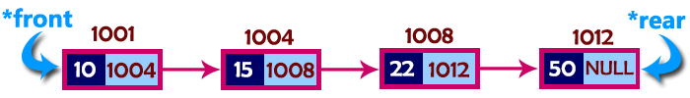

In above example, the last inserted node is 50 and it is pointed by '**rear**' and the first inserted node is 10 and it is pointed by '**front**'. The order of elements inserted is 10, 15, 22 and 50.

**Operations**

To implement queue using linked list, we need to set the following things before implementing actual operations.

* **Step 1:** Include all the **header files** which are used in the program. And declare all the **user defined functions**.
* **Step 2:** Define a '**Node**' structure with two members **data** and **next**.
* **Step 3:** Define two **Node** pointers '**front**' and '**rear**' and set both to **NULL**.
* **Step 4:** Implement the **main** method by displaying Menu of list of operations and make suitable function calls in the **main** method to perform user selected operation.

**enQueue(value) - Inserting an element into the Queue**

We can use the following steps to insert a new node into the queue...

* **Step 1:** Create a **newNode** with given value and set '**newNode → next**' to **NULL**.
* **Step 2:** Check whether queue is **Empty** (**rear** == **NULL**)
* **Step 3:** If it is **Empty** then, set **front** = **newNode** and **rear** = **newNode**.
* **Step 4:** If it is **Not Empty** then, set **rear → next** = **newNode** and **rear** = **newNode**.

**deQueue() - Deleting an Element from Queue**

We can use the following steps to delete a node from the queue...

* **Step 1:** Check whether **queue** is **Empty** (**front == NULL**).
* **Step 2:** If it is **Empty**, then display **"Queue is Empty!!! Deletion is not possible!!!"** and terminate from the function
* **Step 3:** If it is **Not Empty** then, define a Node pointer '**temp**' and set it to '**front**'.
* **Step 4:** Then set '**front** = **front → next**' and delete '**temp**' (**free(temp)**).

**display() - Displaying the elements of Queue**

We can use the following steps to display the elements (nodes) of a queue...

* **Step 1:** Check whether queue is **Empty** (**front** == **NULL**).
* **Step 2:** If it is **Empty** then, display **'Queue is Empty!!!'** and terminate the function.
* **Step 3:** If it is **Not Empty** then, define a Node pointer **'temp'** and initialize with **front**.
* **Step 4:** Display '**temp → data** --->' and move it to the next node. Repeat the same until '**temp**' reaches to '**rear**' (**temp → next** != **NULL**).
* **Step 4:** Finally! Display '**temp → data** ---> **NULL**'.

// Queue as linked list

#include<iostream>

#include<cstdlib>

using namespace std;

struct node{

int info;

struct node *next;

};

class Queue{

private:

node *rear;

node *front;

public:

Queue();

void enqueue();

void dequeue();

void display();

};

Queue::Queue(){

rear = NULL;

front = NULL;

}

void Queue::insert(){

int data;

node *temp = new node;

cout<<"Enter the data to queue: ";

cin>>data;

temp->info = data;

temp->next = NULL;

if(front == NULL){

front = temp;

}else{

rear->next = temp;

}

rear = temp;

}

void Queue::delete(){

node *temp = new node;

if(front == NULL){

cout<<"\nQueue is Emtpty\n";

}else{

temp = front;

front = front->next;

cout<<"The data Dequeued is "<<temp->info;

delete temp;

}

}

void Queue::display(){

node *p = new node;

p = front;

if(front == NULL){

cout<<"\nNothing to Display\n";

}else{

while(p!=NULL){

cout<<endl<<p->info;

p = p->next;

}

}

}

int main(){

Queue queue;

int choice;

while(true){

cout<<"\n1.Enqueue\n2. Dequeue\n3. Display\n 4.Quit";

cout<<"\nEnter your choice: ";

cin>>choice;

switch(choice){

case 1:

queue.enqueue();

break;

case 2:

queue.dequeue();

break;

case 3:

queue.display();

break;

case 4:

exit(0);

break;

default:

cout<<"\nInvalid Input. Try again! \n";

break;

}

}

return 0;

}

**3**

In a normal Queue Data Structure, we can insert elements until queue becomes full. But once if queue becomes full, we can not insert the next element until all the elements are deleted from the queue. For example consider the queue below...  
  
After inserting all the elements into the queue.

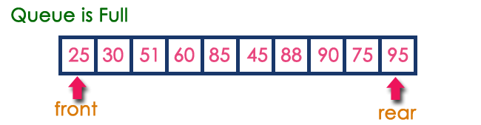

Now consider the following situation after deleting three elements from the queue...

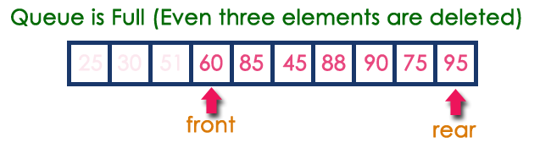

This situation also says that Queue is Full and we can not insert the new element because, '**rear**' is still at last position. In above situation, even though we have empty positions in the queue we can not make use of them to insert new element. This is the major problem in normal queue data structure. To overcome this problem we use circular queue data structure.

**What is Circular Queue?**

A Circular Queue can be defined as follows...

**Circular Queue is a linear data structure in which the operations are performed based on FIFO (First In First Out) principle and the last position is connected back to the first position to make a circle.**

Graphical representation of a circular queue is as follows...

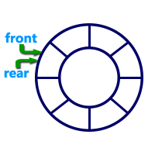

**Implementation of Circular Queue**

To implement a circular queue data structure using array, we first perform the following steps before we implement actual operations.

* **Step 1:** Include all the **header files** which are used in the program and define a constant **'SIZE'** with specific value.
* **Step 2:** Declare all **user defined functions** used in circular queue implementation.
* **Step 3:** Create a one dimensional array with above defined SIZE (**int cQueue[SIZE]**)
* **Step 4:** Define two integer variables **'front'** and '**rear**' and initialize both with **'-1'**. (**int front = -1, rear = -1**)
* **Step 5:** Implement main method by displaying menu of operations list and make suitable function calls to perform operation selected by the user on circular queue.

**enQueue(value) - Inserting value into the Circular Queue**

In a circular queue, enQueue() is a function which is used to insert an element into the circular queue. In a circular queue, the new element is always inserted at **rear** position. The enQueue() function takes one integer value as parameter and inserts that value into the circular queue. We can use the following steps to insert an element into the circular queue...

* **Step 1:** Check whether **queue** is **FULL**. (**(rear == SIZE-1 && front == 0) || (front == rear+1)**)
* **Step 2:** If it is **FULL**, then display **"Queue is FULL!!! Insertion is not possible!!!"** and terminate the function.
* **Step 3:** If it is **NOT FULL**, then check **rear == SIZE - 1 && front != 0** if it is **TRUE**, then set **rear = -1**.
* **Step 4:** Increment **rear** value by one (**rear++**), set **queue[rear]** = **value** and check '**front == -1**' if it is **TRUE**, then set **front = 0**.

**deQueue() - Deleting a value from the Circular Queue**

In a circular queue, deQueue() is a function used to delete an element from the circular queue. In a circular queue, the element is always deleted from **front** position. The deQueue() function doesn't take any value as parameter. We can use the following steps to delete an element from the circular queue...

* **Step 1:** Check whether **queue** is **EMPTY**. (**front == -1 && rear == -1**)
* **Step 2:** If it is **EMPTY**, then display **"Queue is EMPTY!!! Deletion is not possible!!!"** and terminate the function.
* **Step 3:** If it is **NOT EMPTY**, then display **queue[front]** as deleted element and increment the **front** value by one (**front ++**). Then check whether **front == SIZE**, if it is **TRUE**, then set **front = 0**. Then check whether both **front - 1** and **rear** are equal (**front -1** == **rear**), if it **TRUE**, then set both **front** and **rear** to '**-1**' (**front** = **rear** = **-1**).

**display() - Displays the elements of a Circular Queue**

We can use the following steps to display the elements of a circular queue...

* **Step 1:** Check whether **queue** is **EMPTY**. (**front == -1**)
* **Step 2:** If it is **EMPTY**, then display **"Queue is EMPTY!!!"** and terminate the function.
* **Step 3:** If it is **NOT EMPTY**, then define an integer variable '**i**' and set '**i** = **front**'.
* **Step 4:** Check whether '**front <= rear**', if it is **TRUE**, then display '**queue[i]**' value and increment '**i**' value by one (**i++**). Repeat the same until '**i <= rear**' becomes **FALSE**.
* **Step 5:** If '**front <= rear**' is **FALSE**, then display '**queue[i]**' value and increment '**i**' value by one (**i++**). Repeat the same until'**i <= SIZE - 1**' becomes **FALSE**.
* **Step 6:** Set **i** to **0**.
* **Step 7:** Again display '**cQueue[i]**' value and increment **i** value by one (**i++**). Repeat the same until '**i <= rear**' becomes **FALSE**.

Circular queue

#include<stdio.h>

#define max 3

int q[10],front=0,rear=-1;

void main()

{

int ch;

void insert();

void delet();

void display();

clrscr();

printf("**\n**Circular Queue operations**\n**");

printf("1.insert**\n**2.delete**\n**3.display**\n**4.exit**\n**");

while(1)

{

printf("Enter your choice:");

scanf("%d",&ch);

switch(ch)

{

case 1: insert();

**break**;

case 2: delet();

**break**;

case 3:display();

**break**;

case 4:exit();

default:printf("Invalid option**\n**");

}

}

}

void insert()

{

int x;

if((front==0&&rear==max-1)||(front>0&&rear==front-1))

printf("Queue is overflow**\n**");

else

{

printf("Enter element to be insert:");

scanf("%d",&x);

if(rear==max-1&&front>0)

{

rear=0;

q[rear]=x;

}

else

{

if((front==0&&rear==-1)||(rear!=front-1))

q[++rear]=x;

}

}

}

void delet()

{

int a;

if((front==0)&&(rear==-1))

{

printf("Queue is underflow**\n**");

getch();

exit();

}

if(front==rear)

{

a=q[front];

rear=-1;

front=0;

}

else

if(front==max-1)

{

a=q[front];

front=0;

}

else a=q[front++];

printf("Deleted element is:%d**\n**",a);

}

void display()

{

int i,j;

if(front==0&&rear==-1)

{

printf("Queue is underflow**\n**");

getch();

exit();

}

if(front>rear)

{

for(i=0;i<=rear;i++)

printf("**\t**%d",q[i]);

for(j=front;j<=max-1;j++)

printf("**\t**%d",q[j]);

}

else

{

for(i=front;i<=rear;i++)

{

printf("**\t**%d",q[i]);

}

}

printf("**\n**");

}

getch();

Double-Ended Queue

**Double Ended Queue (Dequeue)**

Double Ended Queue is also a Queue data structure in which the insertion and deletion operations are performed at both the ends (**front**and **rear**). That means, we can insert at both front and rear positions and can delete from both front and rear positions.

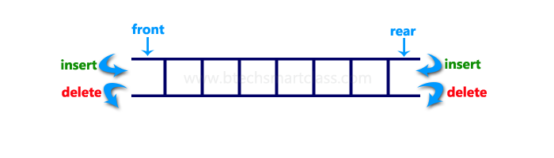

Double Ended Queue can be represented in TWO ways, those are as follows...

1. Input Restricted Double Ended Queue
2. Output Restricted Double Ended Queue

**Input Restricted Double Ended Queue**

In input restricted double ended queue, the insertion operation is performed at only one end and deletion operation is performed at both the ends.

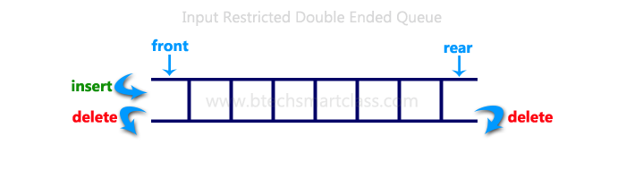

**Output Restricted Double Ended Queue**

In output restricted double ended queue, the deletion operation is performed at only one end and insertion operation is performed at both the ends.

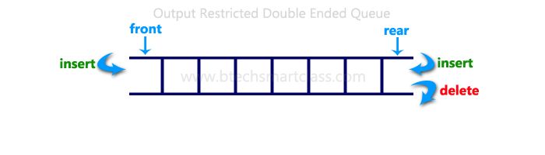

A double-ended queue is an abstract data type similar to an simple queue, it allows you to insert and delete from both sides means items can be added or deleted from the front or rear end.  
  
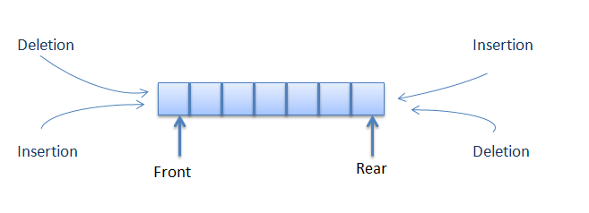

#include<stdio.h>

#include<conio.h>

#define SIZE 100

void enQueue(int);

int deQueueFront();

int deQueueRear();

void enQueueRear(int);

void enQueueFront(int);

void display();

int queue[SIZE];

int rear = 0, front = 0;

int main()

{

char ch;

int choice1, choice2, value;

printf("\n******* Type of Double Ended Queue *******\n");

do

{

printf("\n1.Input-restricted deque \n");

printf("2.output-restricted deque \n");

printf("\nEnter your choice of Queue Type : ");

scanf("%d",&choice1);

switch(choice1)

{

case 1:

printf("\nSelect the Operation\n");

printf("1.Insert\n2.Delete from Rear\n3.Delete from Front\n4. Display");

do

{

printf("\nEnter your choice for the operation in c deque: ");

scanf("%d",&choice2);

switch(choice2)

{

case 1: enQueueRear(value);

display();

break;

case 2: value = deQueueRear();

printf("\nThe value deleted is %d",value);

display();

break;

case 3: value=deQueueFront();

printf("\nThe value deleted is %d",value);

display();

break;

case 4: display();

break;

default:printf("Wrong choice");

}

printf("\nDo you want to perform another operation (Y/N): ");

ch=getch();

}while(ch=='y'||ch=='Y');

getch();

break;

case 2 :

printf("\n---- Select the Operation ----\n");

printf("1. Insert at Rear\n2. Insert at Front\n3. Delete\n4. Display");

do

{

printf("\nEnter your choice for the operation: ");

scanf("%d",&choice2);

switch(choice2)

{

case 1: enQueueRear(value);

display();

break;

case 2: enQueueFront(value);

display();

break;

case 3: value = deQueueFront();

printf("\nThe value deleted is %d",value);

display();

break;

case 4: display();

break;

default:printf("Wrong choice");

}

printf("\nDo you want to perform another operation (Y/N): ");

ch=getch();

} while(ch=='y'||ch=='Y');

getch();

break ;

}

printf("\nDo you want to continue(y/n):");

ch=getch();

}while(ch=='y'||ch=='Y');

}

void enQueueRear(int value)

{

char ch;

if(front >= SIZE)

{

printf("\nQueue is full!!! Insertion is not possible!!! ");

return;

}

do

{

printf("\nEnter the value to be inserted:");

scanf("%d",&value);

queue[front] = value;

front++;

printf("Do you want to continue insertion Y/N");

ch=getch();

}while(ch=='y');

}

void enQueueFront(int value)

{

char ch;

if(front==SIZE/2)

{

printf("\nQueue is full!!! Insertion is not possible!!!");

return;

}

do

{

printf("\nEnter the value to be inserted:");

scanf("%d",&value);

rear--;

queue[rear] = value;

printf("Do you want to continue insertion Y/N");

ch = getch();

}

while(ch == 'y');

}

int deQueueRear()

{

int deleted;

if(front == rear)

{

printf("\nQueue is Empty!!! Deletion is not possible!!!");

return 0;

}

front--;

deleted = queue[front+1];

return deleted;

}

int deQueueFront()

{

int deleted;

if(front == rear)

{

printf("\nQueue is Empty!!! Deletion is not possible!!!");

return 0;

}

rear++;

deleted = queue[rear-1];

return deleted;

}

void display()

{

int i;

if(front == rear)

printf("\nQueue is Empty!!! Deletion is not possible!!!")

else{

printf("\nThe Queue elements are:");

for(i=rear; i < front; i++)

{

printf("%d\t ",queue[i]);

}

}

}

Algorithm for Insertion at rear end

1. Step -1: [Check for overflow]
2. if(rear==MAX)
3. Print("Queue is Overflow”);
4. return;
5. Step-2: [Insert element]
6. else
7. rear=rear+1;
8. q[rear]=no;
9. [Set rear and front pointer]
10. if rear=0
11. rear=1;
12. if front=0
13. front=1;
14. Step-3: return

Implementation of Insertion at rear end

1. void add_item_rear()
2. {
3. int num;
4. printf("\n Enter Item to insert : ");
5. scanf("%d",&num);
6. if(rear==MAX)
7. {
8. printf("\n Queue is Overflow");
9. return;
10. }
11. else
12. {
13. rear++;
14. q[rear]=num;
15. if(rear==0)
16. rear=1;
17. if(front==0)
18. front=1;
19. }
20. }

Algorithm for Insertion at font end

1. Step-1 : [Check for the front position]
2. if(front<=1)
3. Print (“Cannot add item at front end”);
4. return;
5. Step-2 : [Insert at front]
6. else
7. front=front-1;
8. q[front]=no;
9. Step-3 : Return

Implementation of Insertion at front end

1. void add_item_front()
2. {
3. int num;
4. printf("\n Enter item to insert:");
5. scanf("%d",&num);
6. if(front<=1)
7. {
8. printf("\n Cannot add item at front end");
9. return;
10. }
11. else
12. {
13. front--;
14. q[front]=num;
15. }
16. }

Algorithm for Deletion from front end

1. Step-1 [ Check for front pointer]
2. if front=0
3. print(" Queue is Underflow”);
4. return;
5. Step-2 [Perform deletion]
6. else
7. no=q[front];
8. print(“Deleted element is”,no);
9. [Set front and rear pointer]
10. if front=rear
11. front=0;
12. rear=0;
13. else
14. front=front+1;
15. Step-3 : Return

Implementation of Deletion from front end

1. void delete_item_front()
2. {
3. int num;
4. if(front==0)
5. {
6. printf("\n Queue is Underflow\n");
7. return;
8. }
9. else
10. {
11. num=q[front];
12. printf("\n Deleted item is %d\n",num);
13. if(front==rear)
14. {
15. front=0;
16. rear=0;
17. }
18. else
19. {
20. front++;
21. }
22. }
23. }

Algorithm for Deletion from rear end

1. Step-1 : [Check for the rear pointer]
2. if rear=0
3. print(“Cannot delete value at rear end”);
4. return;
5. Step-2: [ perform deletion]
6. else
7. no=q[rear];
8. [Check for the front and rear pointer]
9. if front= rear
10. front=0;
11. rear=0;
12. else
13. rear=rear-1;
14. print(“Deleted element is”,no);
15. Step-3 : Return

Implementation of Deletion from rear end

1. void delete_item_rear()
2. {
3. int num;
4. if(rear==0)
5. {
6. printf("\n Cannot delete item at rear end\n");
7. return;
8. }
9. else
10. {
11. num=q[rear];
12. if(front==rear)
13. {
14. front=0;
15. rear=0;
16. }
17. else
18. {
19. rear--;
20. printf("\n Deleted item is %d\n",num);
21. }
22. }
23. }
24. The algorithm I used to translate the expression is
25. while there is token to be read;
26. read the token;
27. if token is a constant
28. push it to Exp_Postfix;
29. if token is '('
30. push it to stack
31. if token is ')'
32. pop from the stack all symbols until '(' be find and remove '(' from the stack
33. if token is an operator and its arity is 2
34. pop all operators with less or equal priority than the token and store then in the Exp_Postfix;
35. push token to the stack;
36. if token is an operator and its arity is 1
37. if token is '-'
38. push it to Exp_postfix;
39. if token is '+'
40. pass to the next token;
41. pop all remaining symbols in the stack and push then, in order, to the Exp_Postfix;
42. switch(Operator)
43. {
44. case '+': return 1;
45. case '-': return 1;
46. case '*': return 2;
47. case '/': return 2;
48. case '^': return 3;
49. case '(': return 4;
50. case ')': return 5;
51. default : return 0;
52. }

**Double Linked List**

**What is Double Linked List?**

In a single linked list, every node has link to its next node in the sequence. So, we can traverse from one node to other node only in one direction and we can not traverse back. We can solve this kind of problem by using double linked list. Double linked list can be defined as follows...

**Double linked list is a sequence of elements in which every element has links to its previous element and next element in the sequence.**

In double linked list, every node has link to its previous node and next node. So, we can traverse forward by using next field and can traverse backward by using previous field. Every node in a double linked list contains three fields and they are shown in the following figure...

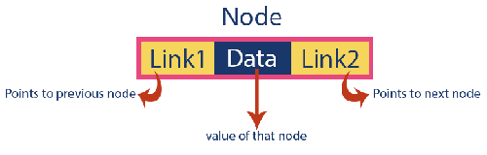

Here, **'link1'** field is used to store the address of the previous node in the sequence, **'link2'** field is used to store the address of the next node in the sequence and **'data'** field is used to store the actual value of that node.

**Example**



**NOTE**

☀ In double linked list, the first node must be always pointed by **head**.  
☀ Always the previous field of the first node must be **NULL**.  
☀ Always the next field of the last node must be **NULL**.

**Operations**

In a double linked list, we perform the following operations...

1. Insertion
2. Deletion
3. Display

**Insertion**

In a double linked list, the insertion operation can be performed in three ways as follows...

1. Inserting At Beginning of the list
2. Inserting At End of the list
3. Inserting At Specific location in the list

**Inserting At Beginning of the list**

We can use the following steps to insert a new node at beginning of the double linked list...

* **Step 1:** Create a **newNode** with given value and **newNode → previous** as **NULL**.
* **Step 2:** Check whether list is **Empty** (**head** == **NULL**)
* **Step 3:** If it is **Empty** then, assign **NULL** to **newNode → next** and **newNode** to **head**.
* **Step 4:** If it is **not Empty** then, assign **head** to **newNode → next** and **newNode** to **head**.

**Inserting At End of the list**

We can use the following steps to insert a new node at end of the double linked list...

* **Step 1:** Create a **newNode** with given value and **newNode → next** as **NULL**.
* **Step 2:** Check whether list is **Empty** (**head** == **NULL**)
* **Step 3:** If it is **Empty**, then assign **NULL** to **newNode → previous** and **newNode** to **head**.
* **Step 4:** If it is **not Empty**, then, define a node pointer **temp** and initialize with **head**.
* **Step 5:** Keep moving the **temp** to its next node until it reaches to the last node in the list (until **temp → next** is equal to **NULL**).
* **Step 6:** Assign **newNode** to **temp → next** and **temp** to **newNode → previous**.

**Inserting At Specific location in the list (After a Node)**

We can use the following steps to insert a new node after a node in the double linked list...

* **Step 1:** Create a **newNode** with given value.
* **Step 2:** Check whether list is **Empty** (**head** == **NULL**)
* **Step 3:** If it is **Empty** then, assign **NULL** to **newNode → previous** & **newNode → next** and **newNode** to **head**.
* **Step 4:** If it is **not Empty** then, define two node pointers **temp1** & **temp2** and initialize **temp1** with **head**.
* **Step 5:** Keep moving the **temp1** to its next node until it reaches to the node after which we want to insert the newNode (until **temp1 → data** is equal to **location**, here location is the node value after which we want to insert the newNode).
* **Step 6:** Every time check whether **temp1** is reached to the last node. If it is reached to the last node then display **'Given node is not found in the list!!! Insertion not possible!!!'** and terminate the function. Otherwise move the **temp1** to next node.
* **Step 7:** Assign **temp1 → next** to **temp2**, **newNode** to **temp1 → next**, **temp1** to **newNode → previous**, **temp2** to **newNode → next**and **newNode** to **temp2 → previous**.

**Deletion**

In a double linked list, the deletion operation can be performed in three ways as follows...

1. Deleting from Beginning of the list
2. Deleting from End of the list
3. Deleting a Specific Node

**Deleting from Beginning of the list**

We can use the following steps to delete a node from beginning of the double linked list...

* **Step 1:** Check whether list is **Empty** (**head** == **NULL**)
* **Step 2:** If it is **Empty** then, display **'List is Empty!!! Deletion is not possible'** and terminate the function.
* **Step 3:** If it is not Empty then, define a Node pointer **'temp'** and initialize with **head**.
* **Step 4:** Check whether list is having only one node (**temp → previous** is equal to **temp → next**)
* **Step 5:** If it is **TRUE**, then set **head** to **NULL** and delete **temp** (Setting **Empty** list conditions)
* **Step 6:** If it is **FALSE**, then assign **temp → next** to **head**, **NULL** to **head → previous** and delete **temp**.

**Deleting from End of the list**

We can use the following steps to delete a node from end of the double linked list...

* **Step 1:** Check whether list is **Empty** (**head** == **NULL**)
* **Step 2:** If it is **Empty**, then display **'List is Empty!!! Deletion is not possible'** and terminate the function.
* **Step 3:** If it is not Empty then, define a Node pointer **'temp'** and initialize with **head**.
* **Step 4:** Check whether list has only one Node (**temp → previous** and **temp → next** both are **NULL**)
* **Step 5:** If it is **TRUE**, then assign **NULL** to **head** and delete **temp**. And terminate from the function. (Setting **Empty** list condition)
* **Step 6:** If it is **FALSE**, then keep moving **temp** until it reaches to the last node in the list. (until **temp → next** is equal to **NULL**)
* **Step 7:** Assign **NULL** to **temp → previous → next** and delete **temp**.

**Deleting a Specific Node from the list**

We can use the following steps to delete a specific node from the double linked list...

* **Step 1:** Check whether list is **Empty** (**head** == **NULL**)
* **Step 2:** If it is **Empty** then, display **'List is Empty!!! Deletion is not possible'** and terminate the function.
* **Step 3:** If it is not Empty, then define a Node pointer **'temp'** and initialize with **head**.
* **Step 4:** Keep moving the **temp** until it reaches to the exact node to be deleted or to the last node.
* **Step 5:** If it is reached to the last node, then display **'Given node not found in the list! Deletion not possible!!!'** and terminate the fuction.
* **Step 6:** If it is reached to the exact node which we want to delete, then check whether list is having only one node or not
* **Step 7:** If list has only one node and that is the node which is to be deleted then set **head** to **NULL** and delete **temp** (**free(temp)**).
* **Step 8:** If list contains multiple nodes, then check whether **temp** is the first node in the list (**temp == head**).
* **Step 9:** If **temp** is the first node, then move the **head** to the next node (**head = head → next**), set **head** of **previous** to **NULL** (**head → previous = NULL**) and delete **temp**.
* **Step 10:** If **temp** is not the first node, then check whether it is the last node in the list (**temp → next == NULL**).
* **Step 11:** If **temp** is the last node then set **temp** of **previous** of **next** to **NULL** (**temp → previous → next = NULL**) and delete **temp**(**free(temp**)).
* **Step 12:** If **temp** is not the first node and not the last node, then set **temp** of **previous** of **next** to **temp** of **next** (**temp → previous → next = temp → next**), **temp** of **next** of **previous** to **temp** of **previous** (**temp → next → previous = temp → previous**) and delete **temp** (**free(temp)**).

**Displaying a Double Linked List**

We can use the following steps to display the elements of a double linked list...

* **Step 1:** Check whether list is **Empty** (**head** == **NULL**)
* **Step 2:** If it is **Empty**, then display **'List is Empty!!!'** and terminate the function.
* **Step 3:** If it is not Empty, then define a Node pointer **'temp'** and initialize with **head**.
* **Step 4:** Display **'NULL <--- '**.
* **Step 5:** Keep displaying **temp → data** with an arrow (**<===>**) until **temp** reaches to the last node
* **Step 6:** Finally, display **temp → data** with arrow pointing to **NULL** (**temp → data ---> NULL**).

1. ***/\****
2. ***\* C Program to Implement a Doubly Linked List & provide Insertion, Deletion & Display Operations***
3. ***\*/***

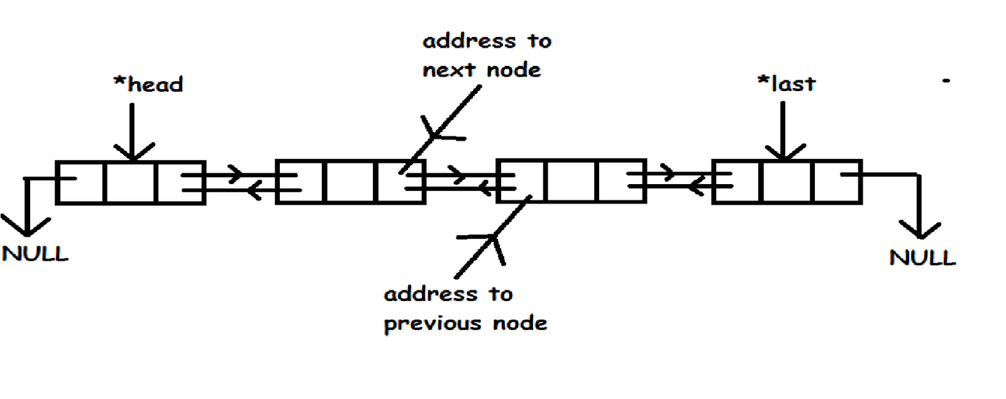

1. #include <stdio.h>
2. #include <stdlib.h>
4. struct node
5. {
6. struct node *prev;
7. int data;
8. struct node *next;
9. }*h,*temp,*temp1,*temp2,*temp4;
11. void insert1();
12. void insert2();
13. void insert3();
14. void traversebeg();
15. void traverseend(int);
16. void sort();
17. void search();
18. void update();
19. void delete();
21. int count = 0;
23. void main()
24. {
25. int ch;
27. h = NULL;
28. temp = temp1 = NULL;
30. printf("**\n** 1 - Insert at beginning");
31. printf("**\n** 2 - Insert at end");
32. printf("**\n** 3 - Insert at position i");
33. printf("**\n** 4 - Delete at i");
34. printf("**\n** 5 - Display from beginning");
35. printf("**\n** 6 - Display from end");
36. printf("**\n** 7 - Search for element");
37. printf("**\n** 8 - Sort the list");
38. printf("**\n** 9 - Update an element");
39. printf("**\n** 10 - Exit");
41. while (1)
42. {
43. printf("**\n** Enter choice : ");
44. scanf("%d", &ch);
45. switch (ch)
46. {
47. case 1:
48. insert1();
49. **break**;
50. case 2:
51. insert2();
52. **break**;
53. case 3:
54. insert3();
55. **break**;
56. case 4:
57. delete();
58. **break**;
59. case 5:
60. traversebeg();
61. **break**;
62. case 6:
63. temp2 = h;
64. if (temp2 == NULL)
65. printf("**\n** Error : List empty to display ");
66. else
67. {
68. printf("**\n** Reverse order of linked list is : ");
69. traverseend(temp2->n);
70. }
71. **break**;
72. case 7:
73. search();
74. **break**;
75. case 8:
76. sort();
77. **break**;
78. case 9:
79. update();
80. **break**;
81. case 10:
82. exit(0);
83. default:
84. printf("**\n** Wrong choice menu");
85. }
86. }
87. }
89. */* TO create an empty node */*
90. void create()
91. {
92. int value;
94. temp =(struct node *)malloc(1*sizeof(struct node));
95. temp->prev = NULL;
96. temp->next = NULL;
97. printf("**\n** Enter value to node : ");
98. scanf("%d", &data);
99. temp->data = value;
100. count++;
101. }
103. */* TO insert at beginning */*
104. void insert1()
105. {
106. if (h == NULL)
107. {
108. create();
109. h = temp;
110. temp1 = h;
111. }
112. else
113. {
114. create();
115. temp->next = h;
116. h->prev = temp;
117. h = temp;
118. }
119. }
121. */* To insert at end */*
122. void insert2()
123. {
124. if (h == NULL)
125. {
126. create();
127. h = temp;
128. temp1 = h;
129. }
130. else
131. {
132. create();
133. temp1->next = temp;
134. temp->prev = temp1;
135. temp1 = temp;
136. }
137. }
139. */* To insert at any position */*
140. void insert3()
141. {
142. int pos, i = 2;
144. printf("**\n** Enter position to be inserted : ");
145. scanf("%d", &pos);
146. temp2 = h;
148. if ((pos < 1) || (pos >= count + 1))
149. {
150. printf("**\n** Position out of range to insert");
151. return;
152. }
153. if ((h == NULL) && (pos != 1))
154. {
155. printf("**\n** Empty list cannot insert other than 1st position");
156. return;
157. }
158. if ((h == NULL) && (pos == 1))
159. {
160. create();
161. h = temp;
162. temp1 = h;
163. return;
164. }
165. else
166. {
167. while (i < pos)
168. {
169. temp2 = temp2->next;
170. i++;
171. }
172. create();
173. temp->prev = temp2;
174. temp->next = temp2->next;
175. temp2->next->prev = temp;
176. temp2->next = temp;
177. }
178. }
180. */* To delete an element */*
181. void delete()
182. {
183. int i = 1, pos;
185. printf("**\n** Enter position to be deleted : ");
186. scanf("%d", &pos);
187. temp2 = h;
189. if ((pos < 1) || (pos >= count + 1))
190. {
191. printf("**\n** Error : Position out of range to delete");
192. return;
193. }
194. if (h == NULL)
195. {
196. printf("**\n** Error : Empty list no elements to delete");
197. return;
198. }
199. else
200. {
201. while (i < pos)
202. {
203. temp2 = temp2->next;
204. i++;
205. }
206. if (i == 1)
207. {
208. if (temp2->next == NULL)
209. {
210. printf("Node deleted from list");
211. free(temp2);
212. temp2 = h = NULL;
213. return;
214. }
215. }
216. if (temp2->next == NULL)
217. {
218. temp2->prev->next = NULL;
219. free(temp2);
220. printf("Node deleted from list");
221. return;
222. }
223. temp2->next->prev = temp2->prev;
224. if (i != 1)
225. temp2->prev->next = temp2->next; */* Might not need this statement if i == 1 check */*
226. if (i == 1)
227. h = temp2->next;
228. printf("**\n** Node deleted");
229. free(temp2);
230. }
231. count--;
232. }
234. */* Traverse from beginning */*
235. void traversebeg()
236. {
237. temp2 = h;
239. if (temp2 == NULL)
240. {
241. printf("List empty to display **\n**");
242. return;
243. }
244. printf("**\n** Linked list elements from begining : ");
246. while (temp2->next != NULL)
247. {
248. printf(" %d ", temp2->n);
249. temp2 = temp2->next;
250. }
251. printf(" %d ", temp2->n);
252. }
254. */* To traverse from end recursively */*
255. void traverseend(int i)
256. {
257. if (temp2 != NULL)
258. {
259. i = temp2->n;
260. temp2 = temp2->next;
261. traverseend(i);
262. printf(" %d ", i);
263. }
264. }
266. */* To search for an element in the list */*
267. void search()
268. {
269. int data, count = 0;
270. temp2 = h;
272. if (temp2 == NULL)
273. {
274. printf("**\n** Error : List empty to search for data");
275. return;
276. }
277. printf("**\n** Enter value to search : ");
278. scanf("%d", &data);
279. while (temp2 != NULL)
280. {
281. if (temp2->n == data)
282. {
283. printf("**\n** Data found in %d position",count + 1);
284. return;
285. }
286. else
287. temp2 = temp2->next;
288. count++;
289. }
290. printf("**\n** Error : %d not found in list", data);
291. }
293. */* To update a node value in the list */*
294. void update()
295. {
296. int data, data1;
298. printf("**\n** Enter node data to be updated : ");
299. scanf("%d", &data);
300. printf("**\n** Enter new data : ");
301. scanf("%d", &data1);
302. temp2 = h;
303. if (temp2 == NULL)
304. {
305. printf("**\n** Error : List empty no node to update");
306. return;
307. }
308. while (temp2 != NULL)
309. {
310. if (temp2->n == data)
311. {
313. temp2->n = data1;
314. traversebeg();
315. return;
316. }
317. else
318. temp2 = temp2->next;
319. }
321. printf("**\n** Error : %d not found in list to update", data);
322. }
324. */* To sort the linked list */*
325. void sort()
326. {
327. int i, j, x;
329. temp2 = h;
330. temp4 = h;
332. if (temp2 == NULL)
333. {
334. printf("**\n** List empty to sort");
335. return;
336. }
338. for (temp2 = h; temp2 != NULL; temp2 = temp2->next)
339. {
340. for (temp4 = temp2->next; temp4 != NULL; temp4 = temp4->next)
341. {
342. if (temp2->n > temp4->n)
343. {
344. x = temp2->n;
345. temp2->n = temp4->n;
346. temp4->n = x;
347. }
348. }
349. }
350. traversebeg();
351. }

OR

#include <stdio.h>

#include <stdlib.h>

/* structure representing a node of the doubly linked list */

struct dnode

{

struct dnode *prev;

int data;

struct dnode *next;

};

struct dnode *start = NULL;

void append(int);

void addatbeg(int);

void remov(int);

void display();

int main()

{

int n, ch;

do

{

printf("\n\nOperations on doubly linked list");

printf("\n1. Append \n2. Add at beginning \n3. Remove\n4. Display\n0. Exit\n");

printf("\nEnter Choice 0-4? : ");

scanf("%d", &ch);

switch (ch)

{

case 1:

printf("\nEnter number: ");

scanf("%d", &n);

append(n);

break;

case 2:

printf("\nEnter number: ");

scanf("%d", &n);

addatbeg(n);

break;

case 3:

printf("\nEnter number to delete: ");

scanf("%d", &n);

remov(n);

break;

case 4:

display();

break;

}

}while (ch != 0);

}

/* adds a new node at the end of the doubly linked list */

void append(int num)

{

struct dnode *nptr, *temp = start;

/*create a new node */

nptr = malloc(sizeof(struct dnode));

nptr->data = num;

nptr->next = NULL;

nptr->prev = NULL;

/* if the linked list is empty */

if (start == NULL)

{

start = nptr;

}

else

{

/* traverse the linked list till the last node is reached */

while (temp->next != NULL)

temp = temp->next;

nptr->prev = temp;

temp->next = nptr;

}

}

/* adds a new node at the begining of the linked list */

void addatbeg(int num)

{

struct dnode *nptr;

/* create a new node */

nptr = malloc(sizeof(struct dnode));

/* assign data and pointer to the new node */

nptr->prev = NULL;

nptr->data = num;

nptr->next = start;

if (start != NULL)

start->prev = nptr;

start = nptr;

}

/* deletes the specified node from the doubly linked list */

void remov(int num)

{

struct dnode *temp = start;

/* traverse the entire linked list */

while (temp != NULL)

{

/* if node to be deleted is found */

if (temp->data == num)

{

/* if node to be deleted is the first node */

if (temp == start)

{

start = start->next;

start->prev = NULL;

}

else

{

/* if node to be deleted is the last node */

if (temp->next == NULL)

temp->prev->next = NULL;

else

/* if node to be deleted is any intermediate node */

{

temp->prev->next = temp->next;

temp->next->prev = temp->prev;

}

free(temp);

}

return ; /* return back after deletion */

}

temp = temp->next; /* go to next node */

}

printf("\n%d not found.", num);

}

/* displays the contents of the linked list */

void display()

{

struct dnode *temp = start;

printf("\n");

/* traverse the entire linked list */

while (temp != NULL)

{

printf("%d\t", temp->data);

temp = temp->next;

}

}

**Circular Linked List**

**What is Circular Linked List?**

In single linked list, every node points to its next node in the sequence and the last node points NULL. But in circular linked list, every node points to its next node in the sequence but the last node points to the first node in the list.

**Circular linked list is a sequence of elements in which every element has link to its next element in the sequence and the last element has a link to the first element in the sequence.**

That means circular linked list is similar to the single linked list except that the last node points to the first node in the list

**Example**

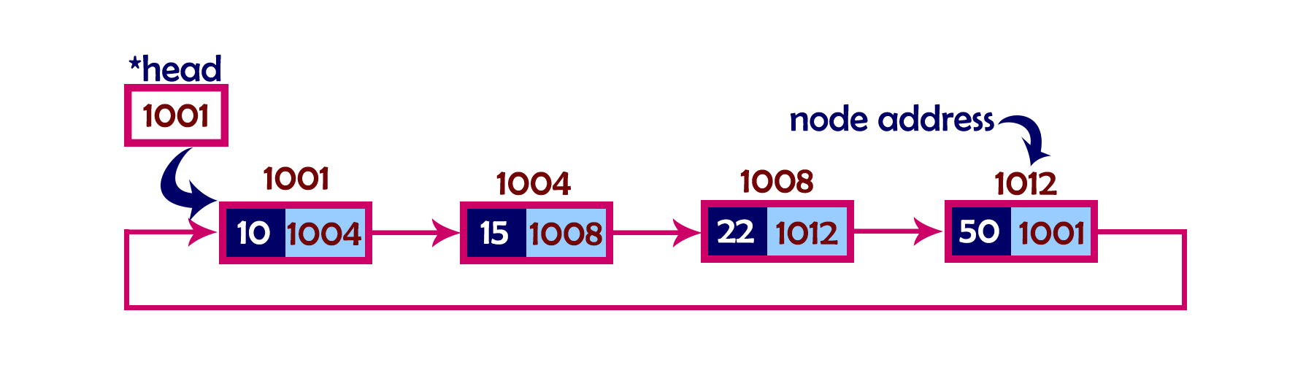

**Operations**

In a circular linked list, we perform the following operations...

1. Insertion
2. Deletion
3. Display

Before we implement actual operations, first we need to setup empty list. First perform the following steps before implementing actual operations.

* **Step 1:** Include all the **header files** which are used in the program.
* **Step 2:** Declare all the **user defined** functions.
* **Step 3:** Define a **Node** structure with two members **data** and **next**
* **Step 4:** Define a Node pointer '**head**' and set it to **NULL**.
* **Step 4:** Implement the **main** method by displaying operations menu and make suitable function calls in the main method to perform user selected operation.

**Insertion**

In a circular linked list, the insertion operation can be performed in three ways. They are as follows...

1. Inserting At Beginning of the list
2. Inserting At End of the list
3. Inserting At Specific location in the list

**Inserting At Beginning of the list**

We can use the following steps to insert a new node at beginning of the circular linked list...

* **Step 1:** Create a **newNode** with given value.
* **Step 2:** Check whether list is **Empty** (**head** == **NULL**)
* **Step 3:** If it is **Empty** then, set **head** = **newNode** and **newNode→next** = **head** .
* **Step 4:** If it is **Not Empty** then, define a Node pointer '**temp**' and initialize with '**head**'.
* **Step 5:** Keep moving the '**temp**' to its next node until it reaches to the last node (until '**temp → next** == **head**').
* **Step 6:** Set '**newNode → next** =**head**', '**head** = **newNode**' and '**temp → next** = **head**'.

**Inserting At End of the list**

We can use the following steps to insert a new node at end of the circular linked list...

* **Step 1:** Create a **newNode** with given value.
* **Step 2:** Check whether list is **Empty** (**head** == **NULL**).
* **Step 3:** If it is **Empty** then, set **head** = **newNode** and **newNode → next** = **head**.
* **Step 4:** If it is **Not Empty** then, define a node pointer **temp** and initialize with **head**.
* **Step 5:** Keep moving the **temp** to its next node until it reaches to the last node in the list (until **temp → next** == **head**).
* **Step 6:** Set **temp → next** = **newNode** and **newNode → next** = **head**.

**Inserting At Specific location in the list (After a Node)**

We can use the following steps to insert a new node after a node in the circular linked list...

* **Step 1:** Create a **newNode** with given value.
* **Step 2:** Check whether list is **Empty** (**head** == **NULL**)
* **Step 3:** If it is **Empty** then, set **head** = **newNode** and **newNode → next** = **head**.
* **Step 4:** If it is **Not Empty** then, define a node pointer **temp** and initialize with **head**.
* **Step 5:** Keep moving the **temp** to its next node until it reaches to the node after which we want to insert the newNode (until **temp1 → data** is equal to **location**, here location is the node value after which we want to insert the newNode).
* **Step 6:** Every time check whether **temp** is reached to the last node or not. If it is reached to last node then display **'Given node is not found in the list!!! Insertion not possible!!!'** and terminate the function. Otherwise move the **temp** to next node.
* **Step 7:** If **temp** is reached to the exact node after which we want to insert the newNode then check whether it is last node (temp → next == head).
* **Step 8:** If **temp** is last node then set **temp → next** = **newNode** and **newNode → next** = **head**.
* **Step 8:** If **temp** is not last node then set **newNode → next** = **temp → next** and **temp → next** = **newNode**.

**Deletion**

In a circular linked list, the deletion operation can be performed in three ways those are as follows...

1. Deleting from Beginning of the list
2. Deleting from End of the list
3. Deleting a Specific Node

**Deleting from Beginning of the list**

We can use the following steps to delete a node from beginning of the circular linked list...

* **Step 1:** Check whether list is **Empty** (**head** == **NULL**)
* **Step 2:** If it is **Empty** then, display **'List is Empty!!! Deletion is not possible'** and terminate the function.
* **Step 3:** If it is **Not Empty** then, define two Node pointers **'temp1'** and '**temp2**' and initialize both '**temp1**' and '**temp2**' with **head**.
* **Step 4:** Check whether list is having only one node (**temp1 → next** == **head**)
* **Step 5:** If it is **TRUE** then set **head** = **NULL** and delete **temp1** (Setting **Empty** list conditions)
* **Step 6:** If it is **FALSE** move the **temp1** until it reaches to the last node. (until **temp1 → next** == **head** )
* **Step 7:** Then set **head** = **temp2 → next**, **temp1 → next** = **head** and delete **temp2**.

**Deleting from End of the list**

We can use the following steps to delete a node from end of the circular linked list...

* **Step 1:** Check whether list is **Empty** (**head** == **NULL**)
* **Step 2:** If it is **Empty** then, display **'List is Empty!!! Deletion is not possible'** and terminate the function.
* **Step 3:** If it is **Not Empty** then, define two Node pointers **'temp1'** and '**temp2'** and initialize '**temp1**' with **head**.
* **Step 4:** Check whether list has only one Node (**temp1 → next** == **head**)
* **Step 5:** If it is **TRUE**. Then, set **head** = **NULL** and delete **temp1**. And terminate from the function. (Setting **Empty** list condition)
* **Step 6:** If it is **FALSE**. Then, set '**temp2 = temp1**' and move **temp1** to its next node. Repeat the same until **temp1** reaches to the last node in the list. (until **temp1 → next** == **head**)
* **Step 7:** Set **temp2 → next**= **head** and delete **temp1**.

**Deleting a Specific Node from the list**

We can use the following steps to delete a specific node from the circular linked list...

* **Step 1:** Check whether list is **Empty** (**head** == **NULL**)
* **Step 2:** If it is **Empty** then, display **'List is Empty!!! Deletion is not possible'** and terminate the function.
* **Step 3:** If it is **Not Empty** then, define two Node pointers **'temp1'** and '**temp2**' and initialize '**temp1**' with **head**.
* **Step 4:** Keep moving the **temp1** until it reaches to the exact node to be deleted or to the last node. And every time set '**temp2 = temp1**' before moving the '**temp1**' to its next node.
* **Step 5:** If it is reached to the last node then display **'Given node not found in the list! Deletion not possible!!!'**. And terminate the function.
* **Step 6:** If it is reached to the exact node which we want to delete, then check whether list is having only one node (**temp1 → next** == **head**)
* **Step 7:** If list has only one node and that is the node to be deleted then set **head** = **NULL** and delete **temp1** (**free(temp1)**).
* **Step 8:** If list contains multiple nodes then check whether **temp1** is the first node in the list (**temp1 == head**).
* **Step 9:** If **temp1** is the first node then set **temp2** = **head** and keep moving **temp2** to its next node until **temp2** reaches to the last node. Then set **head = head → next**, **temp2 → nex**t = **head** and delete **temp1**.
* **Step 10:** If **temp1** is not first node then check whether it is last node in the list (**temp1 → next == head**).
* **Step 11:** If **temp1** is last node then set **temp2 → next** = **head** and delete **temp1** (**free(temp1)**).
* **Step 12:** If **temp1** is not first node and not last node then set **temp2 → next** = **temp1 → next** and delete **temp1** (**free(temp1)**).

**Displaying a circular Linked List**

We can use the following steps to display the elements of a circular linked list...

* **Step 1:** Check whether list is **Empty** (**head** == **NULL**)
* **Step 2:** If it is **Empty**, then display **'List is Empty!!!'** and terminate the function.
* **Step 3:** If it is **Not Empty** then, define a Node pointer **'temp'** and initialize with **head**.
* **Step 4:** Keep displaying **temp → data** with an arrow (**--->**) until **temp** reaches to the last node
* **Step 5:** Finally display **temp → data** with arrow pointing to **head → data**.

## Circular linked list

### Procedure for insertion a node at the beginning of list

Step1. Create the new node  
Step2. Set the new node’s next to itself (circular!)   
Step3. If the list is empty,return new node.  
Step4. Set our new node’s next to the front.  
Step5. Set tail’s next to our new node.   
Step6. Return the end of the list.

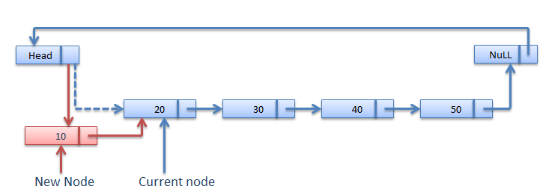

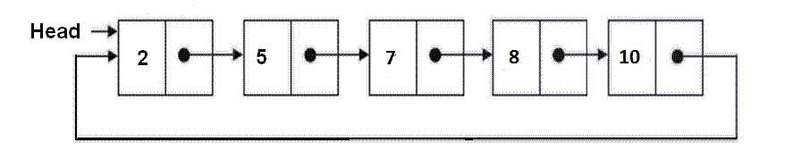

## Circular Linked List

Circular Linked List is little more complicated linked data structure. In the circular linked list we can insert elements anywhere in the list whereas in the array we cannot insert element anywhere in the list because it is in the contiguous memory. In the circular linked list the previous element stores the address of the next element and the last element stores the address of the starting element. The elements points to each other in a circular way which forms a circular chain. The circular linked list has a dynamic size which means the memory can be allocated when it is required.

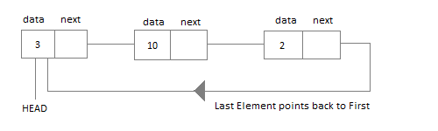

#### Application of Circular Linked List

* The real life application where the circular linked list is used is our Personal Computers, where multiple applications are running. All the running applications are kept in a circular linked list and the OS gives a fixed time slot to all for running. The Operating System keeps on iterating over the linked list until all the applications are completed.
* Another example can be Multiplayer games. All the Players are kept in a Circular Linked List and the pointer keeps on moving forward as a player's chance ends.
* Circular Linked List can also be used to create Circular Queue. In a Queue we have to keep two pointers, FRONT and REAR in memory all the time, where as in Circular Linked List, only one pointer is required.
* ***/\****
* ***\* C Program to Demonstrate Circular Single Linked List***
* ***\*/***
* #include <stdio.h>
* #include <stdlib.h>
* struct node
* {
* int data;
* struct node *link;
* };
* struct node *head = NULL, *x, *y, *z;
* void create();
* void ins_at_beg();
* void ins_at_pos();
* void del_at_beg();
* void del_at_pos();
* void traverse();
* void search();
* void sort();
* void update();
* void rev_traverse(struct node *p);
* void main()
* {
* int ch;
* printf("**\n** 1.Creation **\n** 2.Insertion at beginning **\n** 3.Insertion at remaining");
* printf("**\n**4.Deletion at beginning **\n**5.Deletion at remaining **\n**6.traverse");
* printf("**\n**7.Search**\n**8.sort**\n**9.update**\n**10.Exit**\n**");
* while (1)
* {
* printf("**\n** Enter your choice:");
* scanf("%d", &ch);
* switch(ch)
* {
* case 1:
* create();
* **break**;
* case 2:
* ins_at_beg();
* **break**;
* case 3:
* ins_at_pos();
* **break**;
* case 4:
* del_at_beg();
* **break**;
* case 5:
* del_at_pos();
* **break**;
* case 6:
* traverse();
* **break**;
* case 7:
* search();
* **break**;
* case 8:
* sort();
* **break**;
* case 9:
* update();
* **break**;
* case 10:
* rev_traverse(head);
* **break**;
* default:
* exit(0);
* }
* }
* }
* */*Function to create a new circular linked list*/*
* void create()
* {
* int c;
* x = (struct node*)malloc(sizeof(struct node));
* printf("**\n** Enter the data:");
* scanf("%d", &x->data);
* x->link = x;
* head = x;
* printf("**\n** If you wish to continue press 1 otherwise 0:");
* scanf("%d", &c);
* while (c != 0)
* {
* y = (struct node*)malloc(sizeof(struct node));
* printf("**\n** Enter the data:");
* scanf("%d", &y->data);
* x->link = y;
* y->link = head;
* x = y;
* printf("**\n** If you wish to continue press 1 otherwise 0:");
* scanf("%d", &c);
* }
* }
* */*Function to insert an element at the begining of the list*/*
* void ins_at_beg()
* {
* x = head;
* y = (struct node*)malloc(sizeof(struct node));
* printf("**\n** Enter the data:");
* scanf("%d", &y->data);
* while (x->link != head)
* {
* x = x->link;
* }
* x->link = y;
* y->link = head;
* head = y;
* }
* */*Function to insert an element at any position the list*/*
* void ins_at_pos()
* {
* struct node *ptr;
* int c = 1, pos, count = 1;
* y = (struct node*)malloc(sizeof(struct node));
* if (head == NULL)
* {
* printf("cannot enter an element at this place");
* }
* printf("**\n** Enter the data:");
* scanf("%d", &y->data);
* printf("**\n** Enter the position to be inserted:");
* scanf("%d", &pos);
* x = head;
* ptr = head;
* while (ptr->link != head)
* {
* count++;
* ptr = ptr->link;
* }
* count++;
* if (pos > count)
* {
* printf("OUT OF BOUND");
* return;
* }
* while (c < pos)
* {
* z = x;
* x = x->link;
* c++;
* }
* y->link = x;
* z->link = y;
* }
* */*Function to delete an element at any begining of the list*/*
* void del_at_beg()
* {
* if (head == NULL)
* printf("**\n** List is empty");
* else
* {
* x = head;
* y = head;
* while (x->link != head)
* {
* x = x->link;
* }
* head = y->link;
* x->link = head;
* free(y);
* }
* }
* */*Function to delete an element at any position the list*/*
* void del_at_pos()
* {
* if (head == NULL)
* printf("**\n** List is empty");
* else
* {
* int c = 1, pos;
* printf("**\n** Enter the position to be deleted:");
* scanf("%d", &pos);
* x = head;
* while (c < pos)
* {
* y = x;
* x = x->link;
* c++;
* }
* y->link = x->link;
* free(x);
* }
* }
* */*Function to display the elements in the list*/*
* void traverse()
* {
* if (head == NULL)
* printf("**\n** List is empty");
* else
* {
* x = head;
* while (x->link != head)
* {
* printf("%d->", x->data);
* x = x->link;
* }
* printf("%d", x->data);
* }
* }
* */*Function to search an element in the list*/*
* void search()
* {
* int search_val, count = 0, flag = 0;
* printf("**\n**enter the element to search**\n**");
* scanf("%d", &search_val);
* if (head == NULL)
* printf("**\n**List is empty nothing to search");
* else
* {
* x = head;
* while (x->link != head)
* {
* if (x->data == search_val)
* {
* printf("**\n**the element is found at %d", count);
* flag = 1;
* **break**;
* }
* count++;
* x = x->link;
* }
* if (x->data == search_val)
* {
* printf("element found at postion %d", count);
* }
* if (flag == 0)
* {
* printf("**\n**element not found");
* }
* }
* }
* */*Function to sort the list in ascending order*/*
* void sort()
* {
* struct node *ptr, *nxt;
* int temp;
* if (head == NULL)
* {
* printf("empty linkedlist");
* }
* else
* {
* ptr = head;
* while (ptr->link != head)
* {
* nxt = ptr->link;
* while (nxt != head)
* {
* if (nxt != head)
* {
* if (ptr->data > nxt->data)
* {
* temp = ptr->data;
* ptr->data = nxt->data;
* nxt->data = temp;
* }
* }
* else
* {
* **break**;
* }
* nxt = nxt->link;
* }
* ptr = ptr->link;
* }
* }
* }
* */*Function to update an element at any position the list*/*
* void update()
* {
* struct node *ptr;
* int search_val;
* int replace_val;
* int flag = 0;
* if (head == NULL)
* {
* printf("**\n** empty list");
* }
* else
* {
* printf("enter the value to be edited**\n**");
* scanf("%d", &search_val);
* fflush(stdin);
* printf("enter the value to be replace**\n**");
* scanf("%d", &replace_val);
* ptr = head;
* while (ptr->link != head)
* {
* if (ptr->data == search_val)
* {
* ptr->data = replace_val;
* flag = 1;
* **break**;
* }
* ptr = ptr->link;
* }
* if (ptr->data == search_val)
* {
* ptr->data = replace_val;
* flag = 1;
* }
* if (flag == 1)
* {
* printf("**\n**UPdate sucessful");
* }
* else
* {
* printf("**\n** update not successful");
* }
* }
* }
* */*Function to display the elements of the list in reverse order*/*
* void rev_traverse(struct node *p)
* {
* int i = 0;
* if (head == NULL)
* {
* printf("empty linked list");
* }
* else
* {
* if (p->link != head)
* {
* i = p->data;
* rev_traverse(p->link);
* printf(" %d", i);
* }
* if (p->link == head)
* {
* printf(" %d", p->data);
* }
* }
* }

**Expressions**

**What is an Expression?**

In any programming language, if we want to perform any calculation or to frame a condition etc., we use a set of symbols to perform the task. These set of symbols makes an expression.  
  
An expression can be defined as follows...

**An expression is a collection of operators and operands that represents a specific value.**

In above definition, **operator** is a symbol which performs a particular task like arithmetic operation or logical operation or conditional operation etc.,  
  
**Operands** are the values on which the operators can perform the task. Here operand can be a direct value or variable or address of memory location.

**Expression Types**

Based on the operator position, expressions are divided into THREE types. They are as follows...

1. **Infix Expression**
2. **Postfix Expression**
3. **Prefix Expression**

**Infix Expression**

In infix expression, operator is used in between operands.  
  
The general structure of an Infix expression is as follows...

**Operand1 Operator Operand2**

**Example**



**Infix Expression**

**Postfix Expression**

In postfix expression, operator is used after operands. We can say that "**Operator follows the Operands**".  
  
The general structure of Postfix expression is as follows...

**Operand1 Operand2 Operator**

**Example**

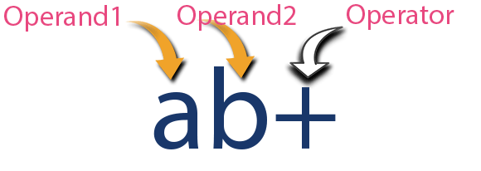

**Postfix Expression**

**Prefix Expression**

In prefix expression, operator is used before operands. We can say that "**Operands follows the Operator**".  
  
The general structure of Prefix expression is as follows...

**Operator Operand1 Operand2**

**Example**

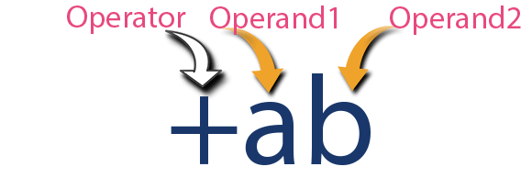

**Prefix Expression**

Any expression can be represented using the above three different types of expressions. And we can convert an expression from one form to another form like **Infix to Postfix**, **Infix to Prefix**, **Prefix to Postfix** and vice versa.

# Expression Conversion

Any expression can be represented using three types of expressions (Infix, Postfix and Prefix). We can also convert one type of expression to another type of expression like Infix to Postfix, Infix to Prefix, Postfix to Prefix and vice versa.  
  
To convert any Infix expression into Postfix or Prefix expression we can use the following procedure...

1. Find all the operators in the given Infix Expression.
2. Find the order of operators evaluated according to their Operator precedence.
3. Convert each operator into required type of expression (Postfix or Prefix) in the same order.

# Example

Consider the following Infix Expression to be converted into Postfix Expression...

#### D = A + B * C

* **Step 1:** The Operators in the given Infix Expression : **= , + , \***
* **Step 2:** The Order of Operators according to their preference : **\* , + , =**
* **Step 3:** Now, convert the first operator **\*** ----- **D = A + B C \***
* **Step 4:** Convert the next operator **+** ----- **D = A BC* +**
* **Step 5:** Convert the next operator **=** ----- **D ABC*+ =**

Finally, given Infix Expression is converted into Postfix Expression as follows...

#### D A B C * + =

# Infix to Postfix Conversion using Stack Data Structure

To convert Infix Expression into Postfix Expression using a stack data structure, We can use the following steps...

1. **Read all the symbols one by one from left to right in the given Infix Expression.**
2. **If the reading symbol is operand, then directly print it to the result (Output).**
3. **If the reading symbol is left parenthesis '(', then Push it on to the Stack.**
4. **If the reading symbol is right parenthesis ')', then Pop all the contents of stack until respective left parenthesis is poped and print each poped symbol to the result.**
5. **If the reading symbol is operator (+ , - , * , / etc.,), then Push it on to the Stack. However, first pop the operators which are already on the stack that have higher or equal precedence than current operator and print them to the result.**

# Example

Consider the following Infix Expression...

#### ( A + B ) * ( C - D )

The given infix expression can be converted into postfix expression using Stack data Structure as follows...

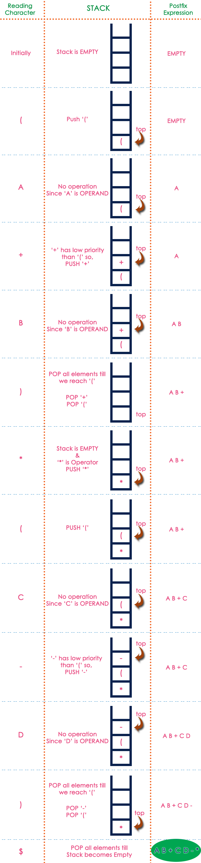

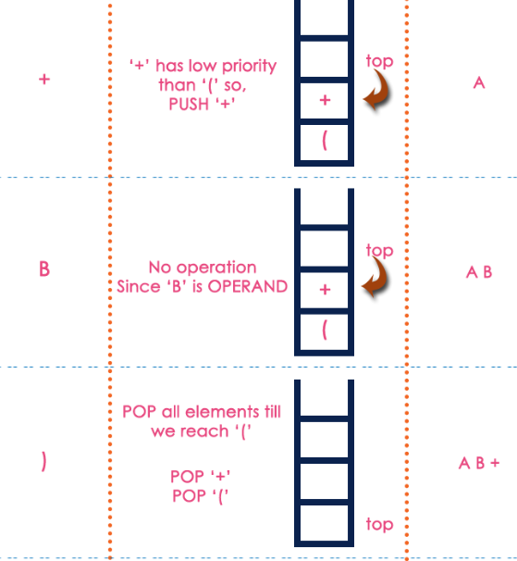

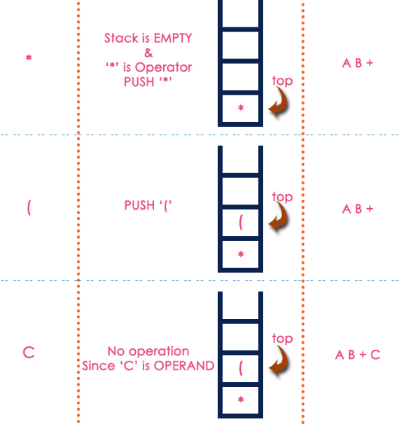

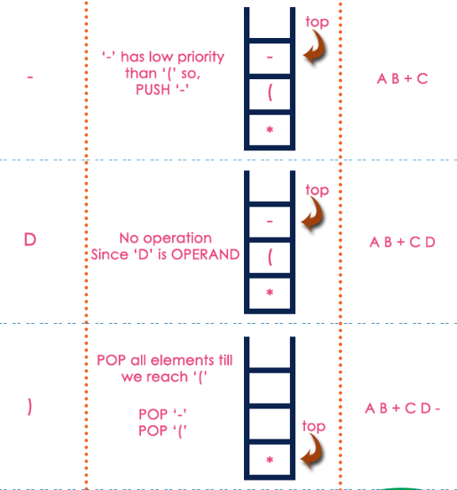



The final Postfix Expression is as follows...

#### A B + C D - *

# Postfix Expression Evaluation

A postfix expression is a collection of operators and operands in which the operator is placed after the operands. That means, in a postfix expression the operator follows the operands.  
  
Postfix Expression has following general structure...

#### Operand1 Operand2 Operator

# Example



# Postfix Expression Evaluation using Stack Data Structure

A postfix expression can be evaluated using the Stack data structure. To evaluate a postfix expression using Stack data structure we can use the following steps...

1. **Read all the symbols one by one from left to right in the given Postfix Expression**
2. **If the reading symbol is operand, then push it on to the Stack.**
3. **If the reading symbol is operator (+ , - , * , / etc.,), then perform TWO pop operations and store the two popped oparands in two different variables (operand1 and operand2). Then perform reading symbol operation using operand1 and operand2 and push result back on to the Stack.**
4. **Finally! perform a pop operation and display the popped value as final result.**

# Example

Consider the following Expression...

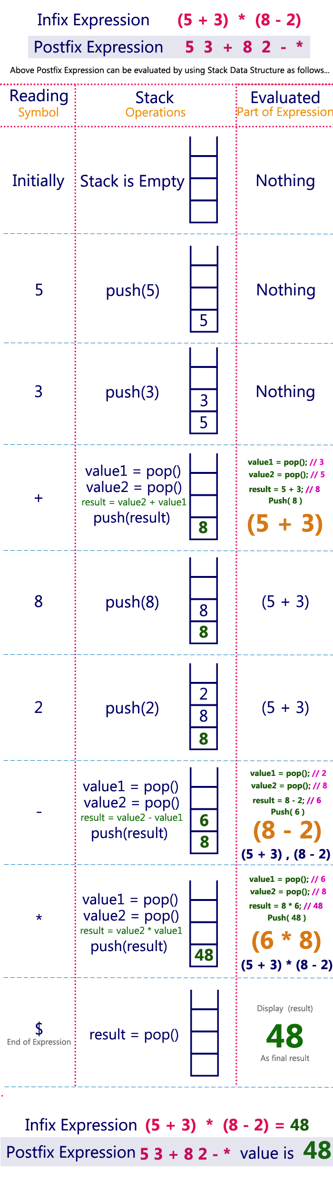

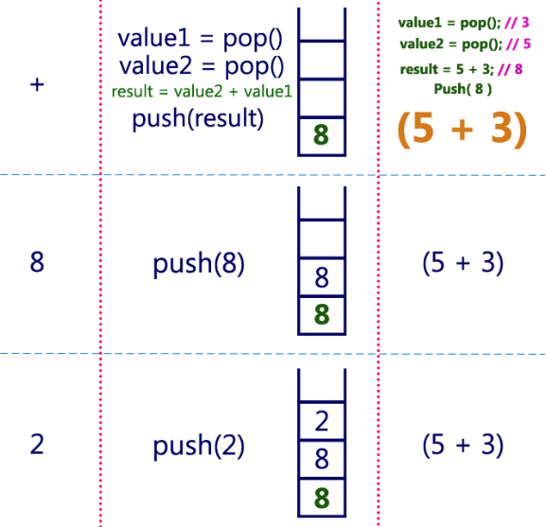

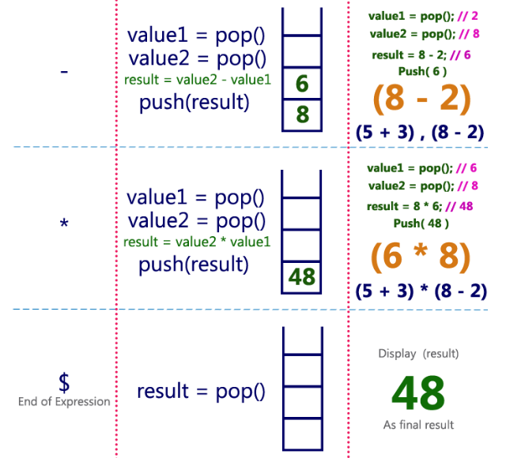

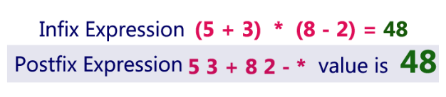

**Tree Terminology**

In linear data structure, data is organized in sequential order and in non-linear data structure, data is organized in random order. Tree is a very popular data structure used in wide range of applications. A tree data structure can be defined as follows...

**Tree is a non-linear data structure which organizes data in hierarchical structure and this is a recursive definition.**

A tree data structure can also be defined as follows...

**Tree data structure is a collection of data (Node) which is organized in hierarchical structure and this is a recursive definition**

In tree data structure, every individual element is called as **Node**. Node in a tree data structure, stores the actual data of that particular element and link to next element in hierarchical structure.  
  
In a tree data structure, if we have **N** number of nodes then we can have a maximum of **N-1** number of links.

**Example**

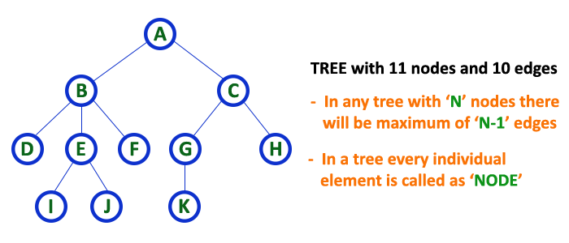

**Terminology**

In a tree data structure, we use the following terminology...

**1. Root**

In a tree data structure, the first node is called as **Root Node**. Every tree must have root node. We can say that root node is the origin of tree data structure. In any tree, there must be only one root node. We never have multiple root nodes in a tree.

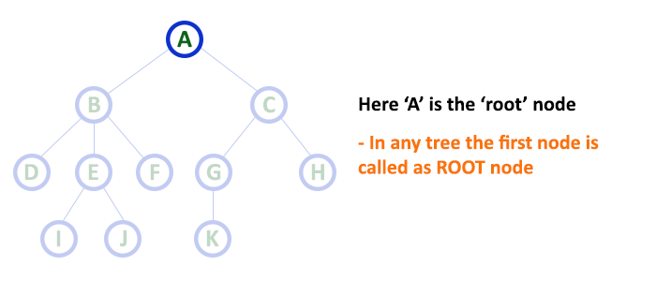

**2. Edge**

In a tree data structure, the connecting link between any two nodes is called as **EDGE**. In a tree with '**N**' number of nodes there will be a maximum of '**N-1**' number of edges.

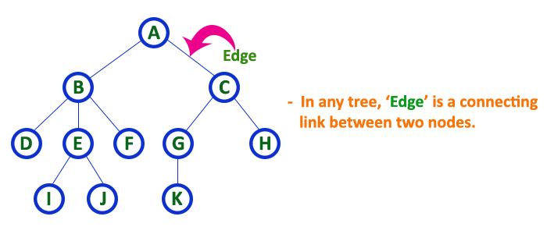

**3. Parent**

In a tree data structure, the node which is predecessor of any node is called as **PARENT NODE**. In simple words, the node which has branch from it to any other node is called as parent node. Parent node can also be defined as "**The node which has child / children**".

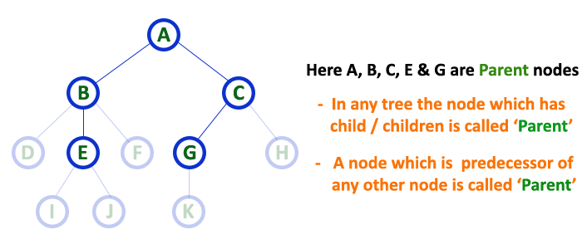

**4. Child**

In a tree data structure, the node which is descendant of any node is called as **CHILD Node**. In simple words, the node which has a link from its parent node is called as child node. In a tree, any parent node can have any number of child nodes. In a tree, all the nodes except root are child nodes.

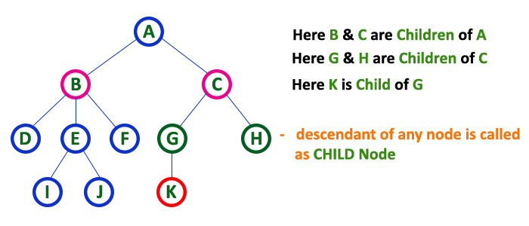

**5. Siblings**

In a tree data structure, nodes which belong to same Parent are called as **SIBLINGS**. In simple words, the nodes with same parent are called as Sibling nodes.

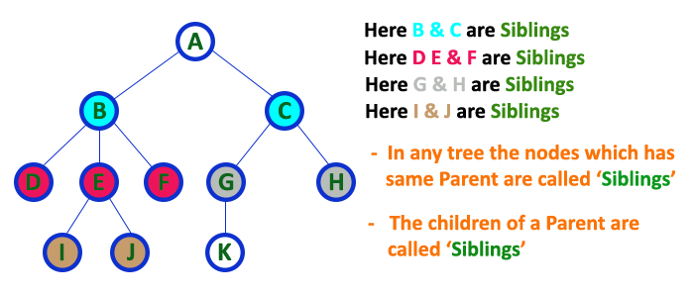

**6. Leaf**

In a tree data structure, the node which does not have a child is called as **LEAF Node**. In simple words, a leaf is a node with no child.   
  
In a tree data structure, the leaf nodes are also called as **External Nodes**. External node is also a node with no child. In a tree, leaf node is also called as '**Terminal**' node.

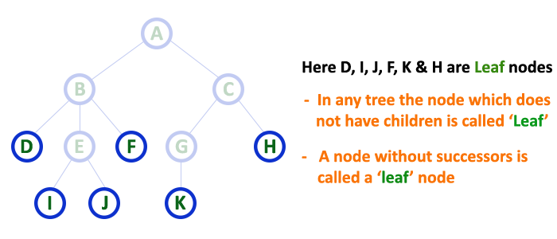

**7. Internal Nodes**

In a tree data structure, the node which has atleast one child is called as **INTERNAL Node**. In simple words, an internal node is a node with atleast one child.   
  
In a tree data structure, nodes other than leaf nodes are called as **Internal Nodes**.**The root node is also said to be Internal Node** if the tree has more than one node. Internal nodes are also called as '**Non-Terminal**' nodes.

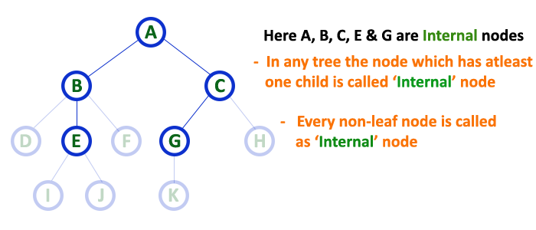

**8. Degree**

In a tree data structure, the total number of children of a node is called as **DEGREE** of that Node. In simple words, the Degree of a node is total number of children it has. The highest degree of a node among all the nodes in a tree is called as '**Degree of Tree**'

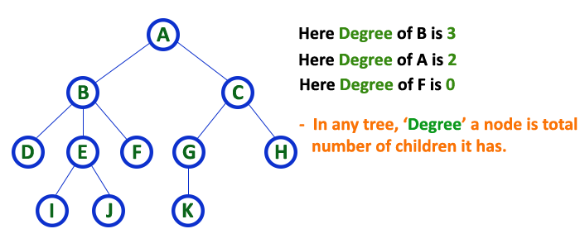

**9. Level**

In a tree data structure, the root node is said to be at Level 0 and the children of root node are at Level 1 and the children of the nodes which are at Level 1 will be at Level 2 and so on... In simple words, in a tree each step from top to bottom is called as a Level and the Level count starts with '0' and incremented by one at each level (Step).

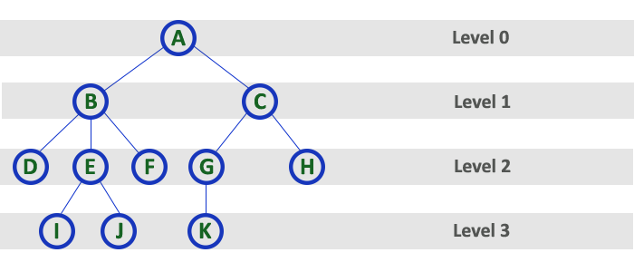

**10. Height**

In a tree data structure, the total number of egdes from leaf node to a particular node in the longest path is called as **HEIGHT** of that Node. In a tree, height of the root node is said to be **height of the tree**. In a tree, **height of all leaf nodes is '0'.**

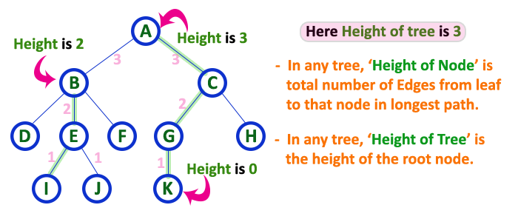

**11. Depth**

In a tree data structure, the total number of egdes from root node to a particular node is called as **DEPTH** of that Node. In a tree, the total number of edges from root node to a leaf node in the longest path is said to be **Depth of the tree**. In simple words, the highest depth of any leaf node in a tree is said to be depth of that tree. In a tree, **depth of the root node is '0'.**

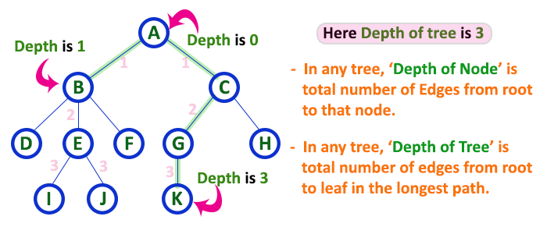

**12. Path**

In a tree data structure, the sequence of Nodes and Edges from one node to another node is called as **PATH** between that two Nodes. **Length of a Path** is total number of nodes in that path. In below example **the path A - B - E - J has length 4**.

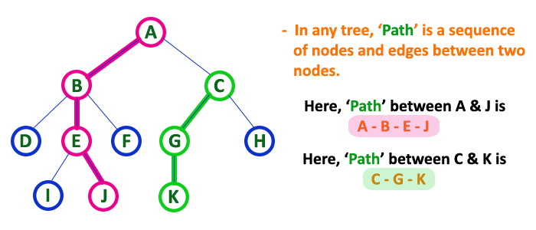

**13. Sub Tree**

In a tree data structure, each child from a node forms a subtree recursively. Every child node will form a subtree on its parent node.

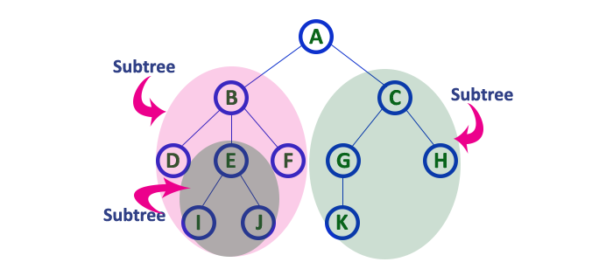

**Tree Representations**

A tree data structure can be represented in two methods. Those methods are as follows...

1. **List Representation**
2. **Left Child - Right Sibling Representation**

Consider the following tree...



**1. List Representation**

In this representation, we use two types of nodes one for representing the node with data and another for representing only references. We start with a node with data from root node in the tree. Then it is linked to an internal node through a reference node and is linked to any other node directly. This process repeats for all the nodes in the tree.

The above tree example can be represented using List representation as follows...

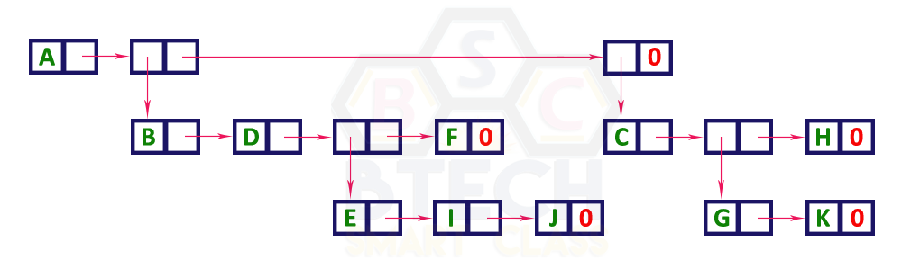

**2. Left Child - Right Sibling Representation**

In this representation, we use list with one type of node which consists of three fields namely Data field, Left child reference field and Right sibling reference field. Data field stores the actual value of a node, left reference field stores the address of the left child and right reference field stores the address of the right sibling node. Graphical representation of that node is as follows...

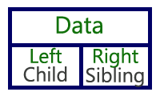

In this representation, every node's data field stores the actual value of that node. If that node has left child, then left reference field stores the address of that left child node otherwise that field stores NULL. If that node has right sibling then right reference field stores the address of right sibling node otherwise that field stores NULL.   
  
The above tree example can be represented using Left Child - Right Sibling representation as follows...

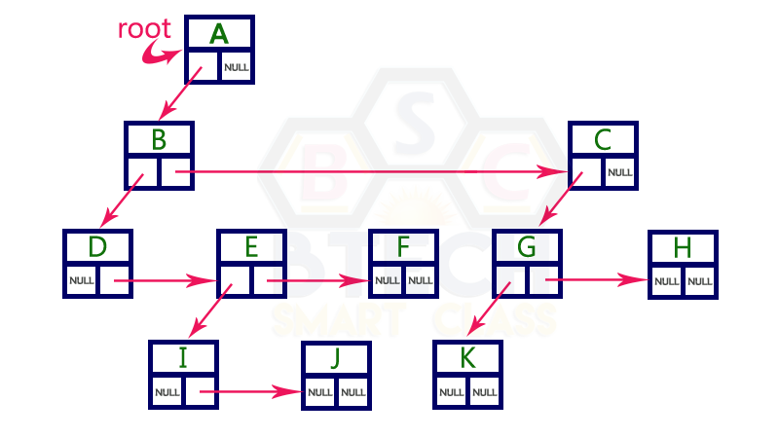

**Binary Tree**

In a normal tree, every node can have any number of children. Binary tree is a special type of tree data structure in which every node can have a **maximum of 2 children**. One is known as left child and the other is known as right child.

**A tree in which every node can have a maximum of two children is called as Binary Tree.**

In a binary tree, every node can have either 0 children or 1 child or 2 children but not more than 2 children.

**Example**

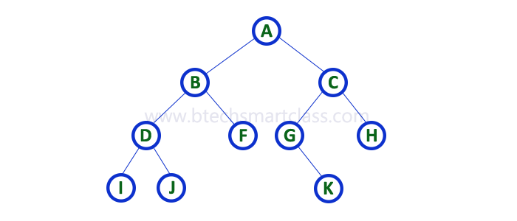

There are different types of binary trees and they are...

**1. Strictly Binary Tree**

In a binary tree, every node can have a maximum of two children. But in strictly binary tree, every node should have exactly two children or none. That means every internal node must have exactly two children. A strictly Binary Tree can be defined as follows...

**A binary tree in which every node has either two or zero number of children is called Strictly Binary Tree**

Strictly binary tree is also called as **Full Binary Tree** or **Proper Binary Tree** or **2-Tree**

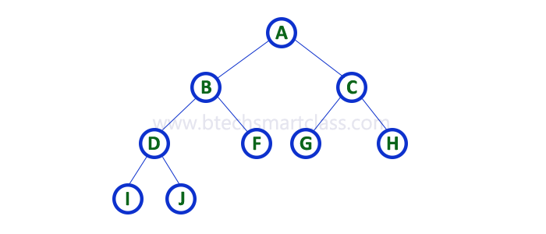

Strictly binary tree data structure is used to represent mathematical expressions.

**Example**

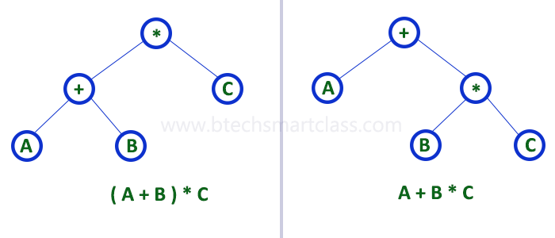

**2. Complete Binary Tree**

In a binary tree, every node can have a maximum of two children. But in strictly binary tree, every node should have exactly two children or none and in complete binary tree all the nodes must have exactly two children and at every level of complete binary tree there must be 2level number of nodes. For example at level 2 there must be 22 = 4 nodes and at level 3 there must be 23 = 8 nodes.

**A binary tree in which every internal node has exactly two children and all leaf nodes are at same level is called Complete Binary Tree.**

Complete binary tree is also called as **Perfect Binary Tree**

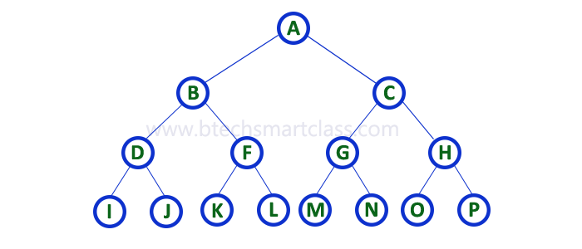

**3. Extended Binary Tree**

A binary tree can be converted into Full Binary tree by adding dummy nodes to existing nodes wherever required.

**The full binary tree obtained by adding dummy nodes to a binary tree is called as Extended Binary Tree.**

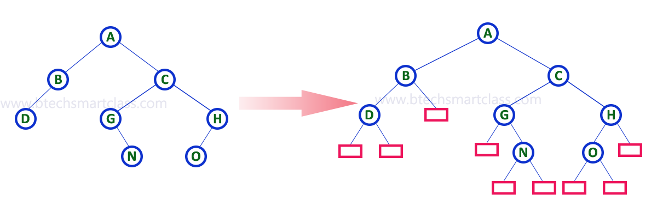

In above figure, a normal binary tree is converted into full binary tree by adding dummy nodes (In pink colour).

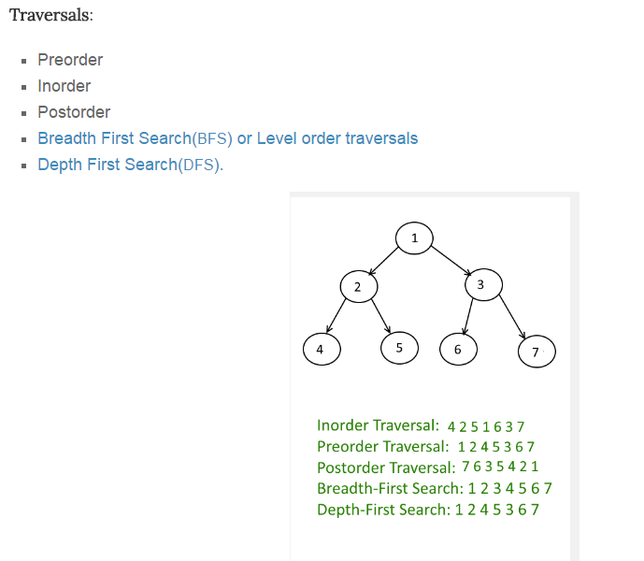

* Binary heap

Heap and their Implementation

A **binary heap** is a [heap](https://en.wikipedia.org/wiki/Heap_(data_structure)) [data structure](https://en.wikipedia.org/wiki/Data_structure) that takes the form of a [binary tree](https://en.wikipedia.org/wiki/Binary_tree). Binary heaps are a common way of implementing [priority queues](https://en.wikipedia.org/wiki/Priority_queue)

A binary heap is defined as a binary tree with two additional constraints:[[2]](https://en.wikipedia.org/wiki/Binary_heap#cite_note-2)

* **Shape property**: a binary heap is a [*complete binary tree*](https://en.wikipedia.org/wiki/Complete_Binary_Tree); that is, all levels of the tree, except possibly the last one (deepest) are fully filled, and, if the last level of the tree is not complete, the nodes of that level are filled from left to right.
* **Heap property**: the key stored in each node is either greater than or equal to or less than or equal to the keys in the node's children, according to some [total order](https://en.wikipedia.org/wiki/Total_order).

Heaps where the parent key is greater than or equal to (≥) the child keys are called *max-heaps*; those where it is less than or equal to (≤) are called *min-heaps*. Efficient ([logarithmic time](https://en.wikipedia.org/wiki/Logarithmic_time)) algorithms are known for the two operations needed to implement a priority queue on a binary heap: inserting an element, and removing the smallest (largest) element from a min-heap (max-heap). Binary heaps are also commonly employed in the [heap sort](https://en.wikipedia.org/wiki/Heapsort) [sorting algorithm](https://en.wikipedia.org/wiki/Sorting_algorithm), which is an in-place algorithm owing to the fact that binary heaps can be implemented as an [implicit data structure](https://en.wikipedia.org/wiki/Implicit_data_structure), storing keys in an array and using their relative positions within that array to represent child-parent relationships.

## Heap operations

Both the insert and remove operations modify the heap to conform to the shape property first, by adding or removing from the end of the heap. Then the heap property is restored by traversing up or down the heap. Both operations take O(log *n*) time.

### Insert

To add an element to a heap we must perform an *up-heap* operation (also known as *bubble-up*, *percolate-up*, *sift-up*, *trickle-up*, *heapify-up*, or *cascade-up*), by following this algorithm:

1. Add the element to the bottom level of the heap.
2. Compare the added element with its parent; if they are in the correct order, stop.
3. If not, swap the element with its parent and return to the previous step.

The number of operations required depends only on the number of levels the new element must rise to satisfy the heap property, thus the insertion operation has a worst-case time complexity of O(log *n*) but an average-case complexity of O(1).[[3]](https://en.wikipedia.org/wiki/Binary_heap#cite_note-3)

As an example of binary heap insertion, say we have a max-heap

[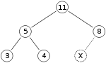](https://en.wikipedia.org/wiki/File:Heap_add_step1.svg)

and we want to add the number 15 to the heap. We first place the 15 in the position marked by the X. However, the heap property is violated since 15 > 8, so we need to swap the 15 and the 8. So, we have the heap looking as follows after the first swap:

[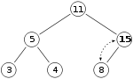](https://en.wikipedia.org/wiki/File:Heap_add_step2.svg)

However the heap property is still violated since 15 > 11, so we need to swap again:

[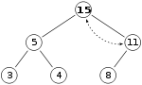](https://en.wikipedia.org/wiki/File:Heap_add_step3.svg)

which is a valid max-heap. There is no need to check the left child after this final step: at the start, the max-heap was valid, meaning 11 > 5; if 15 > 11, and 11 > 5, then 15 > 5, because of the transitive relation.

### Extract

The procedure for deleting the root from the heap (effectively extracting the maximum element in a max-heap or the minimum element in a min-heap) and restoring the properties is called *down-heap* (also known as *bubble-down*, *percolate-down*, *sift-down*, *trickle down*, *heapify-down*, *cascade-down*, and *extract-min/max*).

1. Replace the root of the heap with the last element on the last level.
2. Compare the new root with its children; if they are in the correct order, stop.
3. If not, swap the element with one of its children and return to the previous step. (Swap with its smaller child in a min-heap and its larger child in a max-heap.)

So, if we have the same max-heap as before

[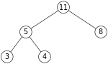](https://en.wikipedia.org/wiki/File:Heap_delete_step0.svg)

We remove the 11 and replace it with the 4.

[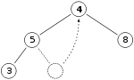](https://en.wikipedia.org/wiki/File:Heap_remove_step1.svg)

Now the heap property is violated since 8 is greater than 4. In this case, swapping the two elements, 4 and 8, is enough to restore the heap property and we need not swap elements further:

[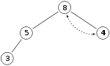](https://en.wikipedia.org/wiki/File:Heap_remove_step2.svg)

The downward-moving node is swapped with the *larger* of its children in a max-heap (in a min-heap it would be swapped with its smaller child), until it satisfies the heap property in its new position. This functionality is achieved by the **Max-Heapify** function as defined below in [pseudocode](https://en.wikipedia.org/wiki/Pseudocode) for an [array](https://en.wikipedia.org/wiki/Array_data_structure)-backed heap *A* of length *heap_length*[*A*]. Note that "A" is indexed starting at 1, not 0 as is common in many real programming languages

Heap Data Structures

Heap is a special case of balanced binary tree data structure where the root-node key is compared with its children and arranged accordingly. If **α** has child node **β** then −

**key(α) ≥ key(β)**

As the value of parent is greater than that of child, this property generates **Max Heap**. Based on this criteria, a heap can be of two types −

For Input → 35 33 42 10 14 19 27 44 26 31

**Min-Heap** − Where the value of the root node is less than or equal to either of its children.

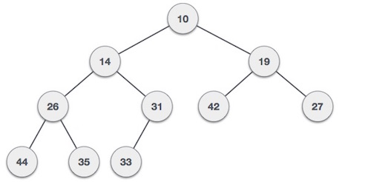

**Max-Heap** − Where the value of the root node is greater than or equal to either of its children.

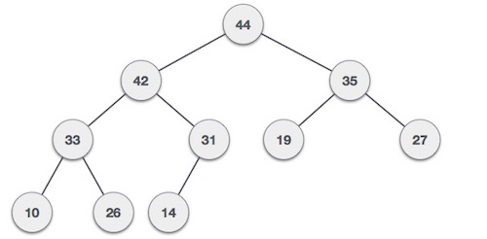

Both trees are constructed using the same input and order of arrival.

## Max Heap Construction Algorithm

We shall use the same example to demonstrate how a Max Heap is created. The procedure to create Min Heap is similar but we go for min values instead of max values.

We are going to derive an algorithm for max heap by inserting one element at a time. At any point of time, heap must maintain its property. While insertion, we also assume that we are inserting a node in an already heapified tree.

**Step 1** − Create a new node at the end of heap.

**Step 2** − Assign new value to the node.

**Step 3** − Compare the value of this child node with its parent.

**Step 4** − If value of parent is less than child, then swap them.

**Step 5** − Repeat step 3 & 4 until Heap property holds.

**Note** − In Min Heap construction algorithm, we expect the value of the parent node to be less than that of the child node.

Let's understand Max Heap construction by an animated illustration. We consider the same input sample that we used earlier.

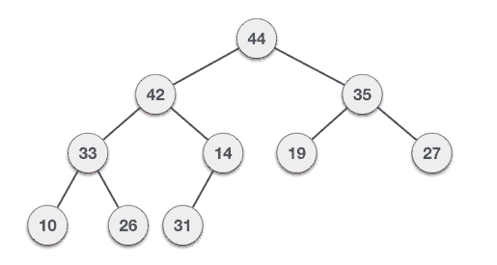

## Max Heap Deletion Algorithm

Let us derive an algorithm to delete from max heap. Deletion in Max (or Min) Heap always happens at the root to remove the Maximum (or minimum) value.

**Step 1** − Remove root node.

**Step 2** − Move the last element of last level to root.

**Step 3** − Compare the value of this child node with its parent.

**Step 4** − If value of parent is less than child, then swap them.

**Step 5** − Repeat step 3 & 4 until Heap property holds.

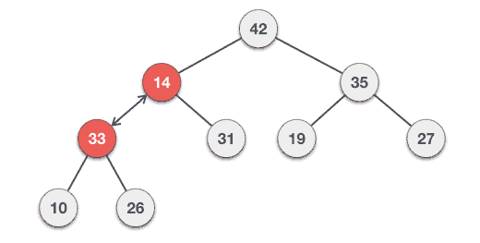

A heap is a partially sorted binary tree. Although a heap is not completely in order, it conforms to a sorting principle: every node has a value less (for the sake of simplicity, we will assume that all orderings are from least to greatest) than either of its children. Additionally, a heap is a "complete tree" -- a complete tree is one in which there are no gaps between leaves. For instance, a tree with a root node that has only one child must have its child as the left node. More precisely, a complete tree is one that has every level filled in before adding a node to the next level, and one that has the nodes in a given level filled in from left to right, with no breaks.

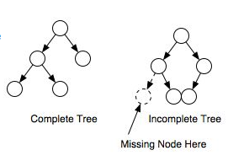

Why use a heap?  
  
A heap can be thought of as a priority queue; the most important node will always be at the top, and when removed, its replacement will be the most important. This can be useful when coding algorithms that require certain things to processed in a complete order, but when you don't want to perform a full sort or need to know anything about the rest of the nodes. For instance, a well-known algorithm for finding the shortest distance between nodes in a graph, Dijkstra's Algorithm, can be optimized by using a priority queue.  
  
Heaps can also be used to sort data. A heap sort is O(nlogn) efficiency, though it is not the fastest possible sorting algorithm. Check out this [tutorial heap sort](http://www.cprogramming.com/tutorial/computersciencetheory/heapsort.html) for more information related to heap sort.   
  
How do you implement a heap?  
  
Although the concept of a heap is simple, the actual implementation can appear tricky. How do you remove the root node and still ensure that it is eventually replaced by the correct node? How do you add a new node to a heap and ensure that it is moved into the proper spot?  
  
The answers to these questions are more straight forward than meets the eye, but to understand the process, let's first take a look at two operations that are used for adding and removing nodes from a heap: upheaping and downheaping.   
  
**Upheap**: The upheap process is used to add a node to a heap. When you upheap a node, you compare its value to its parent node; if its value is less than its parent node, then you switch the two nodes and continue the process. Otherwise the condition is met that the parent node is less than the child node, and so you can stop the process. Once you find a parent node that is less than the node being upheaped, you know that the heap is correct--the node being upheaped is greater than its parent, and its parent is greater than its own parent, all the way up to the root.   
  
**Downheap**: The downheap process is similar to the upheaping process. When you downheap a node, you compare its value with its two children. If the node is less than both of its children, it remains in place; otherwise, if it is greater than one or both of its children, then you switch it with the child of lowest value, thereby ensuring that of the three nodes being compared, the new parent node is lowest. Of course, you cannot be assured that the node being downheaped is in its proper position -- it may be greater than one or both of its new children; the downheap process must be repeated until the node is less than both of its children.

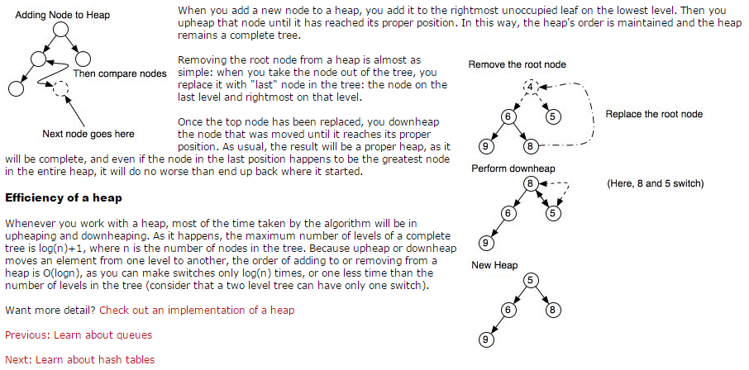

# Multiway Trees

A **multiway tree** is a tree that can have more than two children. A **multiway tree of order m** (or an **m-way tree**) is one in which a tree can have m children.

As with the other trees that have been studied, the nodes in an m-way tree will be made up of key fields, in this case m-1 key fields, and pointers to children.

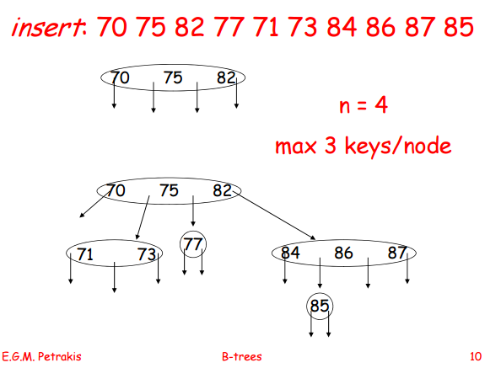

multiway tree of order 5

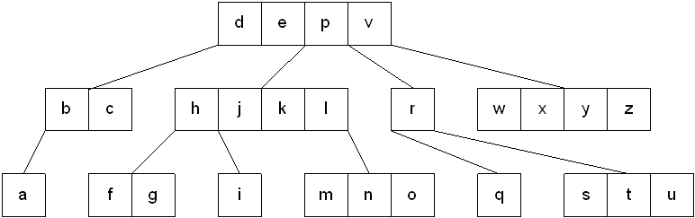

To make the processing of m-way trees easier some type of order will be imposed on the keys within each node, resulting in a **multiway search tree of order m** ( or an **m-way search tree**). By definition an m-way search tree is a m-way tree in which:

* Each node has m children and m-1 key fields
* The keys in each node are in ascending order.
* The keys in the first i children are smaller than the ith key
* The keys in the last m-i children are larger than the ith key

4-way search tree

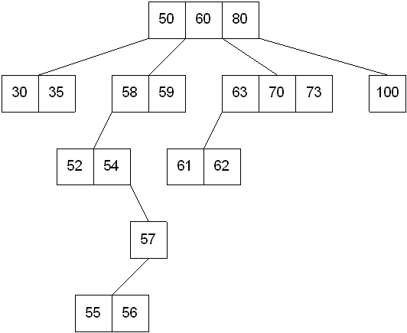

M-way search trees give the same advantages to m-way trees that binary search trees gave to binary trees - they provide fast information retrieval and update. However, they also have the same problems that binary search trees had - they can become unbalanced, which means that the construction of the tree becomes of vital importance.

## B-Trees

An extension of a multiway search tree of order m is a **B-tree of order m**. This type of tree will be used when the data to be accessed/stored is located on secondary storage devices because they allow for large amounts of data to be stored in a node.

A B-tree of order m is a multiway search tree in which:

1. The root has at least two subtrees unless it is the only node in the tree.
2. Each nonroot and each nonleaf node have at most m nonempty children and at least m/2 nonempty children.
3. The number of keys in each nonroot and each nonleaf node is one less than the number of its nonempty children.
4. All leaves are on the same level.

These restrictions make B-trees always at least half full, have few levels, and remain perfectly balanced.

The nodes in a B-tree are usually implemented as a class that contains an array of m-l cells for keys, an array of m pointers to other nodes, and whatever other information is required in order to facilitate tree maintenance.

template <class T, int M>

class BTreeNode

{

public:

BTreeNode();

BTreeNode( const T & );

private:

T keys[M-1];

BTreeNode *pointers[M];

...

};

### Searching a B-tree

An algorithm for finding a key in B-tree is simple. Start at the root and determine which pointer to follow based on a comparison between the search value and key fields in the root node. Follow the appropriate pointer to a child node. Examine the key fields in the child node and continue to follow the appropriate pointers until the search value is found or a leaf node is reached that doesn't contain the desired search value.

### Insertion into a B-tree

The condition that all leaves must be on the same level forces a characteristic behavior of B-trees, namely that B-trees are not allowed to grow at the their leaves; instead they are forced to grow at the root.

When inserting into a B-tree, a value is inserted directly into a leaf. This leads to three common situations that can occur:

1. A key is placed into a leaf that still has room.
2. The leaf in which a key is to be placed is full.
3. The root of the B-tree is full.

**Case 1: A key is placed into a leaf that still has room**

This is the easiest of the cases to solve because the value is simply inserted into the correct sorted position in the leaf node.

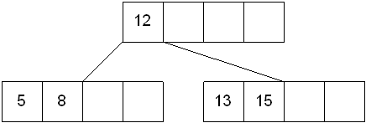

Inserting the number 7 results in:

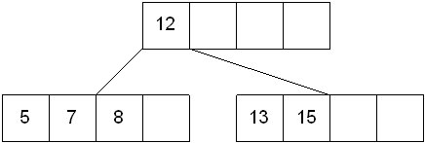

**Case 2: The leaf in which a key is to be placed is full**

In this case, the leaf node where the value should be inserted is split in two, resulting in a new leaf node. Half of the keys will be moved from the full leaf to the new leaf. The new leaf is then incorporated into the B-tree.

The new leaf is incorporated by moving the middle value to the parent and a pointer to the new leaf is also added to the parent. This process is continues up the tree until all of the values have "found" a location.

Insert 6 into the following B-tree:

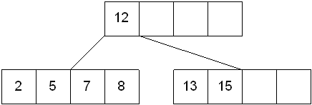

results in a split of the first leaf node:

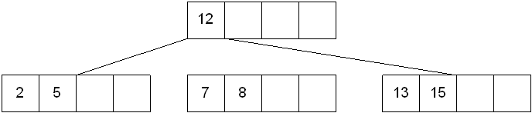

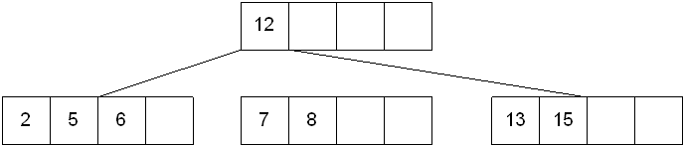

The new node needs to be incorporated into the tree - this is accomplished by taking the middle value and inserting it in the parent:

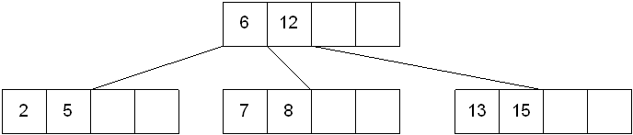

**Case 3: The root of the B-tree is full**

The upward movement of values from case 2 means that it's possible that a value could move up to the root of the B-tree. If the root is full, the same basic process from case 2 will be applied and a new root will be created. This type of split results in 2 new nodes being added to the B-tree.

Inserting 13 into the following tree:

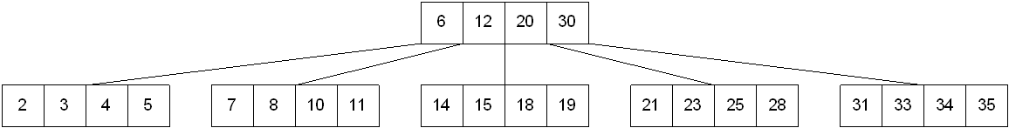

Results in:

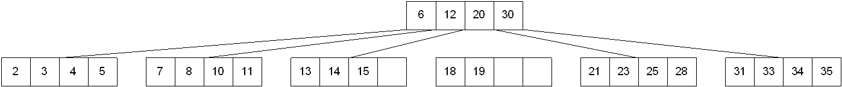

The 15 needs to be moved to the root node but it is full. This means that the root needs to be divided:

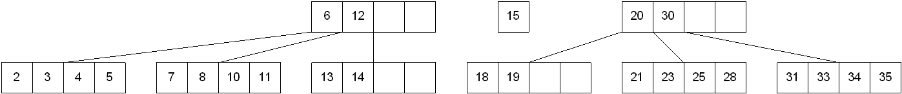

The 15 is inserted into the parent, which means that it becomes the new root node:

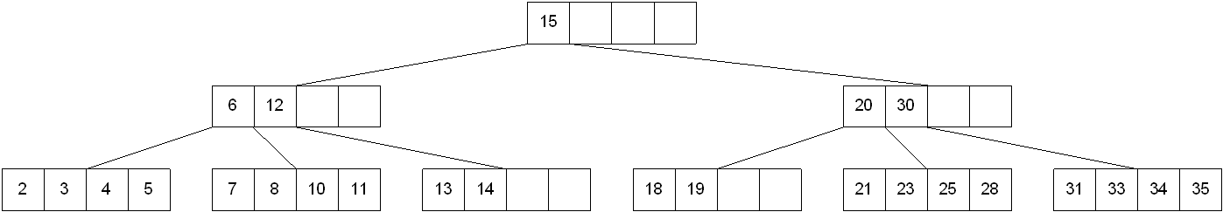

### Deleting from a B-tree

As usual, this is the hardest of the processes to apply. The deletion process will basically be a reversal of the insertion process - rather than splitting nodes, it's possible that nodes will be merged so that B-tree properties, namely the requirement that a node must be at least half full, can be maintained.

There are two main cases to be considered:

1. Deletion from a leaf
2. Deletion from a non-leaf

**Case 1: Deletion from a leaf**

1a) If the leaf is at least half full after deleting the desired value, the remaining larger values are moved to "fill the gap".

Deleting 6 from the following tree:

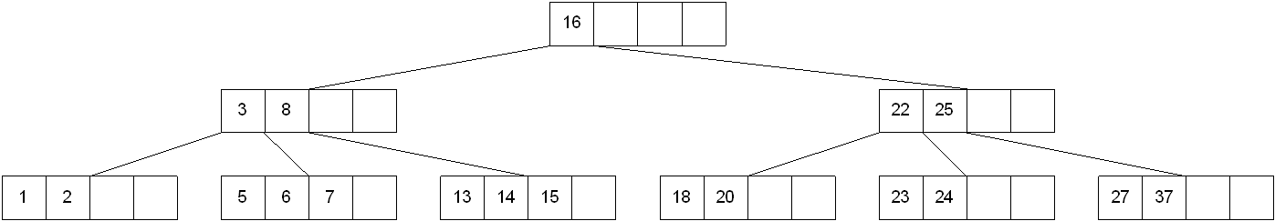

results in:

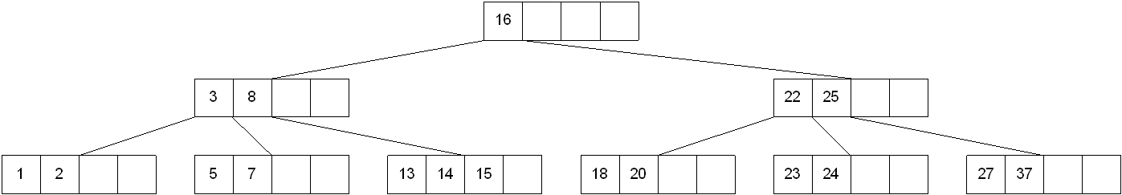

1b) If the leaf is less than half full after deleting the desired value (known as underflow), two things could happen:

Deleting 7 from the tree above results in:

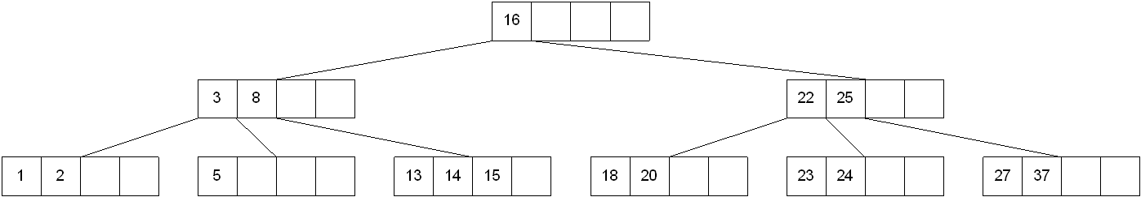

1b-1) If there is a left or right sibling with the number of keys exceeding the minimum requirement, all of the keys from the leaf and sibling will be redistributed between them by moving the separator key from the parent to the leaf and moving the middle key from the node and the sibling combined to the parent.

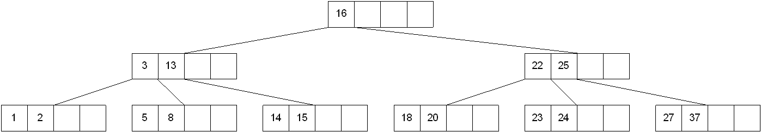

Now delete 8 from the tree:

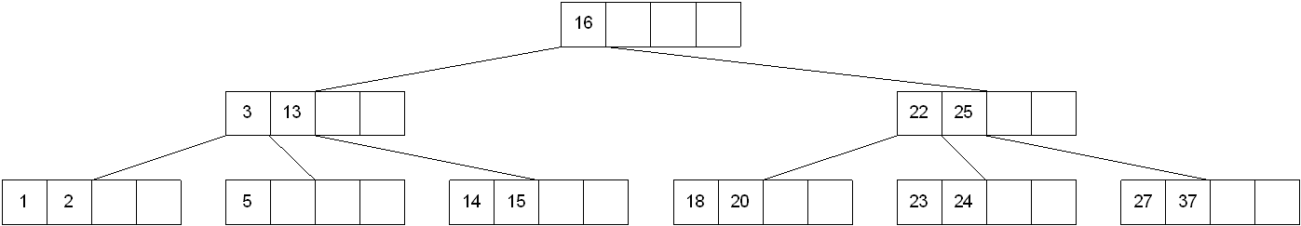

1b-2) If the number of keys in the sibling does not exceed the minimum requirement, then the leaf and sibling are merged by putting the keys from the leaf, the sibling, and the separator from the parent into the leaf. The sibling node is discarded and the keys in the parent are moved to "fill the gap". It's possible that this will cause the parent to underflow. If that is the case, treat the parent as a leaf and continue repeating step 1b-2 until the minimum requirement is met or the root of the tree is reached.

**Special Case for 1b-2:** When merging nodes, if the parent is the root with only one key, the keys from the node, the sibling, and the only key of the root are placed into a node and this will become the new root for the B-tree. Both the sibling and the old root will be discarded.

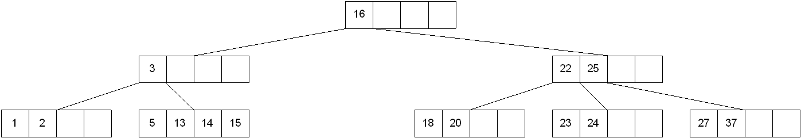

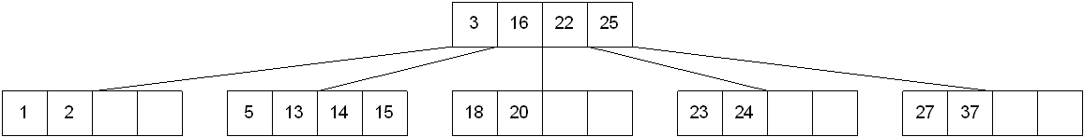

**Case 2: Deletion from a non-leaf**

This case can lead to problems with tree reorganization but it will be solved in a manner similar to deletion from a binary search tree.

The key to be deleted will be replaced by its immediate predecessor (or successor) and then the predecessor (or successor) will be deleted since it can only be found in a leaf node.

Deleting 16 from the tree above results in:

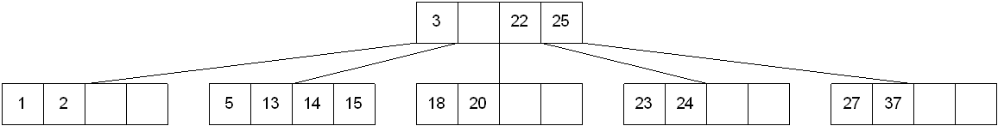

The "gap" is filled in with the immediate predecessor:

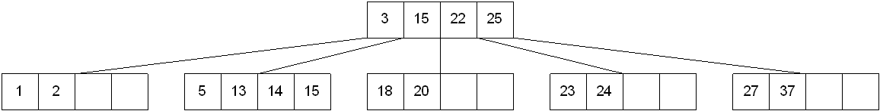

and then the immediate predecessor is deleted:

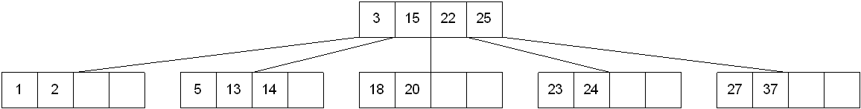

If the immediate successor had been chosen as the replacement:

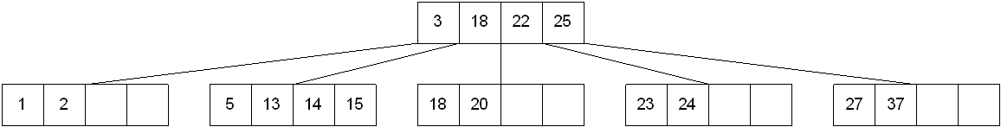

Deleting the successor results in:

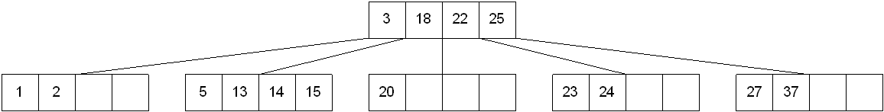

The vales in the left sibling are combined with the separator key (18) and the remaining values. They are divided between the 2 nodes:

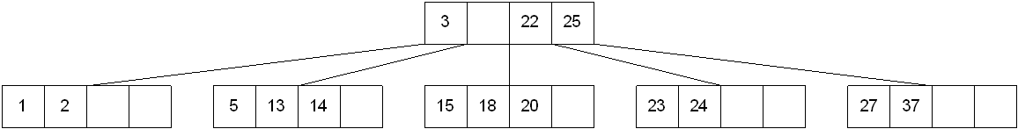

and then the middle value is moved to the parent:

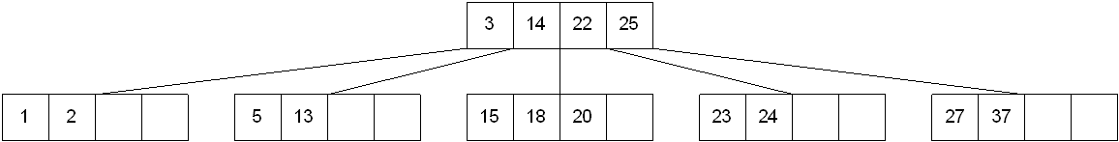

# B-Tree | Set 1 (Introduction)

B-Tree is a self-balancing search tree. In most of the other self-balancing search trees (like [AVL](http://www.geeksforgeeks.org/avl-tree-set-1-insertion/) and Red Black Trees), it is assumed that everything is in main memory. To understand use of B-Trees, we must think of huge amount of data that cannot fit in main memory. When the number of keys is high, the data is read from disk in the form of blocks. Disk access time is very high compared to main memory access time. The main idea of using B-Trees is to reduce the number of disk accesses. Most of the tree operations (search, insert, delete, max, min, ..etc ) require O(h) disk accesses where h is height of the tree. B-tree is a fat tree. Height of B-Trees is kept low by putting maximum possible keys in a B-Tree node. Generally, a B-Tree node size is kept equal to the disk block size. Since h is low for B-Tree, total disk accesses for most of the operations are reduced significantly compared to balanced Binary Search Trees like AVL Tree, Red Black Tree, ..etc.

**Properties of B-Tree**

**1)** All leaves are at same level.

**2)** A B-Tree is defined by the term minimum degree ‘t’. The value of t depends upon disk block size.

**3)** Every node except root must contain at least t-1 keys. Root may contain minimum 1 key.

**4)** All nodes (including root) may contain at most 2t – 1 keys.

**5)** Number of children of a node is equal to the number of keys in it plus 1.

**6)** All keys of a node are sorted in increasing order. The child between two keys k1 and k2 contains all keys in range from k1 and k2.

**7)** B-Tree grows and shrinks from root which is unlike Binary Search Tree. Binary Search Trees grow downward and also shrink from downward.

**8)** Like other balanced Binary Search Trees, time complexity to search, insert and delete is O(Logn).

Following is an example B-Tree of minimum degree 3. Note that in practical B-Trees, the value of minimum degree is much more than 3.

[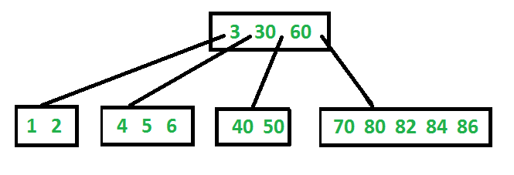](http://d1gjlxt8vb0knt.cloudfront.net/wp-content/uploads/BTreeIntro1.png)

**Search**

Search is similar to search in Binary Search Tree. Let the key to be searched be k. We start from root and recursively traverse down. For every visited non-leaf node, if the node has key, we simply return the node. Otherwise we recur down to the appropriate child (The child which is just before the first greater key) of the node. If we reach a leaf node and don’t find k in the leaf node, we return NULL.

**Traverse**

Traversal is also similar to Inorder traversal of Binary Tree. We start from the leftmost child, recursively print the leftmost child, then repeat the same process for remaining children and keys. In the end, recursively print the rightmost child.

|  |
| --- |
| // C++ implemntation of search() and traverse() methods  #include<iostream>  using namespace std;    // A BTree node  class BTreeNode  {      int *keys;  // An array of keys      int t;      // Minimum degree (defines the range for number of keys)      BTreeNode **C; // An array of child pointers      int n;     // Current number of keys      bool leaf; // Is true when node is leaf. Otherwise false  public:      BTreeNode(int _t, bool _leaf);   // Constructor        // A function to traverse all nodes in a subtree rooted with this node      void traverse();        // A function to search a key in subtree rooted with this node.      BTreeNode *search(int k);   // returns NULL if k is not present.    // Make BTree friend of this so that we can access private members of this  // class in BTree functions  friend class BTree;  };    // A BTree  class BTree  {      BTreeNode *root; // Pointer to root node      int t;  // Minimum degree  public:      // Constructor (Initializes tree as empty)      BTree(int _t)      {  root = NULL;  t = _t; }        // function to traverse the tree      void traverse()      {  if (root != NULL) root->traverse(); }        // function to search a key in this tree      BTreeNode* search(int k)      {  return (root == NULL)? NULL : root->search(k); }  };    // Constructor for BTreeNode class  BTreeNode::BTreeNode(int _t, bool _leaf)  {      // Copy the given minimum degree and leaf property      t = _t;      leaf = _leaf;        // Allocate memory for maximum number of possible keys      // and child pointers      keys = new int[2*t-1];      C = new BTreeNode *[2*t];        // Initialize the number of keys as 0      n = 0;  }    // Function to traverse all nodes in a subtree rooted with this node  void BTreeNode::traverse()  {      // There are n keys and n+1 children, travers through n keys      // and first n children      int i;      for (i = 0; i < n; i++)      {          // If this is not leaf, then before printing key[i],          // traverse the subtree rooted with child C[i].          if (leaf == false)              C[i]->traverse();          cout << " " << keys[i];      }        // Print the subtree rooted with last child      if (leaf == false)          C[i]->traverse();  }    // Function to search key k in subtree rooted with this node  BTreeNode *BTreeNode::search(int k)  {      // Find the first key greater than or equal to k      int i = 0;      while (i < n && k > keys[i])          i++;        // If the found key is equal to k, return this node      if (keys[i] == k)          return this;        // If key is not found here and this is a leaf node      if (leaf == true)          return NULL;        // Go to the appropriate child      return C[i]->search(k);  } |

# B-Tree (Delete)

B-Tree is a type of a multi-way search tree.

**Deletionprocess:**

Deletion from a B-tree is more complicated than insertion, because we can delete a key from any node-not just a leaf—and when we delete a key from an internal node, we will have to rearrange the node’s children.

As in insertion, we must make sure the deletion doesn’t violate the B-tree properties. Just as we had to ensure that a node didn’t get too big due to insertion, we must ensure that a node doesn’t get too small during deletion (except that the root is allowed to have fewer than the minimum number t-1 of keys). Just as a simple insertion algorithm might have to back up if a node on the path to where the key was to be inserted was full, a simple approach to deletion might have to back up if a node (other than the root) along the path to where the key is to be deleted has the minimum number of keys.

The deletion procedure deletes the key k from the subtree rooted at x. This procedure guarantees that whenever it calls itself recursively on a node x, the number of keys in x is at least the minimum degree t . Note that this condition requires one more key than the minimum required by the usual B-tree conditions, so that sometimes a key may have to be moved into a child node before recursion descends to that child. This strengthened condition allows us to delete a key from the tree in one downward pass without having to “back up” (with one exception, which we’ll explain). You should interpret the following specification for deletion from a B-tree with the understanding that if the root node x ever becomes an internal node having no keys (this situation can occur in cases 2c and 3b then we delete x, and x’s only child x.c1 becomes the new root of the tree, decreasing the height of the tree by one and preserving the property that the root of the tree contains at least one key (unless the tree is empty).

We sketch how deletion works with various cases of deleting keys from a B-tree.

**1.** If the key k is in node x and x is a leaf, delete the key k from x.

**2.** If the key k is in node x and x is an internal node, do the following.

* 1. If the child y that precedes k in node x has at least t keys, then find the predecessor k0 of k in the sub-tree rooted at y. Recursively delete k0, and replace k by k0 in x. (We can find k0 and delete it in a single downward pass.
  2. If y has fewer than t keys, then, symmetrically, examine the child z that follows k in node x. If z has at least t keys, then find the successor k0 of k in the subtree rooted at z. Recursively delete k0, and replace k by k0 in x. (We can find k0 and delete it in a single downward pass.
  3. Otherwise, if both y and z have only t-1 keys, merge k and all of z into y, so that x loses both k and the pointer to z, and y now contains 2t-1 keys. Then free z and recursively delete k from y.

1. If the key k is not present in internal node x, determine the root x.c(i) of the appropriate subtree that must contain k, if k is in the tree at all. If x.c(i) has only t-1 keys, execute step 3a or 3b as necessary to guarantee that we descend to a node containing at least t keys. Then finish by recursing on the appropriate child of x.
2. If x.c(i) has only t-1 keys but has an immediate sibling with at least t keys, give x.c(i) an extra key by moving a key from x down into x.c(i), moving a key from x.c(i) ’s immediate left or right sibling up into x, and moving the appropriate child pointer from the sibling into x.c(i).

**b)** If x.c(i) and both of x.c(i)’s immediate siblings have t-1 keys, merge x.c(i) with one sibling, which involves moving a key from x down into the new merged node to become the median key for that node.

Since most of the keys in a B-tree are in the leaves, deletion operations are most often used to delete keys from leaves. The recursive delete procedure then acts in one downward pass through the tree, without having to back up. When deleting a key in an internal node, however, the procedure makes a downward pass through the tree but may have to return to the node from which the key was deleted to replace the key with its predecessor or successor (cases 2a and 2b).

[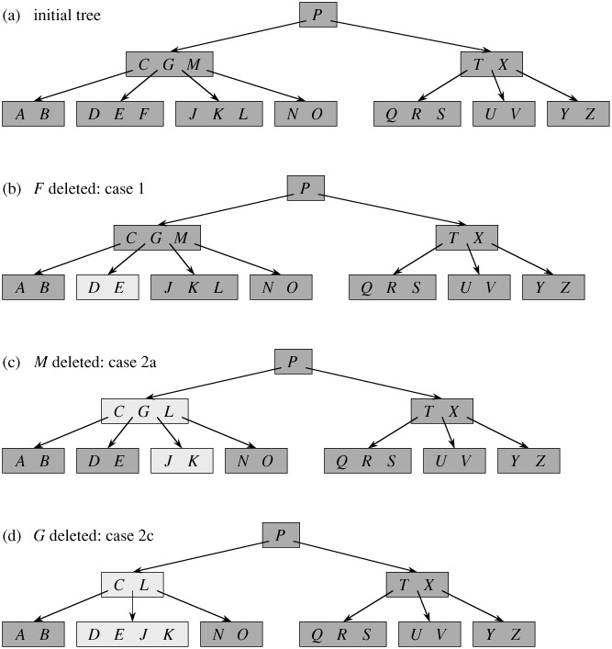](http://d1gjlxt8vb0knt.cloudfront.net/wp-content/uploads/BTreeDelet1.jpg)  
[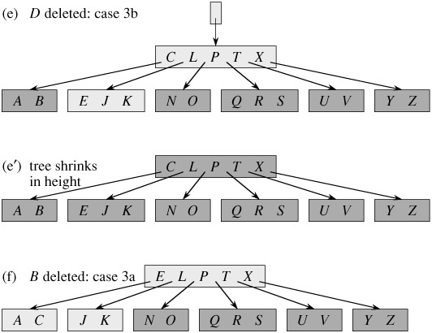](http://d1gjlxt8vb0knt.cloudfront.net/wp-content/uploads/BTreeDelet2.jpg)

## B-Trees

|  |
| --- |
| **Introduction to B-Trees** |
| A B-tree is a tree data structure that keeps data sorted and allows searches, insertions, and deletions in logarithmic amortized time. Unlike self-balancing binary search trees, it is optimized for systems that read and write large blocks of data. It is most commonly used in database and file systems. |
| **The B-Tree Rules** |
| Important properties of a B-tree:   * B-tree nodes have many more than two children. * A B-tree node may contain more than just a single element.   The set formulation of the B-tree rules: Every B-tree depends on a positive constant integer called MINIMUM, which is used to determine how many elements are held in a single node.   * **Rule 1**: The root can have as few as one element (or even no elements if it also has no children); every other node has at least MINIMUM elements. * **Rule 2**: The maximum number of elements in a node is twice the value of MINIMUM. * **Rule 3**: The elements of each B-tree node are stored in a partially filled array, sorted from the smallest element (at index 0) to the largest element (at the final used position of the array). * **Rule 4**: The number of subtrees below a nonleaf node is always one more than the number of elements in the node.   + Subtree 0, subtree 1, ... * **Rule 5**: For any nonleaf node:   + An element at index *i* is greater than all the elements in subtree number *i* of the node, and   + An element at index *i* is less than all the elements in subtree number *i* + 1 of the node. * **Rule 6**: Every leaf in a B-tree has the same depth. Thus it ensures that a B-tree avoids  the problem of a unbalanced tree.  |  |  | | --- | --- | | https://www.cpp.edu/~ftang/courses/CS241/notes/images/trees/b-tree1.bmp | https://www.cpp.edu/~ftang/courses/CS241/notes/images/trees/b-tree2.bmp | |
| **The Set Class Implementation with B-Trees** |
| Remember that "**Every child of a node is also the root of a smaller B-tree**".  public class IntBalancedSet implements Cloneable {     private static final int MINIMUM = 200;     private static final int MAXIMUM = 2*MINIMUM;     int dataCount;     int[] data = new int[MAXIMUM + 1];     int childCount;     IntBalancedSet[] subset = new IntBalancedSet[MAXIMUM + 2];      // Constructor: initialize an empty set     public IntBalancedSet()       // add: add a new element to this set, if the element was already in the set, then there is no change.     public void add(int element)      // clone: generate a copy of this set.     public IntBalancedSet clone()      // contains: determine whether a particular element is in this set     pubic boolean contains(int target)      // remove: remove a specified element from this set     public boolean remove(int target) } |
| **Searching for a Target in a Set** |
| The psuedocode:   1. Make a local variable, *i*, equal to the first index such that data[*i*] >= target. If there is no such index, then set *i* equal to dataCount, indicating that none of the elements is greater than or equal to the target. 2. if (we found the target at data[*i*]) return true; else if (the root has no children) return false; else return subset[i].contains(target);   See the following example, try to search for 10.  https://www.cpp.edu/~ftang/courses/CS241/notes/images/trees/b-tree3.bmp  We can implement a private method:   * private int firstGE(int target), which returns the first location in the root such that data[*x*] >= target. If there's no such location, then return value is dataCount. |
| **Adding an Element to a B-Tree** |
| It is easier to add a new element to a B-tree if we relax one of the B-tree rules.  *Loose addition allows the root node of the B-tree to have MAXIMUM + 1 elements*. For example, suppose we want to add 18 to the tree:  https://www.cpp.edu/~ftang/courses/CS241/notes/images/trees/b-tree4.bmp  The above result is an illegal B-tree. Our plan is to perform a loose addition first, and then fix the root's problem.  **The Loose Addition Operation for a B-Tree**:  private void looseAdd(int element) {     1. i = firstGE(element) // find the first index such that data[i] >= element     2. if (we found the new element at data[i]) return; // since there's already a copy in the set     3. else if (the root has no children)            Add the new element to the root at data[i]. (shift array)     4. else {            subset[i].looseAdd(element);            if the root of subset[i] now has an excess element, then fix that problem before returning.        } }  https://www.cpp.edu/~ftang/courses/CS241/notes/images/trees/b-tree5.bmp  private void fixExcess(int i) // precondition: (i < childCount) and the entire B-tree is valid except that subset[i] has MAXIMUM + 1 elements. // postcondition: the tree is rearranged to satisfy the loose addition rule  **Fixing a Child with an Excess Element**:   * To fix a child with MAXIMIM + 1 elements, the child node is split into two nodes that each contain MINIMUM elements. This leaves one extra element, which is passed up to the parent. * It is always the *middle* element of the split node that moves upward. * The parent of the split node gains one additional child and one additional element. * The children of the split node have been equally distributed between the two smaller nodes.   https://www.cpp.edu/~ftang/courses/CS241/notes/images/trees/b-tree6.bmp    https://www.cpp.edu/~ftang/courses/CS241/notes/images/trees/b-tree7.bmp    **Fixing the Root with an Excess Element**:   * Create a new root. * fixExcess(0).   https://www.cpp.edu/~ftang/courses/CS241/notes/images/trees/b-tree8.bmp |
| A more concrete example for node deletion:  https://www.cpp.edu/~ftang/courses/CS241/notes/images/trees/b-tree15.bmp  https://www.cpp.edu/~ftang/courses/CS241/notes/images/trees/b-tree16.bmp |
| 2-3 Tree |
| A 2-3 tree is a type of B-tree where every node with children (internal node) has either two children and one data element (2-nodes) or three children and two data elements (3-node). Leaf nodes have no children and one or two data elements.  https://www.cpp.edu/~ftang/courses/CS241/notes/images/trees/b-tree14.bmp  Practice: insert the following values in sequence to a 2-3 tree: 50, 19, 21, 66, 84, 29, and 54.  Practice: now, delete 50, 66, 54 from the above B-tree.  Exercises:  Build a 2-3 tree with the following ten values: 10, 9, 8, ..., and 1. Delete 10, 8 and 6 from the tree. |
| Trees -- Time Analysis |
| The implementation of a B-tree is efficient since the depth of the tree is kept small.  Worst-case times for tree operations: the worst-case time performance for the following operations are all O(d), where d is the depth of the tree:   1. Adding an element to a binary search tree (BST), a heap, or a B-tree. 2. Removing an element from a BST, a heap, or a B-tree. 3. Searching for a specified element in a BST or a B-tree.   Time Analysis for BST  Suppose a BST has n elements. What is the maximum depth the tree could have?   * A BST with n elements could have a depth as big as n-1.   Worst-Case Times for BSTs:   * Adding an element, removing an element, or searching for an element in a BST with n elements is O(n).   Time Analysis for Heaps  Remember that a heap is a complete BST, so each level must be full before proceeding to the next level.  Number of nodes needed for a heap to reach depth d is: (1 + 2 + 4 + 8 + ... + 2d-1) + 1 = 2d = n. Thus d = log2n.  Worst-Case Times for Heap Operations:   * Adding or removing an element in a heap with n elements is O(log n).   Time Analysis for B-Tree  Suppose a B-tree has n elements and M is the maximum number of children a node can have. What is the maximum depth the tree could have? What is the minimum depth the tree could have?   * The worst-case depth (maximum depth) of a B-tree is: logM/2 n. * The best-case depth (minimum depth) of a B-tree is: logM n.   Worst-Case Times for B-Trees:   * Adding or removing an element in a B-tree with n elements is O(log n). |

**B - Trees**

In a binary search tree, AVL Tree, Red-Black tree etc., every node can have only one value (key) and maximum of two children but there is another type of search tree called B-Tree in which a node can store more than one value (key) and it can have more than two children. B-Tree was developed in the year of 1972 by **Bayer and McCreight** with the name ***Height Balanced m-way Search Tree***. Later it was named as B-Tree.  
  
B-Tree can be defined as follows...

**B-Tree is a self-balanced search tree with multiple keys in every node and more than two children for every node.**

Here, number of keys in a node and number of children for a node is depend on the order of the B-Tree. Every B-Tree has order.  
  
**B-Tree of Order m** has the following properties...

* **Property #1** - All the **leaf nodes** must be **at same level**.
* **Property #2** - All nodes except root must have at least **[m/2]-1** keys and maximum of **m-1** keys.
* **Property #3** - All non leaf nodes except root (i.e. all internal nodes) must have at least **m/2** children.
* **Property #4** - If the root node is a non leaf node, then it must have **at least 2** children.
* **Property #5** - A non leaf node with **n-1** keys must have **n** number of children.
* **Property #6** - All the **key values within a node** must be in **Ascending Order**.

For example, B-Tree of Order 4 contains maximum 3 key values in a node and maximum 4 children for a node.

**Example**

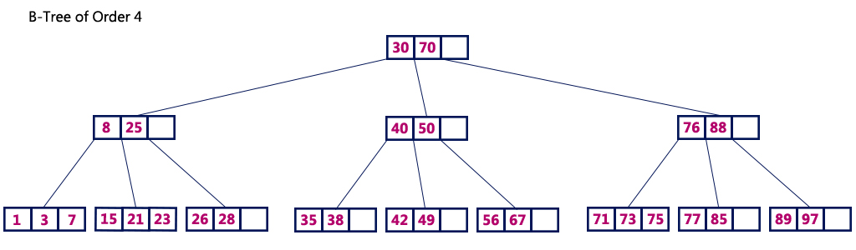

**Operations on a B-Tree**

The following operations are performed on a B-Tree...

1. **Search**
2. **Insertion**
3. **Deletion**

**Search Operation in B-Tree**

In a B-Ttree, the search operation is similar to that of Binary Search Tree. In a Binary search tree, the search process starts from the root node and every time we make a 2-way decision (we go to either left subtree or right subtree). In B-Tree also search process starts from the root node but every time we make n-way decision where n is the total number of children that node has. In a B-Ttree, the search operation is performed with **O(log n)** time complexity. The search operation is performed as follows...

* **Step 1:** Read the search element from the user
* **Step 2:** Compare, the search element with first key value of root node in the tree.
* **Step 3:** If both are matching, then display "Given node found!!!" and terminate the function
* **Step 4:** If both are not matching, then check whether search element is smaller or larger than that key value.
* **Step 5:** If search element is smaller, then continue the search process in left subtree.
* **Step 6:** If search element is larger, then compare with next key value in the same node and repeate step 3, 4, 5 and 6 until we found exact match or comparision completed with last key value in a leaf node.
* **Step 7:** If we completed with last key value in a leaf node, then display "Element is not found" and terminate the function.

**Insertion Operation in B-Tree**

In a B-Tree, the new element must be added only at leaf node. That means, always the new keyValue is attached to leaf node only. The insertion operation is performed as follows...

* **Step 1:** Check whether tree is Empty.
* **Step 2:** If tree is **Empty**, then create a new node with new key value and insert into the tree as a root node.
* **Step 3:** If tree is **Not Empty**, then find a leaf node to which the new key value cab be added using Binary Search Tree logic.
* **Step 4:** If that leaf node has an empty position, then add the new key value to that leaf node by maintaining ascending order of key value within the node.
* **Step 5:** If that leaf node is already full, then **split** that leaf node by sending middle value to its parent node. Repeat tha same until sending value is fixed into a node.
* **Step 6:** If the spilting is occuring to the root node, then the middle value becomes new root node for the tree and the height of the tree is increased by one.

**Example**

Construct a **B-Tree of Order 3** by inserting numbers from 1 to 10.

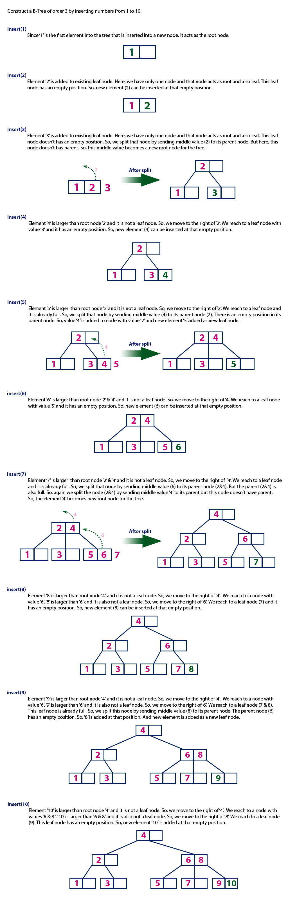

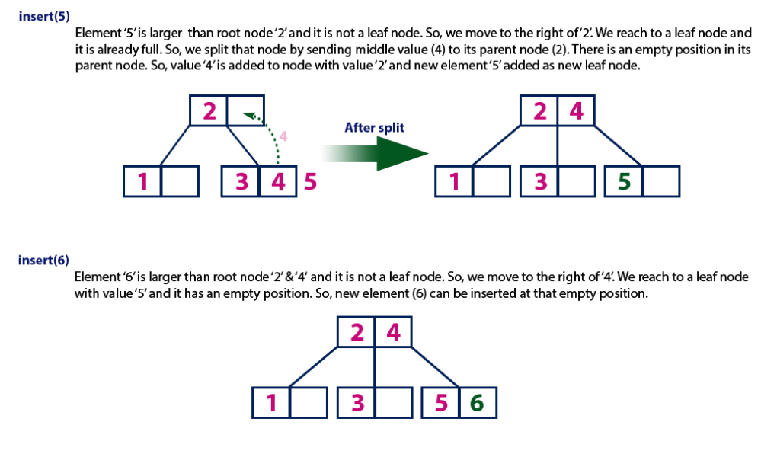

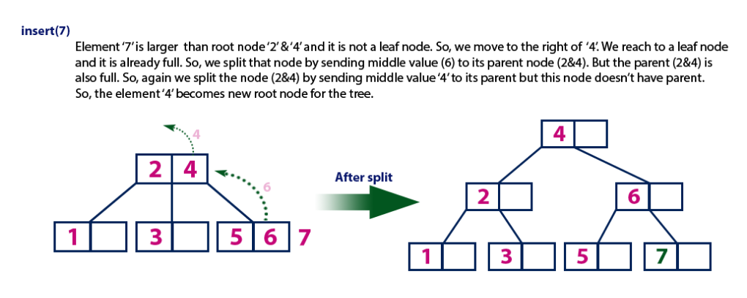

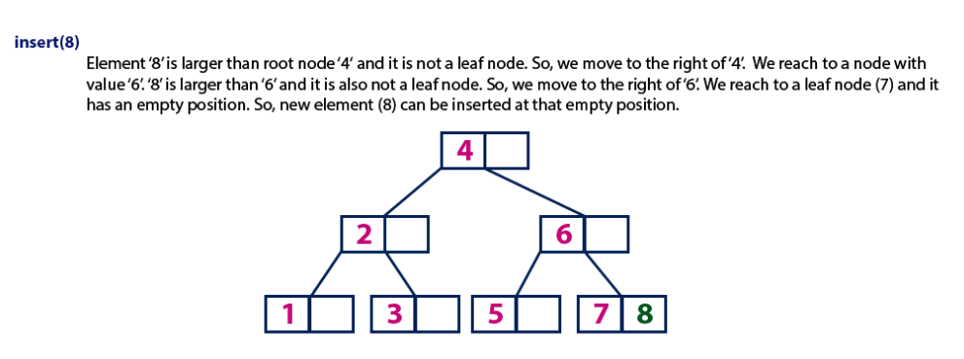

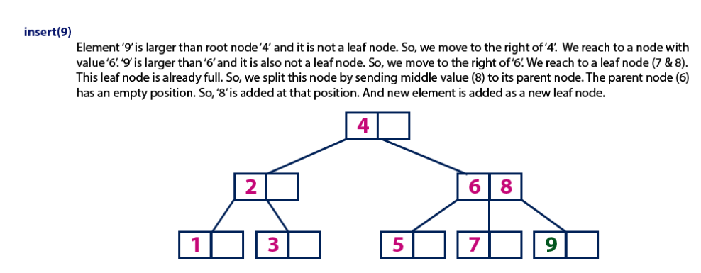

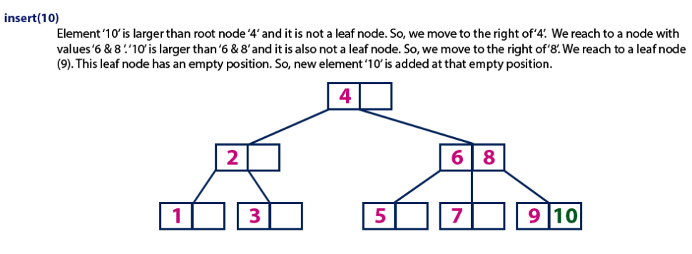

**Sparse Matrix**

**What is Sparse Matrix?**

In computer programming, a matrix can be defined with a 2-dimensional array. Any array with 'm' columns and 'n' rows represents a mXn matrix. There may be a situation in which a matrix contains more number of ZERO values than NON-ZERO values. Such matrix is known as sparse matrix.

**Sparse matrix is a matrix which contains very few non-zero elements.**

When a sparse matrix is represented with 2-dimensional array, we waste lot of space to represent that matrix. For example, consider a matrix of size 100 X 100 containing only 10 non-zero elements. In this matrix, only 10 spaces are filled with non-zero values and remaining spaces of matrix are filled with zero. That means, totally we allocate 100 X 100 X 2 = 20000 bytes of space to store this integer matrix. And to access these 10 non-zero elements we have to make scanning for 10000 times.

**Sparse Matrix Representations**

A sparse matrix can be represented by using TWO representations, those are as follows...

1. Triplet Representation
2. Linked Representation

**Triplet Representation**

In this representation, we consider only non-zero values along with their row and column index values. In this representation, the 0th row stores total rows, total columns and total non-zero values in the matrix.  
  
For example, consider a matrix of size 5 X 6 containing 6 number of non-zero values. This matrix can be represented as shown in the image...

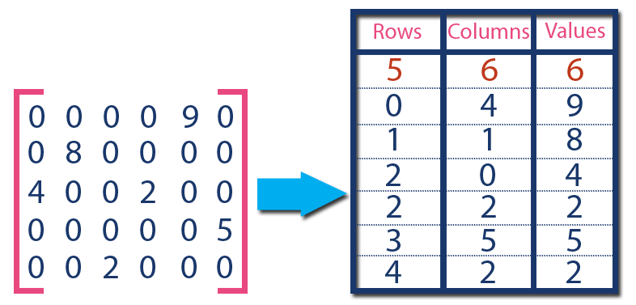

In above example matrix, there are only 6 non-zero elements ( those are 9, 8, 4, 2, 5 & 2) and matrix size is 5 X 6. We represent this matrix as shown in the above image. Here the first row in the right side table is filled with values 5, 6 & 6 which indicates that it is a sparse matrix with 5 rows, 6 columns & 6 non-zero values. Second row is filled with 0, 4, & 9 which indicates the value in the matrix at 0th row, 4th column is 9. In the same way the remaining non-zero values also follows the similar pattern.

**Linked Representation**

In linked representation, we use linked list data structure to represent a sparse matrix. In this linked list, we use two different nodes namely **header node** and **element node**. Header node consists of three fields and element node consists of five fields as shown in the image...

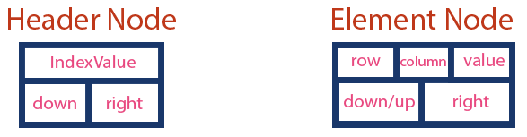

Consider the above same sparse matrix used in the Triplet representation. This sparse matrix can be represented using linked representation as shown in the below image...

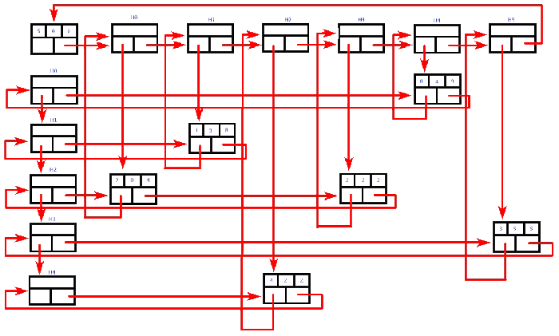

In above representation, H0, H1,...,H5 indicates the header nodes which are used to represent indexes. Remaining nodes are used to represent non-zero elements in the matrix, except the very first node which is used to represent abstract information of the sparse matrix (i.e., It is a matrix of 5 X 6 with 6 non-zero elements).  
  
In this representation, in each row and column, the last node right field points to it's respective header node.

**Space Complexity**

**What is Space complexity?**

When we design an algorithm to solve a problem, it needs some computer memory to complete its execution. For any algorithm, memory is required for the following purposes...

1. Memory required to store program instructions
2. Memory required to store constant values
3. Memory required to store variable values
4. And for few other things

Space complexity of an algorithm can be defined as follows...

**Total amount of computer memory required by an algorithm to complete its execution is called as space complexity of that algorithm**

Generally, when a program is under execution it uses the computer memory for THREE reasons. They are as follows...

1. **Instruction Space:** It is the amount of memory used to store compiled version of instructions.
2. **Environmental Stack:** It is the amount of memory used to store information of partially executed functions at the time of function call.
3. **Data Space:** It is the amount of memory used to store all the variables and constants.

**NOTE**

☀ When we want to perform analysis of an algorithm based on its Space complexity, we consider only Data Space and ignore Instruction Space as well as Environmental Stack.  
That means we calculate only the memory required to store Variables, Constants, Structures, etc.,

To calculate the space complexity, we must know the memory required to store different datatype values (according to the compiler). For example, the C Programming Language compiler requires the following...

1. 2 bytes to store Integer value,
2. 4 bytes to store Floating Point value,
3. 1 byte to store Character value,
4. 6 (OR) 8 bytes to store double value

**Example 1**

Consider the following piece of code...

int square(int a)

{

return a*a;

}

In above piece of code, it requires 2 bytes of memory to store variable '**a**' and another 2 bytes of memory is used for **return value**.  
  
**That means, totally it requires 4 bytes of memory to complete its execution. And this 4 bytes of memory is fixed for any input value of 'a'. This space complexity is said to be *Constant Space Complexity***.

**If any algorithm requires a fixed amount of space for all input values then that space complexity is said to be Constant Space Complexity**

**Example 2**

Consider the following piece of code...

int sum(int A[], int n)

{

int sum = 0, i;

for(i = 0; i < n; i++)

sum = sum + A[i];

return sum;

}

In above piece of code it requires  
  
'**n*2**' bytes of memory to store array variable '**a[]**'  
2 bytes of memory for integer parameter '**n**'  
4 bytes of memory for local integer variables '**sum**' and '**i**' (2 bytes each)  
2 bytes of memory for **return value**.  
  
**That means, totally it requires '2n+8' bytes of memory to complete its execution. Here, the amount of memory depends on the input value of 'n'. This space complexity is said to be *Linear Space Complexity***.

**If the amount of space required by an algorithm is increased with the increase of input value, then that space complexity is said to be Linear Space Complexity**

**Time ComplexityWhat implexity?**

Every algorithm requires some amount of computer time to execute its instruction to perform the task. This computer time required is called time complexity.  
  
Time complexity of an algorithm can be defined as follows...

**The time complexity of an algorithm is the total amount of time required by an algorithm to complete its execution.**

Generally, running time of an algorithm depends upon the following...

1. Whether it is running on **Single** processor machine or **Multi** processor machine.
2. Whether it is a **32 bit** machine or **64 bit** machine
3. **Read** and **Write** speed of the machine.
4. The time it takes to perform **Arithmetic** operations, **logical** operations, **return** value and **assignment** operations etc.,
5. **Input** data

**NOTE**

☀ When we calculate time complexity of an algorithm, we consider only input data and ignore the remaining things, as they are machine dependent. We check only, how our program is behaving for the different input values to perform all the operations like Arithmetic, Logical, Return value and Assignment etc.,

Calculating Time Complexity of an algorithm based on the system configuration is a very difficult task because, the configuration changes from one system to another system. To solve this problem, we must assume a model machine with specific configuration. So that, we can able to calculate generalized time complexity according to that model machine.

To calculate time complexity of an algorithm, we need to define a model machine. Let us assume a machine with following configuration...

1. Single processor machine
2. 32 bit Operating System machine
3. It performs sequential execution
4. It requires 1 unit of time for Arithmetic and Logical operations
5. It requires 1 unit of time for Assignment and Return value
6. It requires 1 unit of time for Read and Write operations

Now, we calculate the time complexity of following example code by using the above defined model machine...

**Example 1**

Consider the following piece of code...

int sum(int a, int b)

{

return a+b;

}

In above sample code, it requires 1 unit of time to calculate a+b and 1 unit of time to return the value. That means, totally it takes 2 units of time to complete its execution. And it does not change based on the input values of a and b. That means for all input values, it requires same amount of time i.e. 2 units.

**If any program requires fixed amount of time for all input values then its time complexity is said to be Constant Time Complexity.**

**Example 2**

Consider the following piece of code...

int sum(int A[], int n)

{

int sum = 0, i;

for(i = 0; i < n; i++)

sum = sum + A[i];

return sum;

}

For the above code, time complexity can be calculated as follows...

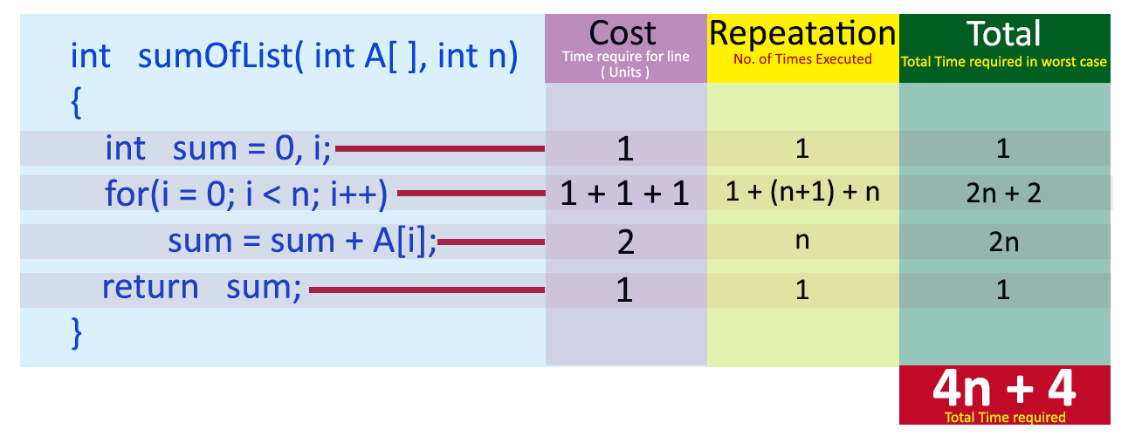

In above calculation **Cost** is the amount of computer time required for a single operation in each line. **Repeatation** is the amount of computer time required by each operation for all its repeatations.   
**Total** is the amount of computer time required by each operation to execute.   
  
So above code requires **'4n+4' Units** of computer time to complete the task. Here the exact time is not fixed. And it changes based on the **n**value. If we increase the **n** value then the time required also increases linearly.   
  
**Totally it takes '4n+4' units of time to complete its execution and it is *Linear Time Complexity***.

**If the amount of time required by an algorithm is increased with the increase of input value then that time complexity is said to be Linear Time Complexity**

# In-order, Pre-order and Post-order Tree Traversal using C Programming

**In-order traversal method:**  
1. Visit Left Sub-Tree  
2. Process Current Node  
3. Visit Right Sub-Tree  
  
**Pre-order traversal method:**  
1. Process Current Node  
2. Visit Left Sub-Tree  
3. Visit Right Sub-Tree  
  
**Post-order traversal method:**  
1. Visit Left Sub-Tree  
2. Visit Right Sub-Tree  
3. Process Current Node

**C/C++ Implementation with full program:**

#include <stdio.h>

#include <stdlib.h>

struct node

{

int value;

node* left;

node* right;

};

struct node* root;

struct node* insert(struct node* r, int data);

void inOrder(struct node* r);

void preOrder(struct node* r);

void postOrder(struct node* r);

int main()

{

root = NULL;

int n, v;

printf("How many data's do you want to insert ?\n");

scanf("%d", &n);

for(int i=0; i<n; i++)

{

printf("Data %d: ", i+1);

scanf("%d", &v);

root = insert(root, v);

}

printf("Inorder Traversal: ");

inOrder(root);

printf("\n");

printf("Preorder Traversal: ");

preOrder(root);

printf("\n");

printf("Postorder Traversal: ");

postOrder(root);

printf("\n");

return 0;

}

struct node* insert(struct node* r, int data)

{

if(r==NULL)

{

r = (struct node*) malloc(sizeof(struct node));

r->value = data;

r->left = NULL;

r->right = NULL;

}

else if(data < r->value){

r->left = insert(r->left, data);

}

else {

r->right = insert(r->right, data);

}

return r;

}

void inOrder(struct node* r)

{

if(r!=NULL){

inOrder(r->left);

printf("%d ", r->value);

inOrder(r->right);

}

}

void preOrder(struct node* r)

{

if(r!=NULL){

printf("%d ", r->value);

preOrder(r->left);

preOrder(r->right);

}

}

void postOrder(struct node* r)

{

if(r!=NULL){

postOrder(r->left);

postOrder(r->right);

printf("%d ", r->value);

}

}

**Tree Terminology**

In linear data structure, data is organized in sequential order and in non-linear data structure, data is organized in random order. Tree is a very popular data structure used in wide range of applications. A tree data structure can be defined as follows...

**Tree is a non-linear data structure which organizes data in hierarchical structure and this is a recursive definition.**

A tree data structure can also be defined as follows...

**Tree data structure is a collection of data (Node) which is organized in hierarchical structure and this is a recursive definition**

In tree data structure, every individual element is called as **Node**. Node in a tree data structure, stores the actual data of that particular element and link to next element in hierarchical structure.  
  
In a tree data structure, if we have **N** number of nodes then we can have a maximum of **N-1** number of links.

**Example**



**Terminology**

In a tree data structure, we use the following terminology...

**1. Root**

In a tree data structure, the first node is called as **Root Node**. Every tree must have root node. We can say that root node is the origin of tree data structure. In any tree, there must be only one root node. We never have multiple root nodes in a tree.



**2. Edge**

In a tree data structure, the connecting link between any two nodes is called as **EDGE**. In a tree with '**N**' number of nodes there will be a maximum of '**N-1**' number of edges.



**3. Parent**

In a tree data structure, the node which is predecessor of any node is called as **PARENT NODE**. In simple words, the node which has branch from it to any other node is called as parent node. Parent node can also be defined as "**The node which has child / children**".



**4. Child**

In a tree data structure, the node which is descendant of any node is called as **CHILD Node**. In simple words, the node which has a link from its parent node is called as child node. In a tree, any parent node can have any number of child nodes. In a tree, all the nodes except root are child nodes.



**5. Siblings**

In a tree data structure, nodes which belong to same Parent are called as **SIBLINGS**. In simple words, the nodes with same parent are called as Sibling nodes.



**6. Leaf**

In a tree data structure, the node which does not have a child is called as **LEAF Node**. In simple words, a leaf is a node with no child.   
  
In a tree data structure, the leaf nodes are also called as **External Nodes**. External node is also a node with no child. In a tree, leaf node is also called as '**Terminal**' node.



**7. Internal Nodes**

In a tree data structure, the node which has atleast one child is called as **INTERNAL Node**. In simple words, an internal node is a node with atleast one child.   
  
In a tree data structure, nodes other than leaf nodes are called as **Internal Nodes**.**The root node is also said to be Internal Node** if the tree has more than one node. Internal nodes are also called as '**Non-Terminal**' nodes.



**8. Degree**

In a tree data structure, the total number of children of a node is called as **DEGREE** of that Node. In simple words, the Degree of a node is total number of children it has. The highest degree of a node among all the nodes in a tree is called as '**Degree of Tree**'



**9. Level**

In a tree data structure, the root node is said to be at Level 0 and the children of root node are at Level 1 and the children of the nodes which are at Level 1 will be at Level 2 and so on... In simple words, in a tree each step from top to bottom is called as a Level and the Level count starts with '0' and incremented by one at each level (Step).



**10. Height**

In a tree data structure, the total number of egdes from leaf node to a particular node in the longest path is called as **HEIGHT** of that Node. In a tree, height of the root node is said to be **height of the tree**. In a tree, **height of all leaf nodes is '0'.**



**11. Depth**

In a tree data structure, the total number of egdes from root node to a particular node is called as **DEPTH** of that Node. In a tree, the total number of edges from root node to a leaf node in the longest path is said to be **Depth of the tree**. In simple words, the highest depth of any leaf node in a tree is said to be depth of that tree. In a tree, **depth of the root node is '0'.**



**12. Path**

In a tree data structure, the sequence of Nodes and Edges from one node to another node is called as **PATH** between that two Nodes. **Length of a Path** is total number of nodes in that path. In below example **the path A - B - E - J has length 4**.



**13. Sub Tree**

In a tree data structure, each child from a node forms a subtree recursively. Every child node will form a subtree on its parent node.



**Tree Representations**

A tree data structure can be represented in two methods. Those methods are as follows...

1. **List Representation**
2. **Left Child - Right Sibling Representation**

Consider the following tree...



**1. List Representation**

In this representation, we use two types of nodes one for representing the node with data and another for representing only references. We start with a node with data from root node in the tree. Then it is linked to an internal node through a reference node and is linked to any other node directly. This process repeats for all the nodes in the tree.

The above tree example can be represented using List representation as follows...



**2. Left Child - Right Sibling Representation**

In this representation, we use list with one type of node which consists of three fields namely Data field, Left child reference field and Right sibling reference field. Data field stores the actual value of a node, left reference field stores the address of the left child and right reference field stores the address of the right sibling node. Graphical representation of that node is as follows...



In this representation, every node's data field stores the actual value of that node. If that node has left child, then left reference field stores the address of that left child node otherwise that field stores NULL. If that node has right sibling then right reference field stores the address of right sibling node otherwise that field stores NULL.   
  
The above tree example can be represented using Left Child - Right Sibling representation as follows...



**Binary Tree**

In a normal tree, every node can have any number of children. Binary tree is a special type of tree data structure in which every node can have a **maximum of 2 children**. One is known as left child and the other is known as right child.

**A tree in which every node can have a maximum of two children is called as Binary Tree.**

In a binary tree, every node can have either 0 children or 1 child or 2 children but not more than 2 children.

**Example**



There are different types of binary trees and they are...

**1. Strictly Binary Tree**

In a binary tree, every node can have a maximum of two children. But in strictly binary tree, every node should have exactly two children or none. That means every internal node must have exactly two children. A strictly Binary Tree can be defined as follows...

**A binary tree in which every node has either two or zero number of children is called Strictly Binary Tree**

Strictly binary tree is also called as **Full Binary Tree** or **Proper Binary Tree** or **2-Tree**



Strictly binary tree data structure is used to represent mathematical expressions.

**Example**



**2. Complete Binary Tree**

In a binary tree, every node can have a maximum of two children. But in strictly binary tree, every node should have exactly two children or none and in complete binary tree all the nodes must have exactly two children and at every level of complete binary tree there must be 2level number of nodes. For example at level 2 there must be 22 = 4 nodes and at level 3 there must be 23 = 8 nodes.

**A binary tree in which every internal node has exactly two children and all leaf nodes are at same level is called Complete Binary Tree.**

Complete binary tree is also called as **Perfect Binary Tree**



**3. Extended Binary Tree**

A binary tree can be converted into Full Binary tree by adding dummy nodes to existing nodes wherever required.

**The full binary tree obtained by adding dummy nodes to a binary tree is called as Extended Binary Tree.**



In above figure, a normal binary tree is converted into full binary tree by adding dummy nodes (In pink colour).

**Binary Tree Representations**

A binary tree data structure is represented using two methods. Those methods are as follows...

1. **Array Representation**
2. **Linked List Representation**

Consider the following binary tree...



**1. Array Representation**

In array representation of binary tree, we use a one dimensional array (1-D Array) to represent a binary tree.  
Consider the above example of binary tree and it is represented as follows...

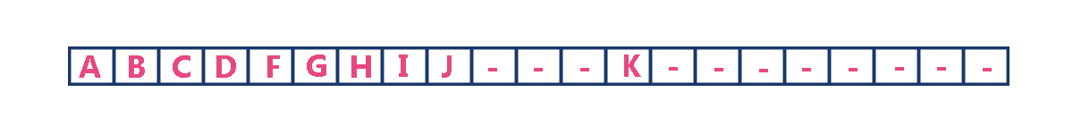

To represent a binary tree of depth **'n'** using array representation, we need one dimensional array with a maximum size of **2n+1 - 1**.

**2. Linked List Representation**

We use double linked list to represent a binary tree. In a double linked list, every node consists of three fields. First field for storing left child address, second for storing actual data and third for storing right child address.  
In this linked list representation, a node has the following structure...



The above example of binary tree represented using Linked list representation is shown as follows...

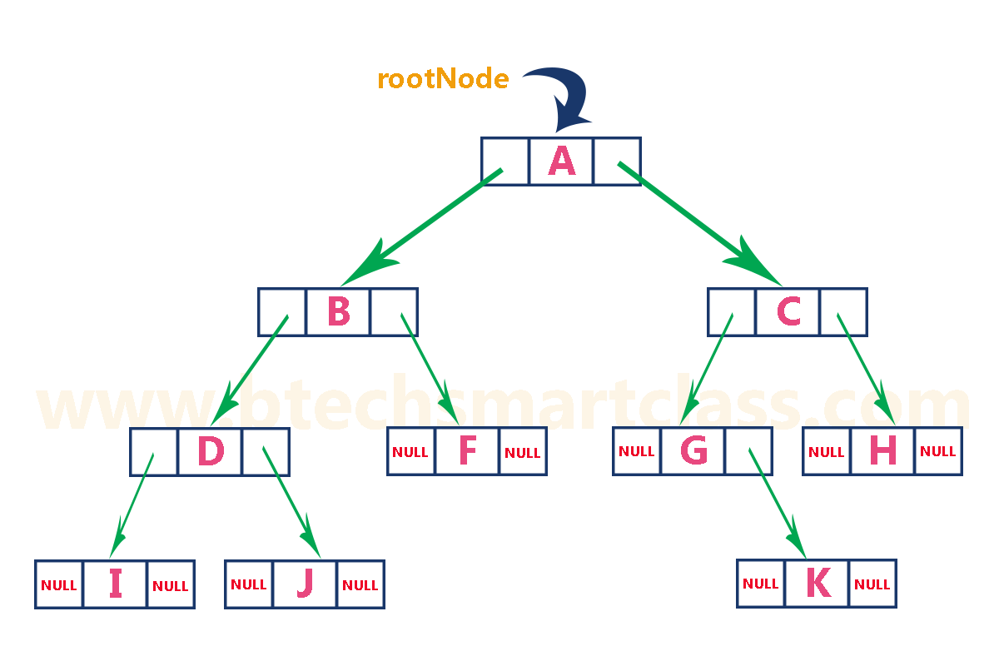

# Binary Tree Traversals

# When we wanted to display a binary tree, we need to follow some order in which all the nodes of that binary tree must be displayed. In any binary tree displaying order of nodes depends on the traversal method.

**Displaying (or) visiting order of nodes in a binary tree is called as Binary Tree Traversal.**

There are three types of binary tree traversals.

1. **In - Order Traversal**
2. **Pre - Order Traversal**
3. **Post - Order Traversal**

Consider the following binary tree...



# 1. In - Order Traversal ( leftChild - root - rightChild )

In In-Order traversal, the root node is visited between left child and right child. In this traversal, the left child node is visited first, then the root node is visited and later we go for visiting right child node. This in-order traversal is applicable for every root node of all subtrees in the tree. This is performed recursively for all nodes in the tree.  
  
In the above example of binary tree, first we try to visit left child of root node 'A', but A's left child is a root node for left subtree. so we try to visit its (B's) left child 'D' and again D is a root for subtree with nodes D, I and J. So we try to visit its left child 'I' and it is the left most child. So first we visit **'I'** then go for its root node **'D'** and later we visit D's right child **'J'**. With this we have completed the left part of node B. Then visit **'B'** and next B's right child **'F'** is visited. With this we have completed left part of node A. Then visit root node **'A'**. With this we have completed left and root parts of node A. Then we go for right part of the node A. In right of A again there is a subtree with root C. So go for left child of C and again it is a subtree with root G. But G does not have left part so we visit **'G'** and then visit G's right child K. With this we have completed the left part of node C. Then visit root node **'C'** and next visit C's right child **'H'** which is the right most child in the tree so we stop the process.  
  
That means here we have visited in the order of **I - D - J - B - F - A - G - K - C - H** using In-Order Traversal.

**In-Order Traversal for above example of binary tree is**

#### I - D - J - B - F - A - G - K - C - H

# 2. Pre - Order Traversal ( root - leftChild - rightChild )

In Pre-Order traversal, the root node is visited before left child and right child nodes. In this traversal, the root node is visited first, then its left child and later its right child. This pre-order traversal is applicable for every root node of all subtrees in the tree.   
  
In the above example of binary tree, first we visit root node **'A'** then visit its left child **'B'** which is a root for D and F. So we visit B's left child **'D'** and again D is a root for I and J. So we visit D's left child **'I'** which is the left most child. So next we go for visiting D's right child **'J'**. With this we have completed root, left and right parts of node D and root, left parts of node B. Next visit B's right child **'F'**. With this we have completed root and left parts of node A. So we go for A's right child **'C'** which is a root node for G and H. After visiting C, we go for its left child **'G'** which is a root for node K. So next we visit left of G, but it does not have left child so we go for G's right child **'K'**. With this we have completed node C's root and left parts. Next visit C's right child **'H'** which is the right most child in the tree. So we stop the process.  
  
That means here we have visited in the order of **A-B-D-I-J-F-C-G-K-H** using Pre-Order Traversal.

**Pre-Order Traversal for above example binary tree is**

#### A - B - D - I - J - F - C - G - K - H

# 2. Post - Order Traversal ( leftChild - rightChild - root )

In Post-Order traversal, the root node is visited after left child and right child. In this traversal, left child node is visited first, then its right child and then its root node. This is recursively performed until the right most node is visited.  
  
Here we have visited in the order of **I - J - D - F - B - K - G - H - C - A** using Post-Order Traversal.

**Post-Order Traversal for above example binary tree is**

#### I - J - D - F - B - K - G - H - C - A

**Create Binary Search Tree and perform Inorder Traversal**

#include <stdio.h>

#include <stdlib.h>

struct node

{

int value;

node* left;

node* right;

};

struct node* root;

struct node* insert(struct node* r, int data);

void inOrder(struct node* r);

void preOrder(struct node* r);

void postOrder(struct node* r);

int main()

{

root = NULL;

int n, v;

printf("How many data's do you want to insert ?\n");

scanf("%d", &n);

for(int i=0; i<n; i++){

printf("Data %d: ", i+1);

scanf("%d", &v);

root = insert(root, v);

}

printf("Inorder Traversal: ");

inOrder(root);

printf("\n");

printf("Preorder Traversal: ");

preOrder(root);

printf("\n");

printf("Postorder Traversal: ");

postOrder(root);

printf("\n");

return 0;

}

struct node* insert(struct node* r, int data)

{

if(r==NULL)

{

r = (struct node*) malloc(sizeof(struct node));

r->value = data;

r->left = NULL;

r->right = NULL;

}

else if(data < r->value){

r->left = insert(r->left, data);

}

else {

r->right = insert(r->right, data);

}

return r;

}

void inOrder(struct node* r)

{

if(r!=NULL){

inOrder(r->left);

printf("%d ", r->value);

inOrder(r->right);

}

}

void preOrder(struct node* r)

{

if(r!=NULL){

printf("%d ", r->value);

preOrder(r->left);

preOrder(r->right);

}

}

void postOrder(struct node* r)

{

if(r!=NULL){

postOrder(r->left);

postOrder(r->right);

printf("%d ", r->value);

}

}

# Threaded Binary Tree

A binary tree is represented using array representation or linked list representation. When a binary tree is represented using linked list representation, if any node is not having a child we use NULL pointer in that position. In any binary tree linked list representation, there are more number of NULL pointer than actual pointers. Generally, in any binary tree linked list representation, if there are **2N** number of reference fields, then **N+1** number of reference fields are filled with NULL ( **N+1 are NULL out of 2N** ). This NULL pointer does not play any role except indicating there is no link (no child).  
  
A. J. Perlis and C. Thornton have proposed new binary tree called "***Threaded Binary Tree***", which make use of NULL pointer to improve its traversal processes. In threaded binary tree, NULL pointers are replaced by references to other nodes in the tree, called ***threads***.

**Threaded Binary Tree is also a binary tree in which all left child pointers that are NULL (in Linked list representation) points to its in-order predecessor, and all right child pointers that are NULL (in Linked list representation) points to its in-order successor.**

If there is no in-order predecessor or in-order successor, then it point to root node.

Consider the following binary tree...

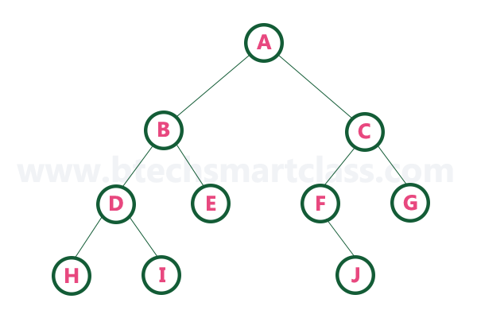

To convert above binary tree into threaded binary tree, first find the in-order traversal of that tree...

**In-order traversal of above binary tree...**

#### H - D - I - B - E - A - F - J - C - G

When we represent above binary tree using linked list representation, nodes **H, I, E, F, J** and **G** left child pointers are NULL. This NULL is replaced by address of its in-order predecessor, respectively (I to D, E to B, F to A, J to F and G to C), but here the node H does not have its in-order predecessor, so it points to the root node A. And nodes **H, I, E, J** and **G** right child pointers are NULL. This NULL ponters are replaced by address of its in-order successor, respectively (H to D, I to B, E to A, and J to C), but here the node G does not have its in-order successor, so it points to the root node A.   
  
Above example binary tree become as follows after converting into threaded binary tree.

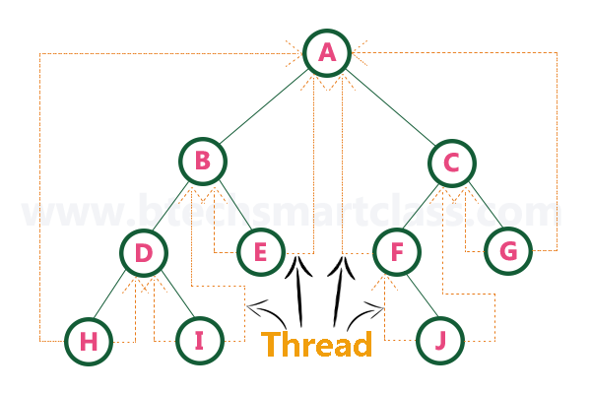

In above figure threadeds are indicated with dotted links.

**Heap Data Structure**

Heap data structure is a specialized binary tree based data structure. Heap is a binary tree with special characteristics. In a heap data structure, nodes are arranged based on thier value. A heap data structure, some time called as Binary Heap.  
  
There are two types of heap data structures and they are as follows...

1. **Max Heap**
2. **Min Heap**

Every heap data structure has the following properties...

**Property #1 (Ordering):**Nodes must be arranged in a order according to values based on Max heap or Min heap.

**Property #2 (Structural):**All levels in a heap must full, except last level and nodes must be filled from left to right strictly.

**Max Heap**

Max heap data structure is a specialized full binary tree data structure except last leaf node can be alone. In a max heap nodes are arranged based on node value.  
  
Max heap is defined as follows...

**Max heap is a specialized full binary tree in which every parent node contains greater or equal value than its child nodes. And last leaf node can be alone.**

**Example**

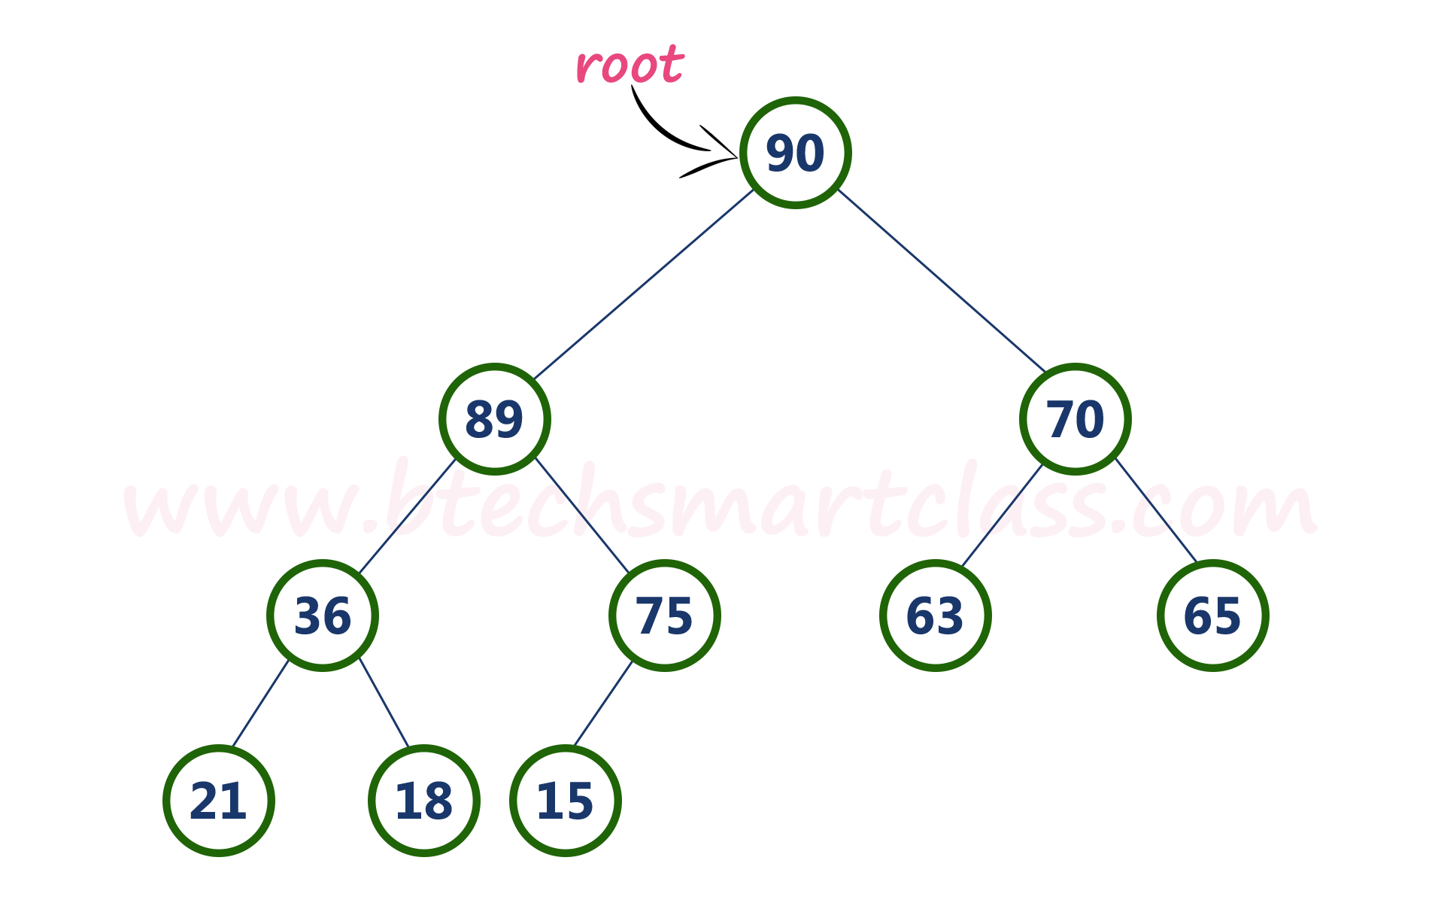

Above tree is satisfying both Ordering property and Structural property according to the Max Heap data structure.

**Operations on Max Heap**

The following operations are performed on a Max heap data structure...

1. **Finding Maximum**
2. **Insertion**
3. **Deletion**

**Finding Maximum Value Operation in Max Heap**

Finding the node which has maximum value in a max heap is very simple. In max heap, the root node has the maximum value than all other nodes in the max heap. So, directly we can display root node value as maximum value in max heap.

**Insertion Operation in Max Heap**

Insertion Operation in max heap is performed as follows...

* **Step 1:** Insert the **newNode** as **last leaf** from left to right.
* **Step 2:** Compare **newNode value** with its **Parent node**.
* **Step 3:** If **newNode value is greater** than its parent, then **swap** both of them.
* **Step 4:** Repeat step 2 and step 3 until newNode value is less than its parent nede (or) newNode reached to root.

**Example**  
Consider the above max heap. **Insert a new node with value 85.**

* **Step 1:** Insert the **newNode** with value 85 as **last leaf** from left to right. That means newNode is added as a right child of node with value 75. After adding max heap is as follows...

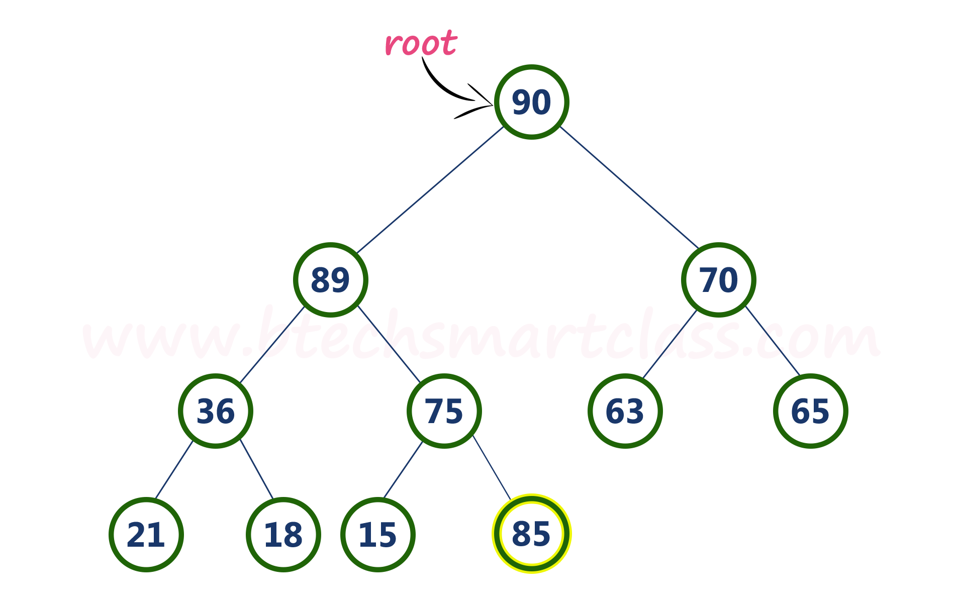

* **Step 2:** Compare **newNode value (85)** with its **Parent node value (75)**. That means **85 > 75**

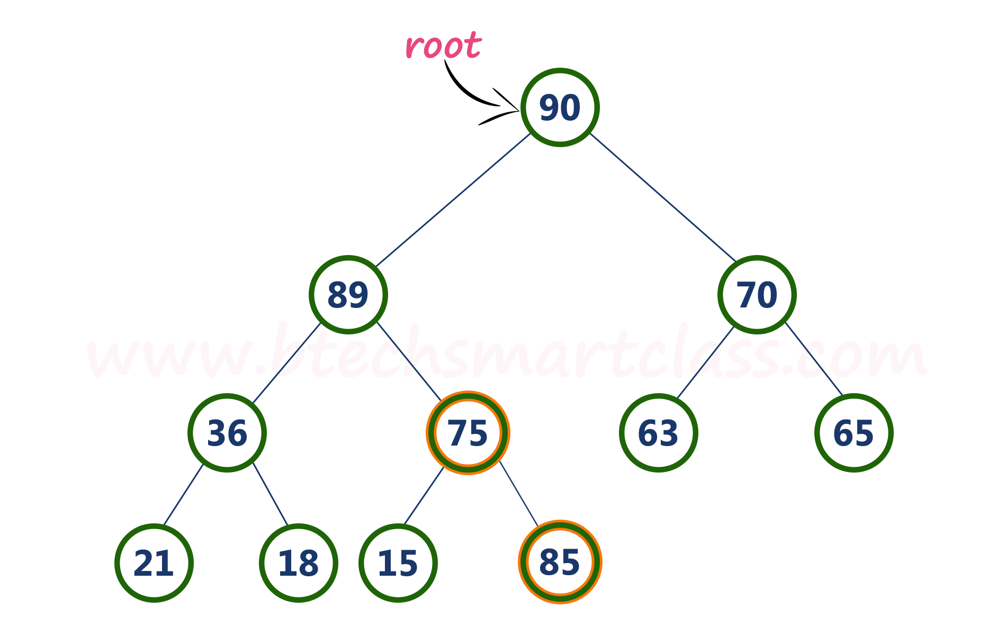

* **Step 3:** Here **newNode value (85) is greater** than its **parent value (75)**, then **swap** both of them. After wsapping, max heap is as follows...

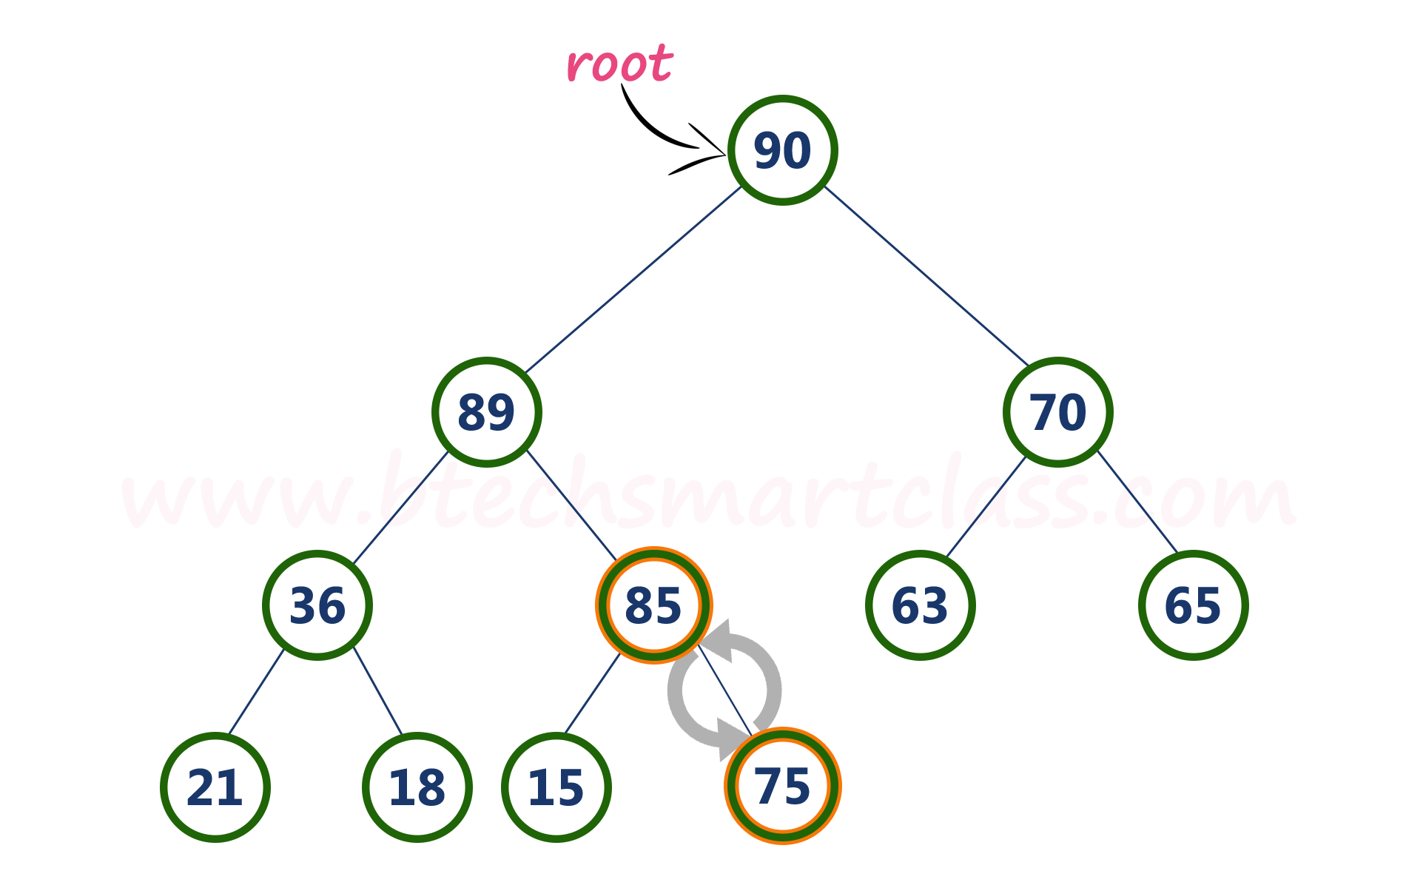

* **Step 4:** Now, again compare newNode value (85) with its parent nede value (89).

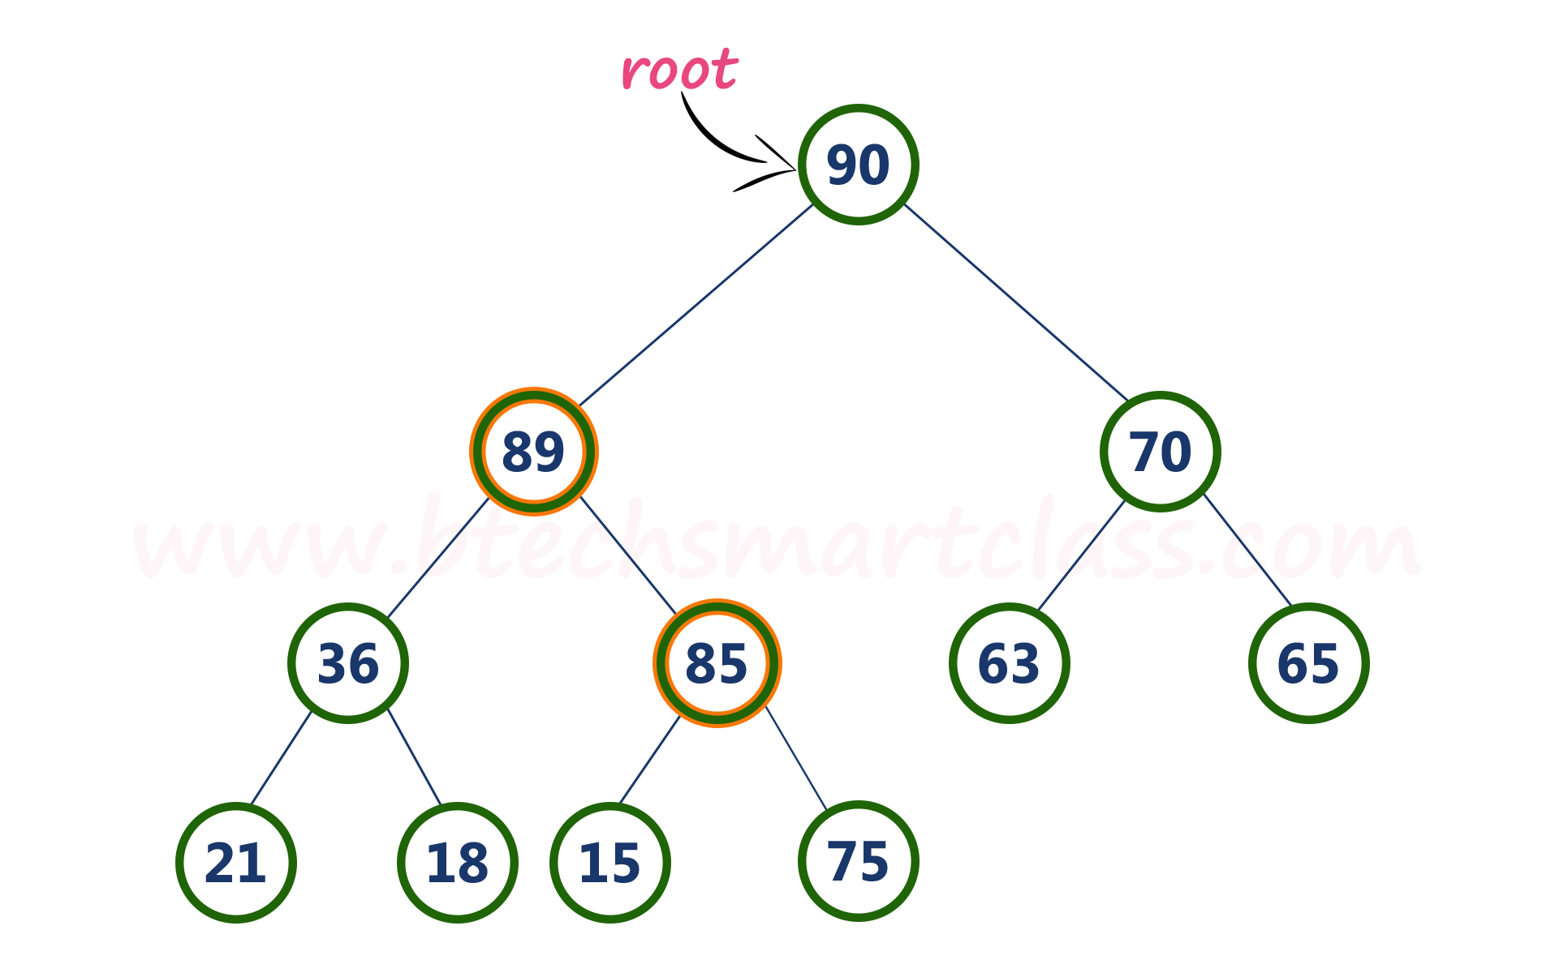

Here, newNode value (85) is smaller than its parent node value (89). So, we stop insertion process. Finally, max heap after insetion of a new node with value 85 is as follows...

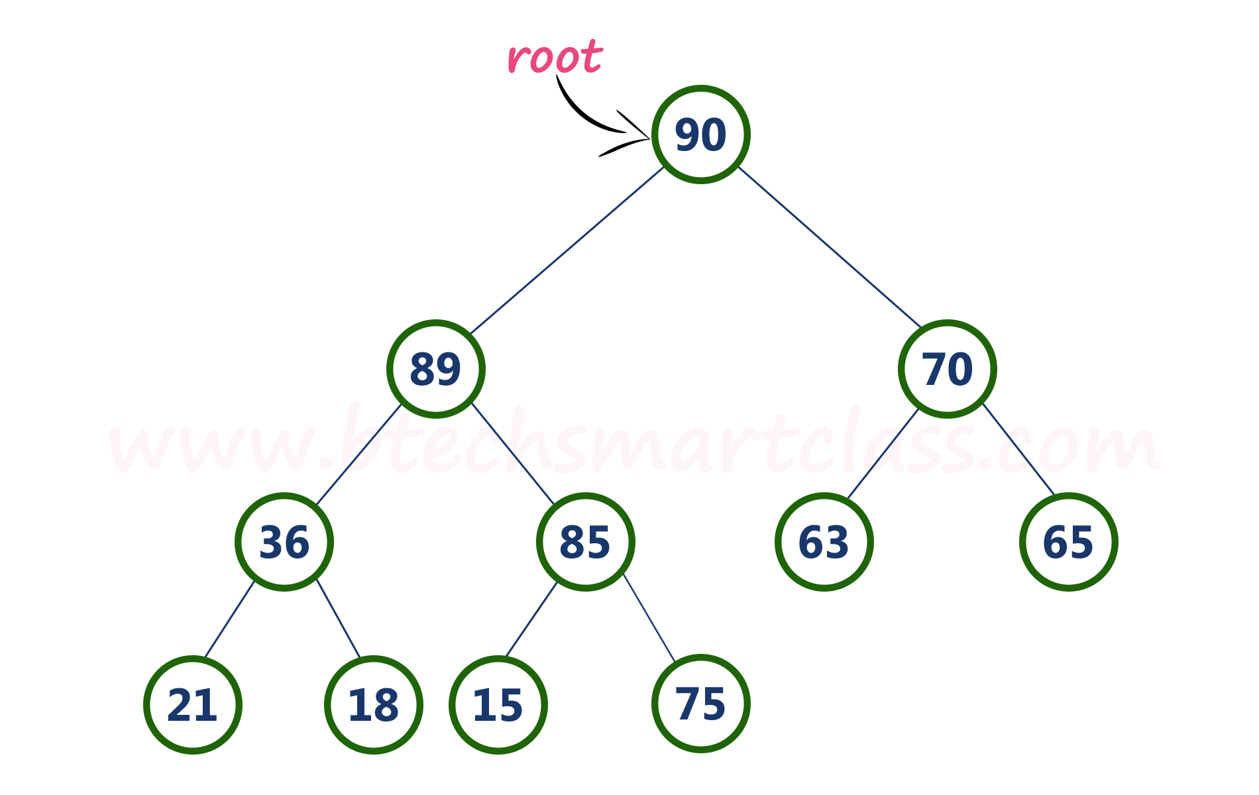

**Deletion Operation in Max Heap**

In a max heap, deleting last node is very simple as it is not disturbing max heap properties.  
  
Deleting root node from a max heap is title difficult as it disturbing the max heap properties. We use the following steps to delete root node from a max heap...

* **Step 1:** **Swap** the **root** node with **last** node in max heap
* **Step 2:** **Delete** last node.
* **Step 3:** Now, compare **root value** with its **left child value**.
* **Step 4:** If **root value is smaller** than its left child, then compare **left child** with its **right sibling**. Else goto **Step 6**
* **Step 5:** If **left child value is larger** than its **right sibling**, then **swap root** with **left child**. otherwise **swap root** with its **right child**.
* **Step 6:** If **root value is larger** than its left child, then compare **root value** with its **right child** value.
* **Step 7:** If **root value is smaller** than its **right child**, then **swap root** with **rith child**. otherwise **stop the process**.
* **Step 8:** Repeat the same until root node is fixed at its exact position.
* **Example**  
  Consider the above max heap. **Delete root node (90) from the max heap.**
* **Step 1:** **Swap** the **root node (90)** with **last node 75** in max heap After swapping max heap is as follows...

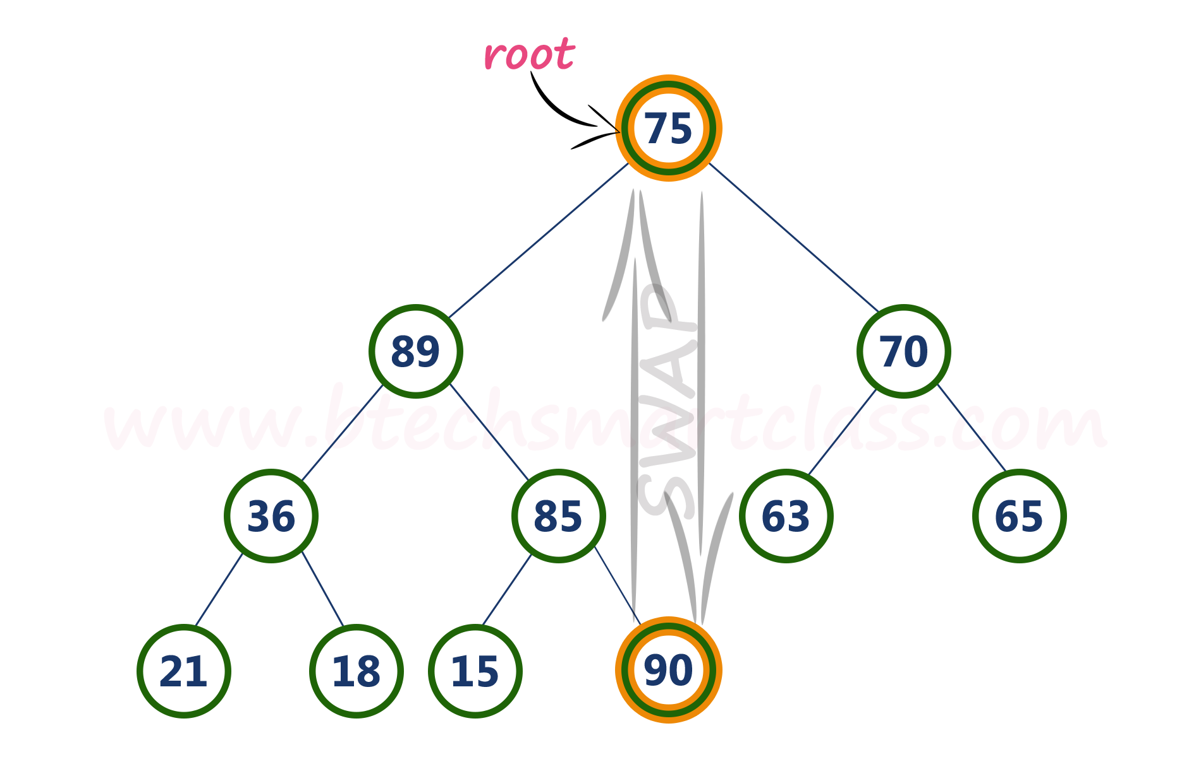

* **Step 2:** **Delete** last node. Here node with value 90. After deleting node with value 90 from heap, max heap is as follows...

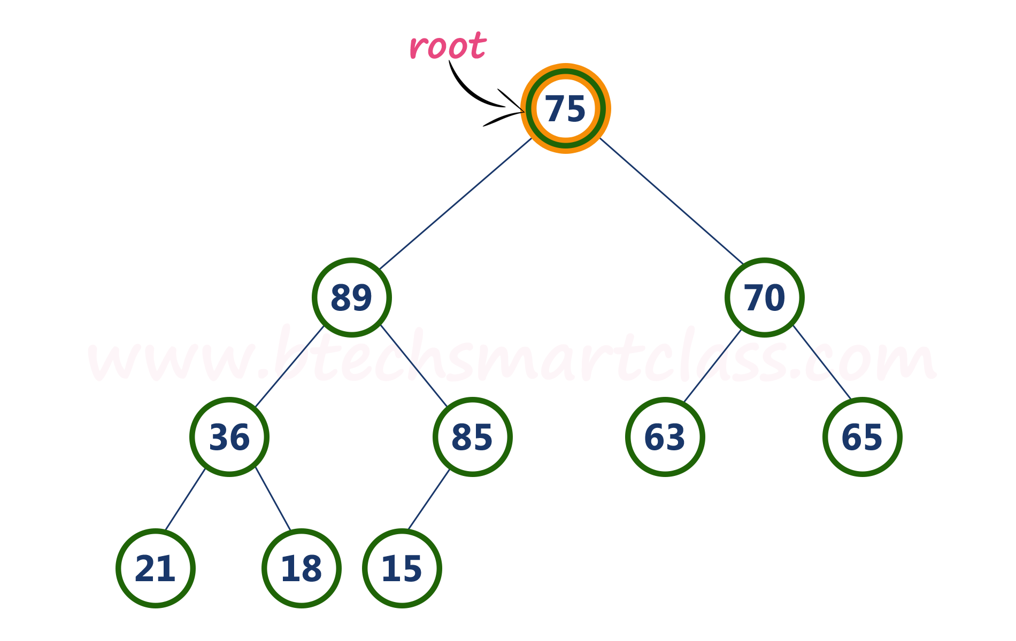

* **Step 3:** Compare **root node (75)** with its **left child (89)**.

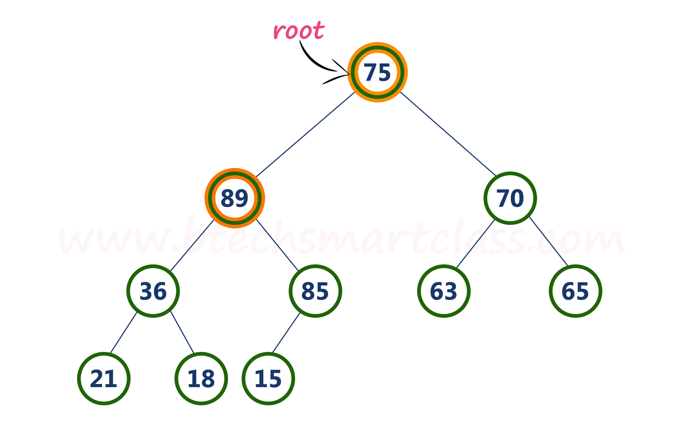

Here, **root value (75) is smaller** than its left child value (89). So, compare left child (89) with its right sibling (70).

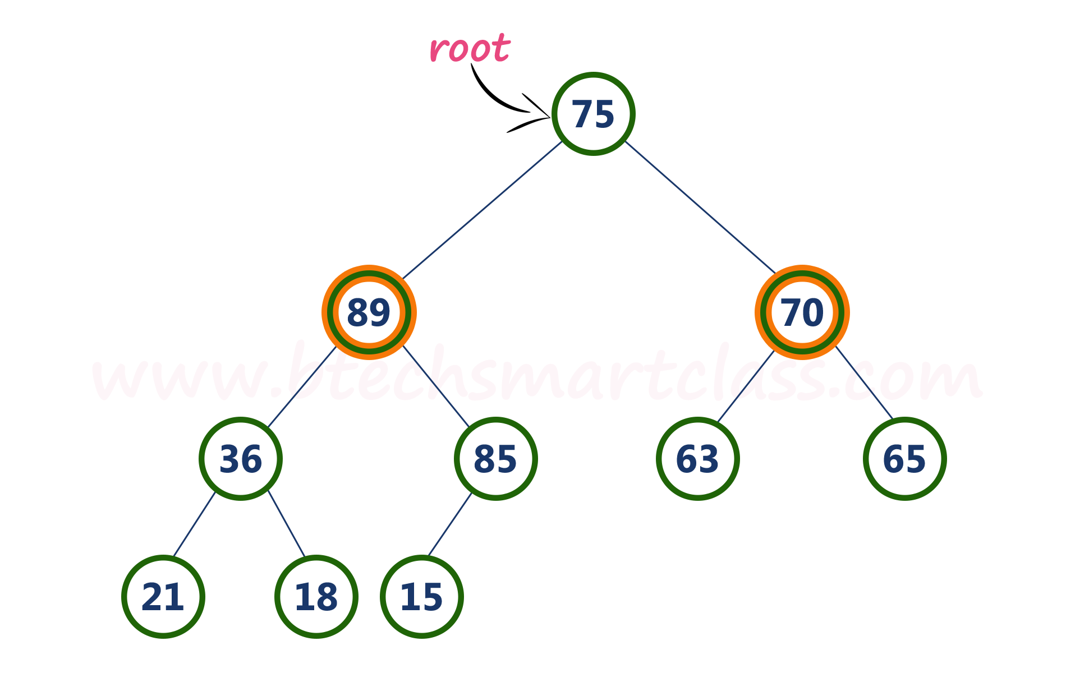

* **Step 4:** Here, **left child value (89) is larger** than its **right sibling (70)**, So, **swap root (75)** with **left child (89)**.

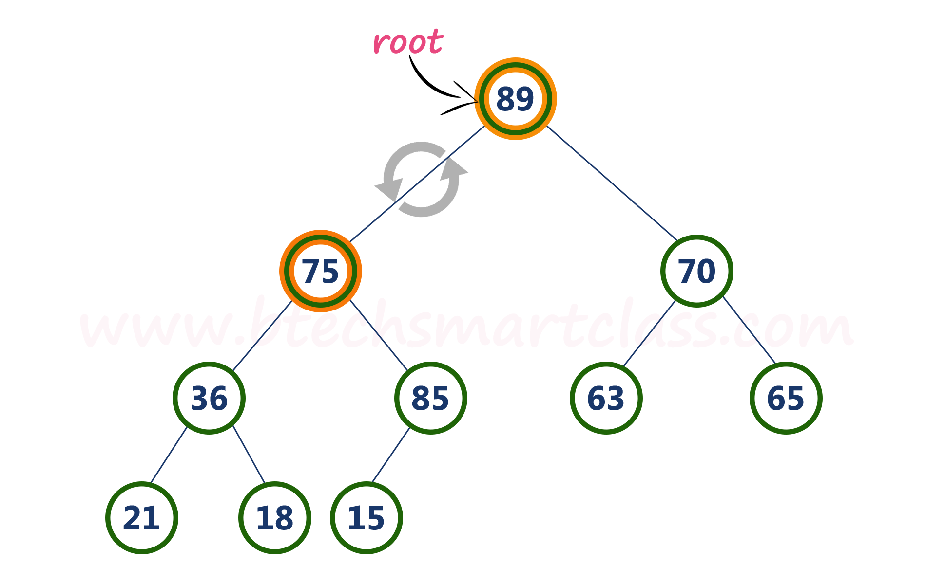

* **Step 5:** Now, again compare **75** with its **left child (36)**.

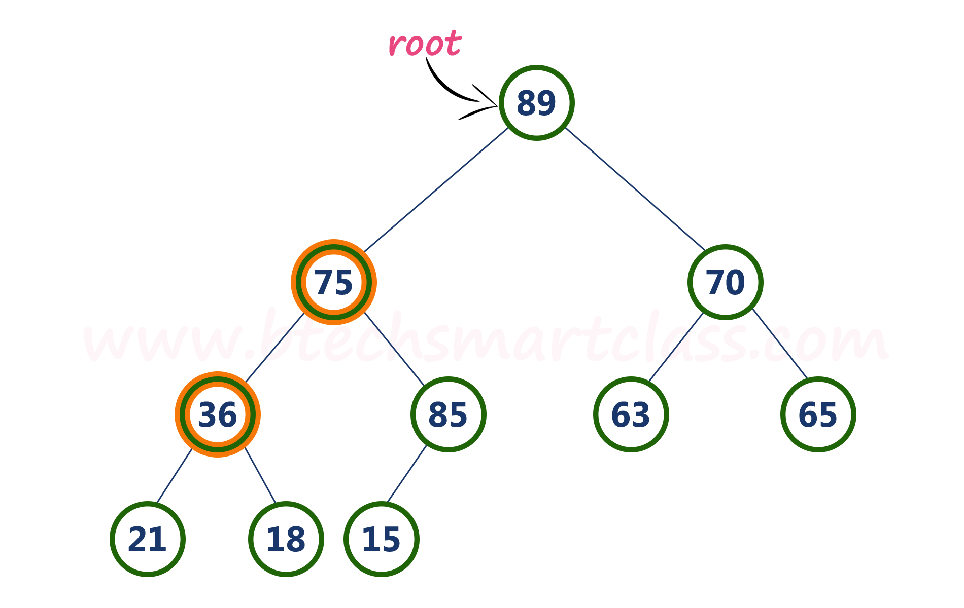

Here, node with value **75** is larger than its left child. So, we compare node with value **75** is compared with its right child **85**.

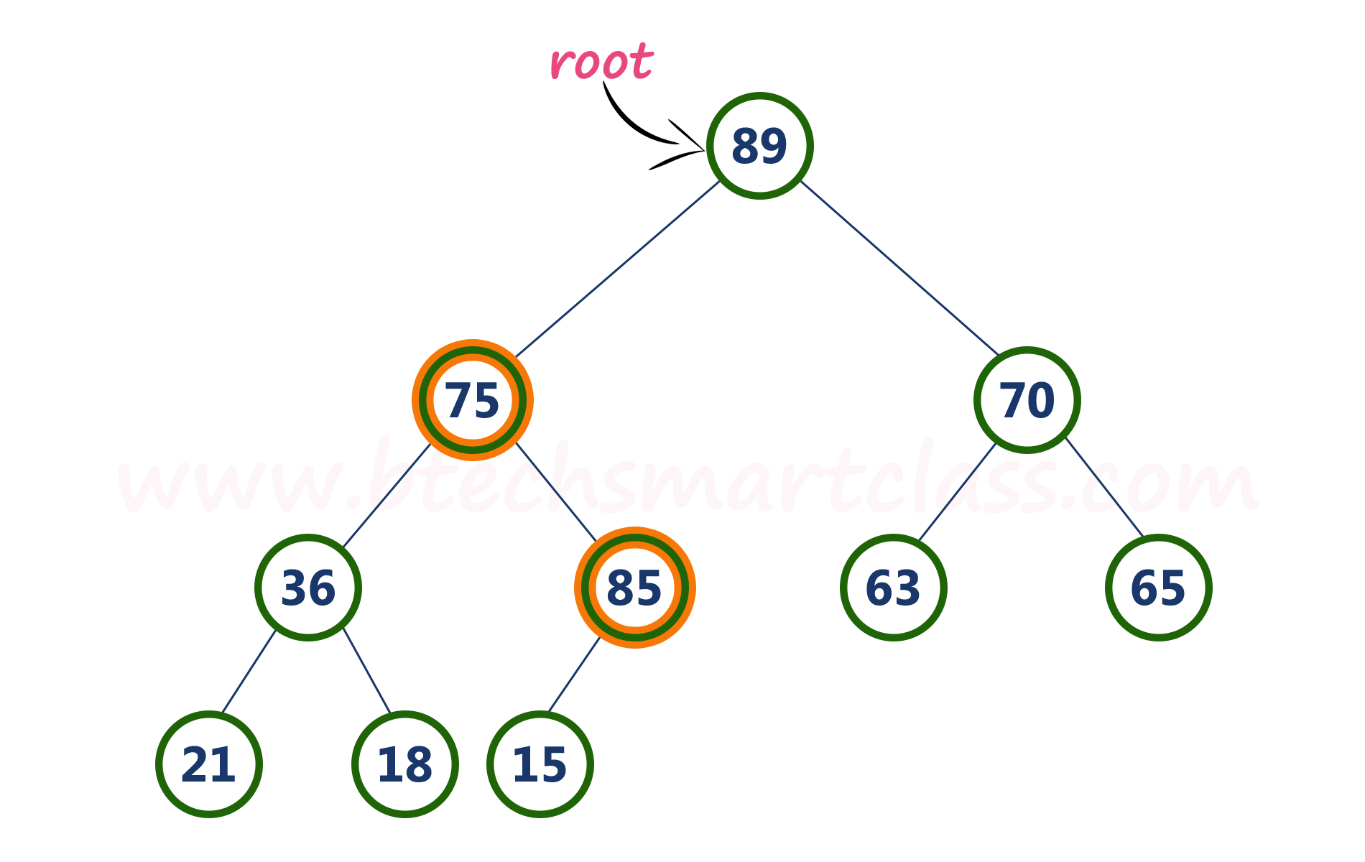

* **Step 6:** Here, node with value **75** is smaller than its **right child (85)**. So, we swap both of them. After swapping max heap is as follows...

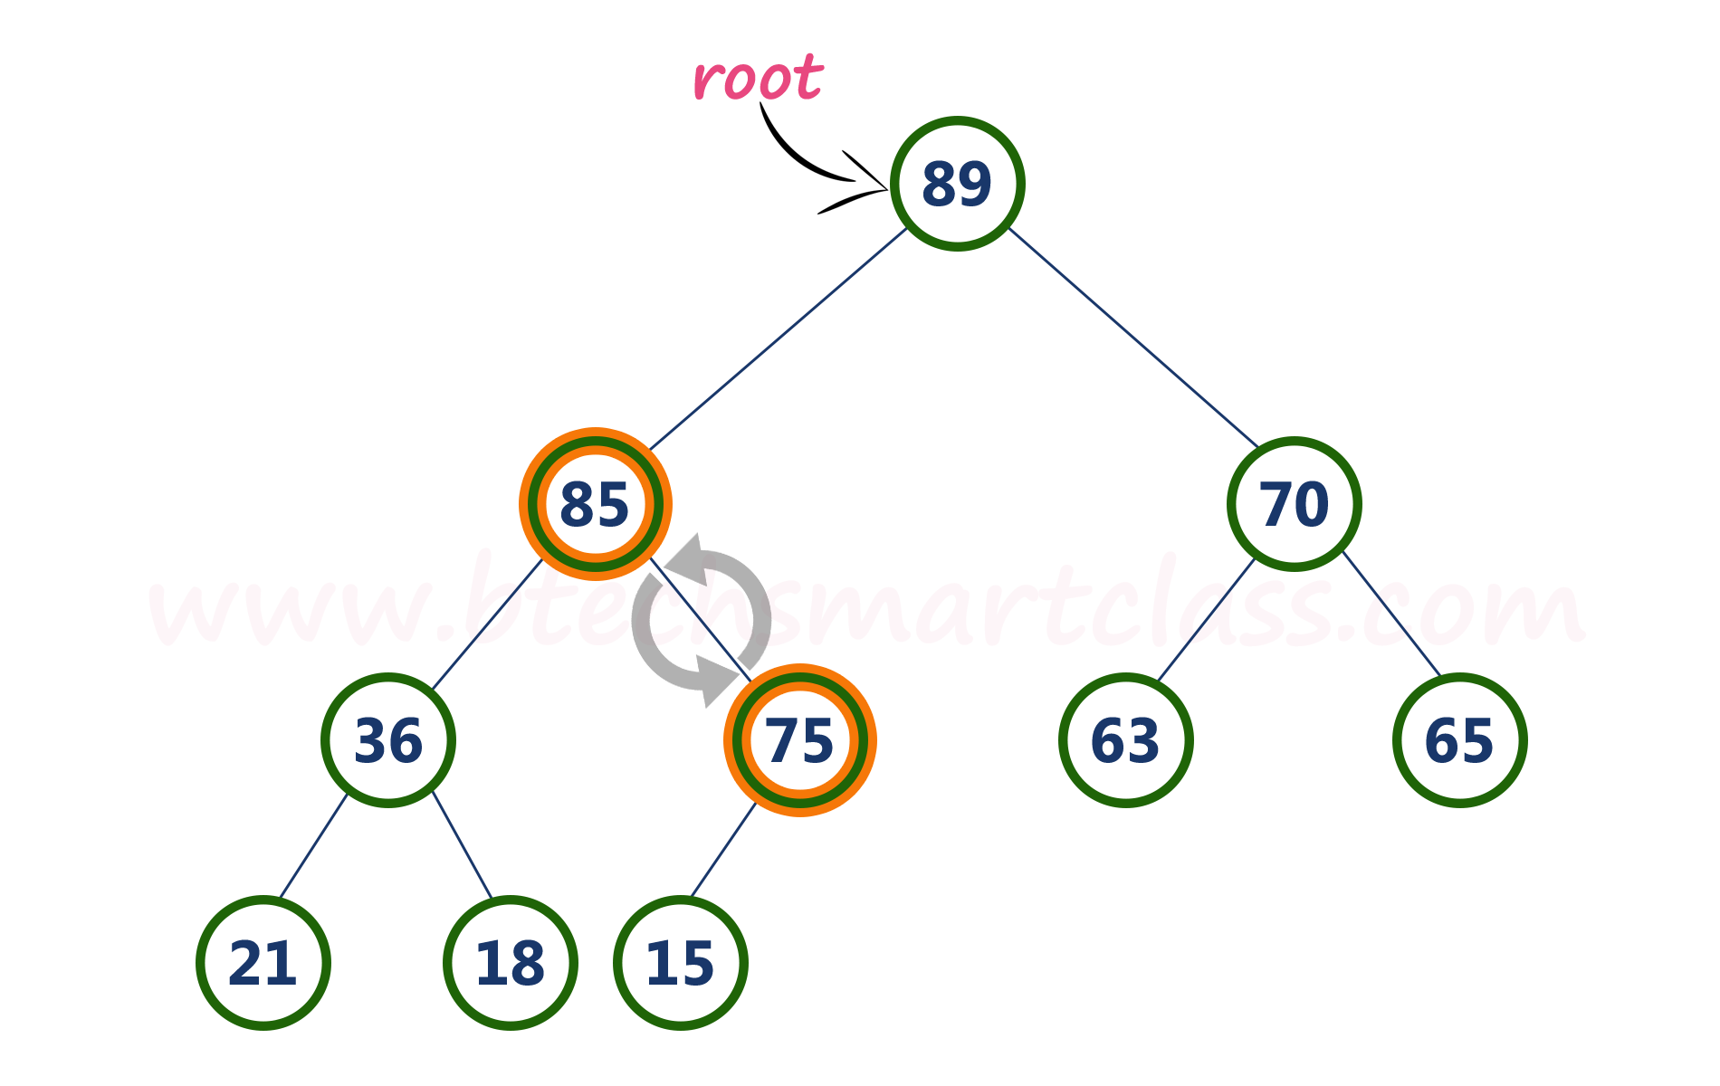

* **Step 7:** Now, compare node with value **75** with its left child (**15**).

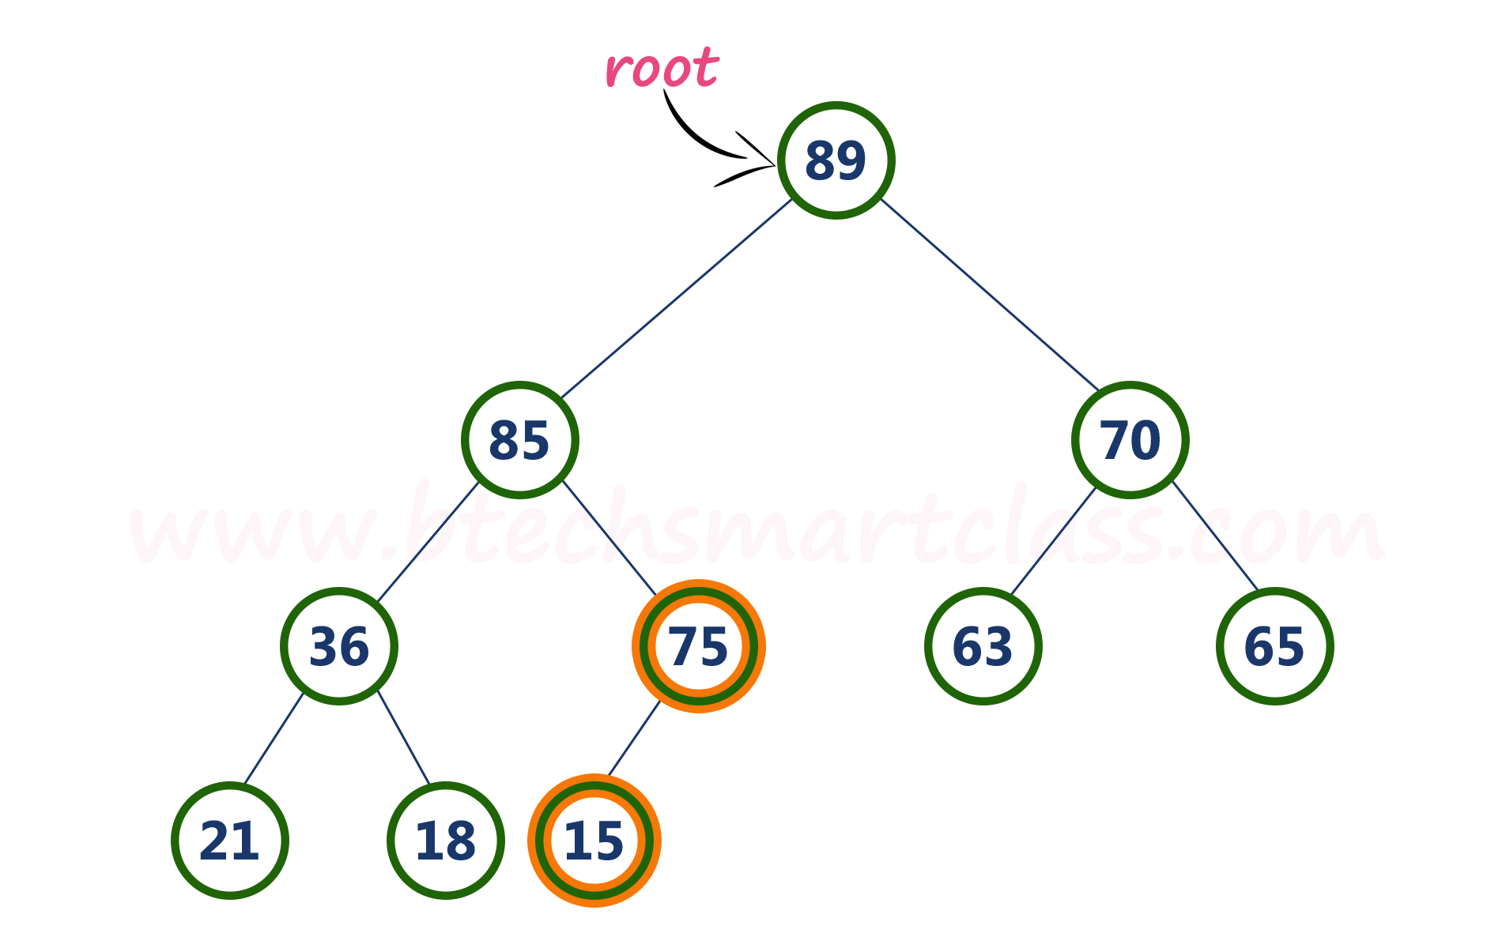

Here, node with value **75** is larger than its left child (**15**) and it does not have right child. So we stop the process.  
  
Finally, max heap after deleting root node (**90**) is as follows...

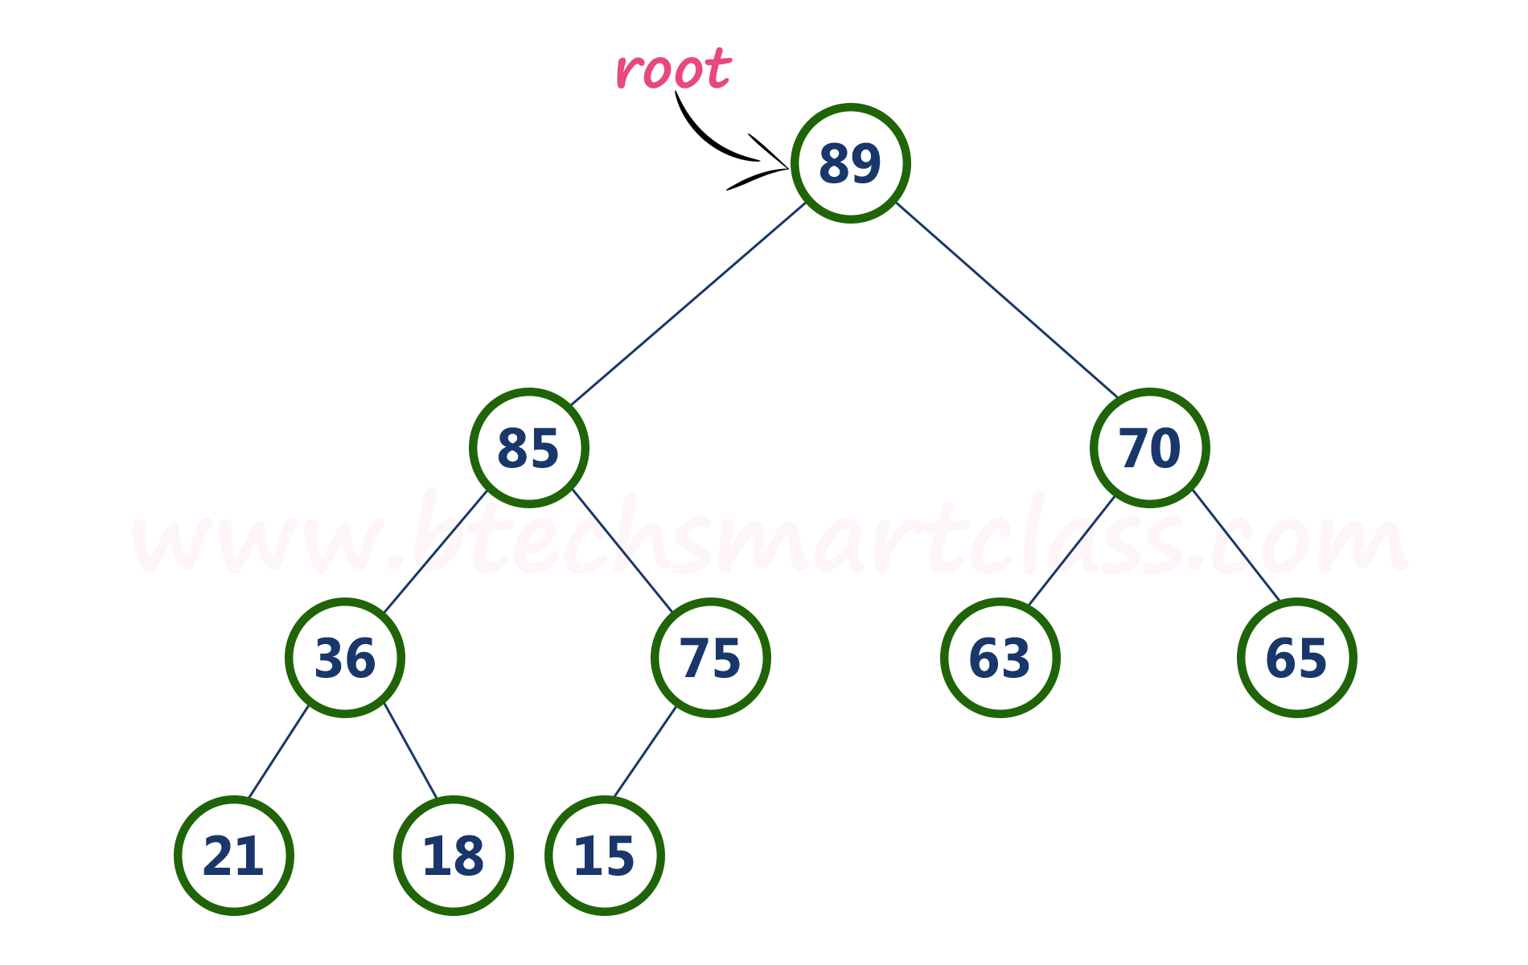

**Introduction to Graphs**

Graph is a non linear data structure, it contains a set of points known as nodes (or vertices) and set of linkes known as edges (or Arcs) which connets the vertices. A graph is defined as follows...

**Graph is a collection of vertices and arcs which connects vertices in the graph**

**Graph is a collection of nodes and edges which connects nodes in the graph**

Generally, a graph **G** is represented as **G = ( V , E )**, where **V is set of vertices** and **E is set of edges**.

**Example**

The following is a graph with 5 vertices and 6 edges.  
This graph G can be defined as G = ( V , E )  
Where V = {A,B,C,D,E} and E = {(A,B),(A,C)(A,D),(B,D),(C,D),(B,E),(E,D)}.



**Graph Terminology**

We use the following terms in graph data structure...

**Vertex**

A individual data element of a graph is called as Vertex. **Vertex** is also known as **node**. In above example graph, A, B, C, D & E are known as vertices.

**Edge**

An edge is a connecting link between two vertices. **Edge** is also known as **Arc**. An edge is represented as (startingVertex, endingVertex). For example, in above graph, the link between vertices A and B is represented as (A,B). In above example graph, there are 7 edges (i.e., (A,B), (A,C), (A,D), (B,D), (B,E), (C,D), (D,E)).  
  
Edges are three types.

1. **Undirected Edge -**An undirected egde is a bidirectional edge. If there is a undirected edge between vertices A and B then edge (A , B) is equal to edge (B , A).
2. **Directed Edge -**A directed egde is a unidirectional edge. If there is a directed edge between vertices A and B then edge (A , B) is not equal to edge (B , A).
3. **Weighted Edge -**A weighted egde is an edge with cost on it.

**Undirected Graph**

A graph with only undirected edges is said to be undirected graph.

**Directed Graph**

A graph with only directed edges is said to be directed graph.

**Mixed Graph**

A graph with undirected and directed edges is said to be mixed graph.

**End vertices or Endpoints**

The two vertices joined by an edge are called the end vertices (or endpoints) of the edge.

**Origin**

If an edge is directed, its first endpoint is said to be origin of it.

**Destination**

If an edge is directed, its first endpoint is said to be origin of it and the other endpoint is said to be the destination of the edge.

**Adjacent**

If there is an edge between vertices A and B then both A and B are said to be adjacent. In other words, Two vertices A and B are said to be adjacent if there is an edge whose end vertices are A and B.

**Incident**

An edge is said to be incident on a vertex if the vertex is one of the endpoints of that edge.

**Outgoing Edge**

A directed edge is said to be outgoing edge on its orign vertex.

**Incoming Edge**

A directed edge is said to be incoming edge on its destination vertex.

**Degree**

Total number of edges connected to a vertex is said to be degree of that vertex.

**Indegree**

Total number of incoming edges connected to a vertex is said to be indegree of that vertex.

**Outdegree**

Total number of outgoing edges connected to a vertex is said to be outdegree of that vertex.

**Parallel edges or Multiple edges**

If there are two undirected edges to have the same end vertices, and for two directed edges to have the same origin and the same destination. Such edges are called parallel edges or multiple edges.

**Self-loop**

An edge (undirected or directed) is a self-loop if its two endpoints coincide.

**Simple Graph**

A graph is said to be simple if there are no parallel and self-loop edges.

**Path**

A path is a sequence of alternating vertices and edges that starts at a vertex and ends at a vertex such that each edge is incident to its predecessor and successor vertex.

**Graph Representations**

Graph data structure is represented using following representations...

1. **Adjacency Matrix**
2. **Incidence Matrix**
3. **Adjacency List**

**Adjacency Matrix**

In this representation, graph can be represented using a matrix of size total number of vertices by total number of vertices. That means if a graph with 4 vertices can be represented using a matrix of 4X4 class. In this matrix, rows and columns both represents vertices. This matrix is filled with either 1 or 0. Here, 1 represents there is an edge from row vertex to column vertex and 0 represents there is no edge from row vertex to column vertex.  
  
For example, consider the following undirected graph representation...

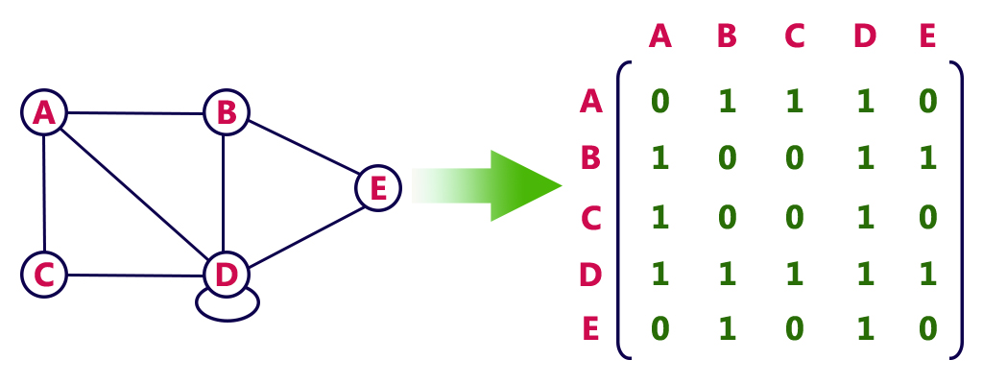

Directed graph representation...

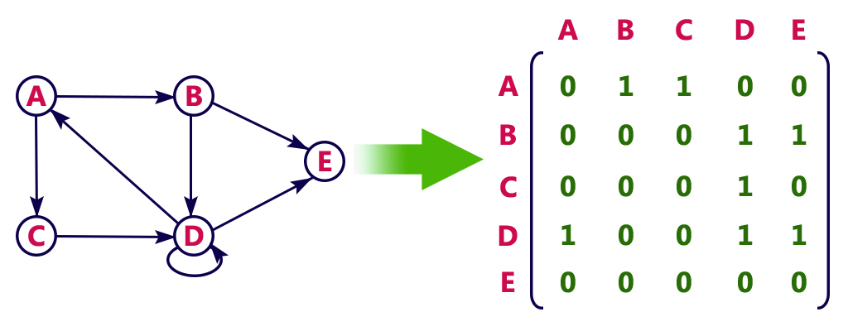

**Incidence Matrix**

In this representation, graph can be represented using a matrix of size total number of vertices by total number of edges. That means if a graph with 4 vertices and 6 edges can be represented using a matrix of 4X6 class. In this matrix, rows represents vertices and columns represents edges. This matrix is filled with either 0 or 1 or -1. Here, 0 represents row edge is not connected to column vertex, 1 represents row edge is connected as outgoing edge to column vertex and -1 represents row edge is connected as incoming edge to column vertex.  
  
For example, consider the following directed graph representation...

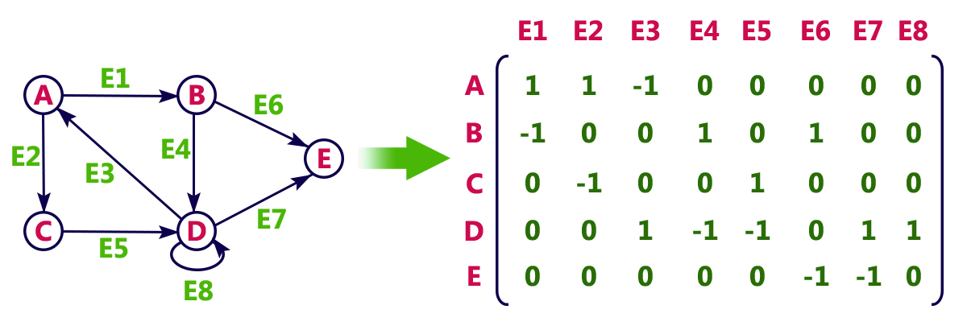

**Adjacency List**

In this representation, every vertex of graph contains list of its adjacent vertices.  
  
For example, consider the following directed graph representation implemented using linked list...

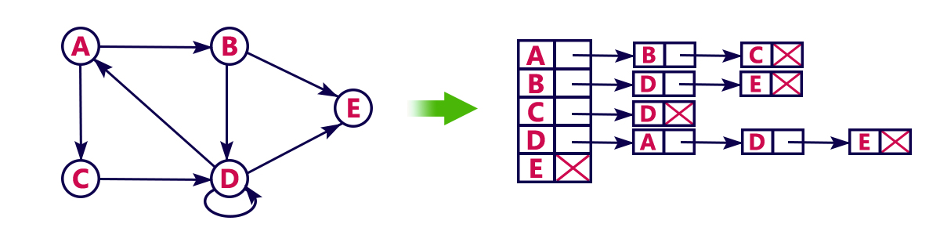

This representation can also be implemented using array as follows..

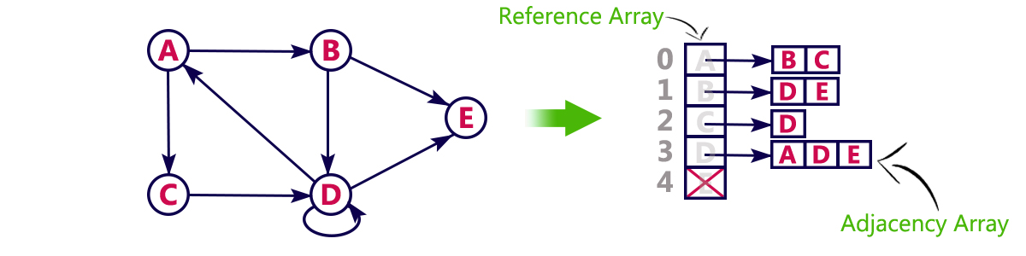

**Graph Traversals - DFS**

Graph traversal is technique used for searching a vertex in a graph. The graph traversal is also used to decide the order of vertices to be visit in the search process. A graph traversal finds the egdes to be used in the search process without creating loops that means using graph traversal we visit all verticces of graph without getting into looping path.  
  
There are two graph traversal techniques and they are as follows...

1. **DFS (Depth First Search)**
2. **BFS (Breadth First Search)**

**DFS (Depth First Search)**

DFS traversal of a graph, produces a **spanning tree** as final result. **Spanning Tree** is a graph without any loops. We use **Stack data structure** with maximum size of total number of vertices in the graph to implement DFS traversal of a graph.  
  
We use the following steps to implement DFS traversal...

* **Step 1:** Define a Stack of size total number of vertices in the graph.
* **Step 2:** Select any vertex as **starting point** for traversal. Visit that vertex and push it on to the Stack.
* **Step 3:** Visit any one of the **adjacent** vertex of the verex which is at top of the stack which is not visited and push it on to the stack.
* **Step 4:** Repeat step 3 until there are no new vertex to be visit from the vertex on top of the stack.
* **Step 5:** When there is no new vertex to be visit then use **back tracking** and pop one vertex from the stack.
* **Step 6:** Repeat steps 3, 4 and 5 until stack becomes Empty.
* **Step 7:** When stack becomes Empty, then produce final spanning tree by removing unused edges from the graph

**Back tracking** is coming back to the vertex from which we came to current vertex.

**Example**

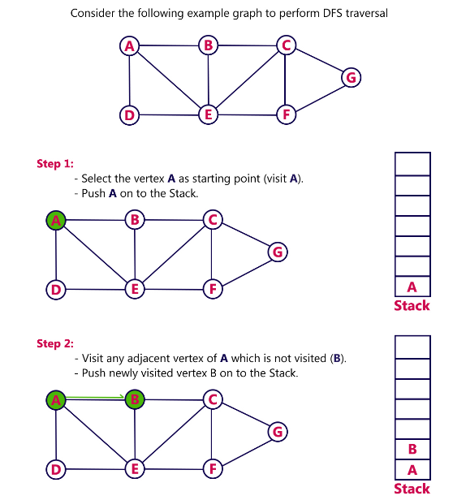

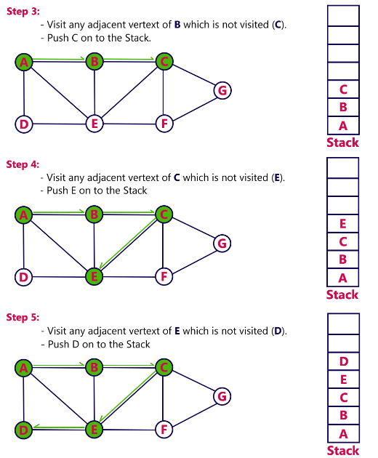

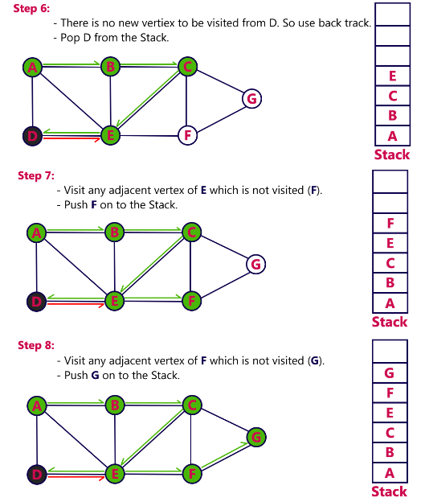

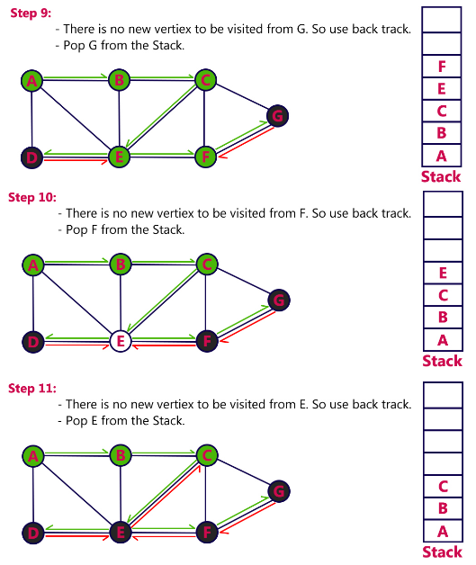

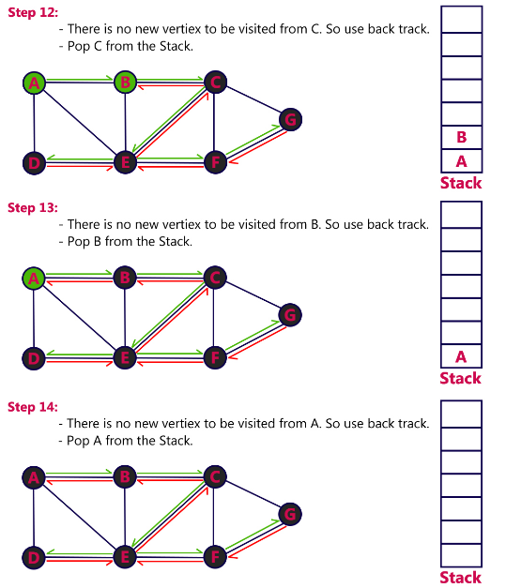

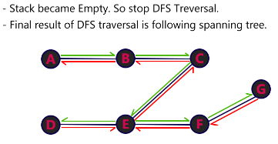

**Graph Traversals - BFS**

Graph traversal is technique used for searching a vertex in a graph. The graph traversal is also used to decide the order of vertices to be visit in the search process. A graph traversal finds the edges to be used in the search process without creating loops that means using graph traversal we visit all vertices of graph without getting into looping path.  
  
There are two graph traversal techniques and they are as follows...

1. **DFS (Depth First Search)**
2. **BFS (Breadth First Search)**

**BFS (Breadth First Search)**

BFS traversal of a graph, produces a **spanning tree** as final result. **Spanning Tree** is a graph without any loops. We use **Queue data structure** with maximum size of total number of vertices in the graph to implement BFS traversal of a graph.  
  
We use the following steps to implement BFS traversal...

* **Step 1:** Define a Queue of size total number of vertices in the graph.
* **Step 2:** Select any vertex as **starting point** for traversal. Visit that vertex and insert it into the Queue.
* **Step 3:** Visit all the **adjacent** vertices of the verex which is at front of the Queue which is not visited and insert them into the Queue.
* **Step 4:** When there is no new vertex to be visit from the vertex at front of the Queue then delete that vertex from the Queue.
* **Step 5:** Repeat step 3 and 4 until queue becomes empty.
* **Step 6:** When queue becomes Empty, then produce final spanning tree by removing unused edges from the graph

**Example**

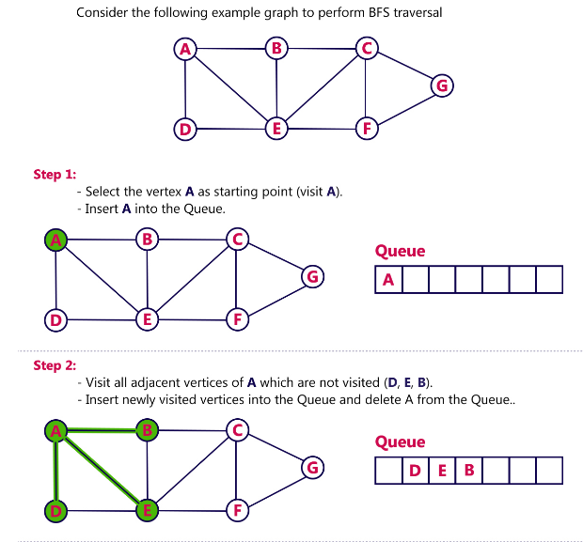

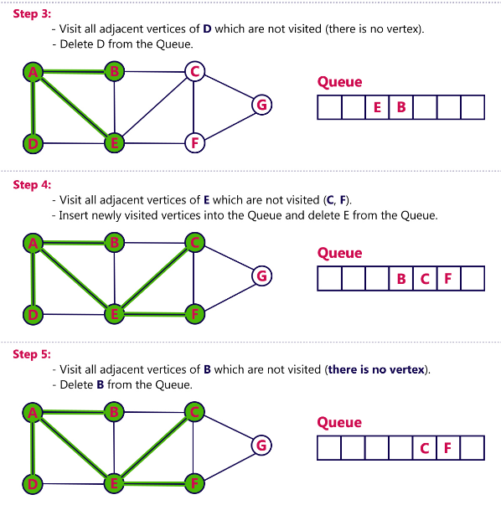

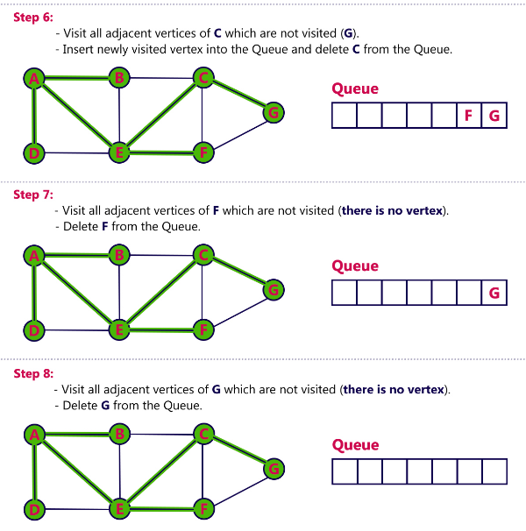

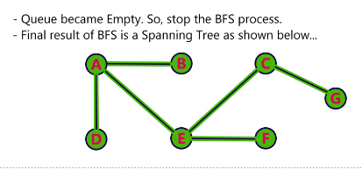

**Hashing**

In all search techniques like linear search, binary search and search trees, the time required to search an element is depends on the total number of element in that data structure. In all these search techniquies, as the number of element are increased the time required to search an element also increased linearly.  
  
Hashing is another approach in which time required to search an element doesn't depend on the number of element. Using hashing data structure, an element is searched with **constant time complexity**. Hashing is an effective way to reduce the number of comparisons to search an element in a data structure.  
  
Hashing is defined as follows...

**Hashing is the process of indexing and retrieving element (data) in a data structure to provide faster way of finding the element using the hash key.**

Here, hash key is a value which provides the index value where tha actual data is likely to store in the datastructure.  
  
In this datastructure, we use a concept called **Hash table** to store data. All the data values are inserted into the hash table based on the hash key value. Hash key value is used to map the data with index in the hash table. And the hash key is generated for every data using a **hash function**. That means every entry in the hash table is based on the key value generated using a hash function.  
  
Hash Table is defined as follows...

**Hash table is just an array which maps a key (data) into the data structure with the help of hash function such that insertion, deletion and search operations can be performed with constant time complexity (i.e. O(1)).**

Hash tables are used to perform the operations like insertion, deletion and search very quickly in a data structure. Using hash table concept insertion, deletion and search operations are accomplished in constant time. Generally, every hash table make use of a function, which we'll call the **hash function** to map the data into the hash table.  
  
A hash function is defined as follows...

**Hash function is a function which takes a piece of data (i.e. key) as input and outputs an integer (i.e. hash value) which maps the data to a particular index in the hash table.**

Basic concept of hashing and hash table is shown in the following figure...

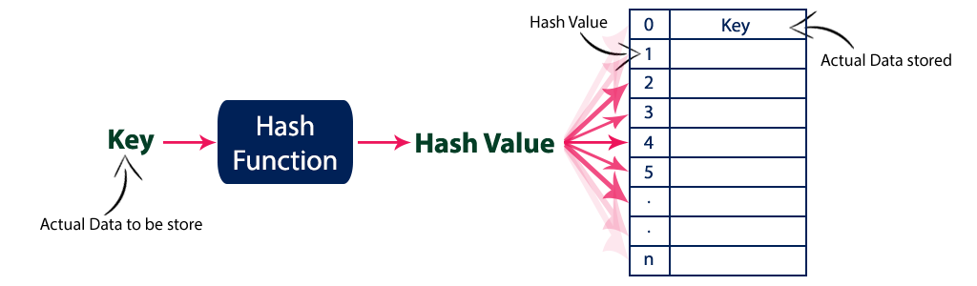

Hash Table

Hash Table is a data structure which stores data in an associative manner. In a hash table, data is stored in an array format, where each data value has its own unique index value. Access of data becomes very fast if we know the index of the desired data.

Thus, it becomes a data structure in which insertion and search operations are very fast irrespective of the size of the data. Hash Table uses an array as a storage medium and uses hash technique to generate an index where an element is to be inserted or is to be located from.

## Hashing

Hashing is a technique to convert a range of key values into a range of indexes of an array. We're going to use modulo operator to get a range of key values. Consider an example of hash table of size 20, and the following items are to be stored. Item are in the (key,value) format.

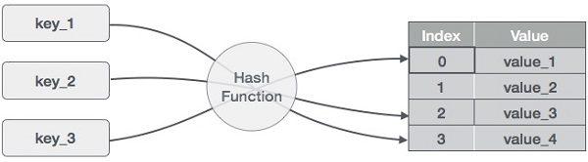

* (1,20)
* (2,70)
* (42,80)
* (4,25)
* (12,44)
* (14,32)
* (17,11)
* (13,78)
* (37,98)

|  |  |  |
| --- | --- | --- |
| **Key** | **Hash** | **Array Index** |
| 1 | 1 % 20 = 1 | 1 |
| 2 | 2 % 20 = 2 | 2 |
| 42 | 42 % 20 = 2 | 2 |
| 4 | 4 % 20 = 4 | 4 |
| 12 | 12 % 20 = 12 | 12 |
| 14 | 14 % 20 = 14 | 14 |
| 17 | 17 % 20 = 17 | 17 |
| 13 | 13 % 20 = 13 | 13 |
| 37 | 37 % 20 = 17 | 17 |

## Linear Probing

As we can see, it may happen that the hashing technique is used to create an already used index of the array. In such a case, we can search the next empty location in the array by looking into the next cell until we find an empty cell. This technique is called linear probing.

|  |  |  |  |  |
| --- | --- | --- | --- | --- |
| **Sr. No.** | **Key** | **Hash** | **Array Index** | **After Linear Probing, Array Index** |
| 1 | 1 | 1 % 20 = 1 | 1 | 1 |
| 2 | 2 | 2 % 20 = 2 | 2 | 2 |
| 3 | 42 | 42 % 20 = 2 | 2 | 3 |
| 4 | 4 | 4 % 20 = 4 | 4 | 4 |
| 5 | 12 | 12 % 20 = 12 | 12 | 12 |
| 6 | 14 | 14 % 20 = 14 | 14 | 14 |
| 7 | 17 | 17 % 20 = 17 | 17 | 17 |
| 8 | 13 | 13 % 20 = 13 | 13 | 13 |
| 9 | 37 | 37 % 20 = 17 | 17 | 18 |

## Basic Operations

Following are the basic primary operations of a hash table.

* **Search** − Searches an element in a hash table.
* **Insert** − inserts an element in a hash table.
* **delete** − Deletes an element from a hash table.

## DataItem

Define a data item having some data and key, based on which the search is to be conducted in a hash table.

struct DataItem {

int data;

int key;

};

## Hash Method

Define a hashing method to compute the hash code of the key of the data item.

int hashCode(int key){

return key % SIZE;

}

## Search Operation

Whenever an element is to be searched, compute the hash code of the key passed and locate the element using that hash code as index in the array. Use linear probing to get the element ahead if the element is not found at the computed hash code.

### Example

struct DataItem *search(int key) {

//get the hash

int hashIndex = hashCode(key);

//move in array until an empty

while(hashArray[hashIndex] != NULL) {

if(hashArray[hashIndex]->key == key)

return hashArray[hashIndex];

//go to next cell

++hashIndex;

//wrap around the table

hashIndex %= SIZE; //hashIndex=hashIndex%SIZE;

}

return NULL;

}

## Insert Operation

Whenever an element is to be inserted, compute the hash code of the key passed and locate the index using that hash code as an index in the array. Use linear probing for empty location, if an element is found at the computed hash code.

### Example

void insert(int key,int data) {

struct DataItem *item = (struct DataItem*) malloc(sizeof(struct DataItem));

item->data = data;

item->key = key;

//get the hash

int hashIndex = hashCode(key);

//move in array until an empty or deleted cell

while(hashArray[hashIndex] != NULL && hashArray[hashIndex]->key != -1) {

//go to next cell

++hashIndex;

//wrap around the table

hashIndex %= SIZE;

}

hashArray[hashIndex] = item;

}

## Delete Operation

Whenever an element is to be deleted, compute the hash code of the key passed and locate the index using that hash code as an index in the array. Use linear probing to get the element ahead if an element is not found at the computed hash code. When found, store a dummy item there to keep the performance of the hash table intact.

### Example

struct DataItem* delete(struct DataItem* item) {

int key = item->key;

//get the hash

int hashIndex = hashCode(key);

//move in array until an empty

while(hashArray[hashIndex] !=NULL) {

if(hashArray[hashIndex]->key == key) {

struct DataItem* temp = hashArray[hashIndex];

//assign a dummy item at deleted position

hashArray[hashIndex] = dummyItem;

return temp;

}

//go to next cell

++hashIndex;

//wrap around the table

hashIndex %= SIZE;

}

return NULL;

}

# Quadratic Probing

Quadratic Probing and Double Hashing attempt to find ways to reduce the size of the clusters that are formed by linear probing.

## Quadratic Probing

Quadratic Probing is similar to Linear probing. The difference is that if you were to try to insert into a space that is filled you would first check 1^2 = 11​2​​=1 element away then 2^2 = 42​2​​=4 elements away, then 3^2 =93​2​​=9elements away then 4^2=164​2​​=16 elements away and so on.

With linear probing we know that we will always find an open spot if one exists (It might be a long search but we will find it). However, this is not the case with quadratic probing unless you take care in the choosing of the table size. For example consider what would happen in the following situation:

Table size is 16. First 5 pieces of data that all hash to index 2

* First piece goes to index 2.
* Second piece goes to 3 ((2 + 1)%16
* Third piece goes to 6 ((2+4)%16
* Fourth piece goes to 11((2+9)%16
* Fifth piece dosen't get inserted because (2+16)%16==2 which is full so we end up back where we started and we haven't searched all empty spots.

In order to guarantee that your quadratic probes will hit every single available spots eventually, your table size must meet these requirements:

* Be a prime number
* never be more than half full (even by one element)

### Double Hashing

Double Hashing is works on a similar idea to linear and quadratic probing. Use a big table and hash into it. Whenever a collision occurs, choose another spot in table to put the value. The difference here is that instead of choosing next opening, a second hash function is used to determine the location of the next spot. For example, given hash function H1 and H2 and key. do the following:

+

* Check location hash1(key). If it is empty, put record in it.
* If it is not empty calculate hash2(key).
* check if hash1(key)+hash2(key) is open, if it is, put it in
* repeat with hash1(key)+2hash2(key), hash1(key)+3hash2(key) and so on, until an opening is found.

like quadratic probing, you must take care in choosing hash2. hash2 CANNOT ever return 0. hash2 must be done so that all cells will be probed eventually.

# Hashing

Hashing can be used to build, search, or delete from a table.

The basic idea behind hashing is to take a field in a record, known as the **key**, and convert it through some fixed process to a numeric value, known as the **hash key**, which represents the position to either store or find an item in the table. The numeric value will be in the range of 0 to n-1, where n is the maximum number of slots (or **buckets**) in the table.

The fixed process to convert a key to a hash key is known as a **hash function**. This function will be used whenever access to the table is needed.

One common method of determining a hash key is the **division method** of hashing. The formula that will be used is:

hash key = key % number of slots in the table

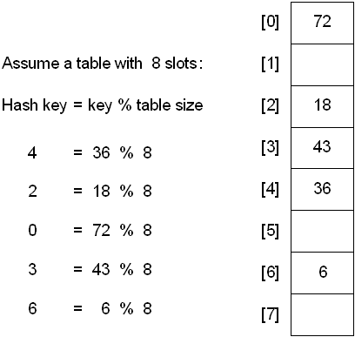

The division method is generally a reasonable strategy, unless the key happens to have some undesirable properties. For example, if the table size is 10 and all of the keys end in zero.

In this case, the choice of hash function and table size needs to be carefully considered. The best table sizes are prime numbers.

One problem though is that keys are not always numeric. In fact, it's common for them to be strings.

One possible solution: add up the ASCII values of the characters in the string to get a numeric value and then perform the division method.

int hashValue = 0;

for( int j = 0; j < stringKey.length(); j++ )

hashValue += stringKey[j];

int hashKey = hashValue % tableSize;

The previous method is simple, but it is flawed if the table size is large. For example, assume a table size of 10007 and that all keys are eight or fewer characters long.

No matter what the hash function, there is the possibility that two keys could resolve to the same hash key. This situation is known as a **collision**.

When this occurs, there are two simple solutions:

1. chaining
2. linear probe (aka linear open addressing)

And two slightly more difficult solutions

1. Quadratic Probe
2. Double Hashing

## Hashing with Chains

When a collision occurs, elements with the same hash key will be **chained** together. A **chain** is simply a linked list of all the elements with the same hash key.

The hash table slots will no longer hold a table element. They will now hold the address of a table element.

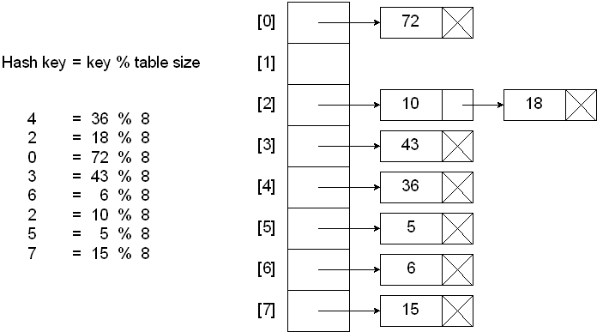

### Searching a hash table with chains:

Compute the hash key

If slot at hash key is null

Key not found

Else

Search the chain at hash key for the desired key

Endif

### Inserting into a hash table with chains:

Compute the hash key

If slot at hash key is null

Insert as first node of chain

Else

Search the chain for a duplicate key

If duplicate key

Don’t insert

Else

Insert into chain

Endif

Endif

### Deleting from a hash table with chains:

Compute the hash key

If slot at hash key is null

Nothing to delete

Else

Search the chain for the desired key

If key is not found

Nothing to delete

Else

Remove node from the chain

Endif

Endif

## Hashing with Linear Probe

When using a linear probe, the item will be stored in the next available slot in the table, assuming that the table is not already full.

This is implemented via a linear search for an empty slot, from the point of collision. If the physical end of table is reached during the linear search, the search will wrap around to the beginning of the table and continue from there.

If an empty slot is not found before reaching the point of collision, the table is full.

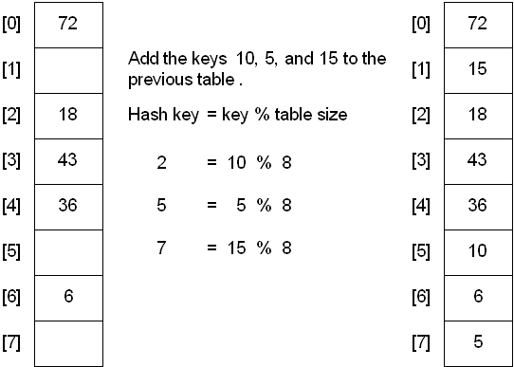

A problem with the linear probe method is that it is possible for blocks of data to form when collisions are resolved. This is known as **primary clustering**.

This means that any key that hashes into the cluster will require several attempts to resolve the collision.

For example, insert the nodes 89, 18, 49, 58, and 69 into a hash table that holds 10 items using the division method:

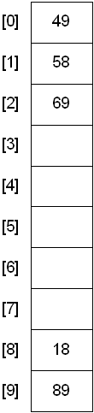

## Hashing with Quadratic Probe

To resolve the primary clustering problem, **quadratic probing** can be used. With quadratic probing, rather than always moving one spot, move i2 spots from the point of collision, where i is the number of attempts to resolve the collision.

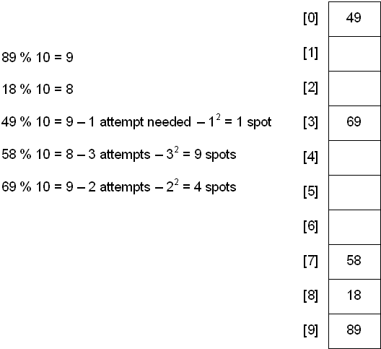

Limitation: at most half of the table can be used as alternative locations to resolve collisions.

This means that once the table is more than half full, it's difficult to find an empty spot. This new problem is known as **secondary clustering** because elements that hash to the same hash key will always probe the same alternative cells.

## Hashing with Double Hashing

Double hashing uses the idea of applying a second hash function to the key when a collision occurs. The result of the second hash function will be the number of positions form the point of collision to insert.

There are a couple of requirements for the second function:

* it must never evaluate to 0
* must make sure that all cells can be probed

A popular second hash function is: Hash2(key) = R - ( key % R ) where R is a prime number that is smaller than the size of the table.

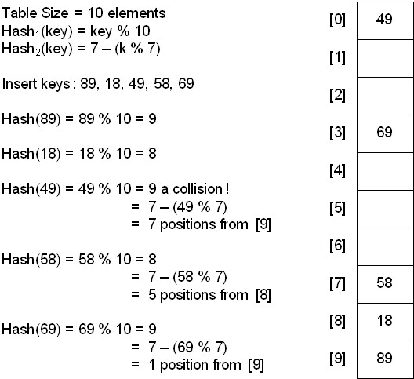

## Hashing with Rehashing

Once the hash table gets too full, the running time for operations will start to take too long and may fail. To solve this problem, a table at least twice the size of the original will be built and the elements will be transferred to the new table.

The new size of the hash table:

* should also be prime
* will be used to calculate the new insertion spot (hence the name **rehashing**)

This is a very expensive operation! O(N) since there are N elements to rehash and the table size is roughly 2N. This is ok though since it doesn't happen that often.

The question becomes when should the rehashing be applied?

Some possible answers:

* once the table becomes half full
* once an insertion fails
* once a specific load factor has been reached, where load factor is the ratio of the number of elements in the hash table to the table size

## Deletion from a Hash Table

The method of deletion depends on the method of insertion. In any of the cases, the same hash function(s) will be used to find the location of the element in the hash table.

There is a major problem that can arise if a collision occurred when inserting -- it's possible to "lose" an element.

|  |
| --- |
| **Linear Probing** |
| **If a collision occurs while trying to store a value at its home address, this algorithm moves forward through the table searching each bucket one by one until an empty slot is found. If the bottom of the table is reached, the search wraps around back to the beginning of the table and continues until either an empty slot is found or the search reaches its starting point, in which case the table is full. For the applet demo, the data size cannot exceed the table capacity; so all storage attempts will be successful.**  **The retrieve algorithm also performs a wrap-around search starting at the home address. The search is considered unsuccessful if the algorithm encounters an empty slot or wraps around to the home address before finding the desired value.** |
| **Quadratic Probing** |
| **This algorithm is similar to linear probing except a different formula is used to calculate which address is searched next. This formula is:**  **address = home address + i*i    where "i" is a zero-based search counter.**  **If the value of an address exceeds the address of the bottom of the table, the search wraps around from address 0.**  **There are variations of this algorithm that, with certain restrictions on the table and input, guarantee each bucket will be searched. The applet's implementation does not impose these restrictions. Instead, the maximum number of searches it will perform for an empty bucket is equal to the number of buckets in the table. When this condition is reached the storage is considered unsuccessful. Retrieval is similar except that a search is also considered unsuccessful if an empty slot is encountered prior to finding the value searched for.** |
| **Bucket Chaining** |
| **Storage using the bucket chaining algorithm requires two passes through the input data set. On the first pass, the home address for a value is determined and the data is inserted in the table if there is an available slot at this address. If there is a collision however, the data is stored in a temporary data structure until the second pass.**  **The second pass works as follows: For each value that wasn't stored on the first pass, the algorithm checks the link of the value's home address. If the link is null, a wrap around linear probing search is done for a completely empty bucket. If an empty bucket is found, the value is inserted and the link of the home address is set to the address where the value was inserted. If the link at the home address is not null, the algorithm searches for an empty slot in the bucket pointed to by the link. If there is an empty slot the value is inserted. If this bucket is also full and has a link that is not null, the next bucket in the chain is searched. If the chain ends with a full bucket, the algorithm performs a wrap around linear probing search for a completely empty bucket. If an empty bucket is found, the value is inserted and the link of the last bucket in the chain is set to the address where the value was inserted. Any wrap around search that returns to its origin is considered unsuccessful.**  **The retrieve algorithm starts at the home address and searches each bucket in the chain. The search is unsuccessful if an empty slot or a full bucket with a null link is encountered prior to finding the value searched for.** |
| **Linked List Chaining** |
| **This algorithm always stores a data value at its home address. Data is inserted in the bucket slots until the bucket is full. Subsequent values hashed to this address are added as new nodes in the link list pointed to by the bucket. For the algorithm demonstrated by the applet, new nodes are added to the front of the list.**  **The retrieve algorithm first searches the slots of the bucket at the home address. If the value is not present, the algorithm searches each node of the linked list one by one. The search is unsuccessful if the end of the chain is reached prior to finding the value searched for.** |
| **Chaining with Separate Overflow** |
| **This algorithm requires two hash tables. The hash function is based on the number of buckets in the primary hash table. All home addresses calculated by the hash function refer to the primary table. Data is inserted in the overflow table only if the home address in the primary table is full. The overflow table used in the applet demo is limited to one slot per bucket.**  **If a collision occurs while trying to store a value at its home address, the algorithm checks the link at this bucket. If the link is null, the algorithm performs a linear probing search of the overflow table for an empty bucket starting at the first bucket in the table. If an empty bucket is found, the value is inserted and the link of the home address is set to the address in the overflow table where the value was inserted.**  **If the link at the home address is not null, the algorithm searches the associated chain in the overflow table until the end of the chain is reached. At this point the algorithm performs a wrap around linear probing search for an empty bucket. If an empty bucket is found, the value is inserted and the link of the last bucket in the chain pointed to this bucket's address. Any wrap around search that returns to its origin is considered unsuccessful.**  **The retrieve algorithm starts at the home address and searches each bucket in the chain. The search is unsuccessful if a full bucket with a null link is encountered prior to finding the value searched for.** |

**B - Trees**

In a binary search tree, AVL Tree, Red-Black tree etc., every node can have only one value (key) and maximum of two children but there is another type of search tree called B-Tree in which a node can store more than one value (key) and it can have more than two children. B-Tree was developed in the year of 1972 by **Bayer and McCreight** with the name ***Height Balanced m-way Search Tree***. Later it was named as B-Tree.  
  
B-Tree can be defined as follows...

**B-Tree is a self-balanced search tree with multiple keys in every node and more than two children for every node.**

Here, number of keys in a node and number of children for a node is depend on the order of the B-Tree. Every B-Tree has order.  
  
**B-Tree of Order m** has the following properties...

* **Property #1** - All the **leaf nodes** must be **at same level**.
* **Property #2** - All nodes except root must have at least **[m/2]-1** keys and maximum of **m-1** keys.
* **Property #3** - All non leaf nodes except root (i.e. all internal nodes) must have at least **m/2** children.
* **Property #4** - If the root node is a non leaf node, then it must have **at least 2** children.
* **Property #5** - A non leaf node with **n-1** keys must have **n** number of children.
* **Property #6** - All the **key values within a node** must be in **Ascending Order**.

For example, B-Tree of Order 4 contains maximum 3 key values in a node and maximum 4 children for a node.

**Example**

**Operations on a B-Tree**

The following operations are performed on a B-Tree...

1. **Search**
2. **Insertion**
3. **Deletion**

**Search Operation in B-Tree**

In a B-Ttree, the search operation is similar to that of Binary Search Tree. In a Binary search tree, the search process starts from the root node and every time we make a 2-way decision (we go to either left subtree or right subtree). In B-Tree also search process starts from the root node but every time we make n-way decision where n is the total number of children that node has. In a B-Ttree, the search operation is performed with **O(log n)** time complexity. The search operation is performed as follows...

* **Step 1:** Read the search element from the user
* **Step 2:** Compare, the search element with first key value of root node in the tree.
* **Step 3:** If both are matching, then display "Given node found!!!" and terminate the function
* **Step 4:** If both are not matching, then check whether search element is smaller or larger than that key value.
* **Step 5:** If search element is smaller, then continue the search process in left subtree.
* **Step 6:** If search element is larger, then compare with next key value in the same node and repeate step 3, 4, 5 and 6 until we found exact match or comparision completed with last key value in a leaf node.
* **Step 7:** If we completed with last key value in a leaf node, then display "Element is not found" and terminate the function.

**Insertion Operation in B-Tree**

In a B-Tree, the new element must be added only at leaf node. That means, always the new keyValue is attached to leaf node only. The insertion operation is performed as follows...

* **Step 1:** Check whether tree is Empty.
* **Step 2:** If tree is **Empty**, then create a new node with new key value and insert into the tree as a root node.
* **Step 3:** If tree is **Not Empty**, then find a leaf node to which the new key value cab be added using Binary Search Tree logic.
* **Step 4:** If that leaf node has an empty position, then add the new key value to that leaf node by maintaining ascending order of key value within the node.
* **Step 5:** If that leaf node is already full, then **split** that leaf node by sending middle value to its parent node. Repeat tha same until sending value is fixed into a node.
* **Step 6:** If the spilting is occuring to the root node, then the middle value becomes new root node for the tree and the height of the tree is increased by one.

**Example**

Construct a **B-Tree of Order 3** by inserting numbers from 1 to 10.

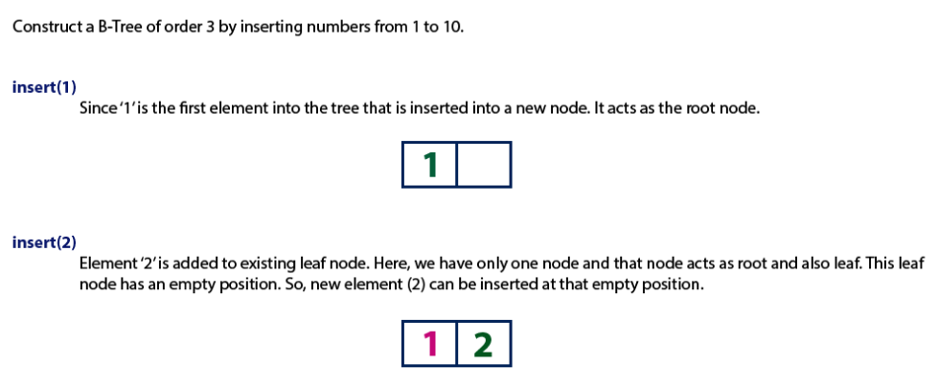

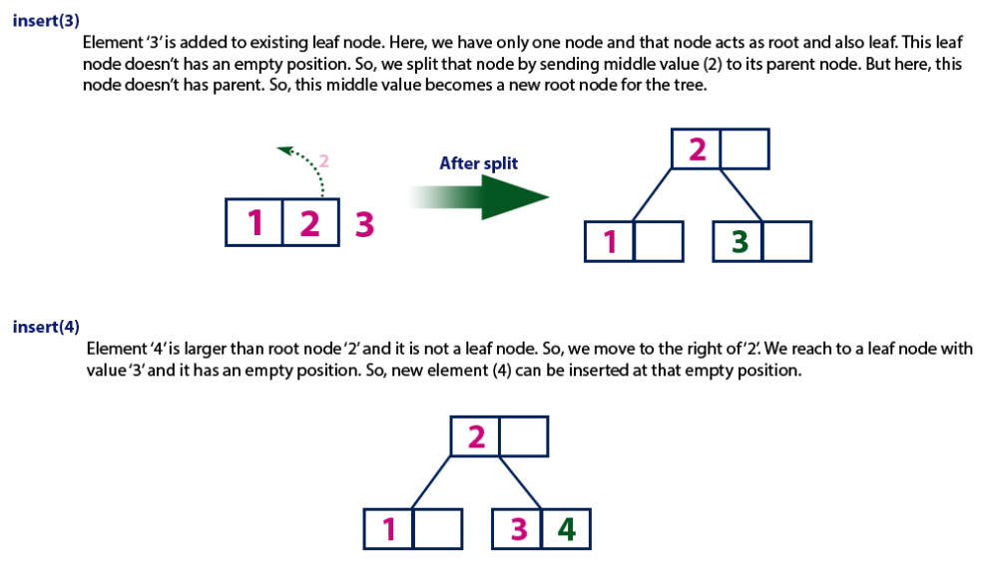

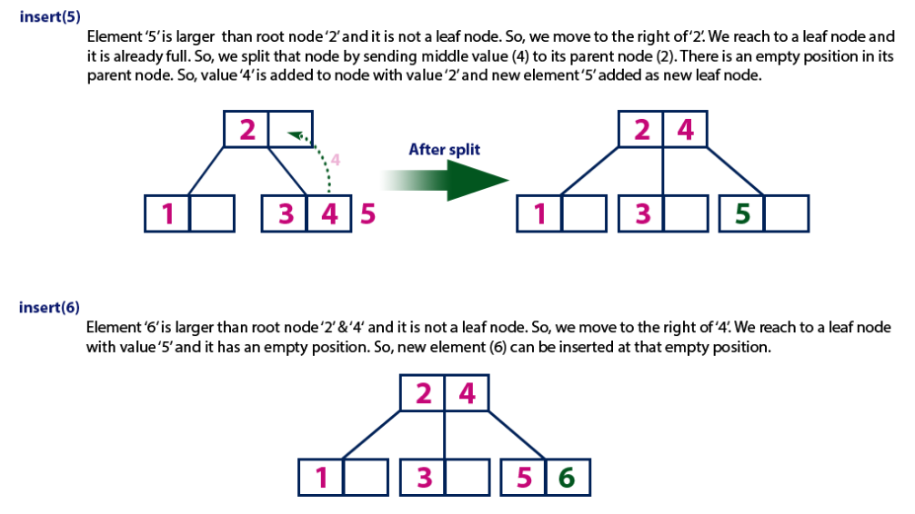

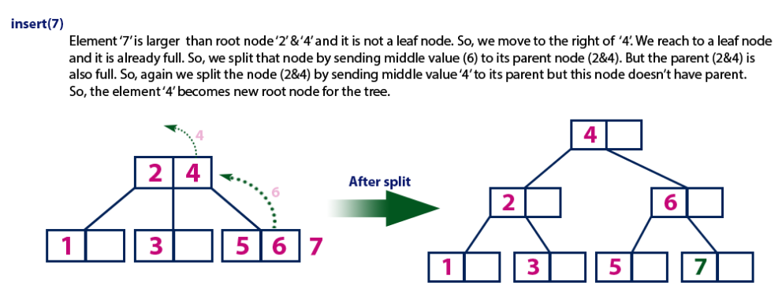

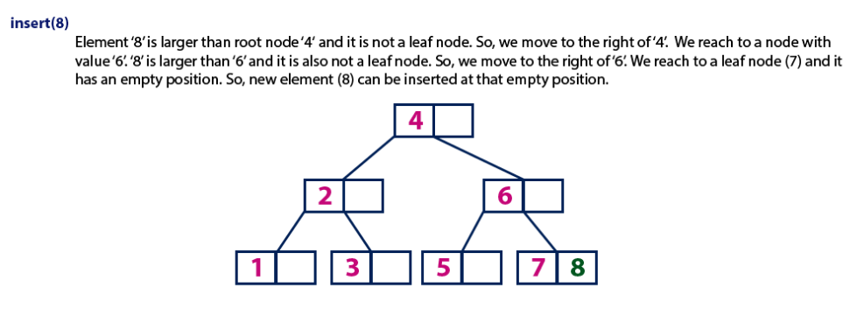

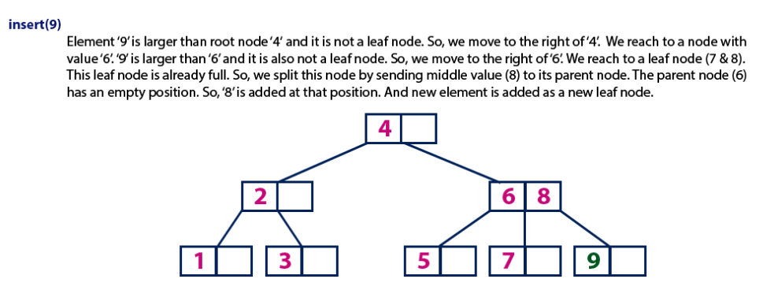

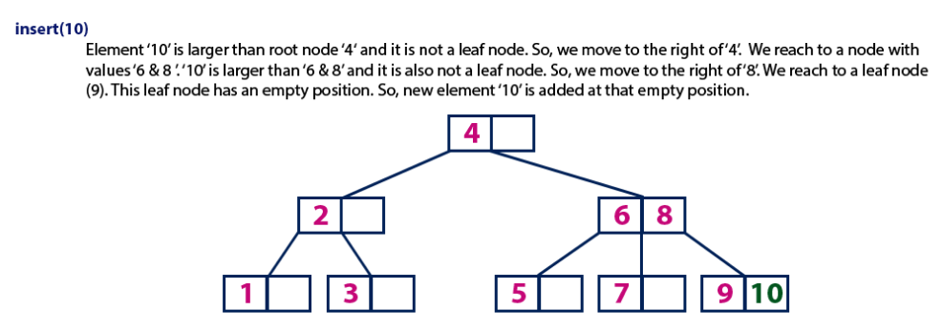

* **Binary Tree :**It is a tree data structure in which **each node** has **at most** **two children**. As such there is no relation between a parent and its left and right descendants. Hence they are unordered.
* **Binary Search Tree :**These are ordered binary trees with a recursive relation **left<root<right**which is followed at every node. Its due to this rule that helps in faster search,insertion and deletion. The best case is achieved when the tree is balanced.  
    
  Note: Not all BSTs are self balancing.
* **B-Tree :**It is a generalization of a BST in that a node can have more than two children. These are self balancing and hence the average and worst complexities is logarithmic.We opt for these when the data is too huge to fit in main memory.  These structures are used in database indexing and help in faster operations on disk.
* **B+ Tree :**In these copies of the keys are stored in the internal nodes; the keys and records are stored in leaves; in addition, a leaf node may include a pointer to the next leaf node to speed sequential access. These are used in File systems, DBMS etc.

Difference between B Tree and B+ Tree

##### **Key difference:** **In computers, the binary trees are tree data structures that store the data, and allow the user to access, search, insert and delete the data at the algorithmic time. The difference between a B and B+ tree is that, in a B-tree, both the keys and data in the internal/leaf nodes can be stored, whereas in a B+ tree only the leaf nodes can be stored.**

The Binary trees are balanced search trees, which are designed to work well on direct access secondary storage devices such as the magnetic disks. Rudolf Bayer and Ed McCreight invented the concept of a B-tree.

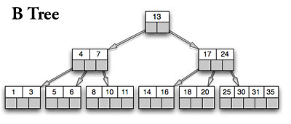

A B-tree is a generalized binary search tree, in which any node can have more than two children. Each internal node in a B-tree contains a number of keys. These keys separate the values, and further forms the sub-trees. The internal nodes in a B-tree can have variable numbers of child nodes, which are arranged within a pre-defined range. At the time when any data is inserted or removed from any respective node, there is a change in the number of child nodes. In order to maintain the pre-defined range, internal nodes may be joined or split. In a B-tree, the range of child nodes are permitted, and due to which the pre-defined range have to be maintained.

The B-trees cannot be rebalanced frequently; and the nodes in these trees are also not always full. Hence, the spaces are consumed unnecessary in these trees. Only the lower and upper bounds on the number of child nodes are typically fixed for a particular implementation. For example, in a 2-3 B-tree (often simply referred to as a 2-3 tree), each internal node may have only 2 or 3 child nodes. The B-tree is optimized for systems that read and write large blocks of data. It is commonly used in databases and file-systems. In the B-tree, all the nodes are kept at the same balancing depths from the root nodes. These depths increase slowly as the number of elements increases; and this results in the leaf nodes which are farther away from the root node. The B- trees are more advantageous as compared to other implementations in the time accessing comparisons.

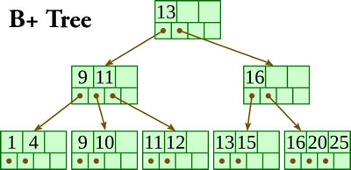A B+ tree is a n-array tree with a node, which consists of large number of children. The root may be a leaf or a node with more than two children. A B+ tree is the same as a B- tree; the only difference is that, in the B+ tree there is an additional level added at the bottom with linked leaves. The balancing factor or the order of a B+ tree measures the capacity of the number of children nodes for the internal nodes. The actual number of children for a node is denoted as m. The root is an exception as it is allowed to have more than two number of children. For example, if the order of a B+ tree is 7, each internal node (except for the root) may have between 4 and 7 children; the root may have between 2 and 7. The primary value of the B+ tree is in storing data for efficient retrieval in a block-oriented storage context and in particular file-systems.

The primary value of the B+ tree is in storing and maintaining the data, so that the data is not lost. This approach is especially applied in block-oriented storage context and in some particular file-systems. The leaves (the bottom-most index blocks) of the B+ tree are often linked to one another in a linked list; this makes range queries or an (ordered) iteration through the blocks simpler and more efficient (though the aforementioned upper bound can be achieved even without this addition). The space factor is not wasted in B+ trees. The B+ tree provides an efficient housing data structure format, which makes them simple in accessing and storing. The B+ trees are particularly useful as a database system index, where the data typically resides on a disk.

# Multiway Trees

A **multiway tree** is a tree that can have more than two children. A **multiway tree of order m** (or an **m-way tree**) is one in which a tree can have m children.

As with the other trees that have been studied, the nodes in an m-way tree will be made up of key fields, in this case m-1 key fields, and pointers to children.

multiway tree of order 5



To make the processing of m-way trees easier some type of order will be imposed on the keys within each node, resulting in a **multiway search tree of order m** ( or an **m-way search tree**). By definition an m-way search tree is a m-way tree in which:

* Each node has m children and m-1 key fields
* The keys in each node are in ascending order.
* The keys in the first i children are smaller than the ith key
* The keys in the last m-i children are larger than the ith key

4-way search tree



M-way search trees give the same advantages to m-way trees that binary search trees gave to binary trees - they provide fast information retrieval and update. However, they also have the same problems that binary search trees had - they can become unbalanced, which means that the construction of the tree becomes of vital importance.

## B-Trees

An extension of a multiway search tree of order m is a **B-tree of order m**. This type of tree will be used when the data to be accessed/stored is located on secondary storage devices because they allow for large amounts of data to be stored in a node.

A B-tree of order m is a multiway search tree in which:

1. The root has at least two subtrees unless it is the only node in the tree.
2. Each nonroot and each nonleaf node have at most m nonempty children and at least m/2 nonempty children.
3. The number of keys in each nonroot and each nonleaf node is one less than the number of its nonempty children.
4. All leaves are on the same level.

These restrictions make B-trees always at least half full, have few levels, and remain perfectly balanced.

The nodes in a B-tree are usually implemented as a class that contains an array of m-l cells for keys, an array of m pointers to other nodes, and whatever other information is required in order to facilitate tree maintenance.

template <class T, int M>

class BTreeNode

{

public:

BTreeNode();

BTreeNode( const T & );

private:

T keys[M-1];

BTreeNode *pointers[M];

...

};

### Searching a B-tree

An algorithm for finding a key in B-tree is simple. Start at the root and determine which pointer to follow based on a comparison between the search value and key fields in the root node. Follow the appropriate pointer to a child node. Examine the key fields in the child node and continue to follow the appropriate pointers until the search value is found or a leaf node is reached that doesn't contain the desired search value.

### Insertion into a B-tree

The condition that all leaves must be on the same level forces a characteristic behavior of B-trees, namely that B-trees are not allowed to grow at the their leaves; instead they are forced to grow at the root.

When inserting into a B-tree, a value is inserted directly into a leaf. This leads to three common situations that can occur:

1. A key is placed into a leaf that still has room.
2. The leaf in which a key is to be placed is full.
3. The root of the B-tree is full.

**Case 1: A key is placed into a leaf that still has room**

This is the easiest of the cases to solve because the value is simply inserted into the correct sorted position in the leaf node.



Inserting the number 7 results in:



**Case 2: The leaf in which a key is to be placed is full**

In this case, the leaf node where the value should be inserted is split in two, resulting in a new leaf node. Half of the keys will be moved from the full leaf to the new leaf. The new leaf is then incorporated into the B-tree.

The new leaf is incorporated by moving the middle value to the parent and a pointer to the new leaf is also added to the parent. This process is continues up the tree until all of the values have "found" a location.

Insert 6 into the following B-tree:



results in a split of the first leaf node:





The new node needs to be incorporated into the tree - this is accomplished by taking the middle value and inserting it in the parent:



**Case 3: The root of the B-tree is full**

The upward movement of values from case 2 means that it's possible that a value could move up to the root of the B-tree. If the root is full, the same basic process from case 2 will be applied and a new root will be created. This type of split results in 2 new nodes being added to the B-tree.

Inserting 13 into the following tree:



Results in:



The 15 needs to be moved to the root node but it is full. This means that the root needs to be divided:



The 15 is inserted into the parent, which means that it becomes the new root node:



### Deleting from a B-tree

As usual, this is the hardest of the processes to apply. The deletion process will basically be a reversal of the insertion process - rather than splitting nodes, it's possible that nodes will be merged so that B-tree properties, namely the requirement that a node must be at least half full, can be maintained.

There are two main cases to be considered:

1. Deletion from a leaf
2. Deletion from a non-leaf

**Case 1: Deletion from a leaf**

1a) If the leaf is at least half full after deleting the desired value, the remaining larger values are moved to "fill the gap".

Deleting 6 from the following tree:



results in:



1b) If the leaf is less than half full after deleting the desired value (known as underflow), two things could happen:

Deleting 7 from the tree above results in:



1b-1) If there is a left or right sibling with the number of keys exceeding the minimum requirement, all of the keys from the leaf and sibling will be redistributed between them by moving the separator key from the parent to the leaf and moving the middle key from the node and the sibling combined to the parent.



Now delete 8 from the tree:



1b-2) If the number of keys in the sibling does not exceed the minimum requirement, then the leaf and sibling are merged by putting the keys from the leaf, the sibling, and the separator from the parent into the leaf. The sibling node is discarded and the keys in the parent are moved to "fill the gap". It's possible that this will cause the parent to underflow. If that is the case, treat the parent as a leaf and continue repeating step 1b-2 until the minimum requirement is met or the root of the tree is reached.

**Special Case for 1b-2:** When merging nodes, if the parent is the root with only one key, the keys from the node, the sibling, and the only key of the root are placed into a node and this will become the new root for the B-tree. Both the sibling and the old root will be discarded.





**Case 2: Deletion from a non-leaf**

This case can lead to problems with tree reorganization but it will be solved in a manner similar to deletion from a binary search tree.

The key to be deleted will be replaced by its immediate predecessor (or successor) and then the predecessor (or successor) will be deleted since it can only be found in a leaf node.

Deleting 16 from the tree above results in:



The "gap" is filled in with the immediate predecessor:



and then the immediate predecessor is deleted:



If the immediate successor had been chosen as the replacement:



Deleting the successor results in:



The vales in the left sibling are combined with the separator key (18) and the remaining values. They are divided between the 2 nodes:



and then the middle value is moved to the parent:



Spanning Tree

A spanning tree is a subset of Graph G, which has all the vertices covered with minimum possible number of edges. Hence, a spanning tree does not have cycles and it cannot be disconnected..

By this definition, we can draw a conclusion that every connected and undirected Graph G has at least one spanning tree. A disconnected graph does not have any spanning tree, as it cannot be spanned to all its vertices.

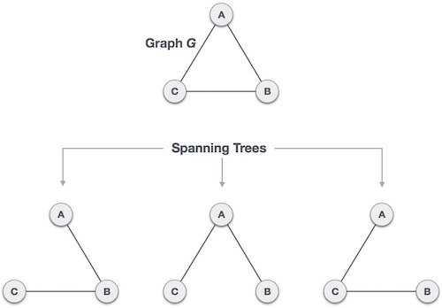

We found three spanning trees off one complete graph. A complete undirected graph can have maximum **nn-2** number of spanning trees, where **n** is the number of nodes. In the above addressed example, **33−2 = 3** spanning trees are possible.

## General Properties of Spanning Tree

We now understand that one graph can have more than one spanning tree. Following are a few properties of the spanning tree connected to graph G −

* A connected graph G can have more than one spanning tree.
* All possible spanning trees of graph G, have the same number of edges and vertices.
* The spanning tree does not have any cycle (loops).
* Removing one edge from the spanning tree will make the graph disconnected, i.e. the spanning tree is **minimally connected**.
* Adding one edge to the spanning tree will create a circuit or loop, i.e. the spanning tree is **maximally acyclic**.

## Mathematical Properties of Spanning Tree

* Spanning tree has **n-1** edges, where **n** is the number of nodes (vertices).
* From a complete graph, by removing maximum **e - n + 1** edges, we can construct a spanning tree.
* A complete graph can have maximum **nn-2** number of spanning trees.

Thus, we can conclude that spanning trees are a subset of connected Graph G and disconnected graphs do not have spanning tree.

## Application of Spanning Tree

Spanning tree is basically used to find a minimum path to connect all nodes in a graph. Common application of spanning trees are −

* **Civil Network Planning**
* **Computer Network Routing Protocol**
* **Cluster Analysis**

Let us understand this through a small example. Consider, city network as a huge graph and now plans to deploy telephone lines in such a way that in minimum lines we can connect to all city nodes. This is where the spanning tree comes into picture.

## Minimum Spanning Tree (MST)

In a weighted graph, a minimum spanning tree is a spanning tree that has minimum weight than all other spanning trees of the same graph. In real-world situations, this weight can be measured as distance, congestion, traffic load or any arbitrary value denoted to the edges.

## Minimum Spanning-Tree Algorithm

We shall learn about two most important spanning tree algorithms here −

* [Kruskal's Algorithm](https://www.tutorialspoint.com/data_structures_algorithms/kruskals_spanning_tree_algorithm.htm)
* [Prim's Algorithm](https://www.tutorialspoint.com/data_structures_algorithms/prims_spanning_tree_algorithm.htm)

Both are greedy algorithms.

**What is a Spanning Tree?**

Given an undirected and connected graph G=(V,E)G=(V,E), a spanning tree of the graph GG is a tree that spans GG (that is, it includes every vertex of GG) and is a subgraph of GG (every edge in the tree belongs to GG)

**What is a Minimum Spanning Tree?**

The cost of the spanning tree is the sum of the weights of all the edges in the tree. There can be many spanning trees. Minimum spanning tree is the spanning tree where the cost is minimum among all the spanning trees. There also can be many minimum spanning trees.

Minimum spanning tree has direct application in the design of networks. It is used in algorithms approximating the travelling salesman problem, multi-terminal minimum cut problem and minimum-cost weighted perfect matching. Other practical applications are:

1. Cluster Analysis
2. Handwriting recognition
3. Image segmentation

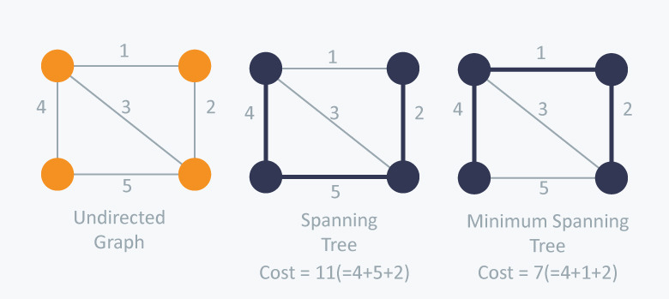

There are two famous algorithms for finding the Minimum Spanning Tree:

**Kruskal’s Algorithm**

Kruskal’s Algorithm builds the spanning tree by adding edges one by one into a growing spanning tree. Kruskal's algorithm follows greedy approach as in each iteration it finds an edge which has least weight and add it to the growing spanning tree.

**Algorithm Steps:**

* Sort the graph edges with respect to their weights.
* Start adding edges to the MST from the edge with the smallest weight until the edge of the largest weight.
* Only add edges which doesn't form a cycle , edges which connect only disconnected components.

So now the question is how to check if 22 vertices are connected or not ?

This could be done using DFS which starts from the first vertex, then check if the second vertex is visited or not. But DFS will make time complexity large as it has an order of O(V+E)O(V+E) where VV is the number of vertices, EE is the number of edges. So the best solution is **"Disjoint Sets":**   
Disjoint sets are sets whose intersection is the empty set so it means that they don't have any element in common.

Consider following example:

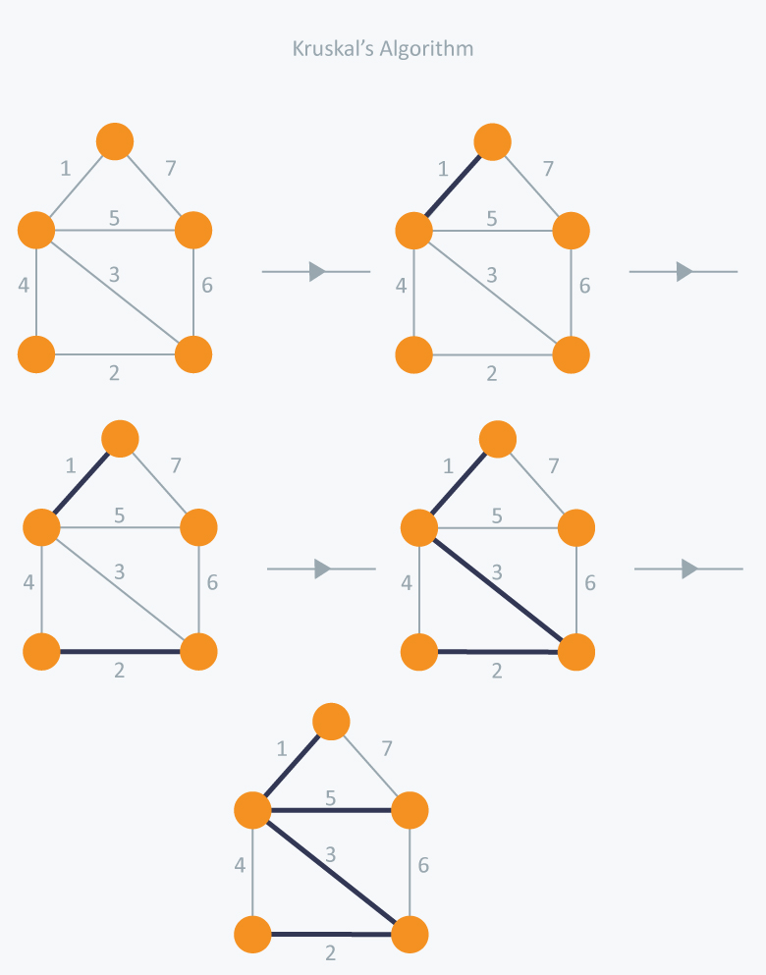

In Kruskal’s algorithm, at each iteration we will select the edge with the lowest weight. So, we will start with the lowest weighted edge first i.e., the edges with weight 1. After that we will select the second lowest weighted edge i.e., edge with weight 2. Notice these two edges are totally disjoint. Now, the next edge will be the third lowest weighted edge i.e., edge with weight 3, which connects the two disjoint pieces of the graph. Now, we are not allowed to pick the edge with weight 4, that will create a cycle and we can’t have any cycles. So we will select the fifth lowest weighted edge i.e., edge with weight 5. Now the other two edges will create cycles so we will ignore them. In the end, we end up with a minimum spanning tree with total cost 11 ( = 1 + 2 + 3 + 5).

**Implementation:**

#include <iostream>

#include <vector>

#include <utility>

#include <algorithm>

using namespace std;

const int MAX = 1e4 + 5;

int id[MAX], nodes, edges;

pair <long long, pair<int, int> > p[MAX];

void initialize()

{

for(int i = 0;i < MAX;++i)

id[i] = i;

}

int root(int x)

{

while(id[x] != x)

{

id[x] = id[id[x]];

x = id[x];

}

return x;

}

void union1(int x, int y)

{

int p = root(x);

int q = root(y);

id[p] = id[q];

}

long long kruskal(pair<long long, pair<int, int> > p[])

{

int x, y;

long long cost, minimumCost = 0;

for(int i = 0;i < edges;++i)

{

// Selecting edges one by one in increasing order from the beginning

x = p[i].second.first;

y = p[i].second.second;

cost = p[i].first;

// Check if the selected edge is creating a cycle or not

if(root(x) != root(y))

{

minimumCost += cost;

union1(x, y);

}

}

return minimumCost;

}

int main()

{

int x, y;

long long weight, cost, minimumCost;

initialize();

cin >> nodes >> edges;

for(int i = 0;i < edges;++i)

{

cin >> x >> y >> weight;

p[i] = make_pair(weight, make_pair(x, y));

}

// Sort the edges in the ascending order

sort(p, p + edges);

minimumCost = kruskal(p);

cout << minimumCost << endl;

return 0;

}

**Time Complexity:**

In Kruskal’s algorithm, most time consuming operation is sorting because the total complexity of the Disjoint-Set operations will be O(ElogV)O(ElogV), which is the overall Time Complexity of the algorithm.

**Prim’s Algorithm**

Prim’s Algorithm also use Greedy approach to find the minimum spanning tree. In Prim’s Algorithm we grow the spanning tree from a starting position. Unlike an **edge** in Kruskal's, we add **vertex** to the growing spanning tree in Prim's.

**Algorithm Steps:**

* Maintain two disjoint sets of vertices. One containing vertices that are in the growing spanning tree and other that are not in the growing spanning tree.
* Select the cheapest vertex that is connected to the growing spanning tree and is not in the growing spanning tree and add it into the growing spanning tree. This can be done using Priority Queues. Insert the vertices, that are connected to growing spanning tree, into the Priority Queue.
* Check for cycles. To do that, mark the nodes which have been already selected and insert only those nodes in the Priority Queue that are not marked.

Consider the example below:

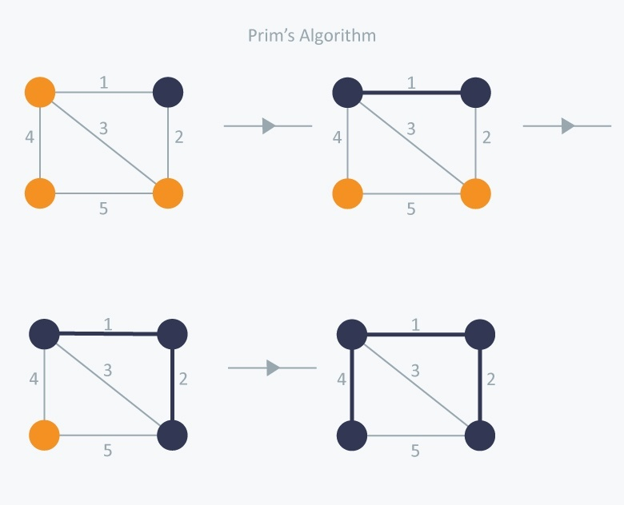

In Prim’s Algorithm, we will start with an arbitrary node (it doesn’t matter which one) and mark it. In each iteration we will mark a new vertex that is adjacent to the one that we have already marked. As a greedy algorithm, Prim’s algorithm will select the cheapest edge and mark the vertex. So we will simply choose the edge with weight 1. In the next iteration we have three options, edges with weight 2, 3 and 4. So, we will select the edge with weight 2 and mark the vertex. Now again we have three options, edges with weight 3, 4 and 5. But we can’t choose edge with weight 3 as it is creating a cycle. So we will select the edge with weight 4 and we end up with the minimum spanning tree of total cost 7 ( = 1 + 2 +4).

**Implementation:**

#include <iostream>

#include <vector>

#include <queue>

#include <functional>

#include <utility>

using namespace std;

const int MAX = 1e4 + 5;

typedef pair<long long, int> PII;

bool marked[MAX];

vector <PII> adj[MAX];

long long prim(int x)

{

priority_queue<PII, vector<PII>, greater<PII> > Q;

int y;

long long minimumCost = 0;

PII p;

Q.push(make_pair(0, x));

while(!Q.empty())

{

// Select the edge with minimum weight

p = Q.top();

Q.pop();

x = p.second;

// Checking for cycle

if(marked[x] == true)

continue;

minimumCost += p.first;

marked[x] = true;

for(int i = 0;i < adj[x].size();++i)

{

y = adj[x][i].second;

if(marked[y] == false)

Q.push(adj[x][i]);

}

}

return minimumCost;

}

int main()

{

int nodes, edges, x, y;

long long weight, minimumCost;

cin >> nodes >> edges;

for(int i = 0;i < edges;++i)

{

cin >> x >> y >> weight;

adj[x].push_back(make_pair(weight, y));

adj[y].push_back(make_pair(weight, x));

}

// Selecting 1 as the starting node

minimumCost = prim(1);

cout << minimumCost << endl;

return 0;

}

**Time Complexity:**  
The time complexity of the Prim’s Algorithm is O((V+E)logV)O((V+E)logV) because each vertex is inserted in the priority queue only once and insertion in priority queue take logarithmic time.

# Minimum Spanning Trees

## Spanning trees

A *spanning tree* of a graph is just a subgraph that contains all the vertices and is a tree. A graph may have many spanning trees; for instance the complete graph on four vertices

o---o

|\ /|

| X |

|/ \|

o---o

has sixteen spanning trees:

o---o o---o o o o---o

| | | | | |

| | | | | |

| | | | | |

o o o---o o---o o---o

o---o o o o o o o

\ / |\ / \ / \ /|

X | X X X |

/ \ |/ \ / \ / \|

o o o o o---o o o

o o o---o o o o---o

|\ | / | /| \

| \ | / | / | \

| \| / |/ | \

o o o---o o o o---o

o---o o o o o o---o

|\ | / \ | /|

| \ | / \ | / |

| \ |/ \| / |

o o o---o o---o o o

## Minimum spanning trees

Now suppose the edges of the graph have weights or lengths. The weight of a tree is just the sum of weights of its edges. Obviously, different trees have different lengths. The problem: how to find the minimum length spanning tree?

This problem can be solved by many different algorithms. It is the topic of some very recent research. There are several "best" algorithms, depending on the assumptions you make:

* A randomized algorithm can solve it in linear expected time. [Karger, Klein, and Tarjan, "A randomized linear-time algorithm to find minimum spanning trees", J. ACM, vol. 42, 1995, pp. 321-328.]
* It can be solved in linear worst case time if the weights are small integers. [Fredman and Willard, "Trans-dichotomous algorithms for minimum spanning trees and shortest paths", 31st IEEE Symp. Foundations of Comp. Sci., 1990, pp. 719--725.]
* Otherwise, the best solution is very close to linear but not exactly linear. The exact bound is O(m log beta(m,n)) where the beta function has a complicated definition: the smallest i such that log(log(log(...log(n)...))) is less than m/n, where the logs are nested i times. [Gabow, Galil, Spencer, and Tarjan, Efficient algorithms for finding minimum spanning trees in undirected and directed graphs. Combinatorica, vol. 6, 1986, pp. 109--122.]

These algorithms are all quite complicated, and probably not that great in practice unless you're looking at really huge graphs. The book tries to keep things simpler, so it only describes one algorithm but (in my opinion) doesn't do a very good job of it. I'll go through three simple classical algorithms (spending not so much time on each one).

## Why minimum spanning trees?

The standard application is to a problem like phone network design. You have a business with several offices; you want to lease phone lines to connect them up with each other; and the phone company charges different amounts of money to connect different pairs of cities. You want a set of lines that connects all your offices with a minimum total cost. It should be a spanning tree, since if a network isn't a tree you can always remove some edges and save money.

A less obvious application is that the minimum spanning tree can be used to approximately solve the traveling salesman problem. A convenient formal way of defining this problem is to find the shortest path that visits each point at least once.

Note that if you have a path visiting all points exactly once, it's a special kind of tree. For instance in the example above, twelve of sixteen spanning trees are actually paths. If you have a path visiting some vertices more than once, you can always drop some edges to get a tree. So in general the MST weight is less than the TSP weight, because it's a minimization over a strictly larger set.

On the other hand, if you draw a path tracing around the minimum spanning tree, you trace each edge twice and visit all points, so the TSP weight is less than twice the MST weight. Therefore this tour is within a factor of two of optimal. There is a more complicated way (*[Christofides](https://www.ics.uci.edu/~eppstein/161/people.html" \l "christofides)' heuristic*) of using minimum spanning trees to find a tour within a factor of 1.5 of optimal; I won't describe this here but it might be covered in ICS 163 (graph algorithms) next year.

## How to find minimum spanning tree?

The stupid method is to list all spanning trees, and find minimum of list. We already know how to find minima... But there are far too many trees for this to be efficient. It's also not really an algorithm, because you'd still need to know how to list all the trees.

A better idea is to find some key property of the MST that lets us be sure that some edge is part of it, and use this property to build up the MST one edge at a time.

For simplicity, we assume that there is a unique minimum spanning tree. (Problem 4.3 of Baase is related to this assumption). You can get ideas like this to work without this assumption but it becomes harder to state your theorems or write your algorithms precisely.

Lemma: Let X be any subset of the vertices of G, and let edge e be the smallest edge connecting X to G-X. Then e is part of the minimum spanning tree.

Proof: Suppose you have a tree T not containing e; then I want to show that T is not the MST. Let e=(u,v), with u in X and v not in X. Then because T is a spanning tree it contains a unique path from u to v, which together with e forms a cycle in G. This path has to include another edge f connecting X to G-X. T+e-f is another spanning tree (it has the same number of edges, and remains connected since you can replace any path containing f by one going the other way around the cycle). It has smaller weight than t since e has smaller weight than f. So T was not minimum, which is what we wanted to prove.

## Kruskal's algorithm

We'll start with [Kruskal](https://www.ics.uci.edu/~eppstein/161/people.html#kruskal)'s algorithm, which is easiest to understand and probably the best one for solving problems by hand.

Kruskal's algorithm:

sort the edges of G in increasing order by length

keep a subgraph S of G, initially empty

for each edge e in sorted order

if the endpoints of e are disconnected in S

add e to S

return S

Note that, whenever you add an edge (u,v), it's always the smallest connecting the part of S reachable from u with the rest of G, so by the lemma it must be part of the MST.

This algorithm is known as a *greedy algorithm*, because it chooses at each step the cheapest edge to add to S. You should be very careful when trying to use greedy algorithms to solve other problems, since it usually doesn't work. E.g. if you want to find a shortest path from a to b, it might be a bad idea to keep taking the shortest edges. The greedy idea only works in Kruskal's algorithm because of the key property we proved.

Analysis: The line testing whether two endpoints are disconnected looks like it should be slow (linear time per iteration, or O(mn) total). But actually there are some complicated data structures that let us perform each test in close to constant time; this is known as the *union-find* problem and is discussed in Baase section 8.5 (I won't get to it in this class, though). The slowest part turns out to be the sorting step, which takes O(m log n) time.

## Prim's algorithm

Rather than build a subgraph one edge at a time, [Prim](https://www.ics.uci.edu/~eppstein/161/people.html#prim)'s algorithm builds a tree one vertex at a time.

Prim's algorithm:

let T be a single vertex x

while (T has fewer than n vertices)

{

find the smallest edge connecting T to G-T

add it to T

}

Since each edge added is the smallest connecting T to G-T, the lemma we proved shows that we only add edges that should be part of the MST.

Again, it looks like the loop has a slow step in it. But again, some data structures can be used to speed this up. The idea is to use a [heap](https://www.ics.uci.edu/~eppstein/161/960116.html#binheap) to remember, for each vertex, the smallest edge connecting T with that vertex.

Prim with heaps:

make a heap of values (vertex,edge,weight(edge))

initially (v,-,infinity) for each vertex

let tree T be empty

while (T has fewer than n vertices)

{

let (v,e,weight(e)) have the smallest weight in the heap

remove (v,e,weight(e)) from the heap

add v and e to T

for each edge f=(u,v)

if u is not already in T

find value (u,g,weight(g)) in heap

if weight(f) < weight(g)

replace (u,g,weight(g)) with (u,f,weight(f))

}

Analysis: We perform n steps in which we remove the smallest element in the heap, and at most 2m steps in which we examine an edge f=(u,v). For each of those steps, we might replace a value on the heap, reducing it's weight. (You also have to find the right value on the heap, but that can be done easily enough by keeping a pointer from the vertices to the corresponding values.) I haven't described how to reduce the weight of an element of a binary heap, but it's easy to do in O(log n) time. Alternately by using a more complicated data structure known as a Fibonacci heap, you can reduce the weight of an element in constant time. The result is a total time bound of O(m + n log n).

## Boruvka's algorithm

(Actually [Boruvka](https://www.ics.uci.edu/~eppstein/161/people.html#boruvka) should be spelled with a small raised circle accent over the "u".) Although this seems a little complicated to explain, it's probably the easiest one for computer implementation since it doesn't require any complicated data structures. The idea is to do steps like Prim's algorithm, in parallel all over the graph at the same time.

Boruvka's algorithm:

make a list L of n trees, each a single vertex

while (L has more than one tree)

for each T in L, find the smallest edge connecting T to G-T

add all those edges to the MST

(causing pairs of trees in L to merge)

As we saw in Prim's algorithm, each edge you add must be part of the MST, so it must be ok to add them all at once.

Analysis: This is similar to merge sort. Each pass reduces the number of trees by a factor of two, so there are O(log n) passes. Each pass takes time O(m) (first figure out which tree each vertex is in, then for each edge test whether it connects two trees and is better than the ones seen before for the trees on either endpoint) so the total is O(m log n).

## A hybrid algorithm

This isn't really a separate algorithm, but you can combine two of the classical algorithms and do better than either one alone. The idea is to do O(log log n) passes of Boruvka's algorithm, then switch to Prim's algorithm. Prim's algorithm then builds one large tree by connecting it with the small trees in the list L built by Boruvka's algorithm, keeping a heap which stores, for each tree in L, the best edge that can be used to connect it to the large tree. Alternately, you can think of collapsing the trees found by Boruvka's algorithm into "supervertices" and running Prim's algorithm on the resulting smaller graph. The point is that this reduces the number of remove min operations in the heap used by Prim's algorithm, to equal the number of trees left in L after Boruvka's algorithm, which is O(n / log n).

Analysis: O(m log log n) for the first part, O(m + (n/log n) log n) = O(m + n) for the second, so O(m log log n) total.

Djikstra's Algorithm

Djikstra's algorithm (named after its discover, [E.W. Dijkstra](https://www.cs.auckland.ac.nz/software/AlgAnim/e_w_dijkstra.html)) solves the problem of finding the shortest path from a point in a graph (the *source*) to a destination. It turns out that one can find the shortest paths from a given source to *all* points in a graph in the same time, hence this problem is sometimes called the **single-source shortest paths** problem.

The somewhat unexpected result that *all* the paths can be found as easily as one further demonstrates the value of reading the literature on algorithms!

This problem is related to the spanning tree one. The graph representing all the paths from one vertex to all the others must be a spanning tree - it must include all vertices. There will also be no cycles as a cycle would define more than one path from the selected vertex to at least one other vertex. For a graph,

|  |  |  |
| --- | --- | --- |
| **G** = **(V,E)** | where | * **V** is a set of vertices and * **E** is a set of edges. |

Dijkstra's algorithm keeps two sets of vertices:

|  |  |  |
| --- | --- | --- |
| **S** |  | the set of vertices whose shortest paths from the source have already been determined *and* |
| **V-S** |  | the remaining vertices. |

The other data structures needed are:

|  |  |
| --- | --- |
| **d** | array of best estimates of shortest path to each vertex |
| **pi** | an array of [predecessors](https://www.cs.auckland.ac.nz/software/AlgAnim/dij_pred.html) for each vertex |

The basic mode of operation is:

1. Initialise **d** and **pi**,
2. Set **S** to empty,
3. While there are still vertices in **V-S**,
   1. Sort the vertices in **V-S** according to the current best estimate of their distance from the source,
   2. Add **u**, the closest vertex in **V-S**, to **S**,
   3. **Relax** all the vertices still in **V-S** connected to **u**

# Greedy Algorithms | (Dijkstra’s shortest path algorithm)

Given a graph and a source vertex in graph, find shortest paths from source to all vertices in the given graph.

Dijkstra’s algorithm is very similar to [Prim’s algorithm for minimum spanning tree](http://www.geeksforgeeks.org/archives/27455). Like Prim’s MST, we generate aSPT (shortest path tree) with given source as root. We maintain two sets, one set contains vertices included in shortest path tree, other set includes vertices not yet included in shortest path tree. At every step of the algorithm, we find a vertex which is in the other set (set of not yet included) and has minimum distance from source.

Below are the detailed steps used in Dijkstra’s algorithm to find the shortest path from a single source vertex to all other vertices in the given graph.  
Algorithm

**1)** Create a set sptSet (shortest path tree set) that keeps track of vertices included in shortest path tree, i.e., whose minimum distance from source is calculated and finalized. Initially, this set is empty.

**2)** Assign a distance value to all vertices in the input graph. Initialize all distance values as INFINITE. Assign distance value as 0 for the source vertex so that it is picked first.

**3)** While sptSet doesn’t include all vertices  
….**a)** Pick a vertex u which is not there in sptSetand has minimum distance value.  
….**b)** Include u to sptSet.  
….**c)** Update distance value of all adjacent vertices of u. To update the distance values, iterate through all adjacent vertices. For every adjacent vertex v, if sum of distance value of u (from source) and weight of edge u-v, is less than the distance value of v, then update the distance value of v.

Let us understand with the following example:  
[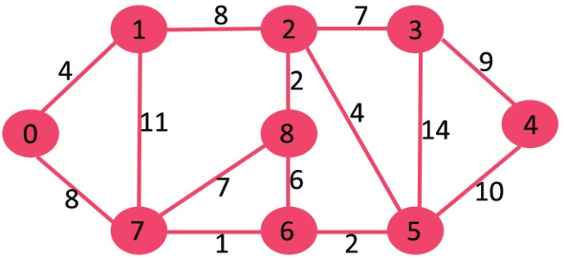](http://degottd575b1t.cloudfront.net/wp-content/uploads/Fig-11.jpg)

The set sptSetis initially empty and distances assigned to vertices are {0, INF, INF, INF, INF, INF, INF, INF} where INF indicates infinite. Now pick the vertex with minimum distance value. The vertex 0 is picked, include it in sptSet. So sptSetbecomes {0}. After including 0 to sptSet, update distance values of its adjacent vertices. Adjacent vertices of 0 are 1 and 7. The distance values of 1 and 7 are updated as 4 and 8. Following subgraph shows vertices and their distance values, only the vertices with finite distance values are shown. The vertices included in SPT are shown in green color.

[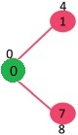](http://degottd575b1t.cloudfront.net/wp-content/uploads/MST1.jpg)

Pick the vertex with minimum distance value and not already included in SPT (not in sptSET). The vertex 1 is picked and added to sptSet. So sptSet now becomes {0, 1}. Update the distance values of adjacent vertices of 1. The distance value of vertex 2 becomes 12.

[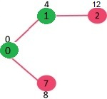](http://degottd575b1t.cloudfront.net/wp-content/uploads/DIJ2.jpg)

Pick the vertex with minimum distance value and not already included in SPT (not in sptSET). Vertex 7 is picked. So sptSet now becomes {0, 1, 7}. Update the distance values of adjacent vertices of 7. The distance value of vertex 6 and 8 becomes finite (15 and 9 respectively).  
[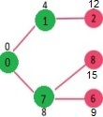](http://degottd575b1t.cloudfront.net/wp-content/uploads/DIJ3.jpg)

Pick the vertex with minimum distance value and not already included in SPT (not in sptSET). Vertex 6 is picked. So sptSet now becomes {0, 1, 7, 6}. Update the distance values of adjacent vertices of 6. The distance value of vertex 5 and 8 are updated.

[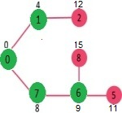](http://degottd575b1t.cloudfront.net/wp-content/uploads/DIJ4.jpg)

We repeat the above steps until sptSetdoesn’t include all vertices of given graph. Finally, we get the following Shortest Path Tree (SPT).

[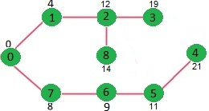](http://degottd575b1t.cloudfront.net/wp-content/uploads/DIJ5.jpg)

We use a boolean array sptSet[] to represent the set of vertices included in SPT. If a value sptSet[v] is true, then vertex v is included in SPT, otherwise not. Array dist[] is used to store shortest distance values of all vertices.

|  |
| --- |
| // A C / C++ program for Dijkstra's single source shortest path algorithm.  // The program is for adjacency matrix representation of the graph    #include <stdio.h>  #include <limits.h>    // Number of vertices in the graph  #define V 9    // A utility function to find the vertex with minimum distance value, from  // the set of vertices not yet included in shortest path tree  int minDistance(int dist[], bool sptSet[])  {     // Initialize min value     int min = INT_MAX, min_index;       for (int v = 0; v < V; v++)       if (sptSet[v] == false && dist[v] <= min)           min = dist[v], min_index = v;       return min_index;  }    // A utility function to print the constructed distance array  int printSolution(int dist[], int n)  {     printf("Vertex   Distance from Source\n");     for (int i = 0; i < V; i++)        printf("%d \t\t %d\n", i, dist[i]);  }    // Funtion that implements Dijkstra's single source shortest path algorithm  // for a graph represented using adjacency matrix representation  void dijkstra(int graph[V][V], int src)  {       int dist[V];     // The output array.  dist[i] will hold the shortest                        // distance from src to i         bool sptSet[V]; // sptSet[i] will true if vertex i is included in shortest                       // path tree or shortest distance from src to i is finalized         // Initialize all distances as INFINITE and stpSet[] as false       for (int i = 0; i < V; i++)          dist[i] = INT_MAX, sptSet[i] = false;         // Distance of source vertex from itself is always 0       dist[src] = 0;         // Find shortest path for all vertices       for (int count = 0; count < V-1; count++)       {         // Pick the minimum distance vertex from the set of vertices not         // yet processed. u is always equal to src in first iteration.         int u = minDistance(dist, sptSet);           // Mark the picked vertex as processed         sptSet[u] = true;           // Update dist value of the adjacent vertices of the picked vertex.         for (int v = 0; v < V; v++)             // Update dist[v] only if is not in sptSet, there is an edge from           // u to v, and total weight of path from src to  v through u is           // smaller than current value of dist[v]           if (!sptSet[v] && graph[u][v] && dist[u] != INT_MAX                                         && dist[u]+graph[u][v] < dist[v])              dist[v] = dist[u] + graph[u][v];       }         // print the constructed distance array       printSolution(dist, V);  }    // driver program to test above function  int main()  {     /* Let us create the example graph discussed above */     int graph[V][V] = {{0, 4, 0, 0, 0, 0, 0, 8, 0},                        {4, 0, 8, 0, 0, 0, 0, 11, 0},                        {0, 8, 0, 7, 0, 4, 0, 0, 2},                        {0, 0, 7, 0, 9, 14, 0, 0, 0},                        {0, 0, 0, 9, 0, 10, 0, 0, 0},                        {0, 0, 4, 14, 10, 0, 2, 0, 0},                        {0, 0, 0, 0, 0, 2, 0, 1, 6},                        {8, 11, 0, 0, 0, 0, 1, 0, 7},                        {0, 0, 2, 0, 0, 0, 6, 7, 0}                       };        dijkstra(graph, 0);        return 0;  } |

Output:

Vertex Distance from Source

0 0

1 4

2 12

3 19

4 21

5 11

6 9

7 8

8 14

**Notes:**  
**1)** The code calculates shortest distance, but doesn’t calculate the path information. We can create a parent array, update the parent array when distance is updated (like [prim’s implementation](http://www.geeksforgeeks.org/archives/27455)) and use it show the shortest path from source to different vertices.

**2)** The code is for undirected graph, same dijekstra function can be used for directed graphs also.

**3)** The code finds shortest distances from source to all vertices. If we are interested only in shortest distance from source to a single target, we can break the for loop when the picked minimum distance vertex is equal to target (Step 3.a of algorithm).

**4)** Time Complexity of the implementation is O(V^2). If the input [graph is represented using adjacency list](http://www.geeksforgeeks.org/archives/27134), it can be reduced to O(E log V) with the help of binary heap. Please see  
[Dijkstra’s Algorithm for Adjacency List Representation](http://www.geeksforgeeks.org/greedy-algorithms-set-7-dijkstras-algorithm-for-adjacency-list-representation/) for more details.

**5)** Dijkstra’s algorithm doesn’t work for graphs with negative weight edges. For graphs with negative weight edges, [Bellman–Ford algorithm](http://en.wikipedia.org/wiki/Bellman-Ford_algorithm) can be used.

### Example: Step by Step operation of Dijkstra algorithm.

 Step1. Given initial graph G=(V, E). All nodes nodes have infinite cost except the source node, s,  which has 0 cost.

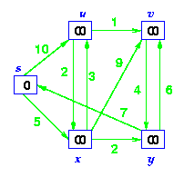

Step 2. First we choose the node, which is closest to the source node, s. We initialize d[s] to 0. Add it to S. Relax all nodes adjacent to source, s. Update predecessor (see red arrow in diagram below) for all nodes updated.

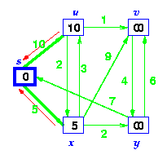

Step 3. Choose the closest node, x. Relax all nodes adjacent to node x. Update predecessors for nodes u, v and y (again notice red arrows in diagram below).

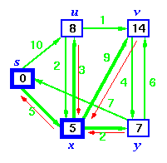

Step 4. Now, node y is the closest node, so add it to S. Relax node v and adjust its predecessor (red arrows remember!).

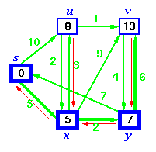

Step 5. Now we have node u that is closest. Choose this node and adjust its neighbor node v.

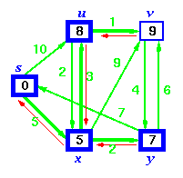

Step 6. Finally, add node v. The predecessor list now defines the shortest path from each node to the source node, s.

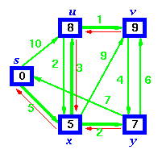

## Explanation – Shortest Path using Dijkstra’s Algorithm

The idea of the algorithm is very simple.

1. It maintains a list of unvisited vertices.
2. It chooses a vertex (the source) and assigns a maximum possible cost (i.e. infinity) to every other vertex.
3. The cost of the source remains zero as it actually takes nothing to reach from the source vertex to itself.
4. In every subsequent step of the algorithm it tries to improve(minimize) the cost for each vertex. Here the cost can be distance, money or time taken to reach that vertex from the source vertex. The minimization of cost is a multi-step process.
   1. For each unvisited neighbor (vertex 2, vertex 3, vertex 4) of the current vertex (vertex 1) calculate the new cost from the vertex (vertex 1).
   2. For e.g. the new cost of vertex 2 is calculated as the minimum of the two ( (existing cost of vertex 2) or (sum of cost of vertex 1 + the cost of edge from vertex 1 to vertex 2) )
5. When all the neighbors of the current node are considered, it marks the current node as visited and is removed from the unvisited list.
6. Select a vertex from the list of unvisited nodes (which has the smallest cost) and repeat step 4.
7. At the end there will be no possibilities to improve it further and then the algorithm ends

For demonstration we will consider the below graph:  
[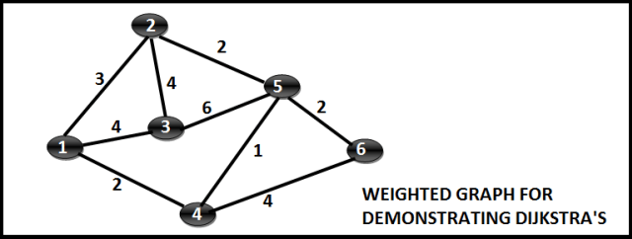](http://i1.wp.com/techieme.in/wp-content/uploads/DJK_0.png)

## Step Wise Execution

##### **Step 1:**

Mark Vertex 1 as the source vertex. Assign a cost zero to Vertex 1 and (infinite to all other vertices). The state is as follows:  
[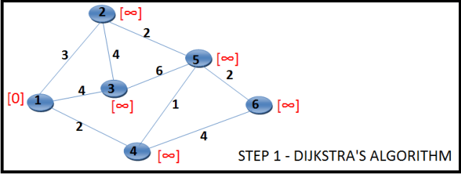](http://i2.wp.com/techieme.in/wp-content/uploads/DJK_1.png)

##### **Step 2:**

For each of the unvisited neighbors (Vertex 2, Vertex 3 and Vertex 4) calculate the minimum cost as min(current cost of vertex under consideration, sum of cost of vertex 1 and connecting edge). Mark Vertex 1 as visited , in the diagram we border it black. The new state would be as follows:  
[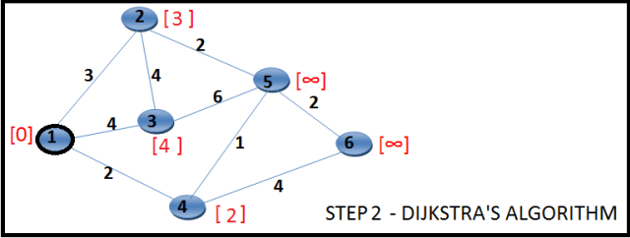](http://i1.wp.com/techieme.in/wp-content/uploads/DJK_2.png)

##### **Step 3:**

Choose the unvisited vertex with minimum cost (vertex 4) and consider all its unvisited neighbors (Vertex 5 and Vertex 6) and calculate the minimum cost for both of them. The state is as follows:  
[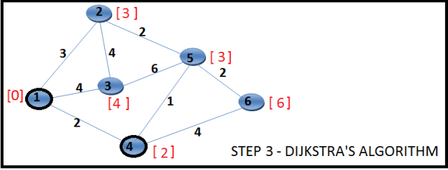](http://i0.wp.com/techieme.in/wp-content/uploads/DJK_3.png)

##### **Step 4:**

Choose the unvisited vertex with minimum cost (vertex 2 or vertex 5, here we choose vertex 2) and consider all its unvisited neighbors (Vertex 3 and Vertex 5) and calculate the minimum cost for both of them. Now, the current cost of Vertex 3 is [4] and the sum of (cost of Vertex 2 + cost of edge (2,3) ) is 3 + 4 = [7]. Minimum of 4, 7 is 4. Hence the cost of vertex 3 won’t change. By the same argument the cost of vertex 5 will not change. We just mark the vertex 2 as visited, all the costs remain same. The state is as follows:  
[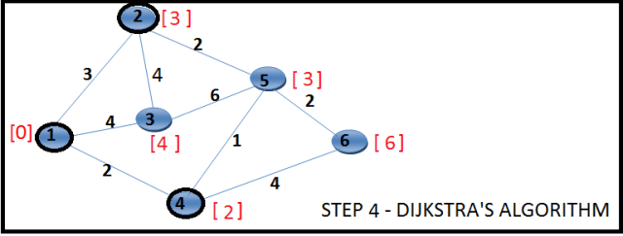](http://i0.wp.com/techieme.in/wp-content/uploads/DJK_4.png)

##### **Step 5:**

Choose the unvisited vertex with minimum cost (vertex 5) and consider all its unvisited neighbors (Vertex 3 and Vertex 6) and calculate the minimum cost for both of them. Now, the current cost of Vertex 3 is [4] and the sum of (cost of Vertex 5 + cost of edge (5,3) ) is 3 + 6 = [9]. Minimum of 4, 9 is 4. Hence the cost of vertex 3 won’t change. Now, the current cost of Vertex 6 is [6] and the sum of (cost of Vertex 5 + cost of edge (3,6) ) is 3 + 2 = [5]. Minimum of 6, 5 is 45. Hence the cost of vertex 6 changes to 5. The state is as follows:  
[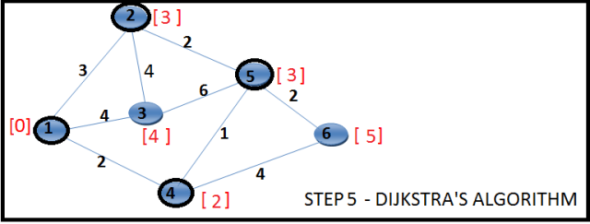](http://i0.wp.com/techieme.in/wp-content/uploads/DJK_5.png)

##### **Step 6:**

Choose the unvisited vertex with minimum cost (vertex 3) and consider all its unvisited neighbors (none). So mark it visited. The state is as follows:  
[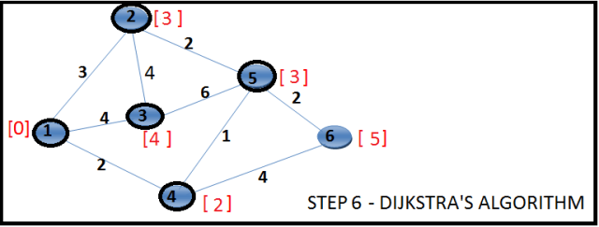](http://i1.wp.com/techieme.in/wp-content/uploads/DJK_6.png)

##### **Step 7:**

Choose the unvisited vertex with minimum cost (vertex 6) and consider all its unvisited neighbors (none). So mark it visited. The state is as follows:  
[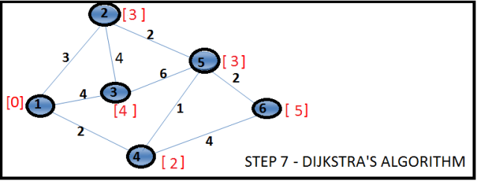](http://i2.wp.com/techieme.in/wp-content/uploads/DJK_7.png)

Now there is no unvisited vertex left and the execution ends. At the end we know the shortest paths for all the vertices from the source vertex 1. Even if we know the shortest path length, we do not know the exact list of vertices which contributes to the shortest path until we maintain them separately or the data structure supports it.

## Pseudo Code



|  |  |
| --- | --- |
| 1  2  3  4  5  6  7  8  9  10  11  12  13  14  15  16 | function dijkstra(G, S)  dist[source] <- 0  previous[source] <- NULL  for each vertex V in G  if V NOT S  dist[V] <- infinite  previous[V] <- NULL  ADD V to Q \\ if we choose the Q as a Priority Queue, extracting minimum will be easy.  while Q IS NOT EMPTY  U <- Extract MIN from Q  for each unvisited neighbour V of U  tempDist <- dist[U] + edge_weight(U, V)  if tempDist < dist[V]     dist[V] <- tempDist     previous[V] <- U  return dist[], previous[] |

## Source Code – Shortest Path using Dijkstra’s Algorithm

|  |  |
| --- | --- |
| 1  2  3  4  5  6  7  8  9  10  11  12  13  14  15  16  17  18  19  20  21  22  23  24  25  26 | public class Dijkstra {        public void dijkstra(Vertex source, List vertices) {          source.min = 0;          PriorityQueue Q = new PriorityQueue();          for(Vertex v : vertices){              Q.add(v);          }            while (!Q.isEmpty()) {              Vertex u = Q.poll();                // Visit each edge exiting u              for (Edge e : u.incidentEdges) {                  Vertex v = e.end;                  int weight = e.weight;                  int tempDistance = u.min + weight;                  if (tempDistance &lt; v.min) {                      Q.remove(v); // remove to re-insert it in the queue with the new cost.                      v.min = tempDistance;                      v.previous = u;                      Q.add(v);                  }              }          }      } |

## Analysis of the algorithm

The outer loop runs for |V| times  
The inner loop runs for |V-1| times for a complete graph as each vertex has |V-1| edges.  
Also, for each iteration of the inner loop we do an extractMin and a reduceKey operation for the vertex.  
Hence the total running time has an upper bound of O(|V| * |V-1|). This is the upper bound, O(|V|2)

# Dynamic Programming | Set 16 (Floyd Warshall Algorithm)

The [Floyd Warshall Algorithm](http://en.wikipedia.org/wiki/Floyd%E2%80%93Warshall_algorithm) is for solving the All Pairs Shortest Path problem. The problem is to find shortest distances between every pair of vertices in a given edge weighted directed Graph.

Example:

**Input:**

graph[][] = { {0, 5, INF, 10},

{INF, 0, 3, INF},

{INF, INF, 0, 1},

{INF, INF, INF, 0} }

which represents the following graph

10

(0)------->(3)

| /|\

5 | |

| | 1

\|/ |

(1)------->(2)

3

Note that the value of graph[i][j] is 0 if i is equal to j

And graph[i][j] is INF (infinite) if there is no edge from vertex i to j.

**Output:**

Shortest distance matrix

0 5 8 9

INF 0 3 4

INF INF 0 1

INF INF INF 0

**Floyd Warshall Algorithm**  
We initialize the solution matrix same as the input graph matrix as a first step. Then we update the solution matrix by considering all vertices as an intermediate vertex. The idea is to one by one pick all vertices and update all shortest paths which include the picked vertex as an intermediate vertex in the shortest path. When we pick vertex number k as an intermediate vertex, we already have considered vertices {0, 1, 2, .. k-1} as intermediate vertices. For every pair (i, j) of source and destination vertices respectively, there are two possible cases.  
**1)** k is not an intermediate vertex in shortest path from i to j. We keep the value of dist[i][j] as it is.  
**2)** k is an intermediate vertex in shortest path from i to j. We update the value of dist[i][j] as dist[i][k] + dist[k][j].

The following figure is taken from the Cormen book. It shows the above optimal substructure property in the all-pairs shortest path problem.

[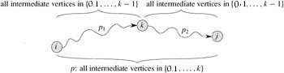](http://degottd575b1t.cloudfront.net/wp-content/uploads/Floyd-Warshell1.jpg)

Following is implementations of the Floyd Warshall algorithm.

|  |
| --- |
| // C Program for Floyd Warshall Algorithm  #include<stdio.h>    // Number of vertices in the graph  #define V 4    /* Define Infinite as a large enough value. This value will be used    for vertices not connected to each other */  #define INF 99999    // A function to print the solution matrix  void printSolution(int dist[][V]);    // Solves the all-pairs shortest path problem using Floyd Warshall algorithm  void floydWarshall (int graph[][V])  {      /* dist[][] will be the output matrix that will finally have the shortest        distances between every pair of vertices */      int dist[V][V], i, j, k;        /* Initialize the solution matrix same as input graph matrix. Or         we can say the initial values of shortest distances are based         on shortest paths considering no intermediate vertex. */      for (i = 0; i < V; i++)          for (j = 0; j < V; j++)              dist[i][j] = graph[i][j];        /* Add all vertices one by one to the set of intermediate vertices.        ---> Before start of a iteration, we have shortest distances between all        pairs of vertices such that the shortest distances consider only the        vertices in set {0, 1, 2, .. k-1} as intermediate vertices.        ----> After the end of a iteration, vertex no. k is added to the set of        intermediate vertices and the set becomes {0, 1, 2, .. k} */      for (k = 0; k < V; k++)      {          // Pick all vertices as source one by one          for (i = 0; i < V; i++)          {              // Pick all vertices as destination for the              // above picked source              for (j = 0; j < V; j++)              {                  // If vertex k is on the shortest path from                  // i to j, then update the value of dist[i][j]                  if (dist[i][k] + dist[k][j] < dist[i][j])                      dist[i][j] = dist[i][k] + dist[k][j];              }          }      }        // Print the shortest distance matrix      printSolution(dist);  }    /* A utility function to print solution */  void printSolution(int dist[][V])  {      printf ("Following matrix shows the shortest distances"              " between every pair of vertices \n");      for (int i = 0; i < V; i++)      {          for (int j = 0; j < V; j++)          {              if (dist[i][j] == INF)                  printf("%7s", "INF");              else                  printf ("%7d", dist[i][j]);          }          printf("\n");      }  }    // driver program to test above function  int main()  {      /* Let us create the following weighted graph              10         (0)------->(3)          |         /|\        5 |          |          |          | 1         \|/         |         (1)------->(2)              3           */      int graph[V][V] = { {0,   5,  INF, 10},                          {INF, 0,   3, INF},                          {INF, INF, 0,   1},                          {INF, INF, INF, 0}                        };        // Print the solution      floydWarshall(graph);      return 0;  } |

Output:

Following matrix shows the shortest distances between every pair of vertices

0 5 8 9

INF 0 3 4

INF INF 0 1

INF INF INF 0

Time Complexity: O(V^3)

The above program only prints the shortest distances. We can modify the solution to print the shortest paths also by storing the predecessor information in a separate 2D matrix.  
Also, the value of INF can be taken as INT_MAX from limits.h to make sure that we handle maximum possible value. When we take INF as INT_MAX, we need to change the if condition in the above program to avoid arithmatic overflow.

#include <limits.h>

#define INF INT_MAX

..........................

if ( dist[i][k] != INF &&

dist[k][j] != INF &&

dist[i][k] + dist[k][j] < dist[i][j]

)

dist[i][j] = dist[i][k] + dist[k][j];

Floyd-Warshall algorithm is a procedure, which is used to find the shorthest (longest) paths among all pairs of nodes in a graph, which does not contain any cycles of negative lenght. The main advantage of Floyd-Warshall algorithm is its simplicity.

## Description

Floyd-Warshall algorithm uses a matrix of lengths  as its input. If there is an edge between nodes  and , than the matrix  contains its length at the corresponding coordinates. The diagonal of the matrix contains only zeros. If there is no edge between edges  and , than the position  contains positive infinity. In other words, the matrix represents lengths of all paths between nodes that does not contain any intermediate node.

In each iteration of Floyd-Warshall algorithm is this matrix recalculated, so it contains lengths of paths among all pairs of nodes using gradually enlarging set of intermediate nodes. The matrix , which is created by the first iteration of the procedure, contains paths among all nodes using exactly one (predefined) intermediate node.  contains lengths using two predefined intermediate nodes. Finally the matrix  uses  intermediate nodes.

This transformation can be described using the following recurrent formula:

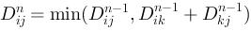

Because this transformation never rewrites elements, which are to be used to calculate the new matrix, we can use the same matrix for both  and .

### Code

procedure [array] FloydWarshall(D, P)

for k in 1 to n do

for i in 1 to n do

for j in 1 to n do

if D[i][j] > D[i][k] + D[k][j] then

D[i][j] = D[i][k] + D[k][j]

P[i][j] = P[k][j]

return P

01./**

02.* Floyd-Warshall algorithm. Finds all shortest paths among all pairs of nodes

03.* @param d matrix of distances (Integer.MAX_VALUE represents positive infinity)

04.* @return matrix of predecessors

05.*/

06.public static int[][] floydWarshall(int[][] d) {

07.int[][] p = constructInitialMatixOfPredecessors(d);

08.for (int k = 0; k < d.length; k++) {

09.for (int i = 0; i < d.length; i++) {

10.for (int j = 0; j < d.length; j++) {

11.if (d[i][k] == Integer.MAX_VALUE || d[k][j] == Integer.MAX_VALUE) {

12.continue;

13.}

14.

15.if (d[i][j] > d[i][k] + d[k][j]) {

16.d[i][j] = d[i][k] + d[k][j];

17.p[i][j] = p[k][j];

18.}

19.

20.}

21.}

22.}

23.return p;

24.}

25.

26./**

27.* Constructs matrix P0

28.* @param d matrix of lengths

29.* @return P0

30.*/

31.private static int[][] constructInitialMatixOfPredecessors(int[][] d) {

32.int[][] p = new int[d.length][d.length];

33.for (int i = 0; i < d.length; i++) {

34.for (int j = 0; j < d.length; j++) {

35.if (d[i][j] != 0 && d[i][j] != Integer.MAX_VALUE) {

36.p[i][j] = i;

37.} else {

38.p[i][j] = -1;

39.}

40.}

41.}

42.return p;

43.}

**Linear Search Algorithm  
(Sequential Search)**

**What is Search?**

Search is a process of finding a value in a list of values. In other words, searching is the process of locating given value position in a list of values.

**Linear Search Algorithm (Sequential Search Algorithm)**

Linear search algorithm finds given element in a list of elements with **O(n)** time complexity where **n** is total number of elements in the list. This search process starts comparing of search element with the first element in the list. If both are matching then results with element found otherwise search element is compared with next element in the list. If both are matched, then the result is "element found". Otherwise, repeat the same with the next element in the list until search element is compared with last element in the list, if that last element also doesn't match, then the result is "Element not found in the list". That means, the search element is compared with element by element in the list.  
  
Linear search is implemented using following steps...

* **Step 1:** Read the search element from the user
* **Step 2:** Compare, the search element with the first element in the list.
* **Step 3:** If both are matching, then display "Given element found!!!" and terminate the function
* **Step 4:** If both are not matching, then compare search element with the next element in the list.
* **Step 5:** Repeat steps 3 and 4 until the search element is compared with the last element in the list.
* **Step 6:** If the last element in the list is also doesn't match, then display "Element not found!!!" and terminate the function.

**Example**

Consider the following list of element and search element...

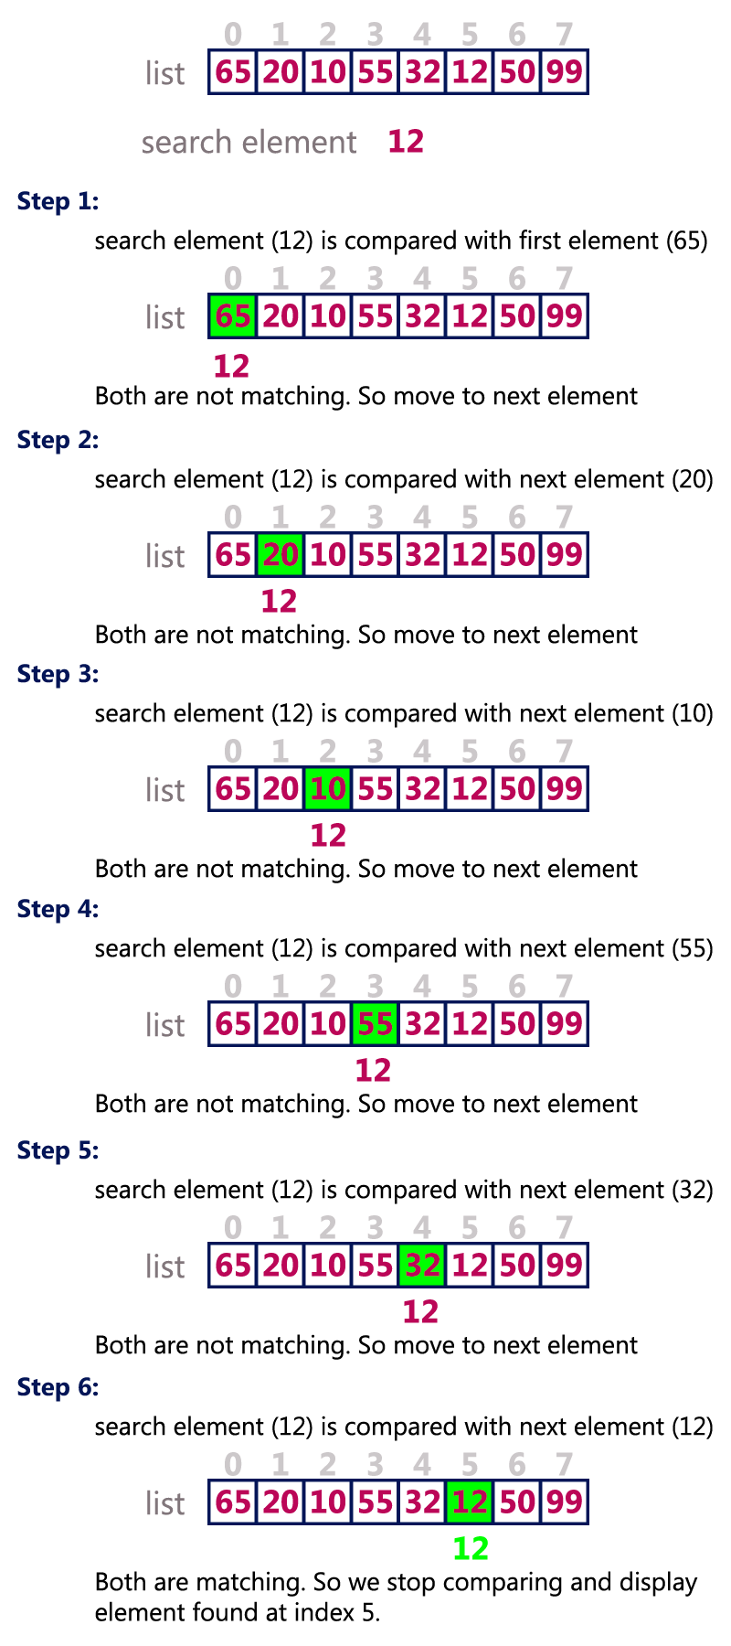

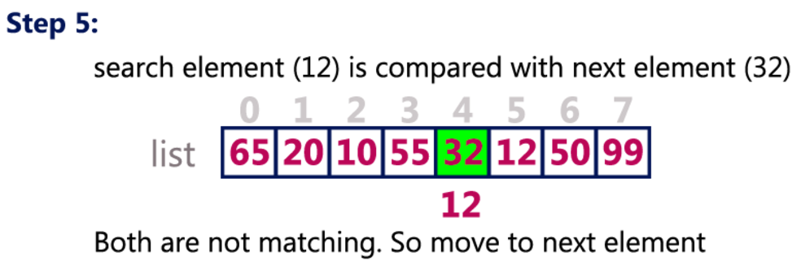

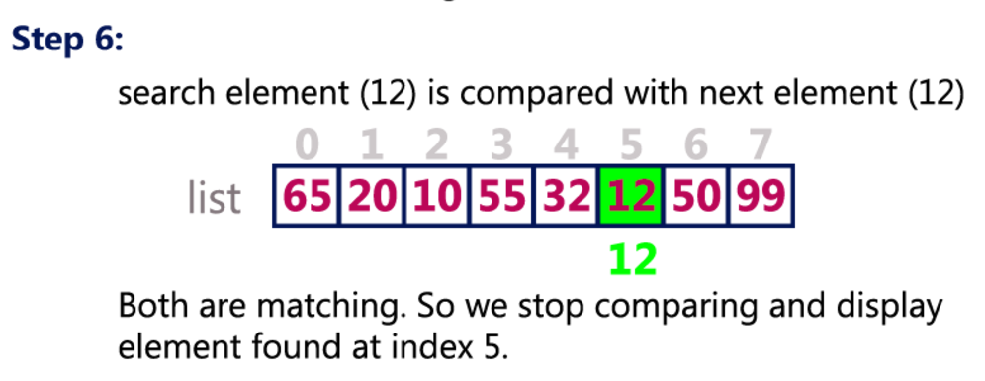

**Binary Search Algorithm**

**What is Search?**

Search is a process of finding a value in a list of values. In other words, searching is the process of locating given value position in a list of values.

**Binary Search Algorithm**

Binary search algorithm finds given element in a list of elements with **O(log n)** time complexity where **n** is total number of elements in the list. The binary search algorithm can be used with only sorted list of element. That means, binary search can be used only with lkist of element which are already arraged in a order. The binary search can not be used for list of element which are in random order. This search process starts comparing of the search element with the middle element in the list. If both are matched, then the result is "element found". Otherwise, we check whether the search element is smaller or larger than the middle element in the list. If the search element is smaller, then we repeat the same process for left sublist of the middle element. If the search element is larger, then we repeat the same process for right sublist of the middle element. We repeat this process until we find the search element in the list or until we left with a sublist of only one element. And if that element also doesn't match with the search element, then the result is "Element not found in the list".  
  
Binary search is implemented using following steps...

* **Step 1:** Read the search element from the user
* **Step 2:** Find the middle element in the sorted list
* **Step 3:** Compare, the search element with the middle element in the sorted list.
* **Step 4:** If both are matching, then display "Given element found!!!" and terminate the function
* **Step 5:** If both are not matching, then check whether the search element is smaller or larger than middle element.
* **Step 6:** If the search element is smaller than middle element, then repeat steps 2, 3, 4 and 5 for the left sublist of the middle element.
* **Step 7:** If the search element is larger than middle element, then repeat steps 2, 3, 4 and 5 for the right sublist of the middle element.
* **Step 8:** Repeat the same process until we find the search element in the list or until sublist contains only one element.
* **Step 9:** If that element also doesn't match with the search element, then display "Element not found in the list!!!" and terminate the function.

**Example**

Consider the following list of element and search element...

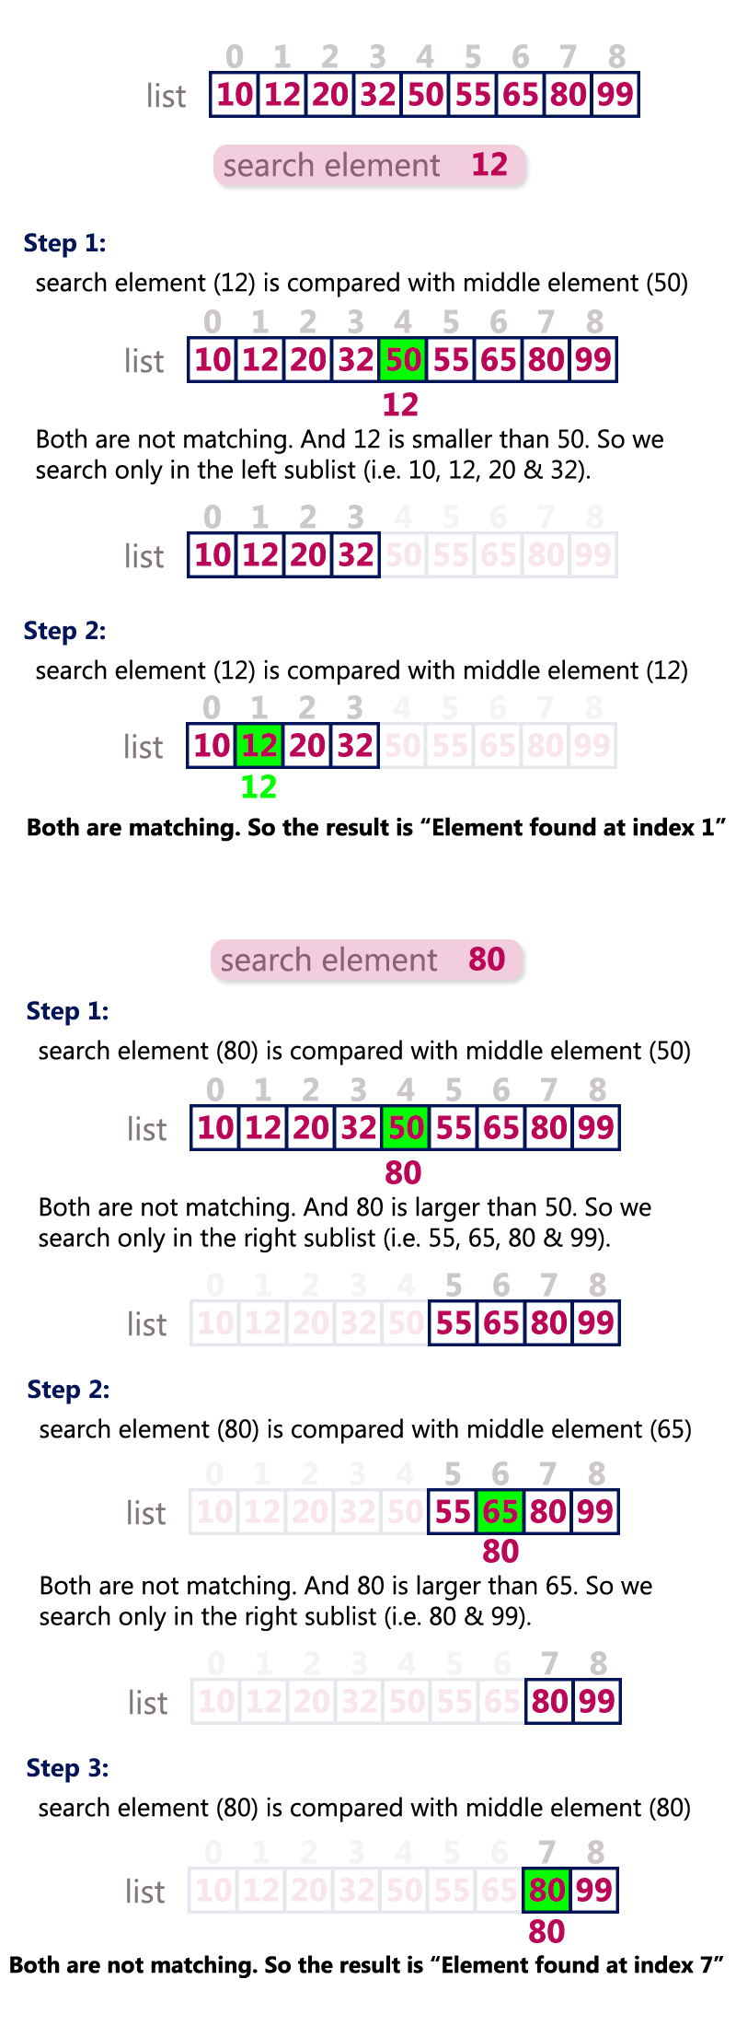

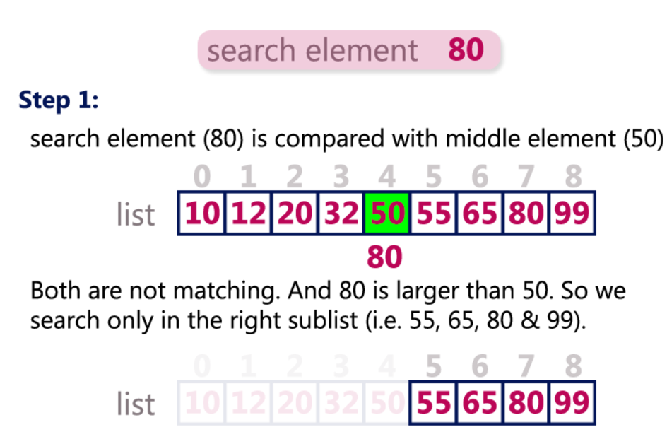

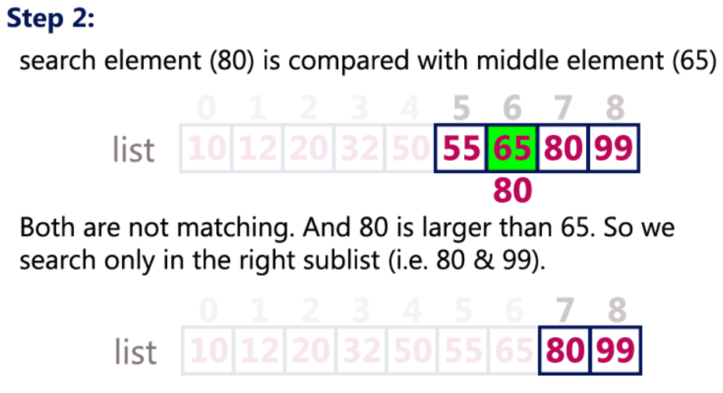

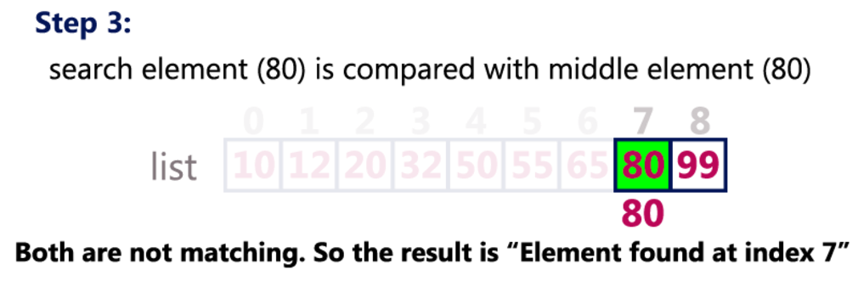

**Insertion Sort**

Sorting is the process of arranging a list of elements in a particular order (Ascending or Descending).  
  
Insertion sort algorithm arranges a list of elements in a particular order. In insertion sort algorithm, every iteration moves an element from unsorted portion to sorted portion until all the elements are sorted in the list.

Step by Step Process

The insertion sort algorithm is performed using following steps...

* **Step 1:** Asume that first element in the list is in sorted portion of the list and remaining all elements are in unsorted portion.
* **Step 2:** Consider first element from the unsorted list and insert that element into the sorted list in order specified.
* **Step 3:** Repeat the above process until all the elements from the unsorted list are moved into the sorted list.

Sorting Logic

Following is the sample code for insrtion sort...

//Insertion sort logic

for i = 1 to size-1 {

temp = list[i];

j = i;

while ((temp < list[j]) && (j > 0)) {

list[j] = list[j-1];

j = j - 1;

}

list[j] = temp;

}

Example

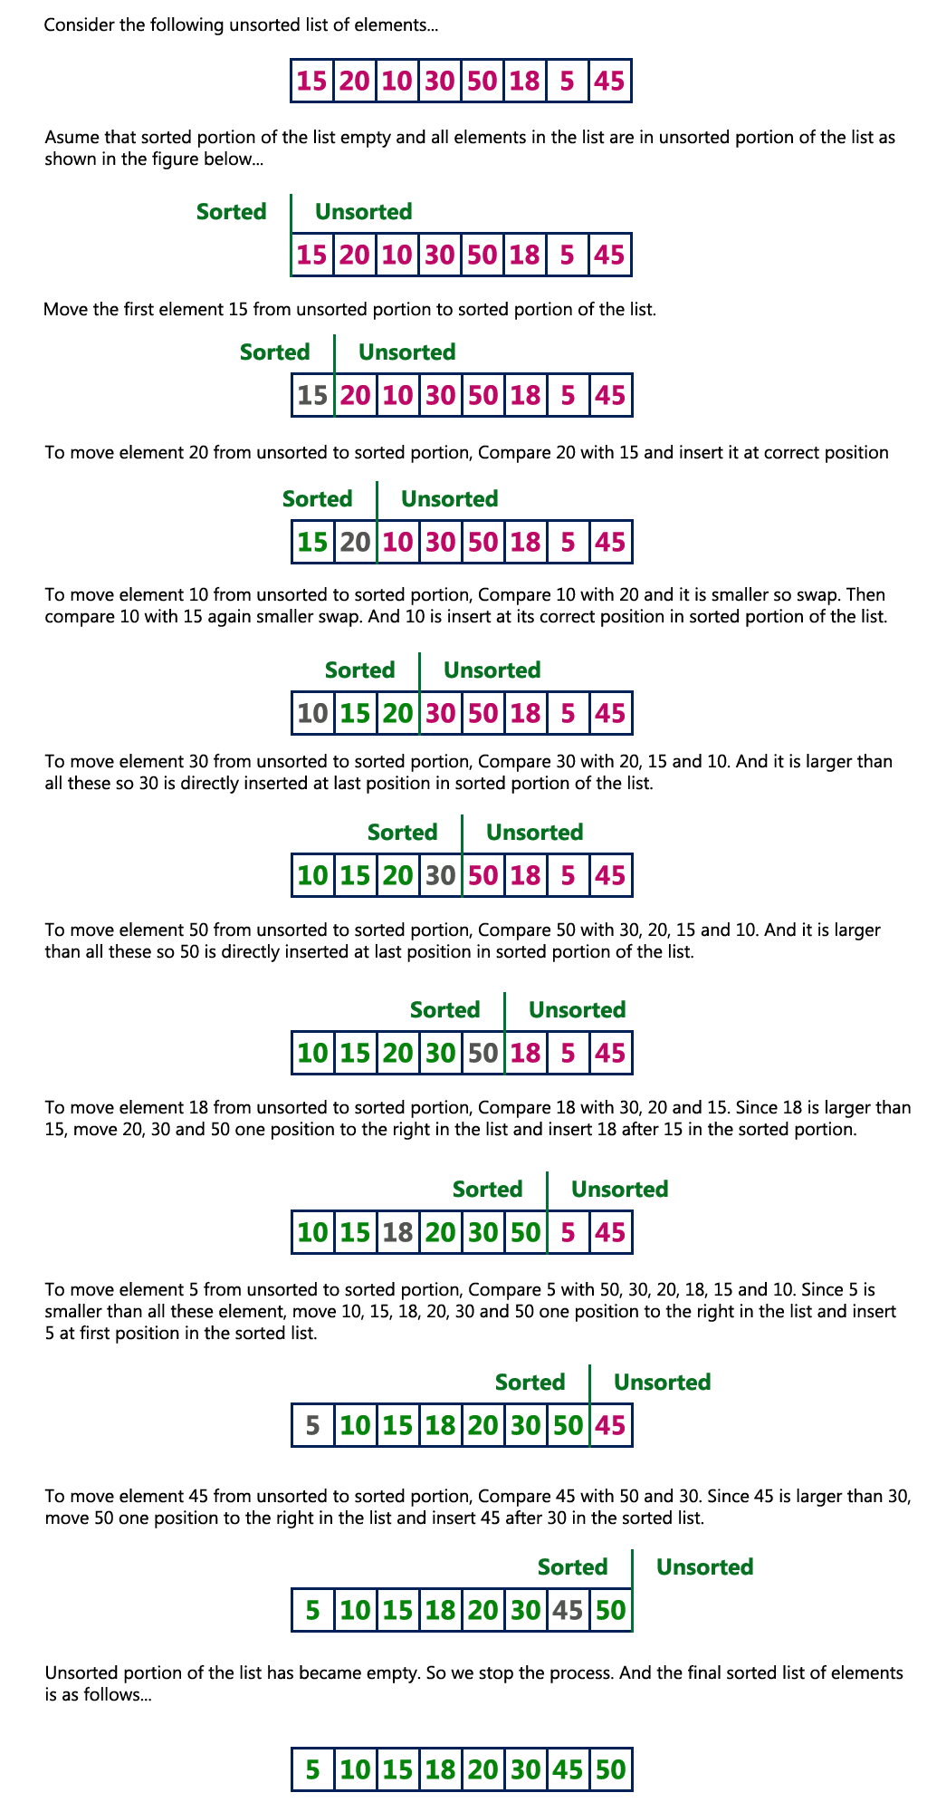

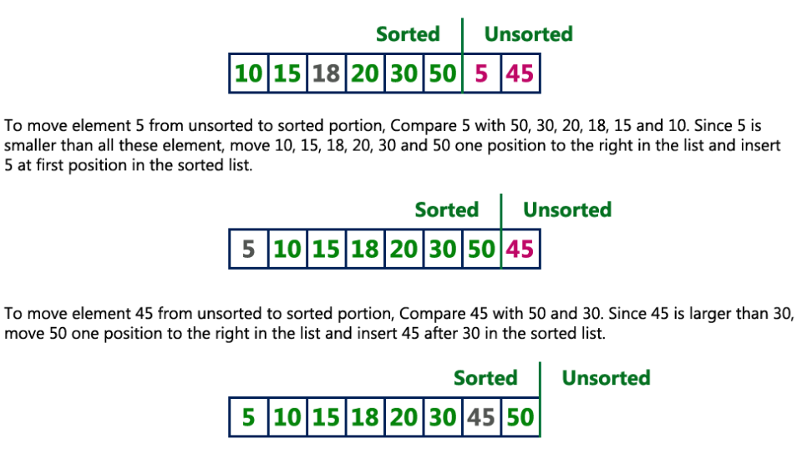

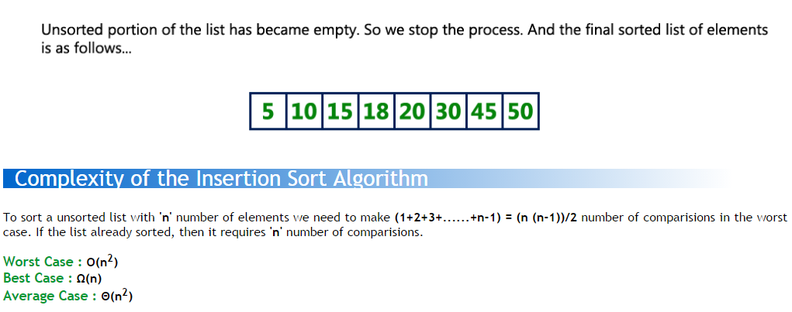

**Selection Sort**

Selection Sort algorithm is used to arrange a list of elements in a particular order (Ascending or Descending). In selection sort, the first element in the list is selected and it is compared repeatedly with remaining all the elements in the list. If any element is smaller than the selected element (for Ascending order), then both are swapped. Then we select the element at second position in the list and it is compared with remaining all elements in the list. If any element is smaller than the selected element, then both are swapped. This procedure is repeated till the entire list is sorted.

Step by Step Process

The selection sort algorithm is performed using following steps...

* **Step 1:** Select the first element of the list (i.e., Element at first position in the list).
* **Step 2:** Compare the selected element with all other elements in the list.
* **Step 3:** For every comparision, if any element is smaller than selected element (for Ascending order), then these two are swapped.
* **Step 4:** Repeat the same procedure with next position in the list till the entire list is sorted.

Sorting Logic

Following is the sample code for selection sort...

//Selection sort logic

for(i=0; i<size; i++){

for(j=i+1; j<size; j++){

if(list[i] > list[j])

{

temp=list[i];

list[i]=list[j];

list[j]=temp;

}

}

}

Example

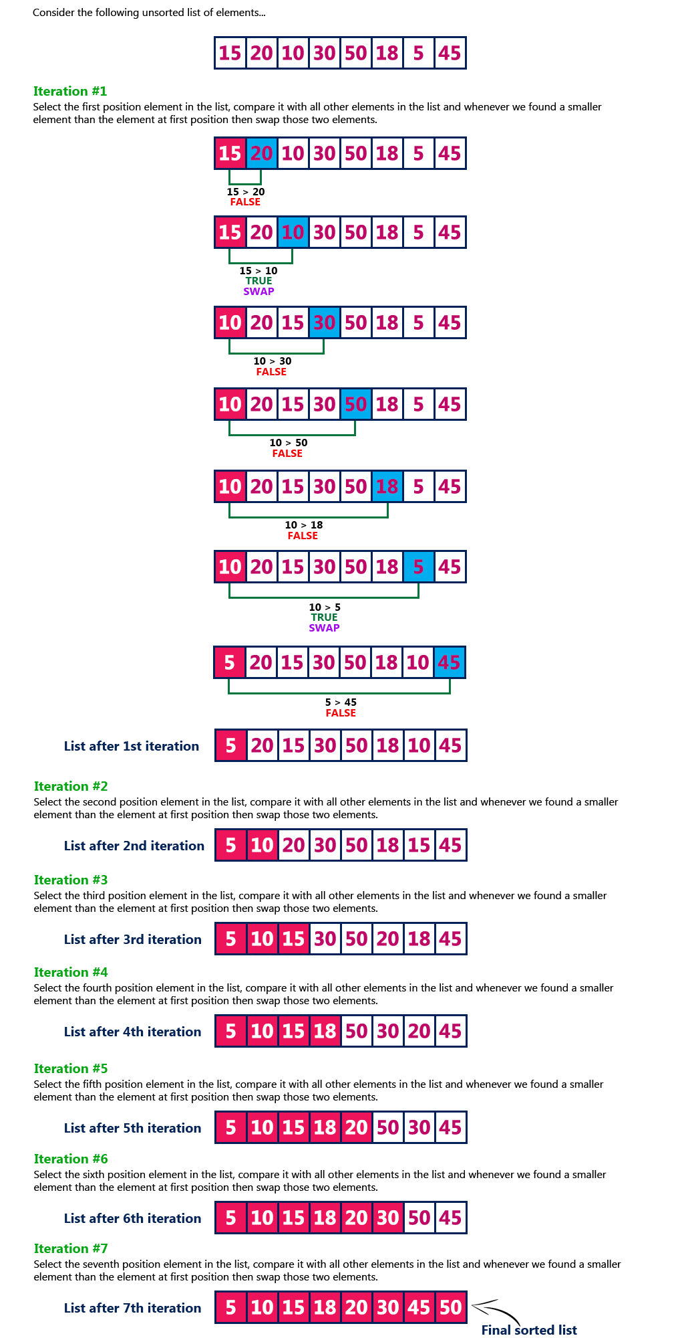

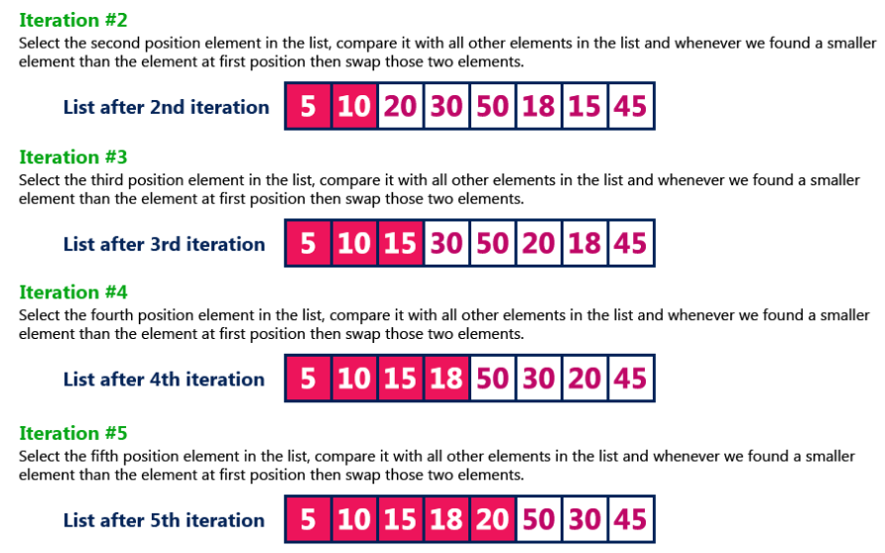

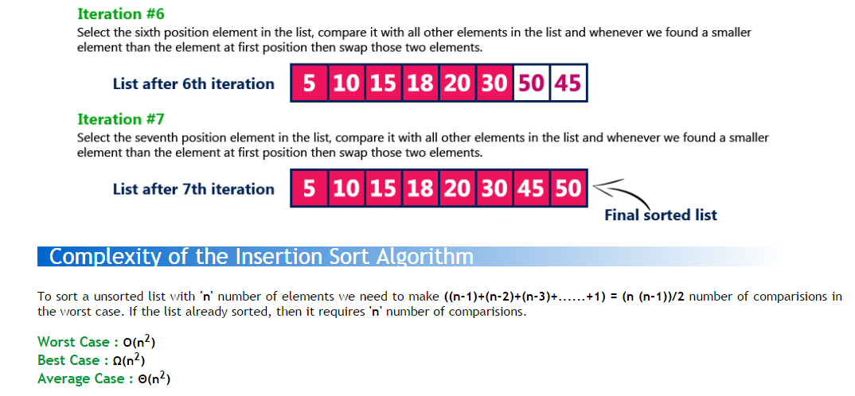

# Binary Search Tree

In a binary tree, every node can have maximum of two children but there is no order of nodes based on their values. In binary tree, the elements are arranged as they arrive to the tree, from top to bottom and left to right.  
  
A binary tree has the following time complexities...

1. **Search Operation - O(n)**
2. **Insertion Operation - O(1)**
3. **Deletion Operation - O(n)**

To enhance the performance of binary tree, we use special type of binary tree known as **Binary Search Tree**. Binary search tree mainly focus on the search operation in binary tree. Binary search tree can be defined as follows...

**Binary Search Tree is a binary tree in which every node contains only smaller values in its left subtree and only larger values in its right subtree.**

In a binary search tree, all the nodes in left subtree of any node contains smaller values and all the nodes in right subtree of that contains larger values as shown in following figure...

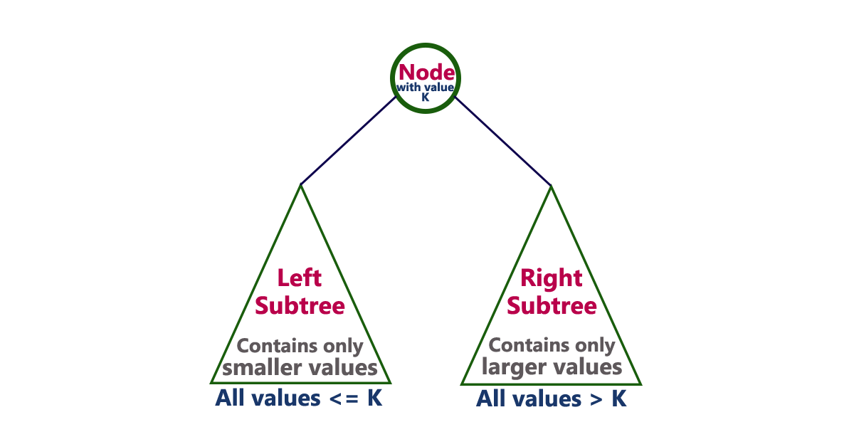

# Example

The following tree is a Binary Search Tree. In this tree, left subtree of every node contains nodes with smaller values and right subtree of every node contains larger values.

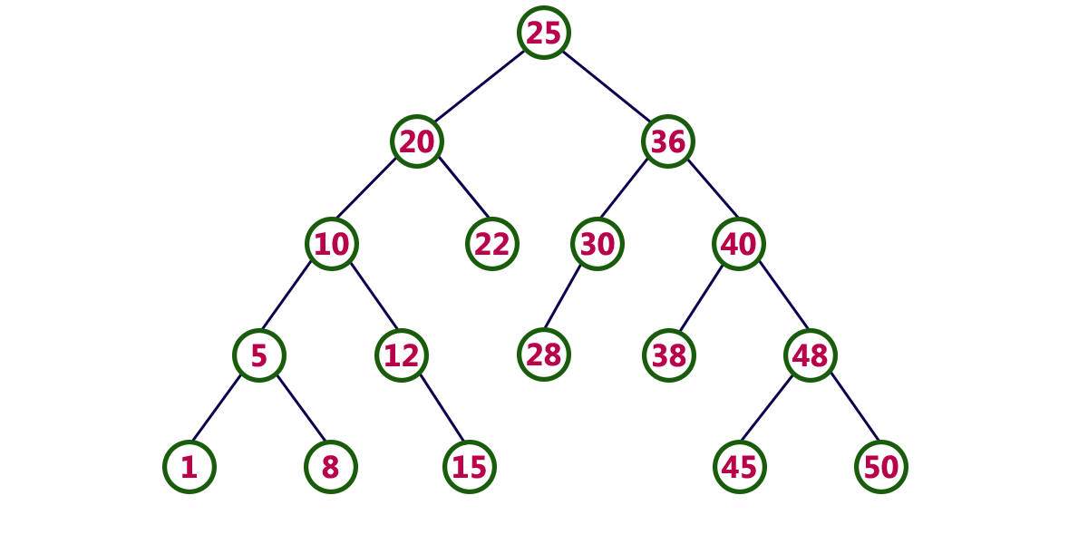

**Every Binary Search Tree is a binary tree but all the Binary Trees need not to be binary search trees.**

# Operations on a Binary Search Tree

The following operations are performed on a binary earch tree...

1. **Search**
2. **Insertion**
3. **Deletion**

# Search Operation in BST

In a binary search tree, the search operation is performed with **O(log n)** time complexity. The search operation is performed as follows...

* **Step 1:** Read the search element from the user
* **Step 2:** Compare, the search element with the value of root node in the tree.
* **Step 3:** If both are matching, then display "Given node found!!!" and terminate the function
* **Step 4:** If both are not matching, then check whether search element is smaller or larger than that node value.
* **Step 5:** If search element is smaller, then continue the search process in left subtree.
* **Step 6:** If search element is larger, then continue the search process in right subtree.
* **Step 7:** Repeat the same until we found exact element or we completed with a leaf node
* **Step 8:** If we reach to the node with search value, then display "Element is found" and terminate the function.
* **Step 9:** If we reach to a leaf node and it is also not matching, then display "Element not found" and terminate the function.

# Insertion Operation in BST

In a binary search tree, the insertion operation is performed with **O(log n)** time complexity. In binary search tree, new node is always inserted as a leaf node. The insertion operation is performed as follows...

* **Step 1:** Create a newNode with given value and set its **left** and **right** to **NULL**.
* **Step 2:** Check whether tree is Empty.
* **Step 3:** If the tree is **Empty**, then set set **root** to **newNode**.
* **Step 4:** If the tree is **Not Empty**, then check whether value of newNode is **smaller** or **larger** than the node (here it is root node).
* **Step 5:** If newNode is **smaller** than **or equal** to the node, then move to its **left** child. If newNode is **larger** than the node, then move to its **right** child.
* **Step 6:** Repeat the above step until we reach to a **leaf** node (e.i., reach to NULL).
* **Step 7:** After reaching a leaf node, then isert the newNode as **left child** if newNode is **smaller or equal** to that leaf else insert it as **right child**.

# Deletion Operation in BST

In a binary search tree, the deletion operation is performed with **O(log n)** time complexity. Deleting a node from Binary search tree has follwing three cases...

* **Case 1: Deleting a Leaf node (A node with no children)**
* **Case 2: Deleting a node with one child**
* **Case 3: Deleting a node with two children**

# ****Case 1:**** Deleting a leaf node

We use the following steps to delete a leaf node from BST...

* **Step 1:** **Find** the node to be deleted using **search operation**
* **Step 2:** Delete the node using **free** function (If it is a leaf) and terminate the function.

# ****Case 2:**** Deleting a node with one child

We use the following steps to delete a node with one child from BST...

* **Step 1:** **Find** the node to be deleted using **search operation**
* **Step 2:** If it has only one child, then create a link between its parent and child nodes.
* **Step 3:** Delete the node using **free** function and terminate the function.

# ****Case 3:**** Deleting a node with two children

We use the following steps to delete a node with two children from BST...

* **Step 1:** **Find** the node to be deleted using **search operation**
* **Step 2:** If it has two children, then find the **largest** node in its **left subtree** (OR) the **smallest** node in its **right subtree**.
* **Step 3:** **Swap** both **deleting node** and node which found in above step.
* **Step 4:** Then, check whether deleting node came to **case 1** or **case 2** else goto steps 2
* **Step 5:** If it comes to **case 1**, then delete using case 1 logic.
* **Step 6:** If it comes to **case 2**, then delete using case 2 logic.
* **Step 7:** Repeat the same process until node is deleted from the tree.

# Example

Construct a Binary Search Tree by inserting the following sequence of numbers...

#### 10,12,5,4,20,8,7,15 and 13

Above elements are inserted into a Binary Search Tree as follows...

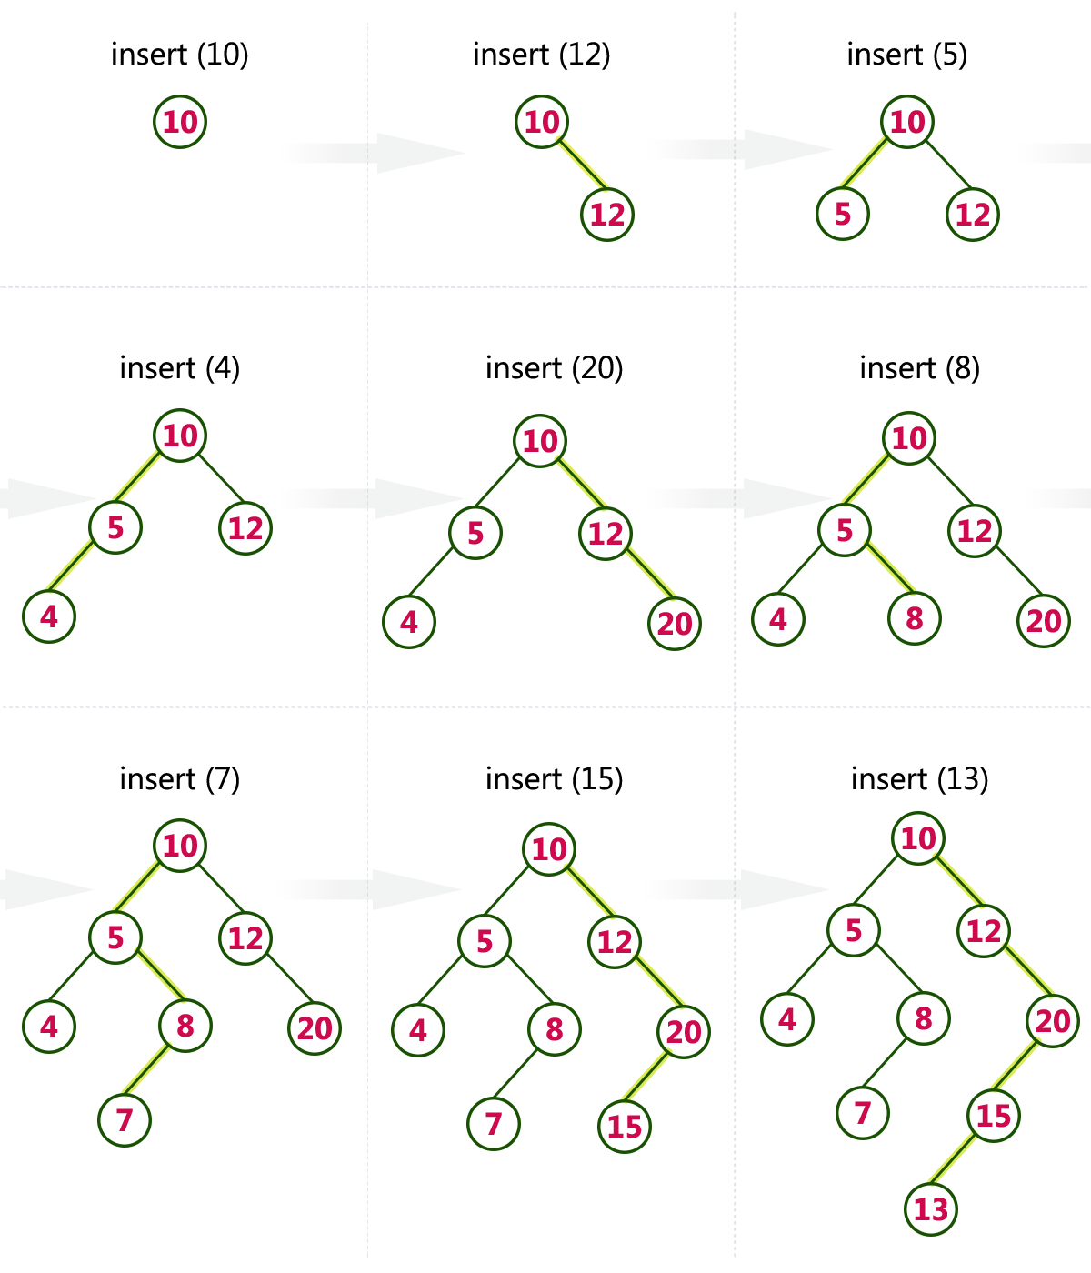

**AVL Tree**

AVL tree is a self balanced binary search tree. That means, an AVL tree is also a binary search tree but it is a balanced tree. A binary tree is said to be balanced, if the difference between the hieghts of left and right subtrees of every node in the tree is either -1, 0 or +1. In other words, a binary tree is said to be balanced if for every node, height of its children differ by at most one. In an AVL tree, every node maintains a extra information known as **balance factor**. The AVL tree was introduced in the year of 1962 by G.M. Adelson-Velsky and E.M. Landis.  
  
An AVL tree is defined as follows...

**An AVL tree is a balanced binary search tree. In an AVL tree, balance factor of every node is either -1, 0 or +1.**

Balance factor of a node is the difference between the heights of left and right subtrees of that node. The balance factor of a node is calculated either **height of left subtree - height of right subtree** (OR) **height of right subtree - height of left subtree**. In the following explanation, we are calculating as follows...

**Balance factor = heightOfLeftSubtree - heightOfRightSubtree**

**Example**

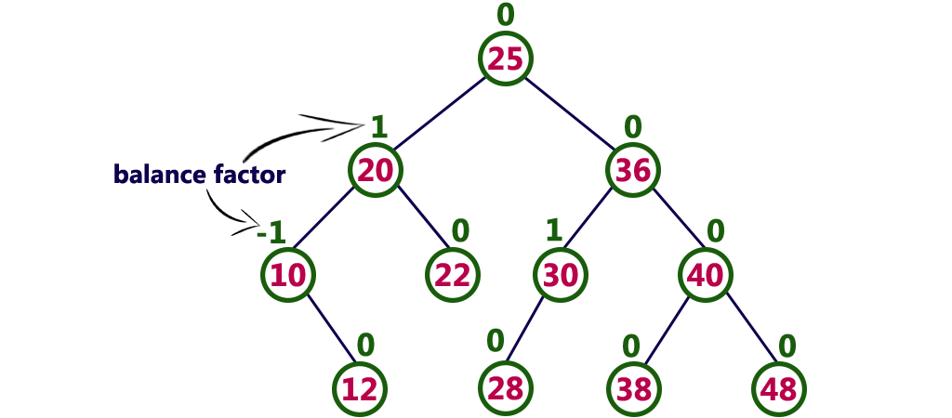

The above tree is a binary search tree and every node is satisfying balance factor condition. So this tree is said to be an AVL tree.

**Every AVL Tree is a binary search tree but all the Binary Search Trees need not to be AVL trees.**

**AVL Tree Rotations**

In AVL tree, after performing every operation like insertion and deletion we need to check the **balance factor** of every node in the tree. If every node satisfies the balance factor condition then we conclude the operation otherwise we must make it balanced. We use **rotation**operations to make the tree balanced whenever the tree is becoming imbalanced due to any operation.  
  
Rotation operations are used to make a tree balanced.

**Rotation is the process of moving the nodes to either left or right to make tree balanced.**

There are **four** rotations and they are classified into **two** types.

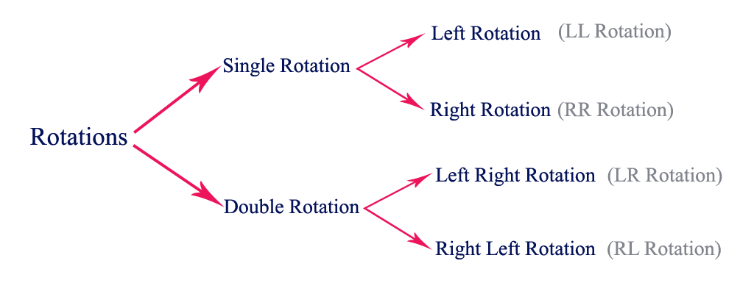

**Single Left Rotation (LL Rotation)**

In LL Rotation every node moves one position to left from the current position. To understand LL Rotation, let us consider following insertion operations into an AVL Tree...

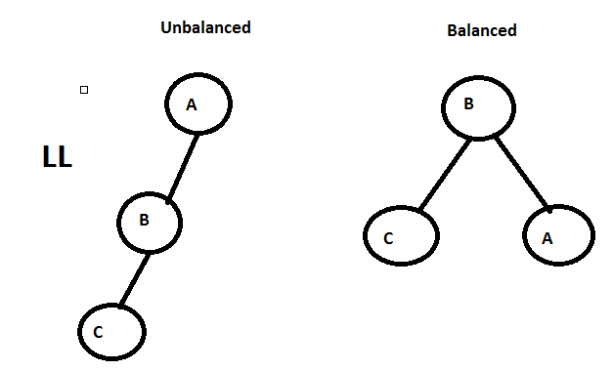

**Single Right Rotation (RR Rotation)**

In RR Rotation every node moves one position to right from the current position. To understand RR Rotation, let us consider following insertion operations into an AVL Tree...

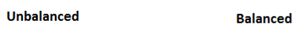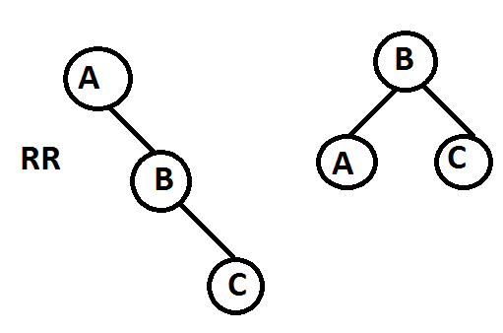

**Left Right Rotation (LR Rotation)**

The LR Rotation is combination of single left rotation followed by single right rotation. In LR Roration, first every node moves one position to left then one position to right from the current position. To understand LR Rotation, let us consider following insertion operations into an AVL Tree...

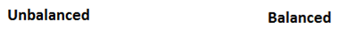

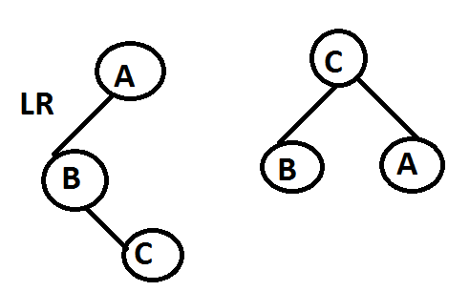

**Right Left Rotation (RL Rotation)**

The RL Rotation is combination of single right rotation followed by single left rotation. In RL Roration, first every node moves one position to right then one position to left from the current position. To understand RL Rotation, let us consider following insertion operations into an AVL Tree...

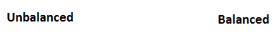

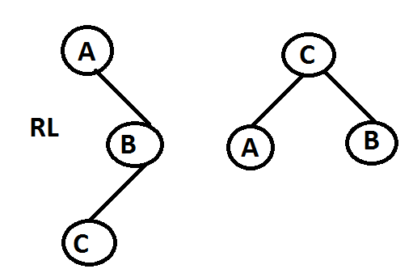

**2-3-4 Trees**

A variation on the B-Tree is a **2-3-4 Tree**, which is a multiway tree in which all non-leaf nodes have 2, 3, or 4 children. Therefore:

1. Each node stores at most 3 values
2. Each internal node is a 2-node, 3-node, or 4-node
3. All the leaves are on the same level

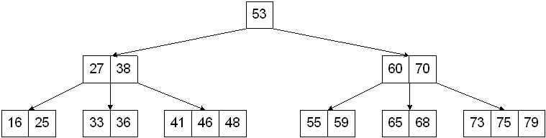

**Processing a 2-3-4 Tree**

Searching is the same as with multiway search trees.

Insertion into a 2-3-4 Tree begins with a single node where values are inserted until it becomes full (ie. until it becomes a 4-node). The next value that is inserted will cause a split into two nodes: one containing values less than the median value and the other containing values greater than the median value. The median value is then stored in the parent node. It's possible that insertion could cause splitting up to the root node.

Insert the values 53, 27, 75, 25, 70, 41, 38, 16, 59, 36, 73, 65, 60, 46, 55, 33, 68, 79, and 48.

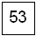

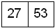

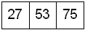

Inserting the 25 results in a split:

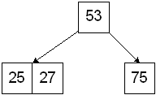

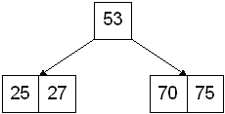

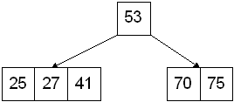

Inserting 38 causes a split:

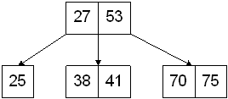

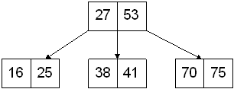

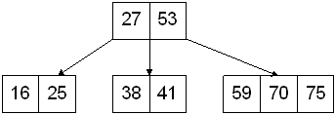

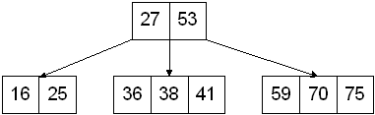

Inserting 73 causes a split:

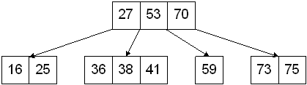

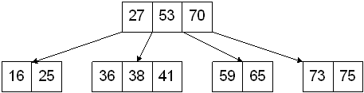

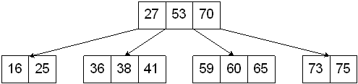

Inserting 46 results in a split that propagates up to the root:

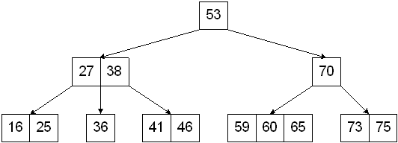

Inserting 55 causes a split:

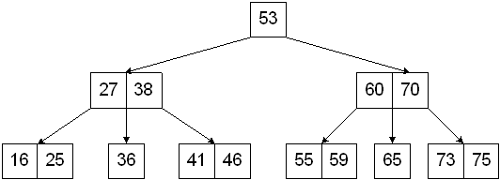

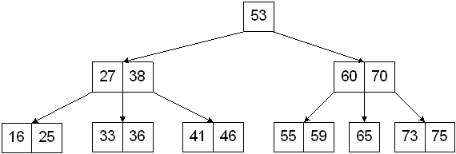

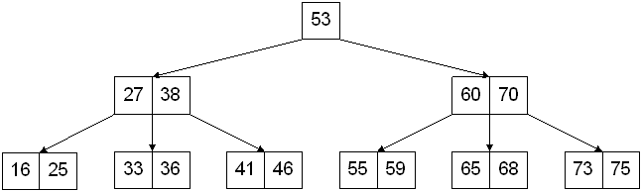

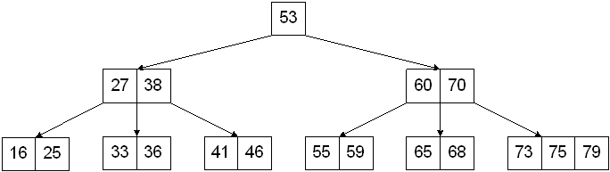

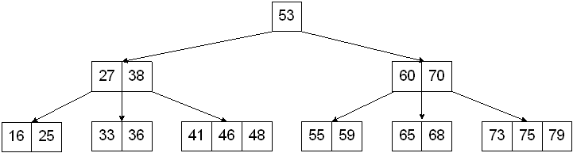

Deletion from a 2-3-4 Tree will always occurs in a leaf node.

* If the value to be deleted is in a leaf node and that node is a 3 or 4-node, then deletion is simple - the value is removed and the node becomes a 2 or 3 node, respectively.
* If the value to be deleted is in a leaf node and that node is a 2 node, then **underflow** occurs. Underflow is "fixed" by transferring a value from the parent node to the node where underflow occurs and transferring a value from a sibling that is a 3 or 4-node. If the node where underflow occurred doesn't have a sibling that is a 3 or 4-node, then **fusion** occurs. The fusion requires the underflow node become a 3-node that contains the value from the sibling node and the separating value from the parent.
* If the value to be deleted is NOT in a leaf node, then it is replaced by its immediate predecessor and the predecessor value is deleted from the tree.

### For a connected, undirected, weighted graph G = (V, E, w) with only nonnegative edge weights, does the predecessor subgraph produced by Dijkstra's Algorithm form a minimum spanning tree of G?

(Note that undirected graphs are a special class of directed graphs, so it is perfectly ok to use Dijkstra's Algorithm on undirected graphs. Furthermore, MST's are defined only for connected, undirected graphs, and are trivial if the graph is not weighted, so we must restrict our inquiry to these graphs.)

A: **Dijkstra's Algorithm** at every step greedily selects the next edge that is closest to some **source vertex s**. It does this until s is connected to every other vertex in the graph. Clearly, the predecessor subgraph that is produced is a spanning tree of G, but is the sum of edge weights minimized?

**Prim's Algorithm**, which is known to produce a minimum spanning tree, is highly similar to Dijkstra's Algorithm, but at each stage it greedily selects the next edge that is closest to **any vertex currently in the working MST at that stage**. Let's use this observation to produce a counterexample.

Counterexample: Consider the undirected graph G = (V, E, w) where

V = { a, b, c, d }

E = { (a,b), (a,c), (a,d), (b,d), (c,d) }

w = { ( (a,b) , 5 ) ( (a,c) , 5 ) ( (a,d) , 5 ) ( (b,d) , 1 ) ( (c,d) , 1 ) }

Take a as the source vertex.

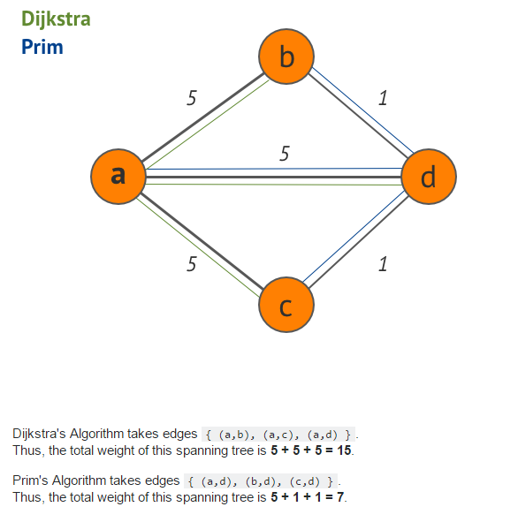

## Introduction to Data Structures

Data Structure is a way of collecting and organising data in such a way that we can perform operations on these data in an effective way. Data Structures is about rendering data elements in terms of some relationship, for better organization and storage. For example, we have data player's name "Virat" and age 26. Here "Virat" is of **String** data type and 26 is of **integer** data type.

We can organize this data as a record like **Player** record. Now we can collect and store player's records in a file or database as a data structure. For example: "Dhoni" 30, "Gambhir" 31, "Sehwag" 33

In simple language, Data Structures are structures programmed to store ordered data, so that various operations can be performed on it easily.

#### Basic types of Data Structures

As we discussed above, anything that can store data can be called as a data strucure, hence Integer, Float, Boolean, Char etc, all are data structures. They are known as **Primitive Data Structures**.

Then we also have some complex Data Structures, which are used to store large and connected data. Some example of **Abstract Data Structure** are :

* Linked List
* Tree
* Graph
* Stack, Queue etc.

All these data structures allow us to perform different operations on data. We select these data structures based on which type of operation is required. We will look into these data structures in more details in our later lessons.

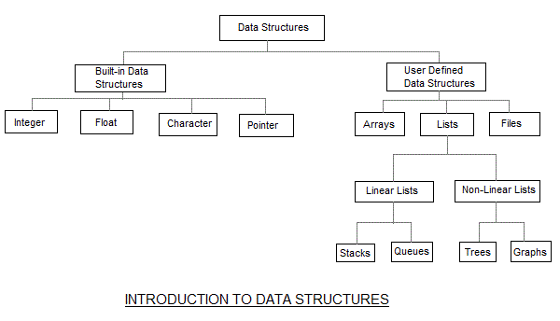

#### What is Algorithm ?

An algorithm is a finite set of instructions or logic, written in order, to accomplish a certain predefined task. Algorithm is not the complete code or program, it is just the core logic(solution) of a problem, which can be expressed either as an informal high level description as **pseudocode** or using a **flowchart**.

An algorithm is said to be efficient and fast, if it takes less time to execute and consumes less memory space. The performance of an algorithm is measured on the basis of following properties :

1. Time Complexity
2. Space Complexity

#### Space Complexity

Its the amount of memory space required by the algorithm, during the course of its execution. Space complexity must be taken seriously for multi-user systems and in situations where limited memory is available.

An algorithm generally requires space for following components :

* **Instruction Space :** Its the space required to store the executable version of the program. This space is fixed, but varies depending upon the number of lines of code in the program.
* **Data Space :** Its the space required to store all the constants and variables value.
* **Environment Space :** Its the space required to store the environment information needed to resume the suspended function.

#### Time Complexity

Time Complexity is a way to represent the amount of time needed by the program to run to completion.

## Time Complexity of Algorithms

Time complexity of an algorithm signifies the total time required by the program to run to completion. The time complexity of algorithms is most commonly expressed using the **big O notation**.

Time Complexity is most commonly estimated by counting the number of elementary functions performed by the algorithm. And since the algorithm's performance may vary with different types of input data, hence for an algorithm we usually use the **worst-case Time complexity** of an algorithm because that is the maximum time taken for any input size.

#### Calculating Time Complexity

Now lets tap onto the next big topic related to Time complexity, which is How to Calculate Time Complexity. It becomes very confusing some times, but we will try to explain it in the simplest way.

Now the most common metric for calculating time complexity is Big O notation. This removes all constant factors so that the running time can be estimated in relation to **N**, as N approaches infinity. In general you can think of it like this :

statement;

Above we have a single statement. Its Time Complexity will be **Constant**. The running time of the statement will not change in relation to N.

for(i=0; i < N; i++)

{

statement;

}

The time complexity for the above algorithm will be **Linear**. The running time of the loop is directly proportional to N. When N doubles, so does the running time.

for(i=0; i < N; i++)

{

for(j=0; j < N;j++)

{

statement;

}

}

This time, the time complexity for the above code will be **Quadratic**. The running time of the two loops is proportional to the square of N. When N doubles, the running time increases by N * N.

while(low <= high)

{

mid = (low + high) / 2;

if (target < list[mid])

high = mid - 1;

else if (target > list[mid])

low = mid + 1;

else break;

}

This is an algorithm to break a set of numbers into halves, to search a particular field(we will study this in detail later). Now, this algorithm will have a **Logarithmic** Time Complexity. The running time of the algorithm is proportional to the number of times N can be divided by 2(N is high-low here). This is because the algorithm divides the working area in half with each iteration.

void quicksort(int list[], int left, int right)

{

int pivot = partition(list, left, right);

quicksort(list, left, pivot - 1);

quicksort(list, pivot + 1, right);

}

Taking the previous algorithm forward, above we have a small logic of Quick Sort(we will study this in detail later). Now in Quick Sort, we divide the list into halves every time, but we repeat the iteration N times(where N is the size of list). Hence time complexity will be **N*log( N )**. The running time consists of N loops (iterative or recursive) that are logarithmic, thus the algorithm is a combination of linear and logarithmic.

**NOTE :**In general, doing something with every item in one dimension is linear, doing something with every item in two dimensions is quadratic, and dividing the working area in half is logarithmic.

#### Types of Notations for Time Complexity

Now we will discuss and understand the various notations used for Time Complexity.

1. **Big Oh** denotes "*fewer than or the same as*" <expression> iterations.
2. **Big Omega** denotes "*more than or the same as*" <expression> iterations.
3. **Big Theta** denotes "*the same as*" <expression> iterations.
4. **Little Oh** denotes "*fewer than*" <expression> iterations.
5. **Little Omega** denotes "*more than*" <expression> iterations.

#### Understanding Notations of Time Complexity with Example

**O(expression)** is the set of functions that grow slower than or at the same rate as expression.

**Omega(expression)** is the set of functions that grow faster than or at the same rate as expression.

**Theta(expression)** consist of all the functions that lie in both O(expression) and Omega(expression).

Suppose you've calculated that an algorithm takes f(n) operations, where,

f(n) = 3*n^2 + 2*n + 4. // n^2 means square of n

Since this polynomial grows at the same rate as **n^2**, then you could say that the function **f** lies in the set**Theta(n^2)**. (It also lies in the sets **O(n^2)** and **Omega(n^2)** for the same reason.)

The simplest explanation is, because **Theta** denotes *the same as* the expression. Hence, as **f(n)** grows by a factor of **n^2**, the time complexity can be best represented as **Theta(n^2)**.

## Introduction to Sorting

Sorting is nothing but storage of data in sorted order, it can be in ascending or descending order. The term Sorting comes into picture with the term Searching. There are so many things in our real life that we need to search, like a particular record in database, roll numbers in merit list, a particular telephone number, any particular page in a book etc.

**Sorting** arranges data in a sequence which makes searching easier. Every record which is going to be sorted will contain one key. Based on the key the record will be sorted. For example, suppose we have a record of students, every such record will have the following data:

* Roll No.
* Name
* Age
* Class

Here Student roll no. can be taken as key for sorting the records in ascending or descending order. Now suppose we have to search a Student with roll no. 15, we don't need to search the complete record we will simply search between the Students with roll no. 10 to 20.

#### Sorting Efficiency

There are many techniques for sorting. Implementation of particular sorting technique depends upon situation. Sorting techniques mainly depends on two parameters. First parameter is the execution time of program, which means time taken for execution of program. Second is the space, which means space taken by the program.

#### Types of Sorting Techniques

There are many types of Sorting techniques, differentiated by their efficiency and space requirements. Following are some sorting techniques which we will be covering in next sections.

1. Bubble Sort
2. Insertion Sort
3. Selection Sort
4. Quick Sort
5. Merge Sort
6. Heap Sort

## Bubble Sorting

**Bubble Sort** is an algorithm which is used to sort **N** elements that are given in a memory for eg: an Array with **N** number of elements. Bubble Sort compares all the element one by one and sort them based on their values.

It is called Bubble sort, because with each iteration the smaller element in the list bubbles up towards the first place, just like a water bubble rises up to the water surface.

Sorting takes place by stepping through all the data items one-by-one in pairs and comparing adjacent data items and swapping each pair that is out of order.

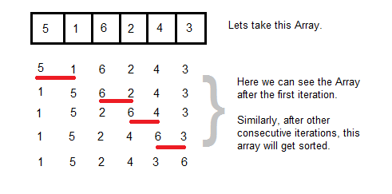

#### Sorting using Bubble Sort Algorithm

Let's consider an array with values {5, 1, 6, 2, 4, 3}

int a[6] = {5, 1, 6, 2, 4, 3};

int i, j, temp;

for(i=0; i<6, i++)

{

for(j=0; j<6-i-1; j++)

{

if( a[j] > a[j+1])

{

temp = a[j];

a[j] = a[j+1];

a[j+1] = temp;

}

}

}

//now you can print the sorted array after this

Above is the algorithm, to sort an array using Bubble Sort. Although the above logic will sort and unsorted array, still the above algorithm isn't efficient and can be enhanced further. Because as per the above logic, the for loop will keep going for six iterations even if the array gets sorted after the second iteration.

Hence we can insert a flag and can keep checking whether swapping of elements is taking place or not. If no swapping is taking place that means the array is sorted and wew can jump out of the for loop.

int a[6] = {5, 1, 6, 2, 4, 3};

int i, j, temp;

for(i=0; i<6, i++)

{

for(j=0; j<6-i-1; j++)

{

int flag = 0; //taking a flag variable

if( a[j] > a[j+1])

{

temp = a[j];

a[j] = a[j+1];

a[j+1] = temp;

flag = 1; //setting flag as 1, if swapping occurs

}

}

if(!flag) //breaking out of for loop if no swapping takes place

{

break;

}

}

In the above code, if in a complete single cycle of j iteration(inner for loop), no swapping takes place, and flag remains 0, then we will break out of the for loops, because the array has already been sorted.

#### Complexity Analysis of Bubble Sorting

In Bubble Sort, n-1 comparisons will be done in 1st pass, n-2 in 2nd pass, n-3 in 3rd pass and so on. So the total number of comparisons will be

(n-1)+(n-2)+(n-3)+.....+3+2+1

Sum = n(n-1)/2

i.e O(n2)

Hence the complexity of Bubble Sort is **O(n2)**.

The main advantage of Bubble Sort is the simplicity of the algorithm.Space complexity for Bubble Sort is **O(1)**, because only single additional memory space is required for **temp** variable

**Best-case** Time Complexity will be **O(n)**, it is when the list is already sorted.

## Insertion Sorting

It is a simple Sorting algorithm which sorts the array by shifting elements one by one. Following are some of the important characteristics of Insertion Sort.

1. It has one of the simplest implementation
2. It is efficient for smaller data sets, but very inefficient for larger lists.
3. Insertion Sort is adaptive, that means it reduces its total number of steps if given a partially sorted list, hence it increases its efficiency.
4. It is better than Selection Sort and Bubble Sort algorithms.
5. Its space complexity is less, like Bubble Sorting, inerstion sort also requires a single additional memory space.
6. It is **Stable**, as it does not change the relative order of elements with equal keys

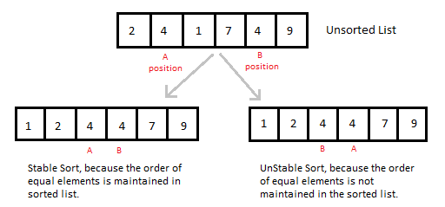

#### How Insertion Sorting Works

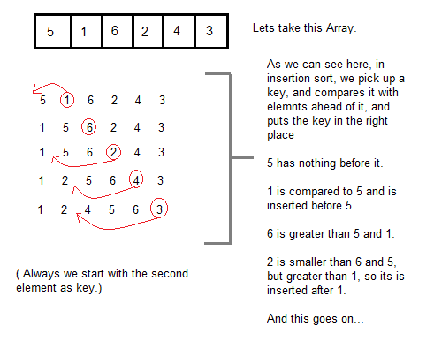

#### Sorting using Insertion Sort Algorithm

int a[6] = {5, 1, 6, 2, 4, 3};

int i, j, key;

for(i=1; i<6; i++)

{

key = a[i];

j = i-1;

while(j>=0 && key < a[j])

{

a[j+1] = a[j];

j--;

}

a[j+1] = key;

}

Now lets, understand the above simple insertion sort algorithm. We took an array with 6 integers. We took a variable **key**, in which we put each element of the array, in each pass, starting from the second element, that is **a[1]**.

Then using the while loop, we iterate, until **j** becomes equal to zero or we find an element which is greater than **key**, and then we insert the key at that position.

In the above array, first we pick 1 as key, we compare it with 5(element before 1), 1 is smaller than 5, we shift 1 before 5. Then we pick 6, and compare it with 5 and 1, no shifting this time. Then 2 becomes the key and is compared with, 6 and 5, and then 2 is placed after 1. And this goes on, until complete array gets sorted.

#### Complexity Analysis of Insertion Sorting

**Worst Case Time Complexity :** O(n2)

**Best Case Time Complexity :** O(n)

**Average Time Complexity :** O(n2)

**Space Complexity :**O(1)

## Selection Sorting

Selection sorting is conceptually the most simplest sorting algorithm. This algorithm first finds the smallest element in the array and exchanges it with the element in the first position, then find the second smallest element and exchange it with the element in the second position, and continues in this way until the entire array is sorted.

#### How Selection Sorting Works

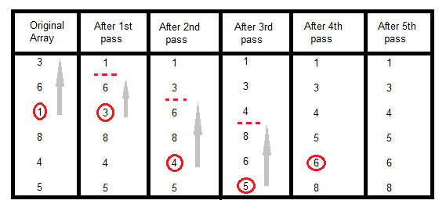

In the first pass, the smallest element found is 1, so it is placed at the first position, then leaving first element, smallest element is searched from the rest of the elements, 3 is the smallest, so it is then placed at the second position. Then we leave 1 nad 3, from the rest of the elements, we search for the smallest and put it at third position and keep doing this, until array is sorted.

#### Sorting using Selection Sort Algorithm

void selectionSort(int a[], int size)

{

int i, j, min, temp;

for(i=0; i < size-1; i++ )

{

min = i; //setting min as i

for(j=i+1; j < size; j++)

{

if(a[j] < a[min]) //if element at j is less than element at min position

{

min = j; //then set min as j

}

}

temp = a[i];

a[i] = a[min];

a[min] = temp;

}

}

#### Complexity Analysis of Selection Sorting

**Worst Case Time Complexity :** O(n2)

**Best Case Time Complexity :** O(n2)

**Average Time Complexity :** O(n2)

**Space Complexity :**O(1)

## Quick Sort Algorithm

Quick Sort, as the name suggests, sorts any list very quickly. Quick sort is not stable search, but it is very fast and requires very less aditional space. It is based on the rule of **Divide and Conquer**(also called *partition-exchange sort*). This algorithm divides the list into three main parts :

1. Elements less than the Pivot element
2. Pivot element
3. Elements greater than the pivot element

In the list of elements, mentioned in below example, we have taken **25** as pivot. So after the first pass, the list will be changed like this.

6 8 17 14 **25** 63 37 52

Hnece after the first pass, pivot will be set at its position, with all the elements smaller to it on its left and all the elements larger than it on the right. Now 6 8 17 14 and 63 37 52 are considered as two separate lists, and same logic is applied on them, and we keep doing this until the complete list is sorted.

#### How Quick Sorting Works

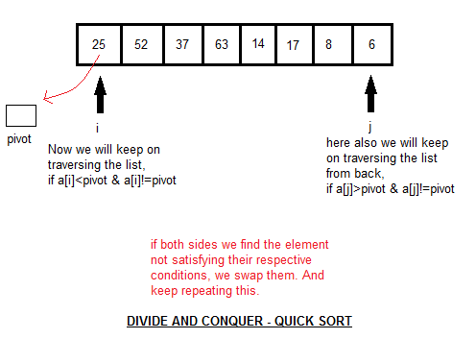

#### Sorting using Quick Sort Algorithm

/* a[] is the array, p is starting index, that is 0,

and r is the last index of array. */

void **quicksort**(int a[], int p, int r)

{

if(p < r)

{

int q;

q = partition(a, p, r);

quicksort(a, p, q);

quicksort(a, q+1, r);

}

}

int **partition**(int a[], int p, int r)

{

int i, j, pivot, temp;

pivot = a[p];

i = p;

j = r;

while(1)

{

while(a[i] < pivot && a[i] != pivot)

i++;

while(a[j] > pivot && a[j] != pivot)

j--;

if(i < j)

{

temp = a[i];

a[i] = a[j];

a[j] = temp;

}

else

{

return j;

}

}

}

#### Complexity Analysis of Quick Sort

**Worst Case Time Complexity :** O(n2)

**Best Case Time Complexity :** O(n log n)

**Average Time Complexity :** O(n log n)

**Space Complexity :**O(n log n)

* Space required by quick sort is very less, only O(n log n) additional space is required.
* Quick sort is not a stable sorting technique, so it might change the occurence of two similar elements in the list while sorting.

## Merge Sort Algorithm

Merge Sort follows the rule of **Divide and Conquer**. But it doesn't divides the list into two halves. In merge sort the unsorted list is divided into N sublists, each having one element, because a list of one element is considered sorted. Then, it repeatedly merge these sublists, to produce new sorted sublists, and at lasts one sorted list is produced.

Merge Sort is quite fast, and has a time complexity of **O(n log n)**. It is also a stable sort, which means the "equal" elements are ordered in the same order in the sorted list.

#### How Merge Sort Works

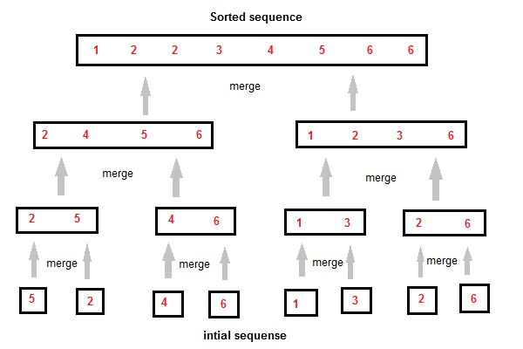

Like we can see in the above example, merge sort first breaks the unsorted list into sorted sublists, and then keep merging these sublists, to finlly get the complete sorted list.

#### Sorting using Merge Sort Algorithm

/* a[] is the array, p is starting index, that is 0,

and r is the last index of array. */

Lets take a[5] = {32, 45, 67, 2, 7} as the array to be sorted.

void **mergesort**(int a[], int p, int r)

{

int q;

if(p < r)

{

q = floor( (p+r) / 2);

mergesort(a, p, q);

mergesort(a, q+1, r);

merge(a, p, q, r);

}

}

void **merge**(int a[], int p, int q, int r)

{

int b[5]; //same size of a[]

int i, j, k;

k = 0;

i = p;

j = q+1;

while(i <= q && j <= r)

{

if(a[i] < a[j])

{

b[k++] = a[i++]; // same as b[k]=a[i]; k++; i++;

}

else

{

b[k++] = a[j++];

}

}

while(i <= q)

{

b[k++] = a[i++];

}

while(j <= r)

{

b[k++] = a[j++];

}

for(i=r; i >= p; i--)

{

a[i] = b[--k]; // copying back the sorted list to a[]

}

}

#### Complexity Analysis of Merge Sort

**Worst Case Time Complexity :** O(n log n)

**Best Case Time Complexity :** O(n log n)

**Average Time Complexity :** O(n log n)

**Space Complexity :**O(n)

* Time complexity of Merge Sort is O(n Log n) in all 3 cases (worst, average and best) as merge sort always divides the array in two halves and take linear time to merge two halves.
* It requires equal amount of additional space as the unsorted list. Hence its not at all recommended for searching large unsorted lists.
* It is the best Sorting technique for sorting **Linked Lists**.

## Heap Sort Algorithm

Heap Sort is one of the best sorting methods being in-place and with no quadratic worst-case scenarios. Heap sort algorithm is divided into two basic parts :

* Creating a Heap of the unsorted list.
* Then a sorted array is created by repeatedly removing the largest/smallest element from the heap, and inserting it into the array. The heap is reconstructed after each removal.

#### What is a Heap ?

Heap is a special tree-based data structure, that satisfies the following special heap properties :

1. **Shape Property :** Heap data structure is always a Complete Binary Tree, which means all levels of the tree are fully filled.

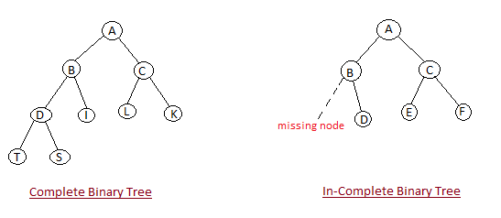

1. **Heap Property :** All nodes are either *[greater than or equal to]* or *[less than or equal to]* each of its children. If the parent nodes are greater than their children, heap is called a **Max-Heap**, and if the parent nodes are smalled than their child nodes, heap is called **Min-Heap**.

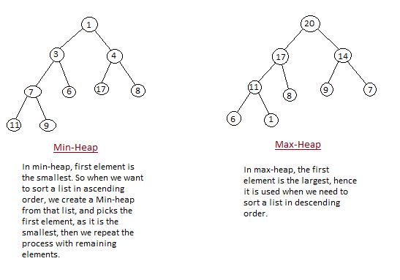

#### How Heap Sort Works

Initially on receiving an unsorted list, the first step in heap sort is to create a Heap data structure(Max-Heap or Min-Heap). Once heap is built, the first element of the Heap is either largest or smallest(depending upon Max-Heap or Min-Heap), so we put the first element of the heap in our array. Then we again make heap using the remaining elements, to again pick the first element of the heap and put it into the array. We keep on doing the same repeatedly untill we have the complete sorted list in our array.

In the below algorithm, initially **heapsort()** function is called, which calls **buildheap()** to build heap, which inturn uses **satisfyheap()** to build the heap.

Heap Sort Program

#### Sorting using Heap Sort Algorithm

/* Below program is written in C++ language */

void heapsort(int[], int);

void buildheap(int [], int);

void satisfyheap(int [], int, int);

void main()

{

int a[10], i, size;

cout << "Enter size of list"; // less than 10, because max size of array is 10

cin >> size;

cout << "Enter" << size << "elements";

for( i=0; i < size; i++)

{

cin >> a[i];

}

heapsort(a, size);

getch();

}

void **heapsort**(int a[], int length)

{

buildheap(a, length);

int heapsize, i, temp;

heapsize = length - 1;

for( i=heapsize; i >= 0; i--)

{

temp = a[0];

a[0] = a[heapsize];

a[heapsize] = temp;

heapsize--;

satisfyheap(a, 0, heapsize);

}

for( i=0; i < length; i++)

{

cout << "\t" << a[i];

}

}

void **buildheap**(int a[], int length)

{

int i, heapsize;

heapsize = length - 1;

for( i=(length/2); i >= 0; i--)

{

satisfyheap(a, i, heapsize);

}

}

void **satisfyheap**(int a[], int i, int heapsize)

{

int l, r, largest, temp;

l = 2*i;

r = 2*i + 1;

if(l <= heapsize && a[l] > a[i])

{

largest = l;

}

else

{

largest = i;

}

if( r <= heapsize && a[r] > a[largest])

{

largest = r;

}

if(largest != i)

{

temp = a[i];

a[i] = a[largest];

a[largest] = temp;

satisfyheap(a, largest, heapsize);

}

}

#### Complexity Analysis of Heap Sort

**Worst Case Time Complexity :** O(n log n)

**Best Case Time Complexity :** O(n log n)

**Average Time Complexity :** O(n log n)

**Space Complexity :**O(n)

* Heap sort is not a Stable sort, and requires a constant space for sorting a list.
* Heap Sort is very fast and is widely used for sorting.

## Searching Algorithms on Array

Before studying searching algorithms on array we should know what is an algorithm?

An **algorithm** is a step-by-step procedure or method for solving a problem by a computer in a given number of steps. The steps of an algorithm may include repetition depending upon the problem for which the algorithm is being developed. The algorithm is written in human readable and understandable form. To search an element in a given array, it can be done in two ways Linear search and Binary search.

#### Linear Search

A linear search is the basic and simple search algorithm. A linear search searches an element or value from an array till the desired element or value is not found and it searches in a sequence order. It compares the element with all the other elements given in the list and if the element is matched it returns the value index else it return -1. Linear Search is applied on the unsorted or unordered list when there are fewer elements in a list.

#### Example with Implementation

To search the element 5 it will go step by step in a sequence order.

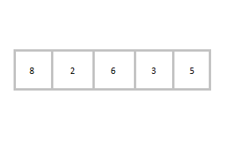

function **findIndex**(values, target)

{

for(var i = 0; i < values.length; ++i)

{

if (values[i] == target)

{

return i;

}

}

return -1;

}

//*call the function findIndex with array and number to be searched*

findIndex([ 8 , 2 , 6 , 3 , 5 ] , 5) ;

#### Binary Search

Binary Search is applied on the sorted array or list. In binary search, we first compare the value with the elements in the middle position of the array. If the value is matched, then we return the value. If the value is less than the middle element, then it must lie in the lower half of the array and if it's greater than the element then it must lie in the upper half of the array. We repeat this procedure on the lower (or upper) half of the array. Binary Search is useful when there are large numbers of elements in an array.

#### Example with Implementation

To search an element 13 from the sorted array or list.

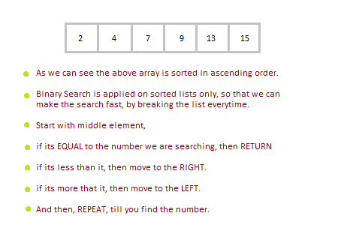

function findIndex(values, target)

{

return **binarySearch**(values, target, 0, values.length - 1);

};

function binarySearch(values, target, start, end) {

if (start > end) { return -1; } *//does not exist*

var middle = Math.floor((start + end) / 2);

var value = values[middle];

if (value > target) { return **binarySearch**(values, target, start, middle-1); }

if (value < target) { return **binarySearch**(values, target, middle+1, end); }

return middle; *//found!*

}

findIndex([2, 4, 7, 9, 13, 15], 13);

In the above program logic, we are first comparing the middle number of the list, with the target, if it matches we return. If it doesn't, we see whether the middle number is greater than or smaller than the target.

If the Middle number is greater than the Target, we start the binary search again, but this time on the left half of the list, that is from the start of the list to the middle, not beyond that.

If the Middle number is smaller than the Target, we start the binary search again, but on the right half of the list, that is from the middle of the list to the end of the list.

## Stacks

Stack is an abstract data type with a bounded(predefined) capacity. It is a simple data structure that allows adding and removing elements in a particular order. Every time an element is added, it goes on the top of the stack, the only element that can be removed is the element that was at the top of the stack, just like a pile of objects.

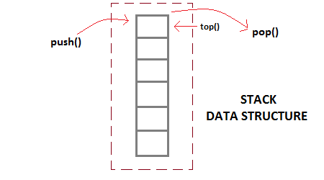

#### Basic features of Stack

1. Stack is an ordered list of similar data type.
2. Stack is a **LIFO** structure. (Last in First out).
3. **push()** function is used to insert new elements into the Stack and **pop()** is used to delete an element from the stack. Both insertion and deletion are allowed at only one end of Stack called **Top**.
4. Stack is said to be in **Overflow** state when it is completely full and is said to be in **Underflow** state if it is completely empty.

#### Applications of Stack

The simplest application of a stack is to reverse a word. You push a given word to stack - letter by letter - and then pop letters from the stack.

There are other uses also like : **Parsing**, **Expression Conversion**(Infix to Postfix, Postfix to Prefix etc) and many more.

#### Implementation of Stack

Stack can be easily implemented using an Array or a Linked List. Arrays are quick, but are limited in size and Linked List requires overhead to allocate, link, unlink, and deallocate, but is not limited in size. Here we will implement Stack using array.

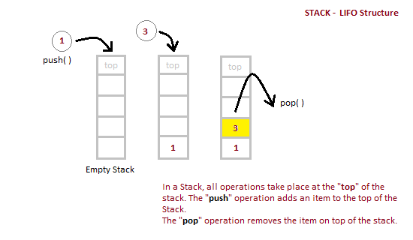

/* Below program is written in C++ language */

Class **Stack**

{

int top;

public:

int a[10]; //Maximum size of Stack

Stack()

{

top = -1;

}

};

void Stack::**push(int x)**

{

if( top >= 10)

{

cout << "Stack Overflow";

}

else

{

a[++top] = x;

cout << "Element Inserted";

}

}

int Stack::**pop()**

{

if(top < 0)

{

cout << "Stack Underflow";

return 0;

}

else

{

int d = a[--top];

return d;

}

}

void Stack::**isEmpty()**

{

if(top < 0)

{

cout << "Stack is empty";

}

else

{

cout << "Stack is not empty";

}

}

|  |  |
| --- | --- |
| **Position of Top** | **Status of Stack** |
| -1 | Stack is Empty |
| 0 | Only one element in Stack |
| N-1 | Stack is Full |
| N | Overflow state of Stack |

#### Analysis of Stacks

Below mentioned are the time complexities for various operations that can be performed on the Stack data structure.

* **Push Operation** : O(1)
* **Pop Operation** : O(1)
* **Top Operation** : O(1)
* **Search Operation** : O(n)

## Queue Data Structures

Queue is also an abstract data type or a linear data structure, in which the first element is inserted from one end called **REAR**(also called tail), and the deletion of exisiting element takes place from the other end called as **FRONT**(also called head). This makes queue as FIFO data structure, which means that element inserted first will also be removed first.

The process to add an element into queue is called **Enqueue** and the process of removal of an element from queue is called **Dequeue**.

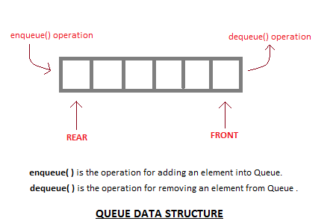

#### Basic features of Queue

1. Like Stack, Queue is also an ordered list of elements of similar data types.
2. Queue is a FIFO( First in First Out ) structure.
3. Once a new element is inserted into the Queue, all the elements inserted before the new element in the queue must be removed, to remove the new element.
4. **peek( )** function is oftenly used to return the value of first element without dequeuing it.

#### Applications of Queue

Queue, as the name suggests is used whenever we need to have any group of objects in an order in which the first one coming in, also gets out first while the others wait for there turn, like in the following scenarios :

1. Serving requests on a single shared resource, like a printer, CPU task scheduling etc.
2. In real life, Call Center phone systems will use Queues, to hold people calling them in an order, until a service representative is free.
3. Handling of interrupts in real-time systems. The interrupts are handled in the same order as they arrive, First come first served.

#### Implementation of Queue

Queue can be implemented using an Array, Stack or Linked List. The easiest way of implementing a queue is by using an Array. Initially the **head**(FRONT) and the **tail**(REAR) of the queue points at the first index of the array (starting the index of array from 0). As we add elements to the queue, the tail keeps on moving ahead, always pointing to the position where the next element will be inserted, while the head remains at the first index.

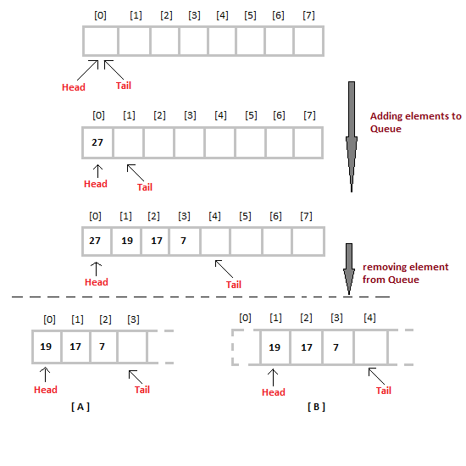

When we remove element from Queue, we can follow two possible approaches (mentioned [A] and [B] in above diagram). In [A] approach, we remove the element at **head** position, and then one by one move all the other elements on position forward. In approach [B] we remove the element from **head** position and then move **head** to the next position.

In approach [A] there is an overhead of shifting the elements one position forward every time we remove the first element. In approach [B] there is no such overhead, but whener we move head one position ahead, after removal of first element, the size on Queue is reduced by one space each time.

/* Below program is wtitten in C++ language */

#define SIZE 100

class **Queue**

{

int a[100];

int rear; //same as tail

int front; //same as head

public:

Queue()

{

rear = front = -1;

}

void enqueue(int x); //declaring enqueue, dequeue and display functions

int dequeue();

void display();

}

void Queue :: **enqueue**(int x)

{

if( rear = SIZE-1)

{

cout << "Queue is full";

}

else

{

a[++rear] = x;

}

}

int queue :: **dequeue**()

{

return a[++front]; //following approach [B], explained above

}

void queue :: **display**()

{

int i;

for( i = front; i <= rear; i++)

{

cout << a[i];

}

}

To implement approach [A], you simply need to change the dequeue method, and include a for loop which will shift all the remaining elements one position.

return a[0]; //returning first element

for (i = 0; i < tail-1; i++) //shifting all other elements

{

a[i]= a[i+1];

tail--;

}

#### Analysis of Queue

* Enqueue : **O(1)**
* Dequeue : **O(1)**
* Size : **O(1)**

## Introduction to Linked Lists

Linked List is a linear data structure and it is very common data structure which consists of group of nodes in a sequence which is divided in two parts. Each node consists of its own data and the address of the next node and forms a chain. Linked Lists are used to create trees and graphs.

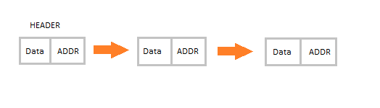

#### Advantages of Linked Lists

* They are a dynamic in nature which allocates the memory when required.
* Insertion and deletion operations can be easily implemented.
* Stacks and queues can be easily executed.
* Linked List reduces the access time.

#### Disadvantages of Linked Lists

* The memory is wasted as pointers require extra memory for storage.
* No element can be accessed randomly; it has to access each node sequentially.
* Reverse Traversing is difficult in linked list.

#### Applications of Linked Lists

* Linked lists are used to implement stacks, queues, graphs, etc.
* Linked lists let you insert elements at the beginning and end of the list.
* In Linked Lists we don’t need to know the size in advance.

#### Types of Linked Lists

* **Singly Linked List :** Singly linked lists contain nodes which have a data part as well as an address part i.e. next, which points to the next node in sequence of nodes. The operations we can perform on singly linked lists are insertion, deletion and traversal.

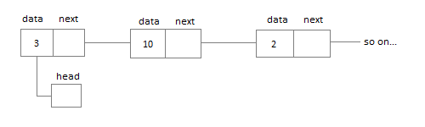

* **Doubly Linked List :** In a doubly linked list, each node contains two links the first link points to the previous node and the next link points to the next node in the sequence.

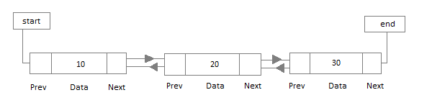

* **Circular Linked List :** In the circular linked list the last node of the list contains the address of the first node and forms a circular chain.



## Linear Linked List

The element can be inserted in linked list in 2 ways :

* Insertion at beginning of the list.
* Insertion at the end of the list.

We will also be adding some more useful methods like :

* Checking whether Linked List is empty or not.
* Searching any element in the Linked List
* Deleting a particular Node from the List

Before inserting the node in the list we will create a class **Node**. Like shown below :

class **Node** {

public:

int data;

*//pointer to the next node*

node* next;

**node**() {

data = 0;

next = NULL;

}

**node**(int x) {

data = x;

next = NULL;

}

}

We can also make the properties data and next as private, in that case we will need to add the getter and setter methods to access them. You can add the getters and setter like this :

int **getData**() {

return data;

}

void **setData**(int x) {

this.data = x;

}

node* **getNext**() {

return next;

}

void **setNext**(node *n) {

this.next = n;

}

Node class basically creates a node for the data which you enter to be included into Linked List. Once the node is created, we use various functions to fit in that node into the Linked List.

#### Linked List class

As we are following the complete OOPS methodology, hence we will create a separate class for **Linked List**, which will have all its methods. Following will be the Linked List class :

class **LinkedList** {

public:

node *head;

*//declaring the functions*

*//function to add Node at front*

int addAtFront(node *n);

*//function to check whether Linked list is empty*

int isEmpty();

*//function to add Node at the End of list*

int addAtEnd(node *n);

*//function to search a value*

node* search(int k);

*//function to delete any Node*

node* deleteNode(int x);

**LinkedList**() {

head = NULL;

}

}

#### Insertion at the Beginning

Steps to insert a Node at beginning :

1. The first Node is the Head for any Linked List.
2. When a new Linked List is instantiated, it just has the Head, which is Null.
3. Else, the Head holds the pointer to the first Node of the List.
4. When we want to add any Node at the front, we must make the head point to it.
5. And the Next pointer of the newly added Node, must point to the previous Head, whether it be NULL(in case of new List) or the pointer to the first Node of the List.
6. The previous Head Node is now the second Node of Linked List, because the new Node is added at the front.

int LinkedList :: **addAtFront**(node *n) {

int i = 0;

*//making the next of the new Node point to Head*

n**->**next = head;

*//making the new Node as Head*

head = n;

i++;

*//returning the position where Node is added*

return i;

}

#### Inserting at the End

Steps to insert a Node at the end :

1. If the Linked List is empty then we simply, add the new Node as the Head of the Linked List.
2. If the Linked List is not empty then we find the last node, and make it' next to the new Node, hence making the new node the last Node.

int LinkedList :: **addAtEnd**(node *n) {

*//If list is empty*

if(head == NULL) {

*//making the new Node as Head*

head = n;

*//making the next pointe of the new Node as Null*

n**->**next = NULL;

}

else {

*//getting the last node*

node *n2 = **getLastNode**();

n2**->**next = n;

}

}

node* LinkedList :: **getLastNode**() {

*//creating a pointer pointing to Head*

node* ptr = head;

*//Iterating over the list till the node whose Next pointer points to null*

*//Return that node, because that will be the last node.*

while(ptr**->**next!=NULL) {

*//if Next is not Null, take the pointer one step forward*

ptr = ptr**->**next;

}

return ptr;

}

#### Searching for an Element in the List

In searhing we do not have to do much, we just need to traverse like we did while getting the last node, in this case we will also compare the **data** of the Node. If we get the Node with the same data, we will return it, otherwise we will make our pointer point the next Node, and so on.

node* LinkedList :: **search**(int x) {

node *ptr = head;

while(ptr != NULL && ptr**->**data != x) {

*//until we reach the end or we find a Node with data x, we keep moving*

ptr = ptr**->**next;

}

return ptr;

}

#### Deleting a Node from the List

Deleting a node can be done in many ways, like we first search the Node with **data** which we want to delete and then we delete it. In our approach, we will define a method which will take the **data** to be deleted as argument, will use the search method to locate it and will then remove the Node from the List.

To remove any Node from the list, we need to do the following :

* If the Node to be deleted is the first node, then simply set the Next pointer of the Head to point to the next element from the Node to be deleted.
* If the Node is in the middle somewhere, then find the Node before it, and make the Node before it point to the Node next to it.

node* LinkedList :: **deleteNode**(int x) {

*//searching the Node with data x*

node *n = **search**(x);

node *ptr = head;

if(ptr == n) {

ptr**->**next = n**->**next;

return n;

}

else {

while(ptr**->**next != n) {

ptr = ptr**->**next;

}

ptr**->**next = n**->**next;

return n;

}

}

#### Checking whether the List is empty or not

We just need to check whether the **Head** of the List is NULL or not.

int LinkedList :: **isEmpty**() {

if(head == NULL) {

return **1**;

}

else { return **0**; }

}

Now you know a lot about how to handle List, how to traverse it, how to search an element. You can yourself try to write new methods around the List.

If you are still figuring out, how to call all these methods, then below is how your main() method will look like. As we have followed OOP standards, we will create the objects of **LinkedList** class to initialize our List and then we will create objects of **Node** class whenever we want to add any new node to the List.

int main() {

LinkedList L;

*//We will ask value from user, read the value and add the value to our Node*

int x;

cout << "Please enter an integer value : ";

cin >> x;

Node *n1;

*//Creating a new node with data as x*

n1 = new Node(x);

*//Adding the node to the list*

L.addAtFront(n1);

}

## Circular Linked List

Circular Linked List is little more complicated linked data structure. In the circular linked list we can insert elements anywhere in the list whereas in the array we cannot insert element anywhere in the list because it is in the contiguous memory. In the circular linked list the previous element stores the address of the next element and the last element stores the address of the starting element. The elements points to each other in a circular way which forms a circular chain. The circular linked list has a dynamic size which means the memory can be allocated when it is required.



#### Application of Circular Linked List

* The real life application where the circular linked list is used is our Personal Computers, where multiple applications are running. All the running applications are kept in a circular linked list and the OS gives a fixed time slot to all for running. The Operating System keeps on iterating over the linked list until all the applications are completed.
* Another example can be Multiplayer games. All the Players are kept in a Circular Linked List and the pointer keeps on moving forward as a player's chance ends.
* Circular Linked List can also be used to create Circular Queue. In a Queue we have to keep two pointers, FRONT and REAR in memory all the time, where as in Circular Linked List, only one pointer is required.

### Implementing Circular Linked List

Implementing a circular linked list is very easy and almost similar to linear linked list implementation, with the only difference being that, in circular linked list the last **Node** will have it's **next** point to the **Head** of the List. In Linear linked list the last Node simply holds NULL in it's next pointer.

So this will be oue Node class, as we have already studied in the lesson, it will be used to form the List.

class **Node** {

public:

int data;

*//pointer to the next node*

node* next;

**node**() {

data = 0;

next = NULL;

}

**node**(int x) {

data = x;

next = NULL;

}

}

#### Circular Linked List

Circular Linked List class will be almost same as the Linked List class that we studied in the previous lesson, with a few difference in the implementation of class methods.

class **CircularLinkedList** {

public:

node *head;

*//declaring the functions*

*//function to add Node at front*

int addAtFront(node *n);

*//function to check whether Linked list is empty*

int isEmpty();

*//function to add Node at the End of list*

int addAtEnd(node *n);

*//function to search a value*

node* search(int k);

*//function to delete any Node*

node* deleteNode(int x);

**CircularLinkedList**() {

head = NULL;

}

}

#### Insertion at the Beginning

Steps to insert a Node at beginning :

1. The first Node is the Head for any Linked List.
2. When a new Linked List is instantiated, it just has the Head, which is Null.
3. Else, the Head holds the pointer to the fisrt Node of the List.
4. When we want to add any Node at the front, we must make the head point to it.
5. And the Next pointer of the newly added Node, must point to the previous Head, whether it be NULL(in case of new List) or the pointer to the first Node of the List.
6. The previous Head Node is now the second Node of Linked List, because the new Node is added at the front.

int CircularLinkedList :: **addAtFront**(node *n) {

int i = 0;

*/* If the list is empty */*

if(head == NULL) {

n**->**next = head;

*//making the new Node as Head*

head = n;

i++;

}

else {

n->next = head;

*//get the Last Node and make its next point to new Node*

Node* last = **getLastNode**();

last->next = n;

*//also make the head point to the new first Node*

head = n;

i++;

}

*//returning the position where Node is added*

return i;

}

#### Insertion at the End

Steps to insert a Node at the end :

1. If the Linked List is empty then we simply, add the new Node as the Head of the Linked List.
2. If the Linked List is not empty then we find the last node, and make it' next to the new Node, and make the next of the Newly added Node point to the Head of the List.

int CircularLinkedList :: **addAtEnd**(node *n) {

*//If list is empty*

if(head == NULL) {

*//making the new Node as Head*

head = n;

*//making the next pointer of the new Node as Null*

n**->**next = NULL;

}

else {

*//getting the last node*

node *last = **getLastNode**();

last**->**next = n;

*//making the next pointer of new node point to head*

n**->**next = head;

}

}

#### Searching for an Element in the List

In searhing we do not have to do much, we just need to traverse like we did while getting the last node, in this case we will also compare the **data** of the Node. If we get the Node with the same data, we will return it, otherwise we will make our pointer point the next Node, and so on.

node* CircularLinkedList :: **search**(int x) {

node *ptr = head;

while(ptr != NULL && ptr**->**data != x) {

*//until we reach the end or we find a Node with data x, we keep moving*

ptr = ptr**->**next;

}

return ptr;

}

#### Deleting a Node from the List

Deleting a node can be done in many ways, like we first search the Node with **data** which we want to delete and then we delete it. In our approach, we will define a method which will take the **data** to be deleted as argument, will use the search method to locate it and will then remove the Node from the List.

To remove any Node from the list, we need to do the following :

* If the Node to be deleted is the first node, then simply set the Next pointer of the Head to point to the next element from the Node to be deleted. And update the next pointer of the Last Node as well.
* If the Node is in the middle somewhere, then find the Node before it, and make the Node before it point to the Node next to it.
* If the Node is at the end, then remove it and make the new last node point to the head.

node* CircularLinkedList :: **deleteNode**(int x) {

*//searching the Node with data x*

node *n = **search**(x);

node *ptr = head;

**if**(ptr == NULL) {

cout << "List is empty";

return NULL;

}

**else if**(ptr == n) {

ptr**->**next = n**->**next;

return n;

}

**else** {

while(ptr**->**next != n) {

ptr = ptr**->**next;

}

ptr**->**next = n**->**next;

return n;

}

}

**Reverse a Singly Linked List**

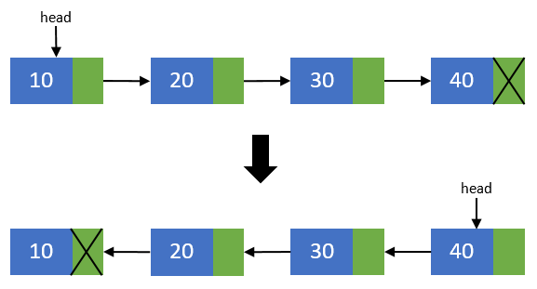

**Algorithm to reverse a Singly Linked List**

**Algorithm to reverse a Singly Linked List**

**%%Input** : ***head*** node of the linked list

**Begin:**

**If** (*head* != **NULL**) then

*prevNode* ← *head*

*head* ← *head.next*

*curNode* ← *head*

*prevNode.next* ← **NULL**

**While** (*head* != **NULL**) do

*head* ← *head.next*

*curNode.next* ← *prevNode*

*prevNode* ← *curNode*

*curNode* ← *head*

**End while**

*head* ← *prevNode*

**End if**

**End**

**Steps to reverse a Singly Linked List**

 Create two more pointers other than head namely prevNode and curNode that will hold the reference of previous node and current node respectively.   
Make sure that prevNode points to first node i.e. prevNode = head.   
head should now point to its next node i.e. the second node head = head->next.   
curNode should also points to the second node i.e. curNode = head.

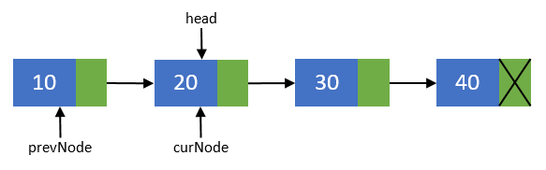

Now, disconnect the previous node i.e. the first node from others. We will make sure that it points to none. As this node is going to be our last node. Perform operation prevNode->next = NULL.

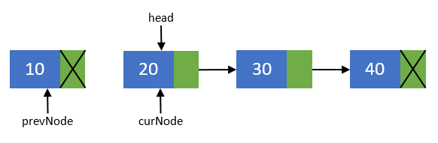

Move the head node to its next node i.e. head = head->next.

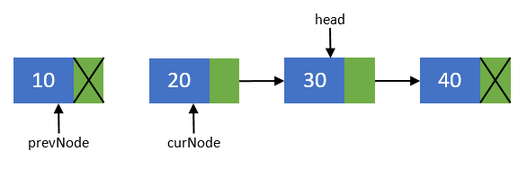

Now, re-connect the current node to its previous node i.e. curNode->next = prevNode;.

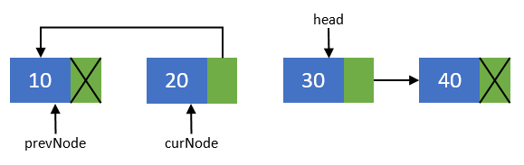

Point the previous node to current node and current node to head node. Means they should now point to prevNode = curNode; and curNode = head.

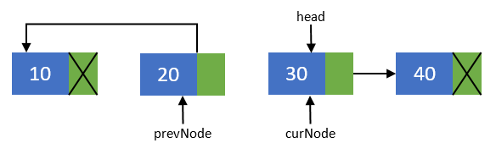

Repeat steps 3-5 till head pointer becomes NULL.

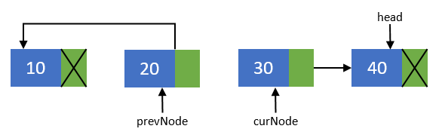

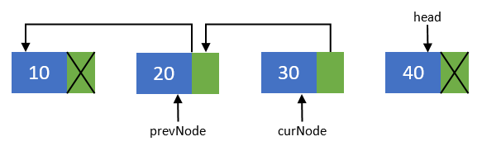

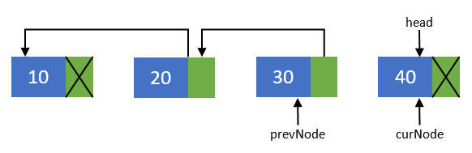

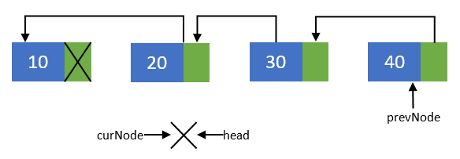

Now, after all nodes has been re-connected in the reverse order. Make the last node as the first node. Means the head pointer should point to prevNode pointer. Perform head = prevNode;. And finally you end up with a reversed linked list of its original.

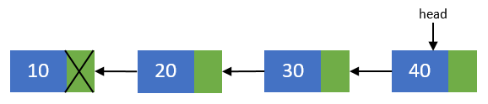

**Program to revere a Singly Linked List**

|  |  |
| --- | --- |
| 1  2  3  4  5  6  7  8  9  10  11  12  13  14  15  16  17  18  19  20  21  22  23  24  25  26  27  28  29  30  31  32  33  34  35  36  37  38  39  40  41  42  43  44  45  46  47  48  49  50  51  52  53  54  55  56  57  58  59  60  61  62  63  64  65  66  67  68  69  70  71  72  73  74  75  76  77  78  79  80  81  82  83  84  85  86  87  88  89  90  91  92  93  94  95  96  97  98  99  100  101  102  103  104  105  106  107  108  109  110  111  112  113  114  115  116  117  118  119  120  121  122  123  124  125  126  127  128  129  130  131  132  133  134  135  136  137  138  139  140  141  142  143  144  145  146  147  148  149  150  151  152  153  154  155  156  157  158  159  160  161  162  163  164  165  166  167  168  169  170  171  172 | /**   * C program to reverse a Singly Linked List   */    #include <stdio.h>  #include <stdlib.h>      /* Structure of a node */  struct node {      int data; //Data part      struct node *next; //Address part  }*head;        void createList(int n);  void reverseList();  void displayList();        int main()  {      int n, choice;        /*       * Creates a singly linked list of n nodes       */      printf("Enter the total number of nodes: ");      scanf("%d", &n);      createList(n);        printf("\nData in the list \n");      displayList();        /*       * Reverses the list       */      printf("\nPress 1 to reverse the order of singly linked list\n");      scanf("%d", &choice);      if(choice == 1)      {          reverseList();      }        printf("\nData in the list\n");      displayList();        return 0;  }        /*   * Create a list of n nodes   */  void createList(int n)  {      struct node *newNode, *temp;      int data, i;        head = (struct node *)malloc(sizeof(struct node));        /*       * If unable to allocate memory for head node       */      if(head == NULL)      {          printf("Unable to allocate memory.");      }      else      {          /*           * Reads data of node from the user           */          printf("Enter the data of node 1: ");          scanf("%d", &data);            head->data = data; //Links the data field with data          head->next = NULL; //Links the address field to NULL            temp = head;            /*           * Creates n nodes and adds to linked list           */          for(i=2; i<=n; i++)          {              newNode = (struct node *)malloc(sizeof(struct node));                /* If memory is not allocated for newNode */              if(newNode == NULL)              {                  printf("Unable to allocate memory.");                  break;              }              else              {                  printf("Enter the data of node %d: ", i);                  scanf("%d", &data);                    newNode->data = data; //Links the data field of newNode with data                  newNode->next = NULL; //Links the address field of newNode with NULL                    temp->next = newNode; //Links previous node i.e. temp to the newNode                  temp = temp->next;              }          }            printf("SINGLY LINKED LIST CREATED SUCCESSFULLY\n");      }  }        /*   * Reverse the order of nodes of a singly linked list   */  void reverseList()  {      struct node *prevNode, *curNode;        if(head != NULL)      {          prevNode = head;          curNode = head->next;          head = head->next;            prevNode->next = NULL; //Makes the first node as last node            while(head != NULL)          {              head = head->next;              curNode->next = prevNode;                prevNode = curNode;              curNode = head;          }            head = prevNode; //Makes the last node as head            printf("SUCCESSFULLY REVERSED LIST\n");      }  }        /*   * Displays the entire list   */  void displayList()  {      struct node *temp;        /*       * If the list is empty i.e. head = NULL       */      if(head == NULL)      {          printf("List is empty.");      }      else      {          temp = head;          while(temp != NULL)          {              printf("Data = %d\n", temp->data); //Prints the data of current node              temp = temp->next; //Advances the position of current node          }      }  } |

 Output

Enter the total number of nodes: 5  
Enter the data of node 1: 10  
Enter the data of node 2: 20  
Enter the data of node 3: 30  
Enter the data of node 4: 40  
Enter the data of node 5: 50  
SINGLY LINKED LIST CREATED SUCCESSFULLY  
  
Data in the list  
Data = 10  
Data = 20  
Data = 30  
Data = 40  
Data = 50

Press 1 to reverse the order of singly linked list  
1  
SUCCESSFULLY REVERSED LIST  
  
Data in the list  
Data = 50  
Data = 40  
Data = 30  
Data = 20  
Data = 10

# C Program to Display the Nodes of a Linked List in Reverse using Recursion

This C Program uses recursive function & reverses the nodes in a linked list and displays the list. A linked list is an ordered set of data elements, each containing a link to its successor. This program makes each data element to link to its predecessor.

Here is the source code of the C program to reverse the nodes and display the linked list. The C Program is successfully compiled and run on a Linux system. The program output is also shown below.

1. */\**
2. *\* Recursive C program to reverse nodes of a linked list and display*
3. *\* them*
4. *\*/*
5. #include <stdio.h>
6. #include <stdlib.h>
8. struct node
9. {
10. int data;
11. struct node *next;
12. };
14. void print_reverse_recursive (struct node *);
15. void print (struct node *);
16. void create_new_node (struct node *, int );
18. *//Driver Function*
19. int main ()
20. {
21. struct node *head = NULL;
22. insert_new_node (&head, 1);
23. insert_new_node (&head, 2);
24. insert_new_node (&head, 3);
25. insert_new_node (&head, 4);
26. printf ("LinkedList : ");
27. print (head);
28. printf ("**\n**LinkedList in reverse order : ");
29. print_reverse_recursive (head);
30. printf ("**\n**");
31. return 0;
32. }
34. *//Recursive Reverse*
35. void print_reverse_recursive (struct node *head)
36. {
37. if (head == NULL)
38. {
39. return;
40. }
42. *//Recursive call first*
43. print_reverse (head -> next);
44. *//Print later*
45. printf ("%d ", head -> data);
46. }
48. *//Print the linkedlist normal*
49. void print (struct node *head)
50. {
51. if (head == NULL)
52. {
53. return;
54. }
55. printf ("%d ", head -> data);
56. print (head -> next);
57. }
59. *//New data added in the start*
60. void insert_new_node (struct node ** head_ref, int new_data)
61. {
62. struct node * new_node = (struct node *) malloc (sizeof (struct node));
63. new_node -> data = new_data;
64. new_node -> next = (*head_ref);
65. (*head_ref) = new_node;
66. }

$ **cc** pgm.c

$ a.out

LinkedList : 4 3 2 1

LinkedList **in** reverse order : 1 2 3 4

**C Program for Infix to Postfix Conversion**

#define SIZE 50 /* Size of Stack */

#include <ctype.h>

char s[SIZE];

int top=-1; */* Global declarations */*

push(char elem)

{ */* Function for PUSH operation */*

s[++top]=elem;

}

char pop()

{ */* Function for POP operation */*

return(s[top--]);

}

int pr(char elem)

{ */* Function for precedence */*

switch(elem)

{

case '#': return 0;

case '(': return 1;

case '+':

case '-': return 2;

case '*':

case '/': return 3;

}

}

main()

{ */* Main Program */*

char infx[50],pofx[50],ch,elem;

int i=0,k=0;

printf("**\n\n**Read the Infix Expression ? ");

scanf("%s",infx);

push('#');

while( (ch=infx[i++]) != '**\0**')

{

if( ch == '(') push(ch);

else

if(isalnum(ch)) pofx[k++]=ch;

else

if( ch == ')')

{

while( s[top] != '(')

pofx[k++]=pop();

elem=pop(); */* Remove ( */*

}

else

{ */* Operator */*

while( pr(s[top]) >= pr(ch) )

pofx[k++]=pop();

push(ch);

}

}

while( s[top] != '#') */* Pop from stack till empty */*

pofx[k++]=pop();

pofx[k]='**\0**'; */* Make pofx as valid string */*

printf("**\n\n**Given Infix Expn: %s Postfix Expn: %s**\n**",infx,pofx);

}

# Infix to Prefix Conversion

#### Algorithm of Infix to Prefix

1. Step 1. Push “)” onto STACK, and add “(“ to end of the A
2. Step 2. Scan A from right to left and repeat step 3 to 6 for each element of A until the STACK is empty
3. Step 3. If an operand is encountered add it to B
4. Step 4. If a right parenthesis is encountered push it onto STACK
5. Step 5. If an operator is encountered then:
6. a. Repeatedly pop from STACK and add to B each operator (on the top of STACK) which has same
7. or higher precedence than the operator.
8. b. Add operator to STACK
9. Step 6. If left parenthesis is encontered then
10. a. Repeatedly pop from the STACK and add to B (each operator on top of stack until a left parenthesis is encounterd)
11. b. Remove the left parenthesis
12. Step 7. Exit

• [Prefix Infix Postfix converter Tool Online](http://scanftree.com/Data_Structure/prefix-postfix-infix-online-converter)

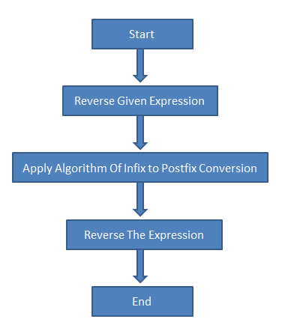

### Infix to prefix conversion

Expression = **(A+B^C)*D+E^5**  
**Step 1.** Reverse the infix expression.  
               **5^E+D*)C^B+A(**  
**Step 2.** Make Every '(' as ')' and every ')' as '('   
                **5^E+D*(C^B+A)**  
**Step 3.** Convert expression to postfix form.

A+(B*C-(D/E-F)*G)*H

|  |  |  |  |
| --- | --- | --- | --- |
| **Expression** | **Stack** | **Output** | **Comment** |
| 5^E+D*(C^B+A) | Empty | - | Initial |
| ^E+D*(C^B+A) | Empty | 5 | Print |
| E+D*(C^B+A) | ^ | 5 | Push |
| +D*(C^B+A) | ^ | 5E | Push |
| D*(C^B+A) | + | 5E^ | Pop And Push |
| *(C^B+A) | + | 5E^D | Print |
| (C^B+A) | +* | 5E^D | Push |
| C^B+A) | +*( | 5E^D | Push |
| ^B+A) | +*( | 5E^DC | Print |
| B+A) | +*(^ | 5E^DC | Push |
| +A) | +*(^ | 5E^DCB | Print |
| A) | +*(+ | 5E^DCB^ | Pop And Push |
| ) | +*(+ | 5E^DCB^A | Print |
| End | +* | 5E^DCB^A+ | Pop Until '(' |
| End | Empty | 5E^DCB^A+*+ | Pop Every element |

**Step 4.** Reverse the expression.  
                **+*+A^BCD^E5** 

#### Result

#### +*+A^BCD^E5

**C Program for Infix to Prefix Conversion**

#define SIZE 50 /* Size of Stack */

#include<string.h>

#include <ctype.h>

char s[SIZE];

int top=-1; */* Global declarations */*

void push(char elem)

{ */* Function for PUSH operation */*

s[++top]=elem;

}

char pop()

{ */* Function for POP operation */*

return(s[top--]);

}

int pr(char elem)

{ */* Function for precedence */*

switch(elem)

{

case '#': return 0;

case ')': return 1;

case '+':

case '-': return 2;

case '*':

case '/': return 3;

}

}

main()

{ */* Main Program */*

char infx[50],prfx[50],ch,elem;

int i=0,k=0;

printf("**\n\n**Read the Infix Expression ? ");

scanf("%s",infx);

push('#');

strrev(infx);

while( (ch=infx[i++]) != '**\0**')

{

if( ch == ')') push(ch);

else

if(isalnum(ch)) prfx[k++]=ch;

else

if( ch == '(')

{

while( s[top] != ')')

prfx[k++]=pop();

elem=pop(); */* Remove ) */*

}

else

{ */* Operator */*

while( pr(s[top]) > pr(ch) )

prfx[k++]=pop();

push(ch);

}

}

while( s[top] != '#') */* Pop from stack till empty */*

prfx[k++]=pop();

prfx[k]='**\0**'; */* Make prfx as valid string */*

strrev(prfx);

strrev(infx);

printf("**\n\n**Given Infix Expn: %s Prefix Expn: %s**\n**",infx,prfx);

}

**Problem:**

Given an infix expression, output the expression in Prefix (Polish Notation) form.

For e.g.

**Note:- Only > priority element will pop out not >= priority like in Infix to Postfix**

[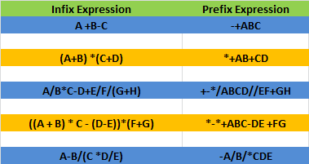](https://yoursandmyideas.files.wordpress.com/2012/04/infixtoprefix.png)

**Solution**:

# Binary Tree Traversal Using Recursive and Non Recursive Function in C

#include<stdio.h>  
#include<conio.h>  
#include<alloc.h>

struct bint  
 {  
 int data,flag;  
 struct bint *left,*right;  
 }node;  
  
node * create(node *r,int d)  
 {  
 if(r == NULL)  
 {  
 r = (node *)malloc(sizeof(node));  
 r->data = d;  
 r->left = r->right = NULL;  
 }  
 else  
 {  
 if(d>=r->data)  
 r->right = create(r->right,d);  
 else  
 r->left = create(r->left,d);  
 }  
 return r;  
 }

void inorder(node *r)  
 {  
 if(r != NULL)  
 {  
 inorder(r->left);  
 printf("%d\t",r->data);  
 inorder(r->right);  
 }  
 }  
  
void non_in(node *r)  
 {  
 int top=0;  
 node *s[20],*pt=r;  
 s[0]=NULL;  
 while(pt != NULL)  
 {  
 s[++top] = pt;  
 pt = pt->left;  
 }  
 pt = s[top--];  
 while(pt != NULL)  
 {  
 printf("%d\t",pt->data);  
 if(pt->right != NULL)  
 {  
 pt = pt->right;  
 while(pt != NULL)  
 {  
 s[++top] = pt;  
 pt = pt->left;  
 }  
 }  
 pt = s[top--];  
 }  
 }

void preorder(node *r)  
 {  
 if(r != NULL)  
 {  
 printf("%d\t",r->data);  
 preorder(r->left);  
 preorder(r->right);  
 }  
 }  
  
void non_pre(node *r)  
 {  
 int top=0;  
 node *s[20],*pt=r;  
 s[0]=NULL;  
 while(pt != NULL)  
 {  
 printf("%d\t",pt->data);  
 if(pt->right != NULL)  
 s[++top] = pt->right;  
 if(pt->left != NULL)  
 pt = pt->left;  
 else  
 pt = s[top--];  
 }  
 }  
  
void postorder(node *r)  
 {  
 if(r != NULL)  
 {  
 postorder(r->left);  
 postorder(r->right);  
 printf("%d\t",r->data);  
 }  
 }  
  
void non_post(node *root)  
 {  
 node *stack[100];  
 int top=-1;  
 node *temp=root;  
 while(temp!=NULL)  
 {  
 while(temp!= NULL)  
 {  
 top++;  
 stack[top] = temp;  
 temp = temp->left;  
 }  
 label:temp =stack[top];  
 top--;  
 if(temp->flag==1)  
 {  
 printf("%d\t",temp->data);  
 break;  
 }  
 else  
 {  
 temp->flag=1;  
 top++;  
 stack[top] = temp;  
 temp=temp->right;  
 }  
 }  
 if(top>=0)  
 goto label;  
 }  
  
  
  
void main()  
{  
 int d;  
 char ch = 'Y';  
 node *head = NULL;  
 clrscr();  
 while(toupper(ch) == 'Y')  
 {  
  printf("\n Enter the item to insert");  
  scanf("%d",&d);  
  head = create(head,d);  
  printf("\n Do you want to continue(y/n)");  
  fflush(stdin);  
  ch = getchar();  
 }  
 printf("\ninorder recursive\n");  
 inorder(head);  
 printf("\ninorder non recursive\n");  
 non_in(head);  
  
 printf("\n\n");  
 printf("\npostorder rrecursive\n");  
 postorder(head);  
 printf("\npostorder non recursive\n");  
 non_post(head);  
  
 printf("\n\n");  
 printf("\npreorder recursive\n");  
 preorder(head);  
 printf("\npreorder non recursive\n");  
 non_pre(head);  
 getch();  
  
}

**OR**

#include <stdio.h>

struct tnode

{

int data;

struct tnode *right;

struct tnode *left;

};

struct tnode *CreateBST(struct tnode *, int);

void Inorder(struct tnode *);

void Preorder(struct tnode *);

void Postorder(struct tnode *);

int main()

{

struct tnode *root = NULL;

int choice, item, n, i;

do

{

printf("\n\nBinary Search Tree Operations\n");

printf("\n1. Creation of BST");

printf("\n2. Traverse in Inorder");

printf("\n3. Traverse in Preorder");

printf("\n4. Traverse in Postorder");

printf("\n5. Exit\n");

printf("\nEnter Choice : ");

scanf("%d",&choice);

switch(choice)

{

case 1:

root = NULL;

printf("\n\nBST for How Many Nodes ? ");

scanf("%d",&n);

for(i = 1; i <= n; i++)

{

printf("\nEnter data for node %d : ", i);

scanf("%d",&item);

root = CreateBST(root,item);

}

printf("\nBST with %d nodes is ready to Use!!\n", n);

break;

case 2:

printf("\nBST Traversal in INORDER \n");

Inorder(root);

break;

case 3:

printf("\nBST Traversal in PREORDER \n");

Preorder(root);

break;

case 4:

printf("\nBST Traversal in POSTORDER \n");

Postorder(root);

break;

case 5:

printf("\n\n Terminating \n\n");

break;

default:

printf("\n\nInvalid Option !!! Try Again !! \n\n");

break;

}

} while(choice != 5);

return 0;

}

struct tnode *CreateBST(struct tnode *root, int item)

{

if(root == NULL)

{

root = (struct tnode *)malloc(sizeof(struct tnode));

root->left = root->right = NULL;

root->data = item;

return root;

}

else

{

if(item < root->data )

root->left = CreateBST(root->left,item);

else if(item > root->data )

root->right = CreateBST(root->right,item);

else

printf(" Duplicate Element !! Not Allowed !!!");

return(root);

}

}

void Inorder(struct tnode *root)

{

if( root != NULL)

{

Inorder(root->left);

printf(" %d ",root->data);

Inorder(root->right);

}

}

void Preorder(struct tnode *root)

{

if( root != NULL)

{

printf(" %d ",root->data);

Preorder(root->left);

Preorder(root->right);

}

}

void Postorder(struct tnode *root)

{

if( root != NULL)

{

Postorder(root->left);

Postorder(root->right);

printf(" %d ",root->data);

}

}

**Priority Queue**

In normal queue data structure, insertion is performed at the end of the queue and deletion is performed based on the FIFO principle. This queue implementation may not be suitable for all situations.  
  
Consider a networking application where server has to respond for requests from multiple clients using queue data structure. Assume four requests arrived to the queue in the order of R1 requires 20 units of time, R2 requires 2 units of time, R3 requires 10 units of time and R4 requires 5 units of time. Queue is as follows...

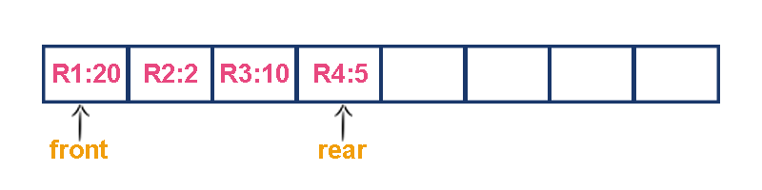

Now, check waiting time for each request to be complete.

1. **R1 : 20 units of time**
2. **R2 : 22 units of time (R2 must wait till R1 complete - 20 units and R2 itself requeres 2 units. Total 22 units)**
3. **R3 : 32 units of time (R3 must wait till R2 complete - 22 units and R3 itself requeres 10 units. Total 32 units)**
4. **R4 : 37 units of time (R4 must wait till R3 complete - 35 units and R4 itself requeres 5 units. Total 37 units)**

**Here, average waiting time for all requests (R1, R2, R3 and R4) is (20+22+32+37)/4 ≈ 27 units of time.**

That means, if we use a normal queue data structure to serve these requests the average waiting time for each request is 27 units of time.  
  
Now, consider another way of serving these requests. If we serve according to their required amount of time. That means, first we serve R2 which has minimum time required (2) then serve R4 which has second minimum time required (5) then serve R3 which has third minimum time required (10) and finnaly R1 which has maximum time required (20).

Now, check waiting time for each request to be complete.

1. **R2 : 2 units of time**
2. **R4 : 7 units of time (R4 must wait till R2 complete 2 units and R4 itself requeres 5 units. Total 7 units)**
3. **R3 : 17 units of time (R3 must wait till R4 complete 7 units and R3 itself requeres 10 units. Total 17 units)**
4. **R1 : 37 units of time (R1 must wait till R3 complete 17 units and R1 itself requeres 20 units. Total 37 units)**

**Here, average waiting time for all requests (R1, R2, R3 and R4) is (2+7+17+37)/4 ≈ 15 units of time.**

From above two situations, it is very clear that, by using second method server can complete all four requests with very less time compared to the first method. This is what exactly done by the priority queue.

**Priority queue is a variant of queue data structure in which insertion is performed in the order of arrival and deletion is performed based on the priority.**

There are two types of priority queues they are as follows...

1. **Max Priority Queue**
2. **Min Priority Queue**

**1. Max Priority Queue**

In max priority queue, elements are inserted in the order in which they arrive the queue and always maximum value is removed first from the queue. For example assume that we insert in order 8, 3, 2, 5 and they are removed in the order 8, 5, 3, 2.  
  
The following are the operations performed in a Max priority queue...

1. **isEmpty() - Check whether queue is Empty.**
2. **insert() - Inserts a new value into the queue.**
3. **findMax() - Find maximum value in the queue.**
4. **remove() - Delete maximum value from the queue.**

**Max Priority Queue Representations**

There are 6 representations of max priority queue.

1. **Using an Unordered Array (Dynamic Array)**
2. **Using an Unordered Array (Dynamic Array) with the index of the maximum value**
3. **Using an Array (Dynamic Array) in Decreasing Order**
4. **Using an Array (Dynamic Array) in Increasing Order**
5. **Using Linked List in Increasing Order**
6. **Using Unordered Linked List with reference to node with the maximum value**

**#1. Using an Unordered Array (Dynamic Array)**

In this representation elements are inserted according to their arrival order and maximum element is deleted first from max priority queue.  
  
For example, assume that elements are inserted in the order of 8, 2, 3 and 5. And they are removed in the order 8, 5, 3 and 2.



Now, let us analyse each operation according to this representation...

**isEmpty()** - If '**front == -1**' queue is Empty. This operation requires **O(1)** time complexity that means constant time.

**insert()** - New element is added at the end of the queue. This operation requires **O(1)** time complexity that means constant time.

**findMax()** - To find maximum element in the queue, we need to compare with all the elements in the queue. This operation requires **O(n)**time complexity.

**remove()** - To remove an element from the queue first we need to perform **findMax()** which requires **O(n)** and removal of particular element requires constant time **O(1)**. This operation requires **O(n)** time complexity.

**#2. Using an Unordered Array (Dynamic Array) with the index of the maximum value**

In this representation elements are inserted according to their arrival order and maximum element is deleted first from max priority queue.  
  
For example, assume that elements are inserted in the order of 8, 2, 3 and 5. And they are removed in the order 8, 5, 3 and 2.

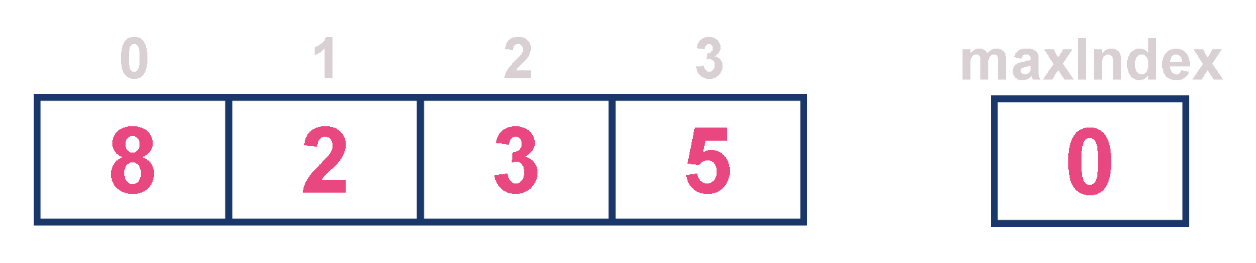

Now, let us analyse each operation according to this representation...

**isEmpty()** - If '**front == -1**' queue is Empty. This operation requires **O(1)** time complexity that means constant time.

**insert()** - New element is added at the end of the queue with **O(1)** and for each insertion we need to update maxIndex with **O(1)**. This operation requires **O(1)** time complexity that means constant time.

**findMax()** - To find maximum element in the queue is very simple as maxIndex has maximum element index. This operation requires **O(1)**time complexity.

**remove()** - To remove an element from the queue first we need to perform **findMax()** which requires **O(1)** , removal of particular element requires constant time **O(1)** and update maxIndex value which requires **O(n)**. This operation requires **O(n)** time complexity.

**#3. Using an Array (Dynamic Array) in Decreasing Order**

In this representation elements are inserted according to their value in decreasing order and maximum element is deleted first from max priority queue.  
  
For example, assume that elements are inserted in the order of 8, 5, 3 and 2. And they are removed in the order 8, 5, 3 and 2.



Now, let us analyse each operation according to this representation...

**isEmpty()** - If '**front == -1**' queue is Empty. This operation requires **O(1)** time complexity that means constant time.

**insert()** - New element is added at a particular position in the decreasing order into the queue with **O(n)**, because we need to shift existing elements inorder to insert new element in decreasing order. This operation requires **O(n)** time complexity.

**findMax()** - To find maximum element in the queue is very simple as maximum element is at the beginning of the queue. This operation requires **O(1)** time complexity.

**remove()** - To remove an element from the queue first we need to perform **findMax()** which requires **O(1)**, removal of particular element requires constant time **O(1)** and rearrange remaining elements which requires **O(n)**. This operation requires **O(n)** time complexity.

**#4. Using an Array (Dynamic Array) in Increasing Order**

In this representation elements are inserted according to their value in increasing order and maximum element is deleted first from max priority queue.  
  
For example, assume that elements are inserted in the order of 2, 3, 5 and 8. And they are removed in the order 8, 5, 3 and 2.



Now, let us analyse each operation according to this representation...

**isEmpty()** - If '**front == -1**' queue is Empty. This operation requires **O(1)** time complexity that means constant time.

**insert()** - New element is added at a particular position in the increasing order into the queue with **O(n)**, because we need to shift existing elements inorder to insert new element in increasing order. This operation requires **O(n)** time complexity.

**findMax()** - To find maximum element in the queue is very simple as maximum element is at the end of the queue. This operation requires **O(1)** time complexity.

**remove()** - To remove an element from the queue first we need to perform **findMax()** which requires **O(1)**, removal of particular element requires constant time **O(1)** and rearrange remaining elements which requires **O(n)**. This operation requires **O(n)** time complexity.

**#5. Using Linked List in Increasing Order**

In this representation, we use a single linked list to represent max priority queue. In this representation elements are inserted according to their value in increasing order and node with maximum value is deleted first from max priority queue.  
  
For example, assume that elements are inserted in the order of 2, 3, 5 and 8. And they are removed in the order 8, 5, 3 and 2.

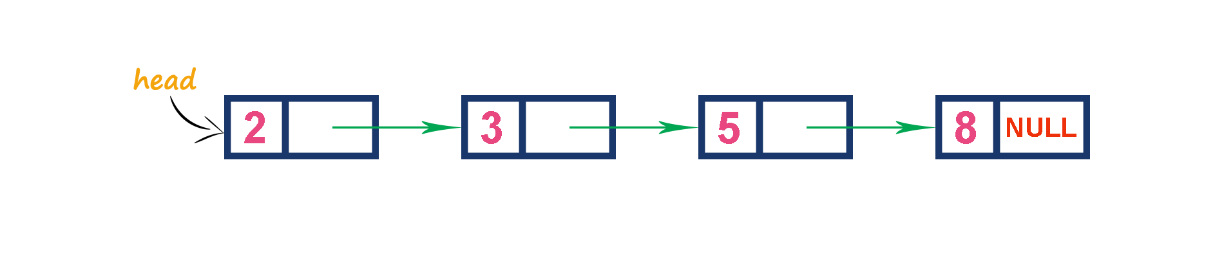

Now, let us analyse each operation according to this representation...

**isEmpty()** - If '**head == NULL**' queue is Empty. This operation requires **O(1)** time complexity that means constant time.

**insert()** - New element is added at a particular position in the increasing order into the queue with **O(n)**, because we need to the position where new element has to be inserted. This operation requires **O(n)** time complexity.

**findMax()** - To find maximum element in the queue is very simple as maximum element is at the end of the queue. This operation requires **O(1)** time complexity.

**remove()** - To remove an element from the queue is simply removing the last node in the queue which requires **O(1)**. This operation requires **O(1)** time complexity.

**#6. Using Unordered Linked List with reference to node with the maximum value**

In this representation, we use a single linked list to represent max priority queue. Always we maitain a reference (maxValue) to the node with maximum value. In this representation elements are inserted according to their arrival and node with maximum value is deleted first from max priority queue.  
  
For example, assume that elements are inserted in the order of 2, 8, 3 and 5. And they are removed in the order 8, 5, 3 and 2.

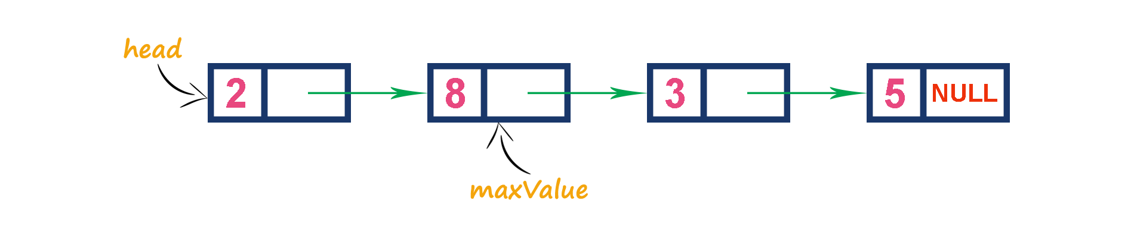

Now, let us analyse each operation according to this representation...

**isEmpty()** - If '**head == NULL**' queue is Empty. This operation requires **O(1)** time complexity that means constant time.

**insert()** - New element is added at end the queue with **O(1)** and update maxValue reference with **O(1)**. This operation requires **O(1)** time complexity.

**findMax()** - To find maximum element in the queue is very simple as maxValue is referenced to the node with maximum value in the queue. This operation requires **O(1)** time complexity.

**remove()** - To remove an element from the queue is deleting the node which referenced by maxValue which requires **O(1)** and update maxValue reference to new node with maximum value in the queue which requires **O(n) time complexity**. This operation requires **O(n)**time complexity.

**2. Min Priority Queue Representations**

Min Priority Queue is similar to max priority queue except removing maximum element first, we remove minimum element first in min priority queue.  
  
The following operations are performed in Min Priority Queue...

1. **isEmpty()** - Check whether queue is Empty.
2. **insert()** - Inserts a new value into the queue.
3. **findMin()** - Find minimum value in the queue.
4. **remove()** - Delete minimum value from the queue.

Min priority queue is also has same representations as Max priority queue with minimum value removal.

**PRIORITY QUEUE USING ARRAY**

1. */\**
2. *\* C Program to Implement Priority Queue to Add and Delete Elements*
3. *\*/*
4. #include <stdio.h>
5. #include <stdlib.h>
7. #define MAX 5
9. void insert_by_priority(int);
10. void delete_by_priority(int);
11. void create();
12. void check(int);
13. void display_pqueue();
15. int pri_que[MAX];
16. int front, rear;
18. void main()
19. {
20. int n, ch;
22. printf("**\n**1 - Insert an element into queue");
23. printf("**\n**2 - Delete an element from queue");
24. printf("**\n**3 - Display queue elements");
25. printf("**\n**4 - Exit");
27. create();
29. while (1)
30. {
31. printf("**\n**Enter your choice : ");
32. scanf("%d", &ch);
34. switch (ch)
35. {
36. case 1:
37. printf("**\n**Enter value to be inserted : ");
38. scanf("%d",&n);
39. insert_by_priority(n);
40. **break**;
41. case 2:
42. printf("**\n**Enter value to delete : ");
43. scanf("%d",&n);
44. delete_by_priority(n);
45. **break**;
46. case 3:
47. display_pqueue();
48. **break**;
49. case 4:
50. exit(0);
51. default:
52. printf("**\n**Choice is incorrect, Enter a correct choice");
53. }
54. }
55. }
57. */* Function to create an empty priority queue */*
58. void create()
59. {
60. front = rear = -1;
61. }
63. */* Function to insert value into priority queue */*
64. void insert_by_priority(int data)
65. {
66. if (rear >= MAX - 1)
67. {
68. printf("**\n**Queue overflow no more elements can be inserted");
69. return;
70. }
71. if ((front == -1) && (rear == -1))
72. {
73. front++;
74. rear++;
75. pri_que[rear] = data;
76. return;
77. }
78. else
79. check(data);
80. rear++;
81. }
83. */* Function to check priority and place element */*
84. void check(int data)
85. {
86. int i,j;
88. for (i = 0; i <= rear; i++)
89. {
90. if (data >= pri_que[i])
91. {
92. for (j = rear + 1; j > i; j--)
93. {
94. pri_que[j] = pri_que[j - 1];
95. }
96. pri_que[i] = data;
97. return;
98. }
99. }
100. pri_que[i] = data;
101. }
103. */* Function to delete an element from queue */*
104. void delete_by_priority(int data)
105. {
106. int i;
108. if ((front==-1) && (rear==-1))
109. {
110. printf("**\n**Queue is empty no elements to delete");
111. return;
112. }
114. for (i = 0; i <= rear; i++)
115. {
116. if (data == pri_que[i])
117. {
118. for (; i < rear; i++)
119. {
120. pri_que[i] = pri_que[i + 1];
121. }
123. pri_que[i] = -99;
124. rear--;
126. if (rear == -1)
127. front = -1;
128. return;
129. }
130. }
131. printf("**\n**%d not found in queue to delete", data);
132. }
134. */* Function to display queue elements */*
135. void display_pqueue()
136. {
137. if ((front == -1) && (rear == -1))
138. {
139. printf("**\n**Queue is empty");
140. return;
141. }
143. for (i=front; i <= rear; i++)
144. {
145. printf(" %d ", pri_que[front]);
146. }
148. front = 0;
149. }

$ **cc** pgm7.c

$ a.out

1 - Insert an element into queue

2 - Delete an element from queue

3 - Display queue elements

4 - Exit

Enter your choice : 1

Enter value to be inserted : 20

Enter your choice : 1

Enter value to be inserted : 45

Enter your choice : 1

Enter value to be inserted : 89

Enter your choice : 3

89 45 20

Enter your choice : 1

Enter value to be inserted : 56

Enter your choice : 3

89 56 45 20

Enter your choice : 2

Enter value to delete : 45

Enter your choice : 3

89 56 20

Enter your choice : 4

**PRIORITY QUEUE USING LINKED LIST**

int info;  
struct node *link;  
}*front = NULL;  
  
main()  
{  
int choice;  
clrscr();  
printf("\n\n PRIORITY QUEUE USING LINKED LIST \n\n");  
while(1)  
{  
printf("\n\n--------------------------- MAIN MENU -------------------------------------\n\n");  
printf("1.Insert.\n\n");  
printf("2.Delete.\n\n");  
printf("3.Display.\n\n");  
printf("4.Quit.\n\n");  
printf("Enter your choice : ");  
scanf("%d", &choice);  
switch(choice)  
{  
case 1:  
insert();  
break;  
case 2:  
del();  
break;  
case 3:  
display();  
break;  
case 4:  
exit(1);  
default :  
printf("INVALID CHOICE TRY AGAIN!!!!!!1\n");  
}  
}  
}  
  
void insert()  
{  
struct node *tmp,*q;  
int added_item,item_priority;  
tmp = (struct node *)malloc(sizeof(struct node));  
printf("\n------------------------------------------------------------------------------\n");  
printf("\nInput the data to be added in the queue : ");  
scanf("%d",&added_item);  
printf("\n\nEnter its priority : ");  
scanf("%d",&item_priority);  
printf("\n\n------------------------------------------------------------------------------\n");  
tmp->info = added_item;  
tmp->priority = item_priority;  
if( front == NULL || item_priority < front->priority )  
{  
tmp->link = front;  
front = tmp;  
}  
else  
{  
q = front;  
while( q->link != NULL && q->link->priority <= item_priority ) q=q->link;  
tmp->link = q->link;  
q->link = tmp;  
}  
}  
void del()  
{  
struct node *tmp;  
if(front == NULL)  
{  
printf("\n--------------------------------------------------------------------");  
printf("\n\nQueue Underflow\n");  
printf("\n------------------------------------------------------------------------");  
}  
else  
{  
tmp = front;  
printf("\n----------------------------------------------------------------------------\n");  
printf("\n\nDeleted data is %d\n",tmp->info);  
printf("\n-----------------------------------------------------------------------------\n\n");  
front = front->link;  
free(tmp);  
}  
}  
  
void display()  
{  
struct node *ptr;  
ptr = front;  
if(front == NULL)  
{  
printf("\n-----------------------------------------------------------------------");  
printf("\n\nQueue is empty\n");  
printf("\n--------------------------------------------------------------------------");  
}  
else  
{  
printf("\n\n---------------------- Queue --------------------------------\n\n");  
printf("Priority\tData\n\n");  
while(ptr != NULL)  
{  
printf("%d \t\t%d\n\n",ptr->priority,ptr->info);  
ptr = ptr->link;  
}  
}  
}

1. */\**
2. *\* C program to determine if a given matrix is* ***a sparse matrix****.*
3. *\* Sparse martix has more zero elements than nonzero elements.*
4. *\*/*
5. #include <stdio.h>
7. void main ()
8. {
9. static int array[10][10];
10. int i, j, m, n;
11. int counter = 0;
13. printf("Enter the order of the matix **\n**");
14. scanf("%d %d", &m, &n);
15. printf("Enter the co-efficients of the matix **\n**");
16. for (i = 0; i < m; i++)
17. {
18. for (j = 0; j < n; j++)
19. {
20. scanf("%d", &array[i][j]);
21. if (array[i][j] == 0)
22. {
23. Counter++;
24. }
25. }
26. }
27. if (counter > ((m * n) / 2))
28. {
29. printf("The given matrix is sparse matrix **\n**");
30. }
31. else
32. printf("The given matrix is not a sparse matrix **\n**");
33. printf("There are %d number of zeros", counter);
34. }

# Infix to Postfix Conversion

### Procedure for Postfix Conversion

|  |  |
| --- | --- |
| **1.** | Scan the Infix string from left to right. |
| **2.** | Initialize an empty stack. |
| **3.** | If the scanned character is an operand, add it to the Postfix string. |
| **4.** | If the scanned character is an operator and if the stack is empty push the character to stack. |
| **5.** | If the scanned character is an Operator and the stack is not empty, compare the precedence of the character with the element on top of the stack. |
| **6.** | If top Stack has higher precedence over the scanned character pop the stack else push the scanned character to stack. Repeat this step until the stack is not empty and top Stack has precedence over the character. |
| **7.** | Repeat 4 and 5 steps till all the characters are scanned. |
| **8.** | After all characters are scanned, we have to add any character that the stack may have to the Postfix string. |
| **9.** | If stack is not empty add top Stack to Postfix string and Pop the stack. |
| **10.** | Repeat this step as long as stack is not empty. |

### Algorithm for Postfix Conversion

1. S:stack
2. while(more tokens)
3. x<=next token
4. if(x == operand)
5. print x
6. else
7. while(precedence(x)<=precedence(top(s)))
8. print(pop(s))
9. push(s,x)
10. while(! empty (s))
11. print(pop(s))

| **Infix Expression** | | | **Prefix Expression** | | **Postfix Expression** |
| --- | --- | --- | --- | --- | --- |
| A + B * C + D | | | + + A * B C D | | A B C * + D + |
| (A + B) * (C + D) | | | * + A B + C D | | A B + C D + * |
| A * B + C * D | | | + * A B * C D | | A B * C D * + |
| A + B + C + D | | | + + + A B C D | | A B + C + D + |
| **Expression** | **Current Symbol** | **Stack** | | **Output** | **Comment** |
| A/B^C-D | Initial State | NULL | | – | Initially Stack is Empty |
| /B^C-D | A | NULL | | A | Print Operand |
| B^C-D | / | / | | A | Push Operator Onto Stack |
| ^C-D | B | / | | AB | Print Operand |
| C-D | ^ | /^ | | AB | Push Operator Onto Stack because Priority of ^ is greater than Current Topmost Symbol of Stack i.e ‘/’ |
| -D | C | /^ | | ABC | Print Operand |
| D | – | / | | ABC^ | **Step 1 :** Now ‘^’ Has Higher Priority than Incoming Operator So We have to Pop Topmost Element . **Step 2 :**Remove Topmost Operator From Stack and Print it |
| D | – | NULL | | ABC^/ | **Step 1 :** Now ‘/’ is topmost Element of Stack Has Higher Priority than Incoming Operator So We have to Pop Topmost Element again. **Step 2 :**Remove Topmost Operator From Stack and Print it |
| D | – | – | | ABC^/ | **Step 1 :** Now Stack Becomes Empty and We can Push Operand Onto Stack |
| NULL | D | – | | ABC^/D | Print Operand |
| NULL | NULL | – | | ABC^/D- | Expression Scanning Ends but we have still one more element in stack so pop it and display it |

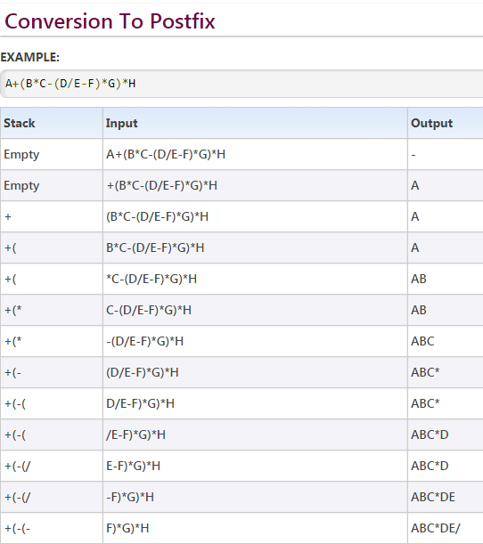

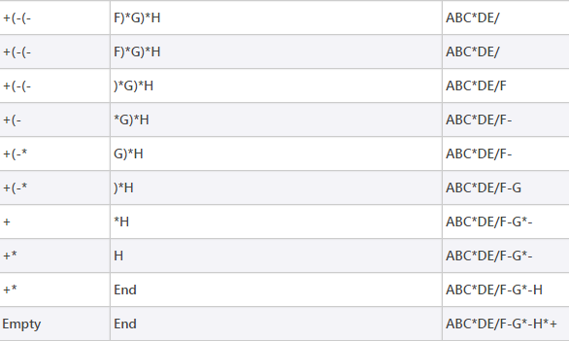

Infix to postfix conversion algorithm

There is an algorithm to convert an infix expression into a postfix expression. It uses a stack; but in this case, the stack is used to hold operators rather than numbers. The purpose of the stack is to reverse the order of the operators in the expression. It also serves as a storage structure, since no operator can be printed until both of its operands have appeared.

In this algorithm, all operands are printed (or sent to output) when they are read. There are more complicated rules to handle operators and parentheses.

Example:

1. A * B + C becomes A B * C +

The order in which the operators appear is not reversed. When the '+' is read, it has lower precedence than the '*', so the '*' must be printed first.

We will show this in a table with three columns. The first will show the symbol currently being read. The second will show what is on the stack and the third will show the current contents of the postfix string. The stack will be written from left to right with the 'bottom' of the stack to the left.

|  |  |  |  |
| --- | --- | --- | --- |
|  | current symbol | operator stack | postfix string |
|  |  |  |  |
| 1 | A |  | A |
| 2 | * | * | A |
| 3 | B | * | A B |
| 4 | + | + | A B * {pop and print the '*' before pushing the '+'} |
| 5 | C | + | A B * C |
| 6 |  |  | A B * C + |

The rule used in lines 1, 3 and 5 is to print an operand when it is read. The rule for line 2 is to push an operator onto the stack if it is empty. The rule for line 4 is if the operator on the top of the stack has higher precedence than the one being read, pop and print the one on top and then push the new operator on. The rule for line 6 is that when the end of the expression has been reached, pop the operators on the stack one at a time and print them.

2. A + B * C becomes A B C * +

Here the order of the operators must be reversed. The stack is suitable for this, since operators will be popped off in the reverse order from that in which they were pushed.

|  |  |  |  |
| --- | --- | --- | --- |
|  | current symbol | operator stack | postfix string |
|  |  |  |  |
| 1 | A |  | A |
| 2 | + | + | A |
| 3 | B | + | A B |
| 4 | * | + * | A B |
| 5 | C | + * | A B C |
| 6 |  |  | A B C * + |

In line 4, the '*' sign is pushed onto the stack because it has higher precedence than the '+' sign which is already there. Then when the are both popped off in lines 6 and 7, their order will be reversed.

3. A * (B + C) becomes A B C + *

A subexpression in parentheses must be done before the rest of the expression.

|  |  |  |  |
| --- | --- | --- | --- |
|  | current symbol | operator stack | postfix string |
|  |  |  |  |
| 1 | A |  | A |
| 2 | * | * | A |
| 3 | ( | * ( | A B |
| 4 | B | * ( | A B |
| 5 | + | * ( + | A B |
| 6 | C | * ( + | A B C |
| 7 | ) | * | A B C + |
| 8 |  |  | A B C + * |

Since expressions in parentheses must be done first, everything on the stack is saved and the left parenthesis is pushed to provide a marker. When the next operator is read, the stack is treated as though it were empty and the new operator (here the '+' sign) is pushed on. Then when the right parenthesis is read, the stack is popped until the corresponding left parenthesis is found. Since postfix expressions have no parentheses, the parentheses are not printed.

4. A - B + C becomes A B - C +

When operators have the same precedence, we must consider association. Left to right association means that the operator on the stack must be done first, while right to left association means the reverse.

|  |  |  |  |
| --- | --- | --- | --- |
|  | current symbol | operator stack | postfix string |
|  |  |  |  |
| 1 | A |  | A |
| 2 | - | - | A |
| 3 | B | - | A B |
| 4 | + | + | A B - |
| 5 | C | + | A B - C |
| 6 |  |  | A B - C + |

In line 4, the '-' will be popped and printed before the '+' is pushed onto the stack. Both operators have the same precedence level, so left to right association tells us to do the first one found before the second.

5. A * B ^ C + D becomes A B C ^ * D +

Here both the exponentiation and the multiplication must be done before the addition.

|  |  |  |  |
| --- | --- | --- | --- |
|  | current symbol | operator stack | postfix string |
|  |  |  |  |
| 1 | A |  | A |
| 2 | * | * | A |
| 3 | B | * | A B |
| 4 | ^ | * ^ | A B |
| 5 | C | * ^ | A B C |
| 6 | + | + | A B C ^ * |
| 7 | D | + | A B C ^ * D |
| 8 |  |  | A B C ^ * D + |

When the '+' is encountered in line 6, it is first compared to the '^' on top of the stack. Since it has lower precedence, the '^' is popped and printed. But instead of pushing the '+' sign onto the stack now, we must compare it with the new top of the stack, the '*'. Since the operator also has higher precedence than the '+', it also must be popped and printed. Now the stack is empty, so the '+' can be pushed onto the stack.

6. A * (B + C * D) + E becomes A B C D * + * E +

|  |  |  |  |
| --- | --- | --- | --- |
|  | current symbol | operator stack | postfix string |
|  |  |  |  |
| 1 | A |  | A |
| 2 | * | * | A |
| 3 | ( | * ( | A |
| 4 | B | * ( | A B |
| 5 | + | * ( + | A B |
| 6 | C | * ( + | A B C |
| 7 | * | * ( + * | A B C |
| 8 | D | * ( + * | A B C D |
| 9 | ) | * | A B C D * + |
| 10 | + | + | A B C D * + * |
| 11 | E | + | A B C D * + * E |
| 12 |  |  | A B C D * + * E + |

A summary of the rules follows:

1. Print operands as they arrive.

2. If the stack is empty or contains a left parenthesis on top, push the incoming operator onto the stack.

3. If the incoming symbol is a left parenthesis, push it on the stack.

4. If the incoming symbol is a right parenthesis, pop the stack and print the operators until you see a left parenthesis. Discard the pair of parentheses.

5. If the incoming symbol has higher precedence than the top of the stack, push it on the stack.

6. If the incoming symbol has equal precedence with the top of the stack, use association. If the association is left to right, pop and print the top of the stack and then push the incoming operator. If the association is right to left, push the incoming operator.

7. If the incoming symbol has lower precedence than the symbol on the top of the stack, pop the stack and print the top operator. Then test the incoming operator against the new top of stack.

8. At the end of the expression, pop and print all operators on the stack. (No parentheses should remain.)

**Red Black Tree**

Red - Black Tree is another varient of Binary Search Tree in which every node is colored either RED or BLACK. We can define a Red Black Tree as follows...

**Red Black Tree is a Binary Search Tree in which every node is colored eigther RED or BLACK.**

In a Red Black Tree the color of a node is decided based on the Red Black Tree properties. Every Red Black Tree has the following properties.

**Properties of Red Black Tree**

* **Property #1:** Red - Black Tree must be a Binary Search Tree.
* **Property #2:** The ROOT node must colored BLACK.
* **Property #3:** The children of Red colored node must colored BLACK. (There should not be two consecutive RED nodes).
* **Property #4:** In all the paths of the tree there must be same number of BLACK colored nodes.
* **Property #5:** Every new node must inserted with RED color.
* **Property #6:** Every leaf (e.i. NULL node) must colored BLACK.

**Example**

THe following is a Red Black Tree which created by inserting numbers from 1 to 9.

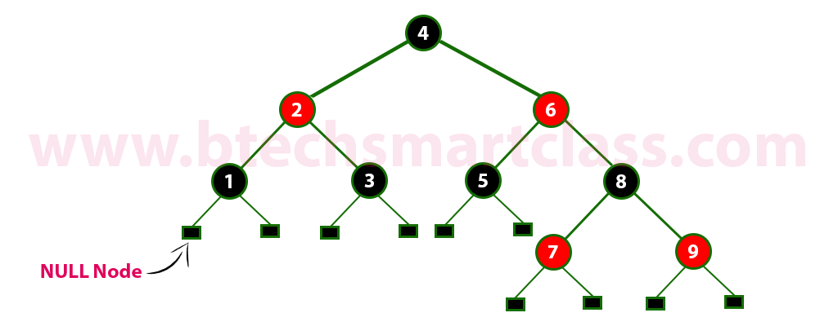

The above tree is a Red Black tree and every node is satisfying all the properties of Red Black Tree.

**Every Red Black Tree is a binary search tree but all the Binary Search Trees need not to be Red Black trees.**

**Insertion into RED BLACK Tree:**

In a Red Black Tree, every new node must be inserted with color RED. The insertion operation in Red Black Tree is similar to insertion operation in Binary Search Tree. But it is inserted with a color property. After every insertion operation, we need to check all the properties of Red Black Tree. If all the properties are satisfied then we go to next operation otherwise we need to perform following operation to make it Red Black Tree.

* **1.** Recolor
* **3.** Rotation followed by Recolor

The insertion operation in Red Black tree is performed using following steps...

* **Step 1:** Check whether tree is Empty.
* **Step 2:** If tree is Empty then insert the **newNode** as Root node with color **Black** and exit from the operation.
* **step 3:** If tree is not Empty then insert the newNode as a leaf node with Red color.
* **Step 4:** If the parent of newNode is Black then exit from the operation.
* **Step 5:** If the parent of newNode is Red then check the color of parent node's sibling of newNode.
* **Step 6:** If it is Black or NULL node then make a suitable Rotation and Recolor it.
* **Step 7:** If it is Red colored node then perform Recolor and Recheck it. Repeat the same until tree becomes Red Black Tree.

**Example**

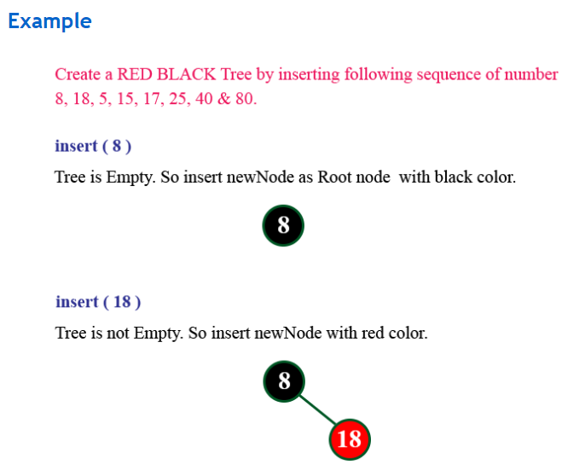

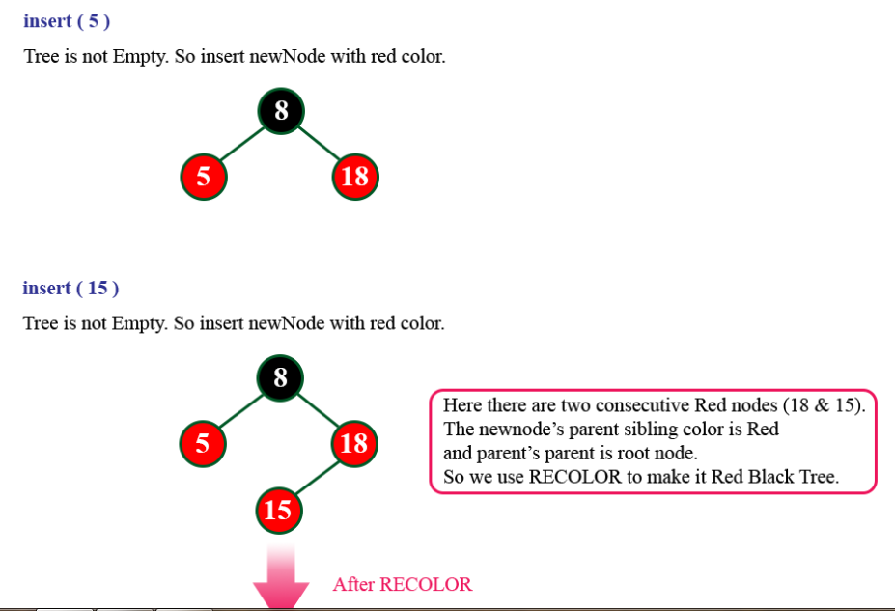

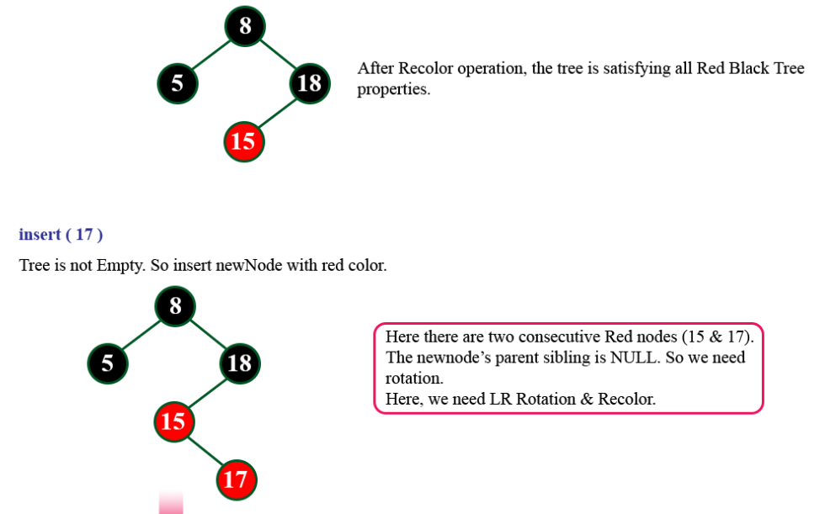

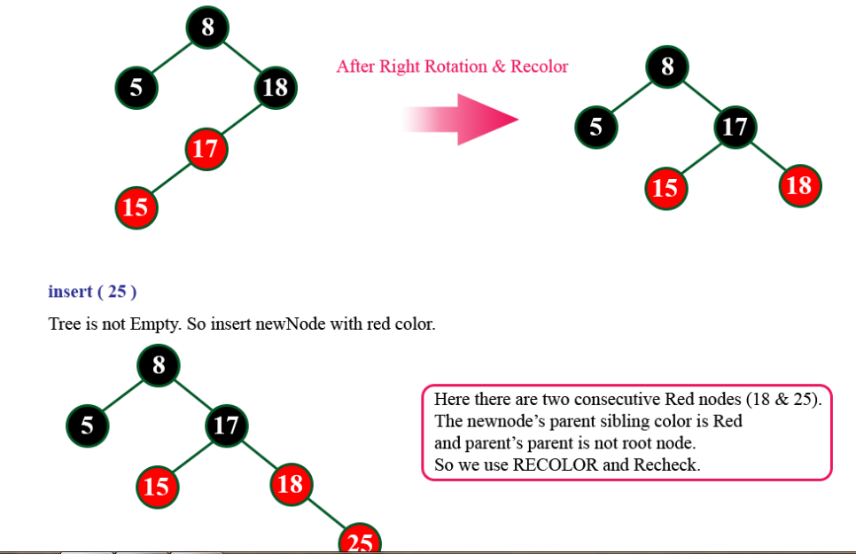

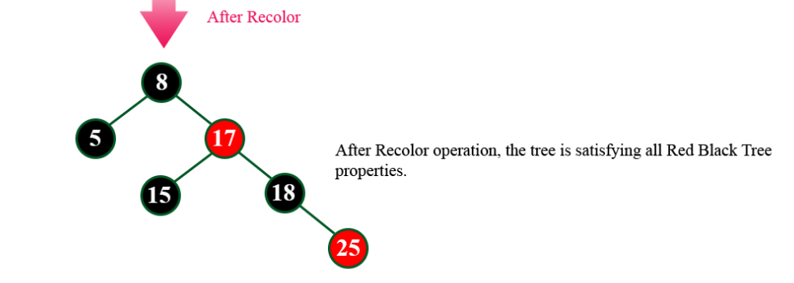

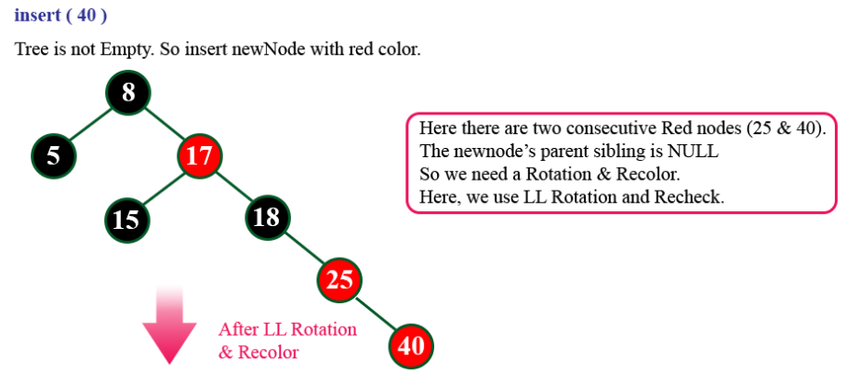

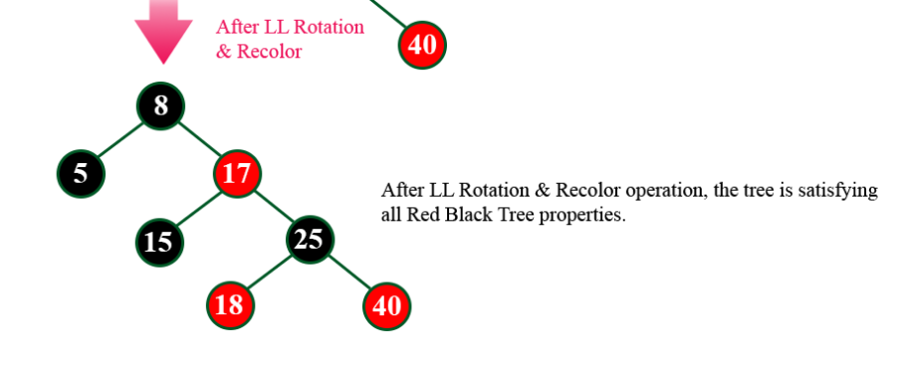

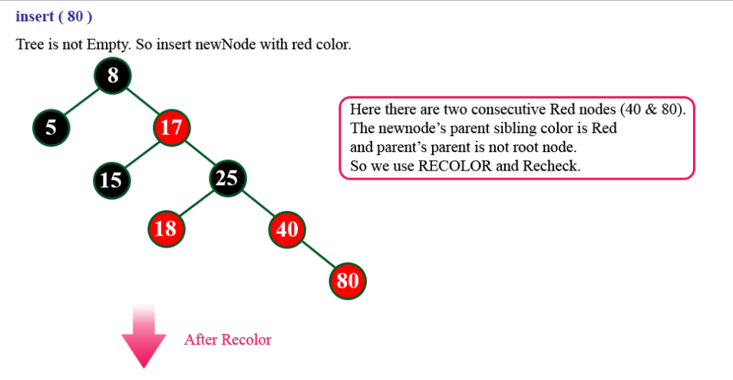

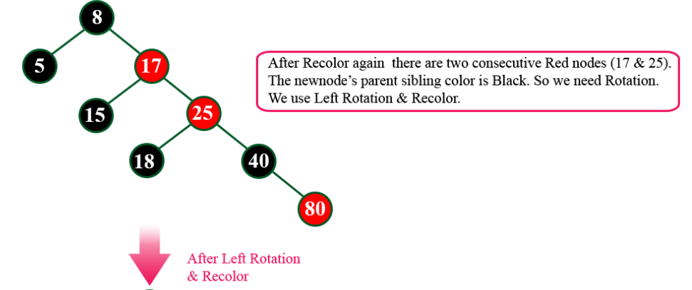

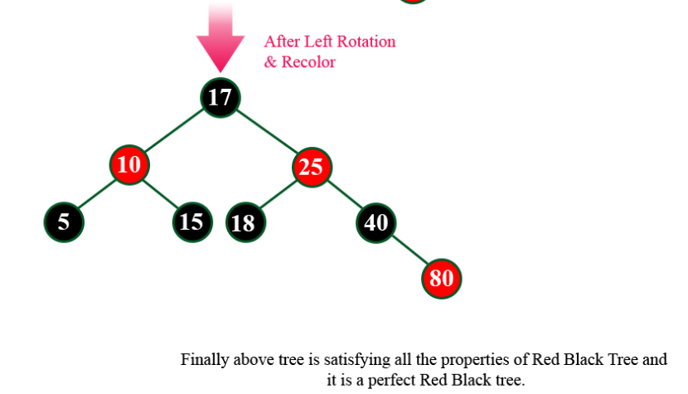

**Deletion Operation in Red Black Tree**

In a Red Black Tree, the deletion operation is similar to deletion operation in BST. But after every deletion operation we need to check with the Red Black Tree properties. If any of the property is voilated then make suitable operation like Recolor or Rotaton & Recolor.

# C Program to Solve Josephus Problem using Linked List

This C Program Solves the Josephus Problem using Linked List. Josephus Problem talks about a problem where there are people standing in a circle waiting to be executed. The counting out begins at some point in the circle and proceeds around the circle in a fixed direction. In each step, a certain number of people are skipped and the next person is executed. The elimination proceeds around the circle (which is becoming smaller and smaller as the executed people are removed), until only the last person remains, who is given freedom.

Here is source code of the C Program to Solve Josephus Problem using Linked List. The C program is successfully compiled and run on a Linux system. The program output is also shown below.

1. */\**
2. *\* C Program to Solve Josephus Problem using Linked List*
3. *\*/*
4. #include <stdio.h>
5. #include <stdlib.h>
7. struct node
8. {
9. int num;
10. struct node *next;
11. };
13. void create(struct node **);
14. void display(struct node *);
15. int survivor(struct node **, int);
17. int main()
18. {
19. struct node *head = NULL;
20. int survive, skip;
22. create(&head);
23. printf("The persons in circular list are:**\n**");
24. display(head);
25. printf("Enter the number of persons to be skipped: ");
26. scanf("%d", &skip);
27. survive = survivor(&head, skip);
28. printf("The person to survive is : %d**\n**", survive);
29. free(head);
31. return 0;
32. }
34. int survivor(struct node **head, int k)
35. {
36. struct node *p, *q;
37. int i;
39. q = p = *head;
40. while (p->next != p)
41. {
42. for (i = 0; i < k - 1; i++)
43. {
44. q = p;
45. p = p->next;
46. }
47. q->next = p->next;
48. printf("%d has been killed.**\n**", p->num);
49. free(p);
50. p = q->next;
51. }
52. *head = p;
54. return (p->num);
55. }
57. void create (struct node **head)
58. {
59. struct node *temp, *rear;
60. int a, ch;
62. do
63. {
64. printf("Enter a number: ");
65. scanf("%d", &a);
66. temp = (struct node *)malloc(sizeof(struct node));
67. temp->num = a;
68. temp->next = NULL;
69. if (*head == NULL)
70. {
71. *head = temp;
72. }
73. else
74. {
75. rear->next = temp;
76. }
77. rear = temp;
78. printf("Do you want to add a number [1/0]? ");
79. scanf("%d", &ch);
80. } while (ch != 0);
81. rear->next = *head;
82. }
84. void display(struct node *head)
85. {
86. struct node *temp;
88. temp = head;
89. printf("%d ", temp->num);
90. temp = temp->next;
91. while (head != temp)
92. {
93. printf("%d ", temp->num);
94. temp = temp->next;
95. }
96. printf("**\n**");
97. }

$ **gcc** josephus.c

$ .**/**a.out

Enter a number: 1

Do you want to add a number **[**1**/**0**]**? 1

Enter a number: 2

Do you want to add a number **[**1**/**0**]**? 1

Enter a number: 3

Do you want to add a number **[**1**/**0**]**? 1

Enter a number: 4

Do you want to add a number **[**1**/**0**]**? 1

Enter a number: 5

Do you want to add a number **[**1**/**0**]**? 1

Enter a number: 6

Do you want to add a number **[**1**/**0**]**? 1

Enter a number: 7

Do you want to add a number **[**1**/**0**]**? 0

The persons **in** circular list are:

1 2 3 4 5 6 7

Enter the number of persons to be skipped: 3

3 has been killed.

6 has been killed.

2 has been killed.

7 has been killed.

5 has been killed.

1 has been killed.

The person to survive is : 4

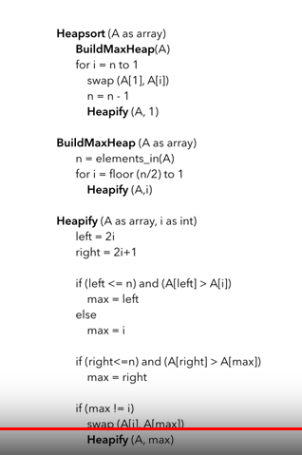

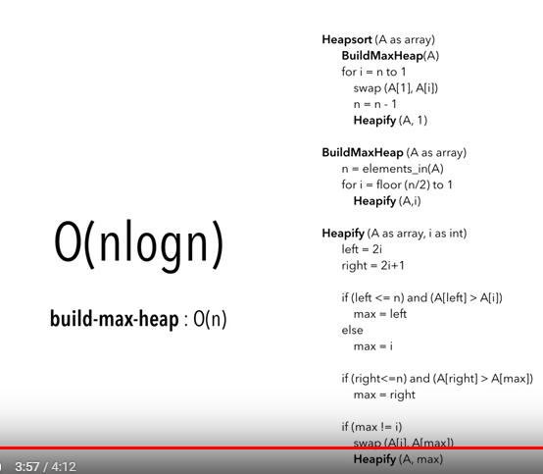

# ShellSort

ShellSort is mainly a variation of Insertion Sort. In insertion sort, we move elements only one position ahead. When an element has to be moved far ahead, many movements are involved. The idea of shellSort is to allow exchange of far items. In shellSort, we make the array h-sorted for a large value of h. We keep reducing the value of h until it becomes 1. An array is said to be h-sorted if all sublists of every h’th element is sorted.

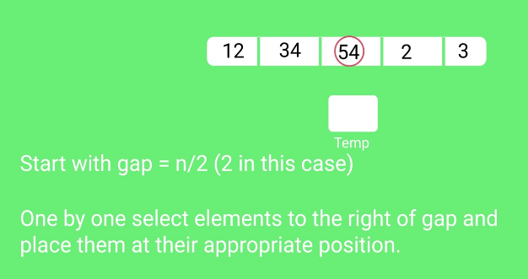

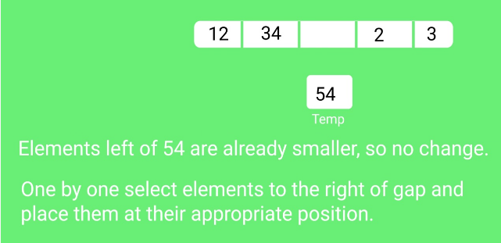

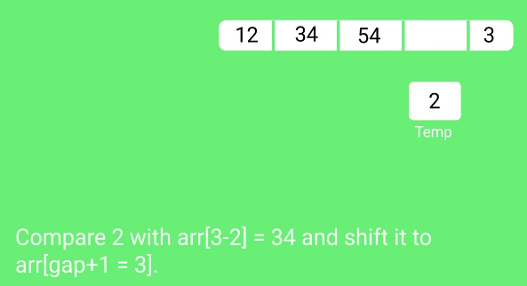

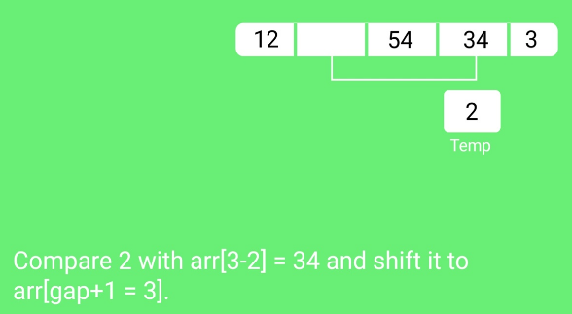

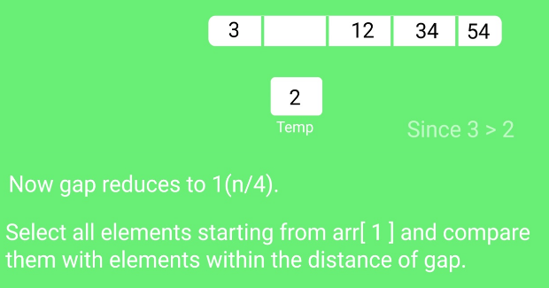

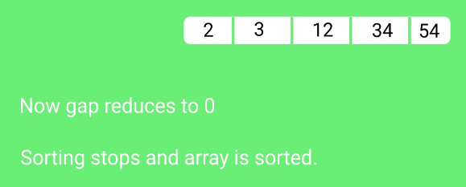

**Example**  
key :- 1,12,8,2,25,6,14,28,17,7,52,16,48,68,3,26,29,53,55,45,67.  
Order = 5  
Procedure for adding key in b-tree  
**Step1.** Add first key as root node.

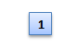

**Step2.** Add next key at the appropriate place in sorted order.



**Step3.** Same process applied until root node full. if root node full then spliting process applied.

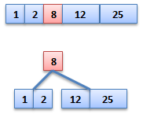

**Some importent steps**

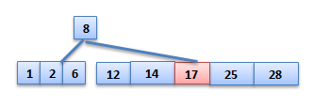

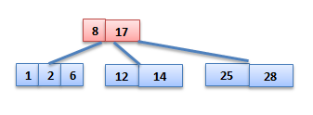

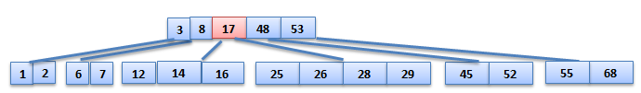

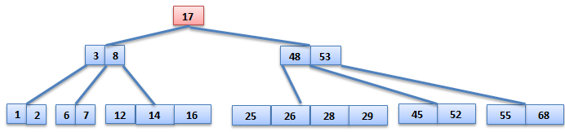

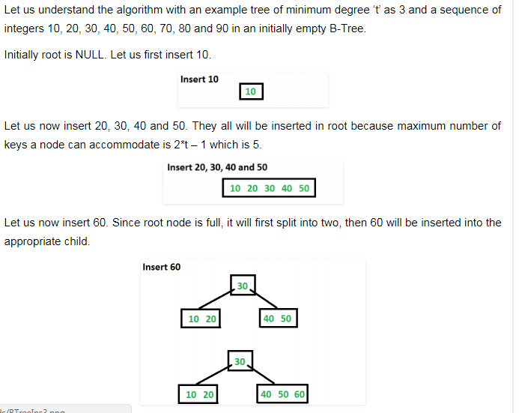

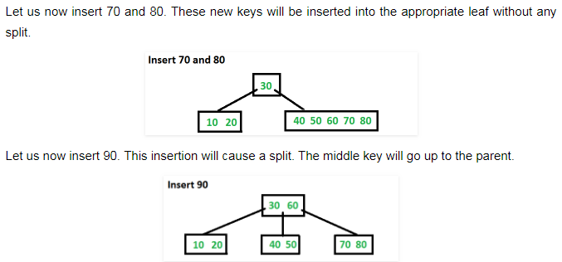

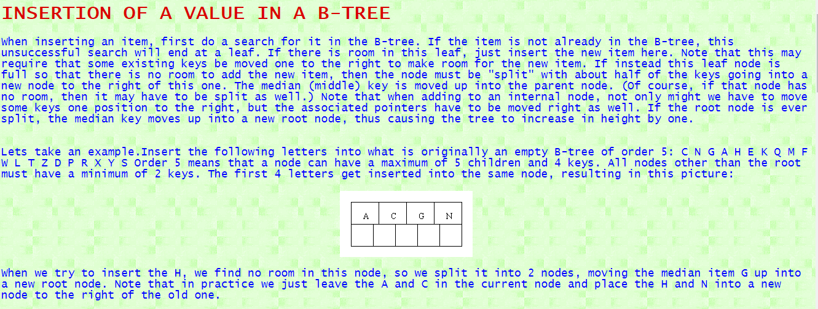

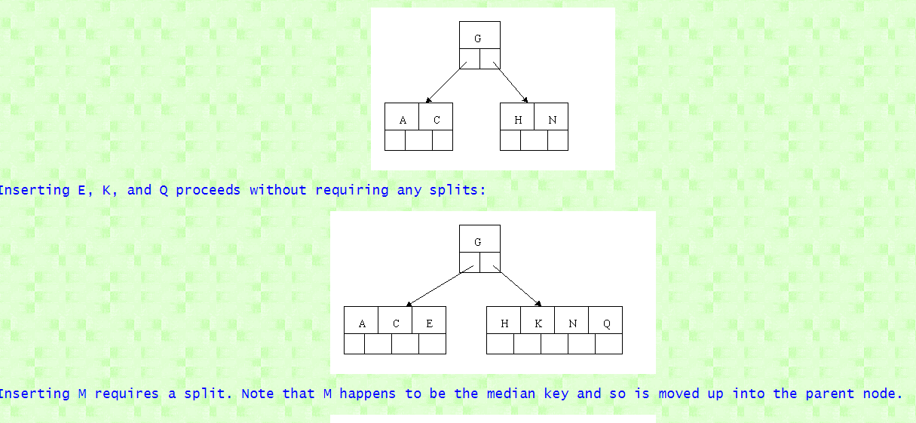

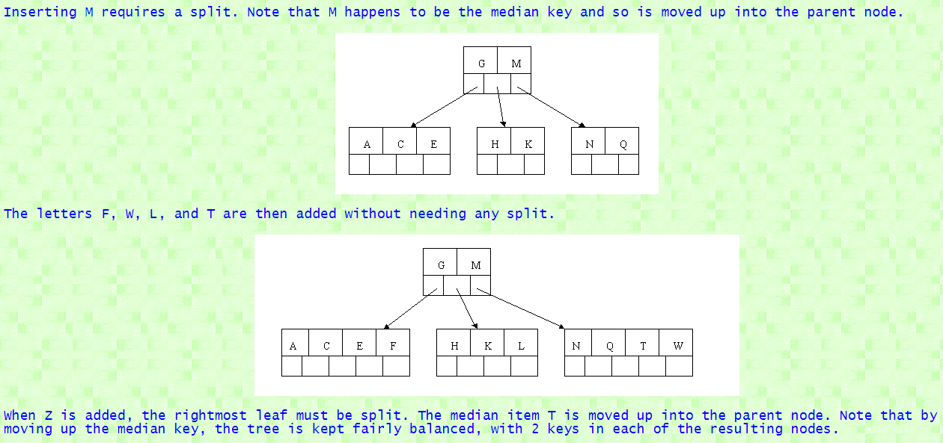

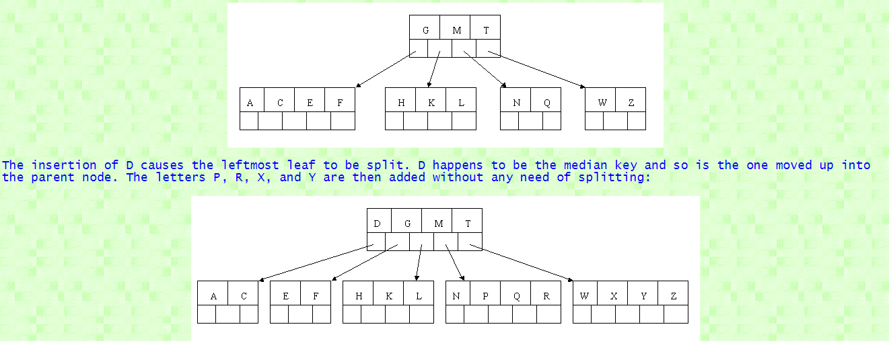

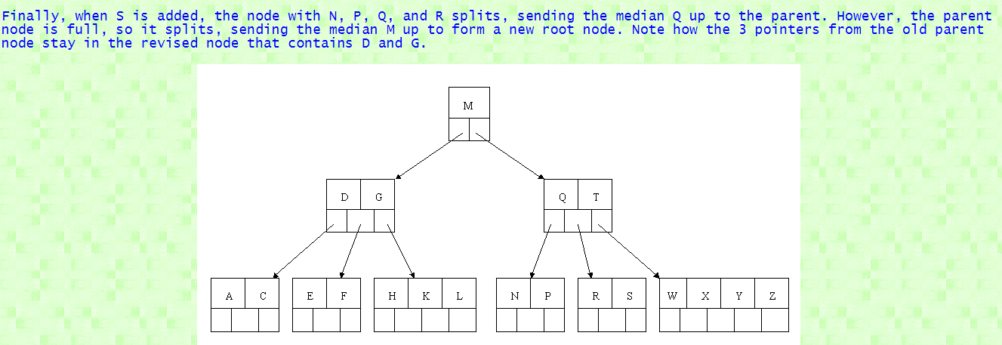

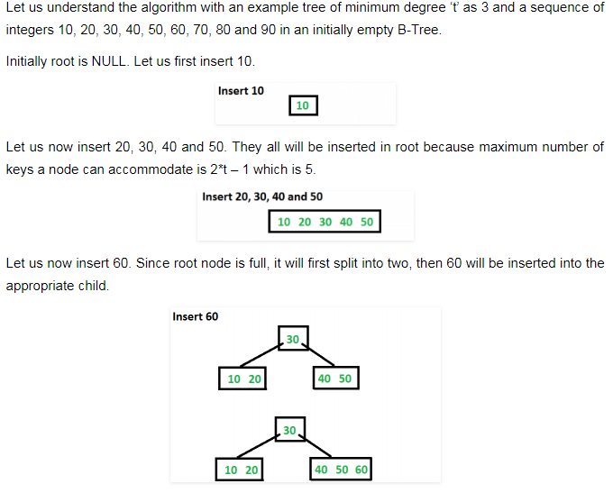

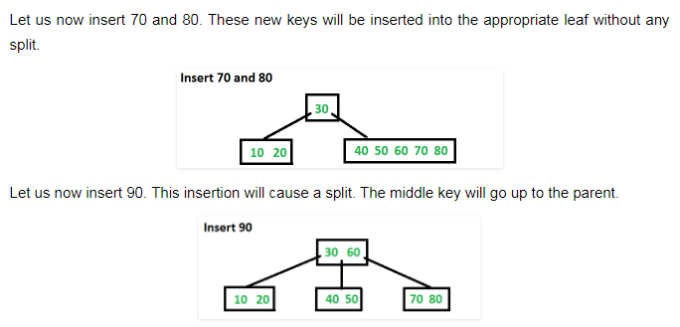

**AVL Tree example**. The insertion sequence is:   50, 25, 10, 5, 7, 3, 30, 20, 8, 15

|  |  |  |  |  |
| --- | --- | --- | --- | --- |
| https://www.cs.wcupa.edu/rkline/assets/img/DS/avl-2-a.png?1318630850 | https://www.cs.wcupa.edu/rkline/assets/img/DS/avl-2-b.png?1318630850 | single rot. left at 50 ⇒ | https://www.cs.wcupa.edu/rkline/assets/img/DS/avl-2-c.png?1318630850 | https://www.cs.wcupa.edu/rkline/assets/img/DS/avl-2-d.png?1318630850 |

|  |  |  |
| --- | --- | --- |
| https://www.cs.wcupa.edu/rkline/assets/img/DS/avl-2-e.png?1318630850 | double rot. left at 10 ⇒ | https://www.cs.wcupa.edu/rkline/assets/img/DS/avl-2-f.png?1318630850 |

|  |  |  |
| --- | --- | --- |
| https://www.cs.wcupa.edu/rkline/assets/img/DS/avl-2-g.png?1318630850 | single rot. left at 25 ⇒ | https://www.cs.wcupa.edu/rkline/assets/img/DS/avl-2-h.png?1318630850 |

|  |  |
| --- | --- |
| https://www.cs.wcupa.edu/rkline/assets/img/DS/avl-2-i.png?1318630850 | add(30), add(20), add(8) need no re-balancing |

|  |  |  |
| --- | --- | --- |
| https://www.cs.wcupa.edu/rkline/assets/img/DS/avl-2-j.png?1318630850 | double rot. right at 7 ⇒ | https://www.cs.wcupa.edu/rkline/assets/img/DS/avl-2-k.png?1318630850 |

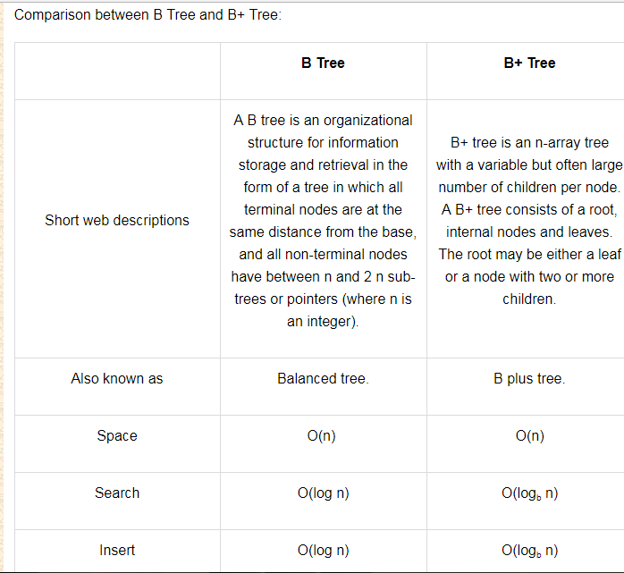

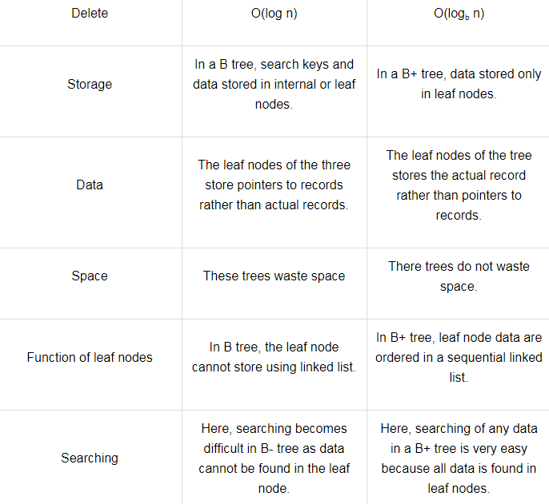

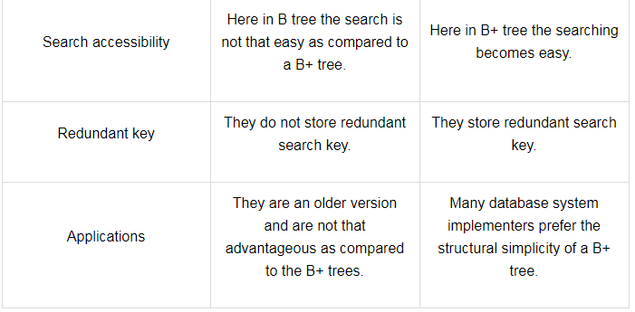

# Stack Applications

last updated 2/22/17

Top of Form

Bottom of Form

Three applications of stacks are presented here.  These examples are central to many activities that a computer must do and deserve time spent with them.

1. Expression evaluation
2. Backtracking (game playing, finding paths, exhaustive searching)
3. Memory management, run-time environment for nested language features.

## Expression evaluation

In particular we will consider arithmetic expressions.  Understand that there are boolean and logical expressions that can be evaluated in the same way.  Control structures can also be treated similarly in a compiler.

This study of arithmetic expression evaluation is an example of problem solving where you solve a simpler problem and then **transform** the actual problem to the simpler one.

Aside: *The NP-Complete problem*. There are a set of apparently intractable problems: finding the shortest route in a graph (Traveling Salesman Problem), bin packing, linear programming, etc. that are similar enough that if a polynomial solution is ever found (exponential solutions abound) for one of these problems, then the solution can be applied to all problems.

## Infix, Prefix and Postfix Notation

We are accustomed to write arithmetic expressions with the operation between the two operands: **a+b**or**c/d**.  If we write **a+b*c**, however, we have to apply precedence rules to avoid the ambiguous evaluation (add first or multiply first?).

There's no real reason to put the operation between the variables or values.  They can just as well precede or follow the operands.  You should note the advantage of prefix and postfix: the need for precedence rules and parentheses are eliminated.

|  |  |  |
| --- | --- | --- |
| **Infix** | **Prefix** | **Postfix** |
| a + b | + a b | a b + |
| a + b * c | + a * b c | a b c * + |
| (a + b) * (c - d) | * + a b - c d | a b + c d - * |
| b * b - 4 * a * c |  |  |
| 40 - 3 * 5 + 1 |  |  |

Postfix expressions are easily evaluated with the aid of a stack.

## Infix, Prefix and Postfix Notation KEY

|  |  |  |
| --- | --- | --- |
| **Infix** | **Prefix** | **Postfix** |
| a + b | + a b | a b + |
| a + b * c | + a * b c | a b c * + |
| (a + b) * (c - d) | * + a b - c d | a b + c d - * |
| b * b - 4 * a * c | **- * b b  * * 4 a c** | **b b * 4 a * c * -** |
| 40 - 3 * 5 + 1       =       **26** | **+  -  40  *  3  5  1** | **40  3  5  *  -  1  +** |

## Postfix Evaluation Algorithm

Assume we have a string of operands and operators, an informal, by hand process is

1. Scan the expression left to right
2. Skip  values or variables (operands)
3. When an operator is found, apply the operation to the preceding two operands
4. Replace the two operands and operator with the calculated value (three symbols are replaced with one operand)
5. Continue scanning until only a value remains--the result of the expression

The time complexity is O(n) because each operand is scanned once, and each operation is performed once.

A more formal algorithm:

create a new stack

while(input stream is not empty){

token = getNextToken();

if(token instanceof operand){

push(token);

} else if (token instance of operator)

op2 = pop();

op1 = pop();

result = calc(token, op1, op2);

push(result);

}

}

return pop();

Demonstration with 2 3 4 + * 5 -

## Infix transformation to Postfix

This process uses a stack as well.  We have to hold information that's expressed inside parentheses while scanning to find the closing ')'. We also have to hold information on operations that are of lower precedence on the stack.  The algorithm is:

1. Create an empty stack and an empty postfix output string/stream
2. Scan the infix input string/stream left to right
3. If the current input token is an operand, simply append it to the output string (note the examples above that the operands remain in the same order)
4. If the current input token is an operator, pop off all operators that have equal or higher precedence and append them to the output string; push the operator onto the stack.  The order of popping is the order in the output.
5. If the current input token is '(', push it onto the stack
6. If the current input token is ')', pop off all operators and append them to the output string until a '(' is popped; discard the '('.
7. If the end of the input string is found, pop all operators and append them to the output string.

This algorithm doesn't handle errors in the input, although careful analysis of parenthesis or lack of parenthesis could point to such error determination.

Apply the algorithm to the above expressions.

## Backtracking

Backtracking is used in algorithms in which there are steps along some path (state) from some starting point to some goal.

* Find your way through a maze.
* Find a path from one point in a graph (roadmap) to another point.
* Play a game in which there are moves to be made (checkers, chess).

In all of these cases, there are choices to be made among a number of options.  We need some way to remember these decision points in case we want/need to come back and try the alternative

Consider the maze.  At a point where a choice is made, we may discover that the choice leads to a dead-end.  We want to retrace back to that decision point and then try the other (next) alternative.

Again, stacks can be used as part of the solution.  Recursion is another, typically more favored, solution, which is actually implemented by a stack.

## Memory Management

Any modern computer environment uses a stack as the primary memory management model for a running program.  Whether it's native code (x86, Sun, VAX) or JVM, a stack is at the center of the run-time environment for Java, C++, Ada, FORTRAN, etc.

The discussion of JVM in the text is consistent with NT, Solaris, VMS, Unix runtime environments.

Each program that is running in a computer system has its own memory allocation containing the typical layout as shown below.

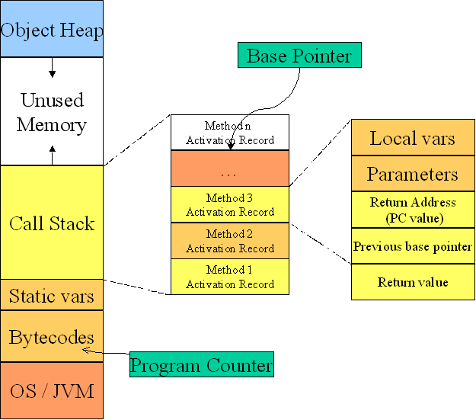

## Call and return process

When a method/function is called

1. An activation record is created; its size depends on the number and size of the local variables and parameters.
2. The Base Pointer value is saved in the special location reserved for it
3. The Program Counter value is saved in the Return Address location
4. The Base Pointer is now reset to the new base (top of the call stack prior to the creation of the AR)
5. The Program Counter is set to the location of the first bytecode of the method being called
6. Copies the calling parameters into the Parameter region
7. Initializes local variables in the local variable region

While the method executes, the local variables and parameters are simply found by adding a constant associated with each variable/parameter to the Base Pointer.

When a method returns

1. Get the program counter from the activation record and replace what's in the PC
2. Get the base pointer value from the AR and replace what's in the BP
3. Pop the AR entirely from the stack.

Application of Stack :

1. Parsing
2. Recursive Function
3. Calling Function
4. Expression Evaluation
5. Expression Conversion
   * Infix to Postfix
   * Infix to Prefix
   * Postfix to Infix
   * Prefix to Infix
6. Towers of hanoi

**Some Useful Links**

<http://www.cs.miami.edu/home/burt/learning/Csc517.091/workbook/hashing_linear.html>

<https://www.youtube.com/watch?v=CwM-Cxilk4g>

<https://www.youtube.com/watch?v=lDMc4hg1lUk>

<https://www.youtube.com/watch?v=_qEnJUPDUFU>

<http://csis.pace.edu/~wolf/CS122/infix-postfix.htm>

<http://scanftree.com/Data_Structure/infix-to-postfix>

<http://interactivepython.org/runestone/static/pythonds/BasicDS/InfixPrefixandPostfixExpressions.html>

<http://cs-study.blogspot.com/2012/11/infix-to-postfix-conversion.html>

<https://www.slideshare.net/mua99/infix-topostfix-examples>

<http://scanftree.com/Data_Structure/creation-of-b-tree>

<http://www.differencebetween.info/difference-between-b-tree-and-b-plus-tree>

<https://ece.uwaterloo.ca/~cmoreno/ece250/2012-03-05--M-way-and-B-trees.pdf>

<https://webdocs.cs.ualberta.ca/~holte/T26/m-way-trees.html>

<http://faculty.cs.niu.edu/~freedman/340/340notes/340multi.htm>

<https://www.cs.montana.edu/defrance/courses/Fall_02/CS223/lectures/Multi.html>

<http://www.cse.iitd.ac.in/~saroj/DS/DS2014/B%20Trees.pdf>

<https://www.youtube.com/watch?v=UlIEyhRPRwE>

<http://www.cs.ucsb.edu/~teo/cs130a.m15/bt.pdf>

<https://www.scribd.com/doc/20637188/M-WAY-TREES-PDF>

<http://www.cs.wcupa.edu/rkline/ds/avl-trees.html>

<http://sandbox.mc.edu/~bennet/cs402/lec/avl/frame01.html>

<https://www.cs.umd.edu/class/summer2016/cmsc132/lectures/Lecture17_2_3_4_tree.pdf>

<http://www.serc.iisc.ernet.in/~viren/Courses/2010/SE286/Lecture16.pdf>

<http://faculty.cs.niu.edu/~freedman/340/340notes/340redblk.htm>

<https://www.cs.purdue.edu/homes/ayg/CS251/slides/chap13b.pdf>

<http://faculty.cs.niu.edu/~freedman/340/340notes/340redblk.htm>

<http://www.serc.iisc.ernet.in/~viren/Courses/2010/SE286/Lecture16.pdf>